18071
Q. Write a program in python to demonstrate Newton Raphson method. Aim: To write a program in python to demonstrate Newton Raphson method.
Formula:
Xn + 1 = xr - f(x) / f’(x)
Xn+1 = (xr - (f(x) / f’(x))
Program:
def f(x, func_str): return eval(func_str, {"x": x, "math":math})
def derivative(x, func_str): h = 1e-5 return (f(x + h, func_str) - f(x - h, func_str)) / (2 * h)
def newton_raphson(func_str, x0, tol): print("\nIter\t x\t\t f(x)\t\t f'(x)\t\t Next x") iter = 1
while True:
fx = f(x0, func_str)
dfx = derivative(x0, func_str)
if dfx == 0:
print("Error: Derivative is zero. Method fails.") return
x1 = x0 - fx / dfx
print(f"{iter}\t {x0:.5f}\t {fx:.5f}\t {dfx:.5f}\t {x1:.5f}")
if abs(x1 - x0) < tol:
break
x0 = x1
iter += 1
print(f"\nApproximate root = {x1:.3f} (correct to 3 decimal places)")
print("=== Newton–Raphson Method ===") func_str = input("Enter the function f(x): ") # Example: x*3 - 2x - 5 x0 = float(input("Enter the initial guess: ")) # Example: 2 tol = 0.0001 # Accuracy
newton_raphson(func_str, x0, tol)
Khushi Vishwakarma | S.I.W.S College | Minor Practical 1

18071 Result:
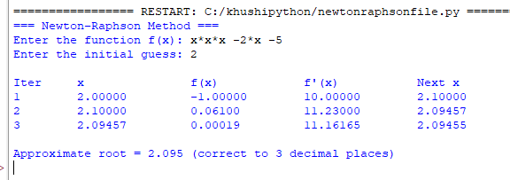
Conclusion: The above program has been executed successfully.
Khushi Vishwakarma | S.I.W.S College | Minor Practical 1

