18071
Modified Euler’s Series.
Q. Write a program in python to demonstrate Modified Euler’s Method.
Aim: To write a program in python to demonstrate Modified Euler’s Method.
Program:
def f(x, y):
return x + y # Example: dy/dx = x + y
main program
if name == "main":
x0 = 0.0 # initial x y0 = 1.0 # initial y
h = 0.1 # step size
n = 5 # number of steps
print("="*70)
print(f"{'Modified Euler’s Method Approximation':^70}") print("="*70)
print(f"{'x':>8} {'y':>15}")
for i in range(n):
k1 = f(x0, y0)
y_predict = y0 + h * k1 # Euler prediction k2 = f(x0 + h, y_predict) # Corrector slope y1 = y0 + (h / 2) * (k1 + k2) # Improved estimate
print(f"{x0:8.4f} {y0:15.6f}")
x0 += h
y0 = y1
print(f"\nApproximate value of y({x0:.1f}) = {y0:.6f}")
Output:
Khushi Vishwakarma | S.I.W.S College | Minor Practical-5

18071
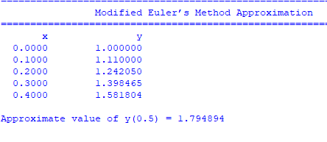
Conclusion: The above program has been executed successfully.
Khushi Vishwakarma | S.I.W.S College | Minor Practical-5

