18071
Q. Write a program in python to find Null value in Forward difference table.
Aim: To write a program in python to find Null value in Forward difference table.
Program:
def solve_missing_term(y): # Coefficients for 5-point formula: y4 - 4y3 + 6y2 - 4y1 + y0 = 0 coeffs = [1, -4, 6, -4, 1]
if y.count(None) != 1:
print("Error: Exactly one value must be 'null'.") return None
m = y.index(None)
total = 0
for i in range(5):
if i != m:
total += coeffs[i] * y[i]
y_missing = -total / coeffs[m]
return m, y_missing
def check_equal_spacing(x): h = x[1] - x[0] for i in range(len(x) - 1): if abs((x[i + 1] - x[i]) - h) > 1e-6: return False return True
def main(): print("=================================================") print("Enter x values (must be equally spaced):") x = [float(input(f"x[{i}]: ")) for i in range(5)]
if not check_equal_spacing(x):
print("Error: x values are not equally spaced.") return
print("Enter y values (use 'null' for the missing one):") y = []
for i in range(5):
val = input(f"y[{i}]: ").strip().lower()
if val == "null":
y.append(None)
else:
y.append(float(val))
KKhushi Vishwakarma | S.I.W.S College | Minor Practical 2

18071
result = solve_missing_term(y)
if result:
idx, y_miss = result
print(f"\nEstimated missing y[{idx}] (at x = {x[idx]:.1f}) = {y_miss:.4f}")
print("=================================================")
if name == "main": main()
Result:
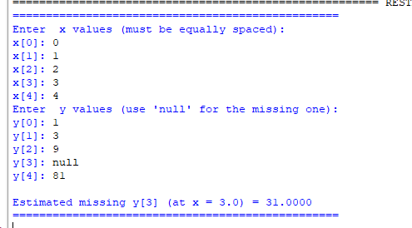
Conclusion: The above program has been executed successfully.
KKhushi Vishwakarma | S.I.W.S College | Minor Practical 2

