18071
Q. Write a program in python to demonstrate Regula Falsi method.
Aim: To write a program in python to demonstrate regula falsi method.
Formula:
Xr = af(b) - bf(a) / f(a) - f(b)
Xr = (((a*f(b)) - (b*f(a))) / (f(a) - f(b)))
Program:
def f(x, func_str): return eval(func_str, {"x": x, "math": math})
def regula_falsi(func_str, a, b, tol): if f(a, func_str) * f(b, func_str) > 0: print("Invalid interval! f(a) and f(b) must have opposite signs.") return
print("\nIter\t a\t b\t Xr\t f(Xr)") iter = 1
Xr_old = a
while True:
# Formula for Regula Falsi
Xr = (a * f(b, func_str) - b * f(a, func_str)) / (f(b, func_str) - f(a, func_str))
fx = f(Xr, func_str)
print(f"{iter}\t {a:.3f}\t {b:.3f}\t {Xr:.3f}\t {fx:.3f}")
if abs(fx) < tol or abs(Xr - Xr_old) < tol: break
if f(a, func_str) * fx < 0:
b = Xr
else:
a = Xr
Xr_old = Xr
iter += 1
print(f"\nApproximate root = {Xr:.3f} (correct to 3 decimal places)")
Khushi Vishwakarma | S.I.W.S College | Minor Practical 1

18071
print("=== Regula Falsi Method ===") func_str = input("Enter the function f(x): ") # Example: x*3 - 2x - 5 a = float(input("Enter starting value a: ")) # Example: 2 b = float(input("Enter ending value b: ")) # Example: 3 tol = 0.0001 # Accuracy
regula_falsi(func_str, a, b, tol)
Result:
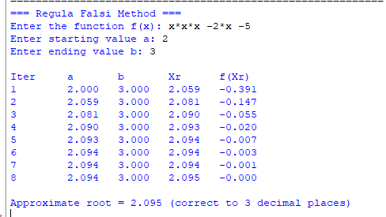
Conclusion: The above program has been executed successfully.
Khushi Vishwakarma | S.I.W.S College | Minor Practical 1

