18071
Runge-Kutta 4th Order Method.
Q. Write a program in python to demonstrate Runge-Kutta 4th Order Method Aim: To write a program in python to demonstrate Runge-Kutta 4th Order Method.
Program:
def f(x, y):
return x + y
Exact solution for checking (for dy/dx = x + y, y(0)=1 → y = 2e^x - x - 1)
def exact_solution(x):
return 2 * math.exp(x) - x - 1
#Initial conditions
x = 0.0
y = 1.0
h = 0.1
steps = int(0.2 / h) # compute up to x = 0.2
print("==================================================================== ")
print(" Runge-Kutta 4th order (RK4) step-by-step")
print("==================================================================== ") print("Equation: y' = x + y ,
y(0)=1\n")
print(f"{'Step':>3} | {'x_n':>6} | {'y_n (before)':>16} | {'k1':>7} | {'k2':>7} | {'k3':>7} | {'k4':>7} | {'y_(n+1)':>10}") print("-"*75)
for i in range(1, steps + 1):
k1 = f(x, y)
Khushi Vishwakarma | S.I.W.S College | Minor Practical-5

18071
k2 = f(x + h/2, y + (h/2)*k1)
k3 = f(x + h/2, y + (h/2)k2)
k4 = f(x + h, y + hk3)
increment = (h/6)*(k1 + 2*k2 + 2*k3 + k4) y_next = y + increment
print(f"{i:3d} | {x:6.3f} | {y:16.9f} | {k1:7.6f} | {k2:7.6f} | {k3:7.6f} | {k4:7.6f} | {y_next:10.9f}")
# update for next iteration
x += h
y = y_next
print("-"*75)
print(f"Final RK4 approximation: y({x:.3f}) = {y:.9f}") print(f"Exact value : y({x:.3f}) = {exact_solution(x):.9f}") print(f"Absolute error : {abs(y - exact_solution(x)):.12e}") Result:
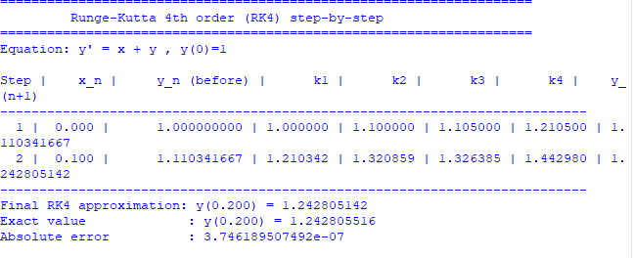
Conclusion: The above program has been executed successfully.
Khushi Vishwakarma | S.I.W.S College | Minor Practical-5

18071
Khushi Vishwakarma | S.I.W.S College | Minor Practical-5

