18071
4. Solution of simultaneous Algebric equation
Gaussian elimination method.
Q. Write a program in python to demonstrateGaussian elimination Method. Aim: To write a program in python to demonstrate Gaussian elimination Method.
Program:
print("="*70) print("Initial augmented matrix [A | b]:")
Input augmented matrix [A|b]
a = [ [1.0, 10.0, -1.0, 3.0], [2.0, 3.0, 20.0, 7.0], [10.0, -1.0, 2.0, 4.0] ]
n = len(a)
Function to print matrix neatly
def print_matrix(a): for row in a: print(" [", end=" ") for val in row: print(f"{val:10.6f}", end=" ") print("]") print()
print_matrix(a)
Forward Elimination
for i in range(n): # Pivoting max_row = i for k in range(i+1, n): if abs(a[k][i]) >
abs(a[max_row][i]): max_row = k if max_row != i: a[i], a[max_row] = a[max_row], a[i] print(f"R{max_row+1} <-> R{i+1}") print_matrix(a)
# Make elements below pivot zero
for k in range(i+1, n):
factor = a[k][i] / a[i][i]
for j in range(i, n+1):
a[k][j] -= factor * a[i][j]
print(f"R{k+1} = R{k+1} - ({factor:.6f})*R{i+1}") print_matrix(a)
print("Upper-triangular matrix after forward elimination:") print_matrix(a)
Back Substitution
Khushi Vishwakarma | S.I.W.S College | Minor Practical-4

18071
x = [0 for _ in range(n)] for i in range(n-1, -1, -1): x[i] = a[i][n] for j in range(i+1, n): x[i] -= a[i][j] * x[j] x[i] /= a[i][i]
print("Solution vector:") for i in range(n): print(f"x{i+1} = {x[i]:.8f}")
Result:
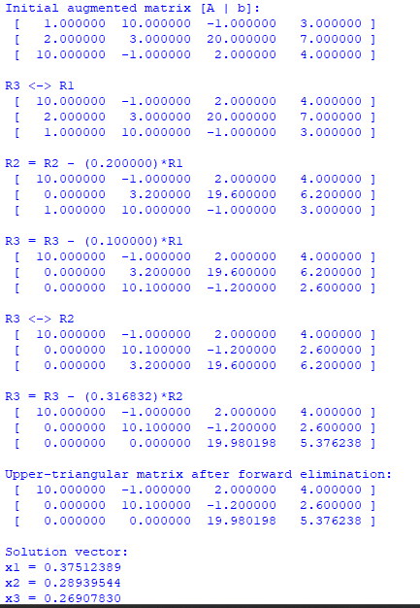
Conclusion: The above program has been executed successfully.
Khushi Vishwakarma | S.I.W.S College | Minor Practical-4

18071
Khushi Vishwakarma | S.I.W.S College | Minor Practical-4

