18071
Q. Write a program in python to demonstrate 2 degree curve fitting.
Aim: To write a program in python to demonstrate 2 degree curve fitting.
Formula:
Sum(y) = na0 + a1sum(x) + a2sum(x^2)
Sum(xy) = a0 sum(x) + a1sum(x^2) + a2sum(x^3)
Sum(x^2y) = a0sum(x^2) + a1sum(x^3) +a2sum(x^4)
Program:
def fit_quadratic(x, y): n = len(x)
# Required summations
sum_x = sum(x)
sum_x2 = sum(i**2 for i in x)
sum_x3 = sum(i**3 for i in x)
sum_x4 = sum(i**4 for i in x)
sum_y = sum(y)
sum_xy = sum(x[i] * y[i] for i in range(n))
sum_x2y = sum((x[i]**2) * y[i] for i in range(n))
# Solving normal equations for a0, a1, a2 # Using Cramer's rule / determinant method
# Main determinant
D = (n*(sum_x2*sum_x4 - sum_x3*sum_x3)
- sum_x*(sum_x*sum_x4 - sum_x2*sum_x3) + sum_x2*(sum_x*sum_x3 - sum_x2*sum_x2))
# Determinant for a0
D0 = (sum_y*(sum_x2*sum_x4 - sum_x3*sum_x3)
- sum_x*(sum_xy*sum_x4 - sum_x3*sum_x2y) + sum_x2*(sum_xy*sum_x3 - sum_x2*sum_x2y))
# Determinant for a1
D1 = (n*(sum_xy*sum_x4 - sum_x3*sum_x2y) - sum_y*(sum_x*sum_x4 - sum_x2*sum_x3)
Khushi Vishwakarma | S.I.W.S College | Minor Practical 3

18071
+ sum_x2*(sum_x*sum_x2y - sum_xy*sum_x2))
# Determinant for a2
D2 = (n*(sum_x2*sum_x2y - sum_xy*sum_x3)
- sum_x*(sum_x*sum_x2y - sum_xy*sum_x2) + sum_y*(sum_x*sum_x3 - sum_x2*sum_x2))
a0 = D0 / D
a1 = D1 / D
a2 = D2 / D
return a0, a1, a2
def main(): n = int(input("How many data points? ")) x, y = [], [] for i in range(n): xi, yi = map(float, input(f"Enter x and y for point {i+1}: ").split()) x.append(xi) y.append(yi)
a0, a1, a2 = fit_quadratic(x, y)
print(f"\nQuadratic Equation: y = {a0:.4f} + {a1:.4f}x + {a2:.4f}x^2")
xv = float(input("Enter x value to predict y: ")) yv = a0 + a1*xv + a2*(xv**2)
print(f"Predicted y = {yv:.4f}")
Run program
main()
Result:
Khushi Vishwakarma | S.I.W.S College | Minor Practical 3

18071
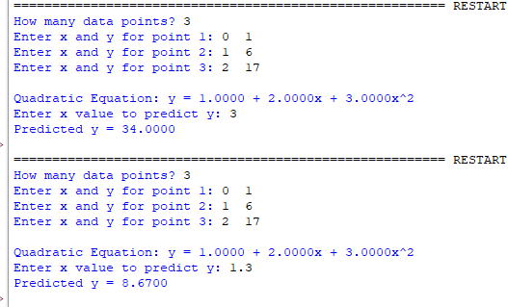
Conclusion: The above program has been executed successfully.
Khushi Vishwakarma | S.I.W.S College | Minor Practical 3

