Reading Level Assessment for School Content for Policy Support using NLP

Khushi Yadav
Department of Computer Science and Engineering,
Lovely Professional University Phagwara, India khushi08yadav03@gmail.com
Yashwant Patel Department of Computer Science and
Engineering,
Lovely Professional University Phagwara, India yashwantpatel993540@gmail.com
Puneet Rao Department of Computer Science and
Engineering,
Lovely Professional University Phagwara, India
puneetrao2003@gmail.com

Abstract
Reading skill is an important component of learning, learning programs, and learning policies. It continues to be a challenging task to ensure school-level content meets the intended reading level of students. Assessment of the reading level of contents by a human being turns out to be a challenging task. Thus, the need to introduce an automated reading level assessment system for school content by applying Natural Language Processing techniques. The system identifies the readability level of given educational text by using features such as the length of sentences and words. It also uses established readability formulae like that of Flesch-Kincaid Reading Ease/Grade Level, SMOG Readability Test, Automated Readability Index, and Coleman-Liau Index. A regression learning model is used with the help of the CommonLit Readability dataset. Then the results obtained from the model can be translated on the basis of school grades. The system has been designed using Python and runs on a web interface. The experimental outcome proves the efficacy of the model in identifying the variability in the complexity of the text successfully and providing an accurate measure for readability. The formulated method provides an optimal solution to make curriculum development, book analysis, and education-oriented policymaking feasible on a large scale with an unbiased approach. The study emphasizes the use of NLP-based tools for assessing readability with a view to improve the quality and inclusiveness of education.
- Introduction
Reading comprehension is one of the basic parts of proper education and has a huge role in academic performances and brain development in students. Educational information in textbooks, digital textbooks, and educational policies has to be designed in a mindful way while keeping in view the reading levels of the target age group, because reading complexity may result in obscuring understanding levels, while too simple information may not be capable of encouraging learning outcomes at all. Therefore, determining reading levels in educational content becomes a crucial responsibility for everyone involved in education. Historically, the determination of the level of text readability has depended on manual analysis by a technical expert or educator. While expert opinion has always been useful, this approach has several limitations, including being a subjective, time-consuming, and unscalable task, especially with the large amount of learning materials being produced on digital platforms and updates in curricula being more frequent.

Natural Language Processing (NLP) techniques are highly effective for the linguistic structure and semantic complexities involved within the textual information. For readability measurement, NLP relies on characteristics like the length of phrases, frequency of words, syllables, and sentence structure, among others, for approximating the readability index for the subject text. The well-known readability formulas are Flesch-Kincaid, SMOG, Automated Readability Index, and Coleman-Liau Index. Yet these formulas might lack the variability while being used for present-day educational texts. In recent years, machine learning has brought about the possibility of developing models based on data that can learn the patterns of readability from annotated datasets. By integrating conventional measures of readability with machine learning models, it has become feasible to make more accurate predictions of the level of readability. This would lead to the provision of the readability level on a continuum with specified levels. This paper presents the design of an automatic reading level estimation tool that applies NLP and machine learning algorithms in order to address the issue. The tool will help support education policy-making since it will aid in analyzing the readability of school content in a reliable and unbiased manner. This will help in improving curriculum relevance in addition to supporting the concept of inclusive education.
- Literature Review
Readability formula research was quite an active area of research for the past few decades, particularly in education, linguistics, and computational linguistics communities. Early research work concentrated on designing math formulas that compute the readability level of a piece of text based on certain surface-level linguistic factors like the number of sentences, sentence complexity, and word complexity. Some of the earliest readability formula calculations that gained widespread acceptance include the Flesch Readability Scale and Flesch-Kincaid formula, which compute readability based on sentence level, syllable, and sentence complexity. Later research included other readability formulae such as SMOG Index, Automated Readability Index (ARI), and Coleman-Liau Index. These formulae incorporated other linguistic features such as character counts and the use of polysyllabic words in attempts to make their predictions even more accurate. Although these classical measures for readability calculation are efficient in terms of computation and are

readily implemented, evidence has been presented in various research studies to exemplify their inadequacies too. These measures neglect semantic complexity, sense, and discourse in contemporary educational texts. However, with the development in Natural Language Processing, studies in the readability assessment task started using machine learning approaches. These studies view readability assessment as a supervised learning task, requiring the model to learn from datasets which have already undergone annotation processes with regard to texts being analyzed using grade levels or scores. The features commonly employed in this task include lexical diversity, syntactic complexity, parts of speech, and n-gram information. Some machine learning models that were shown to work better compared to formula-based models include linear regression, support vector machines, or ensemble models. More contemporary research efforts have employed large-scale readability benchmarks, like that of the CommonLit Readability Prize, to train accurate prediction models. This is because these benchmarks offer a metric representation of text readability, allowing more nuanced text assessment in a way that is not feasible when using grade-level categorizations. The aggregation of traditional readability scores with statistical/linguistic variables has been demonstrated to produce more accurate predictive outcomes by researchers, though many existing approaches pay little heed to explainability or application feasibility in a learning context. Simultaneously, deep learning and transformer models have been investigated and applied for readability evaluation. The models leverage word embeddings in contexts that are dependent on semantics and syntax. These models are highly accurate even though they consume high amounts of computational power and training data. Notwithstanding the progress that has been made regarding the research on the assessment of readability, a gap still exists that pertains to systems targeted towards facilitating educational policy-making. This arises from the fact that the current solutions lack interfaces as well as grade-level classification that can easily be comprehended by policymakers. To fill the gap, the project aims to utilize the services of an NLP system and a machine learning program.

Methodology
- Data Collection
The main dataset used in this research work is the CommonLit Readability Prize dataset. It is a public benchmark dataset designed specifically for the task of readability. It consists of short passages of text taken from a variety of sources, along with continuous scores of readability that have been annotated by human raters. Such scores are a measure of the relative difficulty of the passage and offer a good foundation for a learning task. Each example in the data represents a text snippet and a readability score. This data was chosen because it had high-quality annotations and was appropriate to model in detail the variability in readability. Also, the data was checked in advance for missing values and inconsistencies. Only pairs

that had valid text and scores were kept.
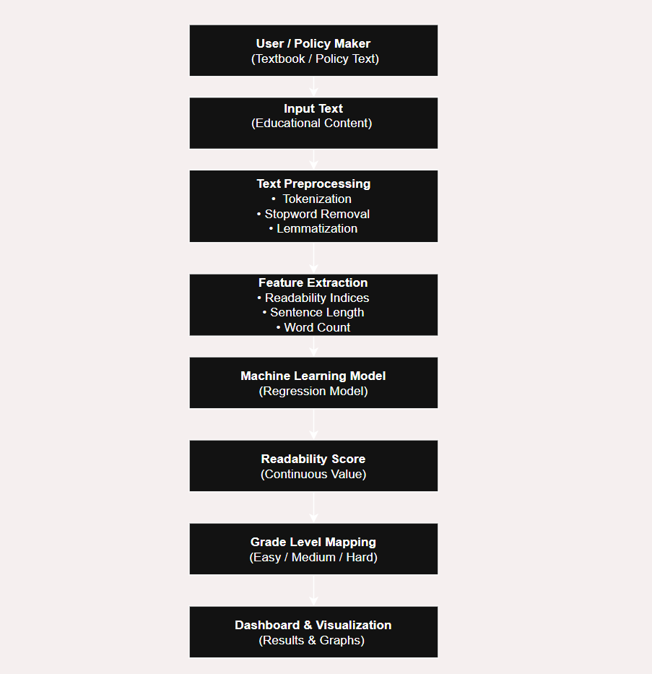
Fig. 1. Block Diagram of working

- Data Analysis
The analysis of data was done through Natural Language Processing techniques, which helped in converting raw text form to meaningful numerical form. The process of text processing involves changing text to their respective lowercase, removal of punctuation and stop words, and lemmatization techniques that helped in forming normalized words. After that, several linguistic features were derived so that different aspects of complexity can be observed. These features include sentence length, total word count, average sentence length, as well as well-known readability formulas such as Flesch-Kincaid Grade Level, SMOG Readability Text, Automated Readability Index, and Coleman-Liau Index. These indices encompass the different aspects of the sentence structure. The features that were extracted were utilized for the development of the regression model for predicting the readability score. This score can then be classified based on grades for better interpretation. The performance criteria for this regression model were used based on Root Mean Square Error. Besides that, there were other regression criteria used.
- Lexicon-Based Sentiment Analysis (NLP)
The reading level assessment system proposed uses classical natural language processing techniques and statistical readability techniques and does not use deep learning-based language models. This helps in using the system as educational policy since the system will be computationally efficient.1. Text Preprocessing Techniques: Some basic NLP preprocessing tasks have been performed on the input text in order to clean the text, which has come from the education sector. These include: Tokenization: The text is broken down into words (token) for the purpose of analysis. Lowercasing: All the characters in the string are changed to lowercase to avoid redundancy. Remove stop-words: "The, is, and" are some common stop-words that are not important in terms of readability, which may be removed.

Lemmatization: It is the process whereby words are converted to base or dictionary form so that different inflected forms of a word are treated the same way.Such preprocessing steps remove the noise and make the linguistic features identified through this approach reliable. 2. Linguistic Feature Extraction: In contrast to semantics-based embedding approaches, a focus here is on linguistic elements clearly impacting reading difficulty. These elements include: Lexical characteristics: Word number and average word length. Syntactic features include the number of sentences in the text and the average number Structural aspects: Distribution of characters and syllables. All of these characteristics address the complexity of education text from the surface level, which has a close link with the comprehension process of reading. 3. Readability Measures (Core NLP Module): The system relies on well-proven readability formulas that are classical statistical models based on NLP. These models are as follows Flesch–Kincaid Grade Level, SMOG Index, Automated Readability Index (ARI), Coleman–Liau Index, Such measures allow the calculation of the text complexity level on the basis of linguistic features such as the number of words in a sentence, the number of syllables, and some specific character frequency. These measures are well-recognized in the field of education. 4. Machine Learning Integration: The NLP features obtained are then fed into a machine learning algorithm of the regression kind, which learns to produce a readability score, which is eventually categorized into levels. Using machine learning ensures effective learning from the labeled data but without losing the simplicity associated with NLP features. 5. Unsupervised NLP Analysis ( Unsupervised machine learning models are also employed using the clustering algorithm K-Means as well as hierarchical clustering. These models help group the texts according to their linguistic characteristics based on similarity, allowing for exploratory data analysis of the patterns of readability within educational content.
- Clustering Algorithms Employed
Along with the supervised learning approach using regression for readability prediction, some unsupervised learning methods were also used in this study to discover the hidden patterns in the education texts by employing clustering algorithms. In this concept, clustering helps in grouping text samples with comparable features. For example, clustering can be helpful in deciding the categories of readability, which remains a major task in deciding the education curriculum. In order to apply clustering, the same set of features used in the supervised classification task was applied to the data, including the set of readability scores, word count, as well as per-sentence features. The features were normalized in order to prevent any one dimension from going on to skew the clustering analysis. The normalization was necessary in order to normalize features with wide ranging values, such as the readability scores, as well as the word count features.
- K-Means Clustering
K-Means clustering was used as the basic unsupervised learning algorithm because of its efficiency and efficacy. The process groups the dataset into K clusters in such a way that the sum of squares within cluster means is minimal. Thus, if text samples belong to the same group, they have a high degree of similarity in terms of readability attributes. Each point in the cluster represents a corresponding difficulty level.
The determination of the optimum value for the number of clusters was done using the elbow method. It depends on the relationship between the value for the number of clusters and the variance within the clusters. Using the results, the optimum value for K was determined. The value forms the basis for the generation of clusters that relate well to easy, medium, and difficult readability. K-Means clustering helps in understanding the major readability patterns present in the dataset, which helps identify the categorization of educational material according to clearly defined levels of readability. Such data is useful for policymakers for understanding the applicability of learning materials for students of different grades.
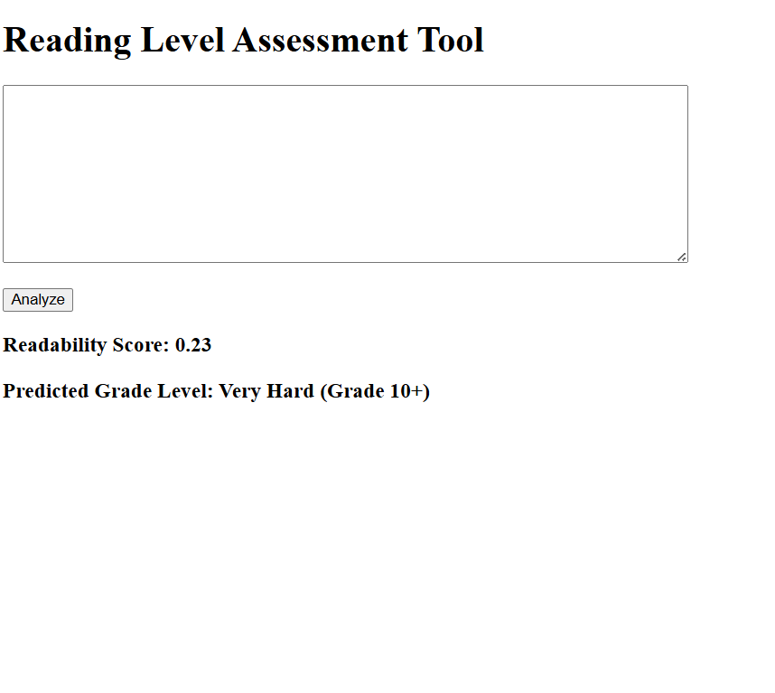
Fig. 2. Assessment.

- Hierarchical Clustering
In order to better understand the relationships between text samples, hierarchical clustering was used. This method has one key difference from K-Means: in hierarchical clustering, the number of clusters does not need to be specified; instead, the method generates what is known as a dendrogram. A dendrogram helps one understand the way text samples come together. Agglomerative hierarchical clustering is employed, rising from a condition whereby each text is initially a separate cluster and is then grouped with others based on distance measures. This is useful in visualizing the levels of readability from simpler texts to more complex texts. Indeed, hierarchical clustering is better in visualizing small differences in levels of difficulty in texts, and in confirming levels of text clusters determined by K-Means clustering.
- Hierarchical Clustering
Clustering analysis provides significant insights for the support of education policies. Based on the grouping of texts by similar characteristics of readability, the system facilitates the detection of discrepancies in the curriculum materials, including the presence of complex material at the lower grade levels. Similarly, the clusters assist in the development of learning pathways by the education policymakers.

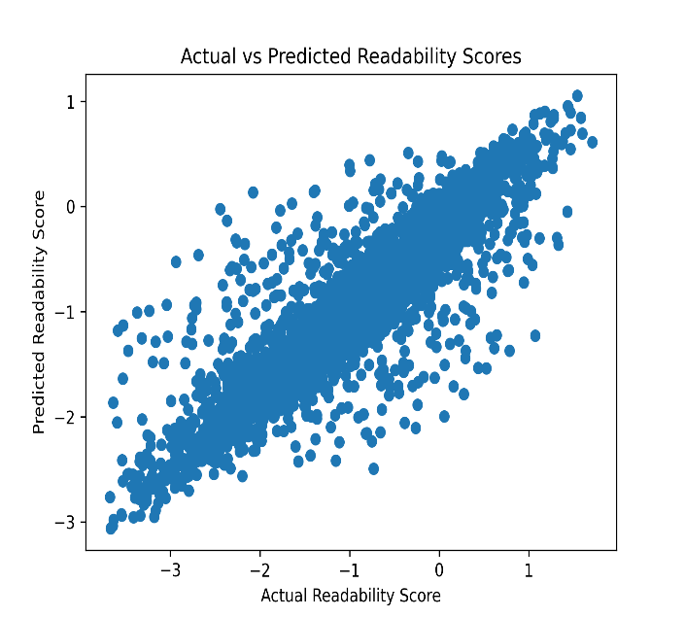
Fig. 3. Actual vs Predicted

- Dashboard and user interface
A user-friendly dashboard and interface were developed to enable practical interaction with the proposed reading level assessment system. The primary objective of the interface is to provide an accessible and intuitive platform for educators, curriculum designers, and policymakers to evaluate the readability of educational content without requiring technical expertise in natural language processing or machine learning. The system is implemented as a lightweight web-based application using the Flask framework. The dashboard allows users to input educational text through a text area, supporting content such as textbook excerpts, policy documents, and learning materials. Upon submission, the system processes the input text in real time and applies the trained readability assessment model to generate predictions. The output of the dashboard includes a numerical readability score along with a mapped grade-level interpretation to enhance usability. Presenting both the quantitative score and the corresponding grade category enables users to understand the relative difficulty of the content while maintaining interpretability. Additionally, the interface provides informative feedback when the input text is short, indicating that longer text samples may yield more reliable predictions. This design consideration improves transparency and helps manage user expectations regarding model performance. The dashboard design intentionally prioritizes simplicity and clarity over visual complexity. A clean layout, minimal color usage, and standard typography were adopted to ensure ease of use and accessibility. This approach aligns with academic and policy-oriented applications, where clarity and functionality are more critical than advanced visual elements. The interface is responsive and can be accessed through standard web browsers, making it suitable for deployment in educational institutions and administrative environments. Overall, the dashboard serves as an effective bridge between the underlying NLP-based analytical framework and end users. By enabling real-time readability analysis through a simple interface, the system supports evidence-based decision-making in curriculum evaluation and educational policy planning.

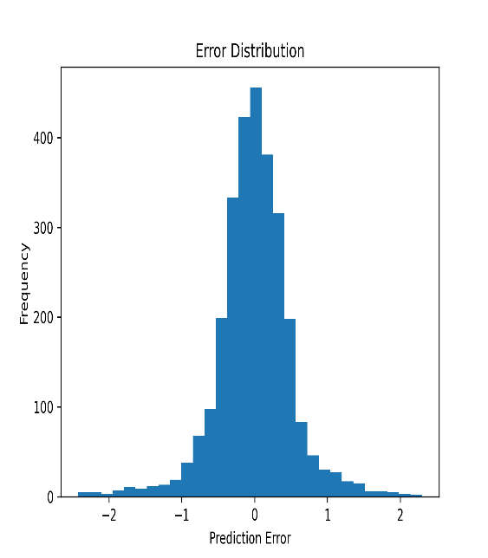
Fig. 4. Error Distribution.

- Result Discussion
This section will discuss the results of experiments conducted on the proposed reading level assessment system with respect to their implications for educational content assessment. The performance evaluation of the proposed model has been done on quantitative parameters such as regression plots, error distribution, and importance scores. A. Model Performance Evaluation: The regression model was trained using linguistic and readability-related features extracted from the CommonLit Readability dataset through supervised machine learning. The regression model predicts a score that represents the relative difficulty of text based on a continuous output. The Root Mean Square Error evaluation metric is used to analyze the average difference in predicted and actual scores of text complexity. The value of the error measure, RMSE, obtained shows that the model has the capability to estimate the variation associated with the complexities present within the text with reasonable accuracy. The results show that merging the traditional measure of readability with statistical attributes of the text enhances accuracy significantly. B. Actual and Predicted Values of Readability Analysis The Actual vs. Predicted Readability Score plot reveals the correlation between the ground truth and predicted scores. Most of the data points are seen to be concentrated around the diagonal line. This suggests that there is consistency between actual and predicted scores. The slight variations are seen when the texts are more extreme in difficulty level. These variations can be justified on the basis of some linguistic complexities that are not captured through surface-level characteristics. This proves that the developed model can perform well on different levels of text complexity and provide a good estimation on the average content used in education. C. Error Distribution Analysis The graph showing error distribution represents the error frequencies for predictions in the data set. The error distribution looks to be broadly symmetric around zero, with no systematic tendency to either overestimate or underestimate the values of readability scores. The errors areRestricted to a band on either side of the graph.

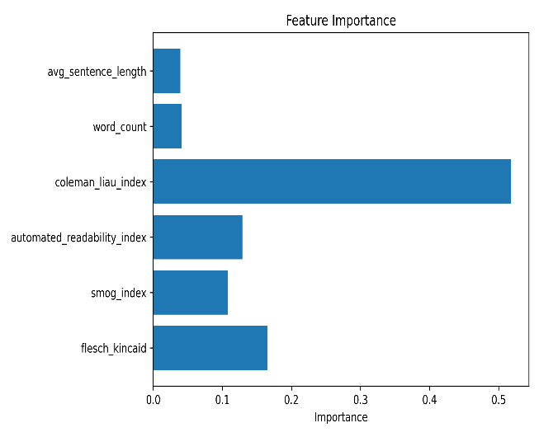
Fig. 5. Feature Importance

- Limitation
Despite the efficiency of the designed level assessment system for reading, there are some limitations that should be acknowledged. It is significant to point out these limitations in order to make use of the results effectively. Firstly, the model mostly uses classical NLP features and readability metrics that mainly revolve around surface-level aspects of language, including sentence length and number of words/syllables. Even though these features work well as approximations for readability scores, they do not account for the underlying semantics that educational texts convey. Secondly, the model is trained from the CommonLit Readability dataset, whose text passages are quite brief. Consequently, the model might not work well for very short inputs or for highly technical academic writing. It would be difficult to judge readability for short pieces of writing because of the lack of context. Third, it examines readability in text only in one language, which is in English. Each language has its own linguistic features, and their variability is great; hence, it is not possible to implement it on multiple or regional language learning resources directly. Moreover, the assignment of continuous readability measures to discrete grade levels requires predetermined thresholds. Although it is a better approach to understanding and interpreting, it can slightly become subjective in assigning levels to texts based on their relative difficulty scores. Lastly, despite the fact that the system has the functionality of exploratory analysis based on the clustering approach, the result of the clusters is not dynamically incorporated into the system interface. This system functionality development emphasizes predictability in readability, as opposed to real-time visualization.
- Conclusion
This article has introduced an automated system to measure the reading level in school content based on Natural Language Processing and machine learning. The proposed methodology can overcome the shortcomings of current manual reading-level assessment to provide an objective and interpretable solution. Using a combination of classical NLP preprocessing techniques, established readability formulas, and regression techniques for predictive modeling, the system is able to successfully predict grades and assign corresponding grades based on the predicted values.

A web-based dashboard has been created to help in assessing the readability of texts in real-time. Thus, the tool is practical for educators, curricular developers, and policy-makers. The implications of the study indicate the potential usefulness of NLP-based readability tests in developing educational policies, texts, and materials.
- FUTURE WORK
Although the proposed system for reading level assessment performance showcases effectiveness through classical NLP and machine learning approaches, a number of areas can be explored to further improve the system's efficacy and use. In the future, work can be done to incorporate increasingly sophisticated language models that take into account deeper semantic information, such as transformer models, to increase the accuracy of readability assessment for challenging educational content. Extending the system to include multilingual readability assessment is another area for future work. Making the system accommodative to local and low-resource languages will make it more useful in various educational institutions. It will need language-specific preprocessing and feature extraction approaches. Enhancements in the coming future might also include the integration of document-level analysis capabilities. This will enable the analysis of entire textbooks, policies, and curriculums rather than partial or short extracts. This will enable the generation of a wider range of insights into the structure of the content and the level of difficulty in each chapter. Overall, the proposed system shows that with the help of interpretable NLP methods and machine learning approaches, one can garner important insights about the complexity of educational content. This will help in enhancing the relevance of education content with the reading capabilities of learners.

References
- J. P. Kincaid, et al., ”Derivation of new readability formulas (Automated Readability Index, Fog Count and Flesch Reading Ease Formula) for Navy enlisted personnel,” Research Branch Report 8-75, 1975.
- G. H. McLaughlin, ”SMOG grading-a new readability formula,” Journal of reading, vol. 12, no. 8, pp. 639–646, 1969.
- S. Crossley, et al., ”Text readability and intuitive simplification: A comparison of readability formulas,” Reading in a Foreign Language, vol. 23, no. 1, pp. 84–101, 2011.
- K. Collins-Thompson and J. Callan, ”A language modeling approach to predicting reading difficulty,” in Proc. of HLT-NAACL, 2004.
- A. Vaswani et al., ”Attention is all you need,” in Advances in neural information processing systems, 2017.
- V. Sanh et al., ”DistilBERT, a distilled version of BERT: smaller, faster, cheaper and lighter,” arXiv preprint arXiv:1910.01108, 2019.
- T. Lin et al., ”Focal Loss for Dense Object Detection,” in Proc. of IEEE ICCV, 2017
- R. Flesch, “A new readability yardstick,” Journal of Applied Psychology, vol. 32, no. 3, pp. 221–233, 1948.
- J. P. Kincaid, R. P. Fishburne Jr., R. L. Rogers, and B. S. Chissom, “Derivation of new readability formulas for navy enlisted personnel,” Research Branch Report 8–75, Naval Technical Training Command, Millington, TN, USA, 1975.
- G. H. McLaughlin, “SMOG grading: A new readability formula,” Journal of Reading, vol. 12, no. 8, pp. 639–646, 1969.
- J. Devlin, M. Chang, K. Lee, and K. Toutanova, “BERT: Pre-training of deep bidirectional transformers for language understanding,” in Proc. NAACL-HLT, Minneapolis, MN, USA, 2019, pp. 4171–4186.
- CommonLit, “The CommonLit Readability Prize Dataset,” Kaggle, 2021. [Online]. Available: https://www.kaggle.com/c/commonlitreadabilityprize

