**Khushmeet Arora**

**MIS: 111803088**

**TY Comp (Div-1: T4)**

**ART GALLERY MANAGEMENT SYSTEM**

**Problem Statement**

To create an Art Gallery Management System that keeps the records of artists, their artwork and details about art exhibition.

**Introduction**

The main aim of this application is to help art enthusiasts know about different exhibition details organized by Euphoria gallery, its artists and their art work. Admin can add Artists and update/add details about new artwork made by these artists. Also, Admin can add details about upcoming exhibitions. Users accessing the gallery webpage can see different paintings and exhibitions.

**This project allows only Admin access**

**The Admin can perform the following functions: -**

1. Add / Update / Remove details of an exhibition of an artist

2. Add / Update / Remove details of an artist

3. Add / Update / Remove details of an art work of an artist

4. Manage its password/login credentials

5. Update sliding headers of the home page based on the exhibition

**The User can:**

1. Visit the art gallery webpage

2. See the various artists of Euphoria Gallery and their art works sorted by year

3. See the upcoming exhibitions of artists of Euphoria Gallery sorted by date of exhibition

**Software Requirements:**

**Front end:** PHP, JavaScript, HTML5, CSS

**Back end:** MySQL

**Schema Diagram based on ER Diagram below:**

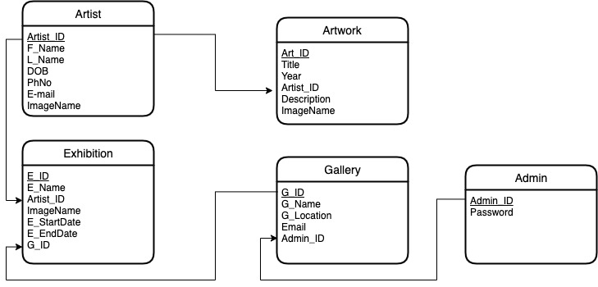

**ER Diagram:**

