Finance Research Agent
Full End-to-End Workflow — A Beginner-Friendly Blueprint

From the moment you type a command to the moment a report lands on disk —
explained so anyone can follow, with every stage mapped to the real code.

Generated June 19, 2026 · Word edition of WORKFLOW.md

Disclaimer (straight from the project)
This software produces educational / research output. It is NOT financial advice, places NO real orders, and uses FREE public data that may be stale or wrong. Always verify before acting.

Table of Contents
The headings below are clickable in Word once the field is updated (right-click → Update Field, or press F9).
Right-click and choose “Update Field” to build the table of contents.

0. TL;DR — Explain It Like I'm 5
Imagine you ask a very careful research team a question like “What are the best IT companies to invest in, in India?”
The research team, in plain language
1. A librarian figures out which companies you might mean (e.g. the big Indian IT firms) and makes a list.
2. A calculator robot downloads free public numbers (profits, debt, price trends) and scores each company on five qualities — just math, no opinions — and prints a “how trustworthy is this data?” sticker.
3. A panel of AI analysts reads those scores and writes short, evidence-based opinions. They are forbidden from making up numbers.
4. Two AIs debate — one optimistic “Bull”, one cautious “Bear”.
5. A risk & tax checker adds rules specific to you (e.g. Indian capital-gains tax, or “keep it low-risk for a German student”).
6. A manager combines everything into a final ranked list and writes a tidy report (Markdown, plus an optional Excel sheet).

You get back a ranked shortlist of stocks with reasons, risks, and tax notes. Nothing is bought; it's purely research.

1. Overview — What This Project Does and Why
The Finance Research Agent (FRA) is a command-line program that ranks the “best” stocks to research for a given theme (for example, “best IT stocks in India” or a single ticker like SAP.DE). It blends deterministic financial math (reproducible, never guesses) with AI language models (which explain and contextualize the math). The result is a written investment research report tailored to one of two investor profiles: an Indian adult investor, or a German student investor.
The core idea
Numbers come from real data and formulas; AI only interprets them. This makes the output more trustworthy than asking a chatbot to “pick stocks,” because the AI is never allowed to invent figures.

2. Key Concepts / Glossary
Term | Plain-language meaning
CLI (Command-Line Interface) | A program you run by typing a command in a terminal instead of clicking buttons. Here it's python -m src.cli ...
Ticker | A stock's short code, e.g. INFY.NS (Infosys, India NSE) or SAP.DE (SAP, Germany Xetra).
Universe | The full list of candidate companies before narrowing down (e.g. all NIFTY 500 companies).
Profile | A saved set of preferences for one kind of investor (country, currency, tax rules, risk, emphasis). YAML files in config/profiles/.
Factor | A measurable “quality” of a company. FRA uses five: Quality, Value, Momentum, Financial Health, Earnings Quality.
Factor engine | The deterministic calculator that scores every company on each factor and ranks them. No AI involved.
Composite score | A single 0–1 number combining the five factors using the profile's weights. Higher = ranks better.
Percentile rank | “Better than X% of the others.” Each company is scored relative to its peers, not on an absolute scale.
LLM (Large Language Model) | An AI that reads and writes text (GPT, Claude, or a local Llama via Ollama). Here, LLMs play “analysts.”
Agent | A single specialized worker in the pipeline (e.g. “fundamentals analyst”). Some use an LLM; many are pure math.
Pipeline / orchestrator | The conveyor belt that runs the agents in order and passes data between them.
Snapshot (CompanySnapshot) | A standardized bundle of one company's data (price, margins, debt, momentum, etc.).
Data health card | A traffic-light summary (OK / WARN / CRITICAL) of how complete and trustworthy this run's data was.
Debate (Bull vs Bear) | Two AI researchers argue the optimistic vs cautious case, so the report shows both sides.
Coverage | The fraction of expected data fields actually available. Low coverage → score is “shrunk” toward neutral.
MCP (Model Context Protocol) | A standard way for AI tools to call external data/tools. Not currently wired into FRA — the shipped version uses yfinance/Stooq directly.

3. High-Level Architecture
FRA is a chain of agents. Data starts as your typed question and flows through each stage, getting richer at every step, until it becomes a report. A single shared object — the AgentState (src/graph/state.py) — is the “clipboard” that travels through the whole chain, accumulating results.
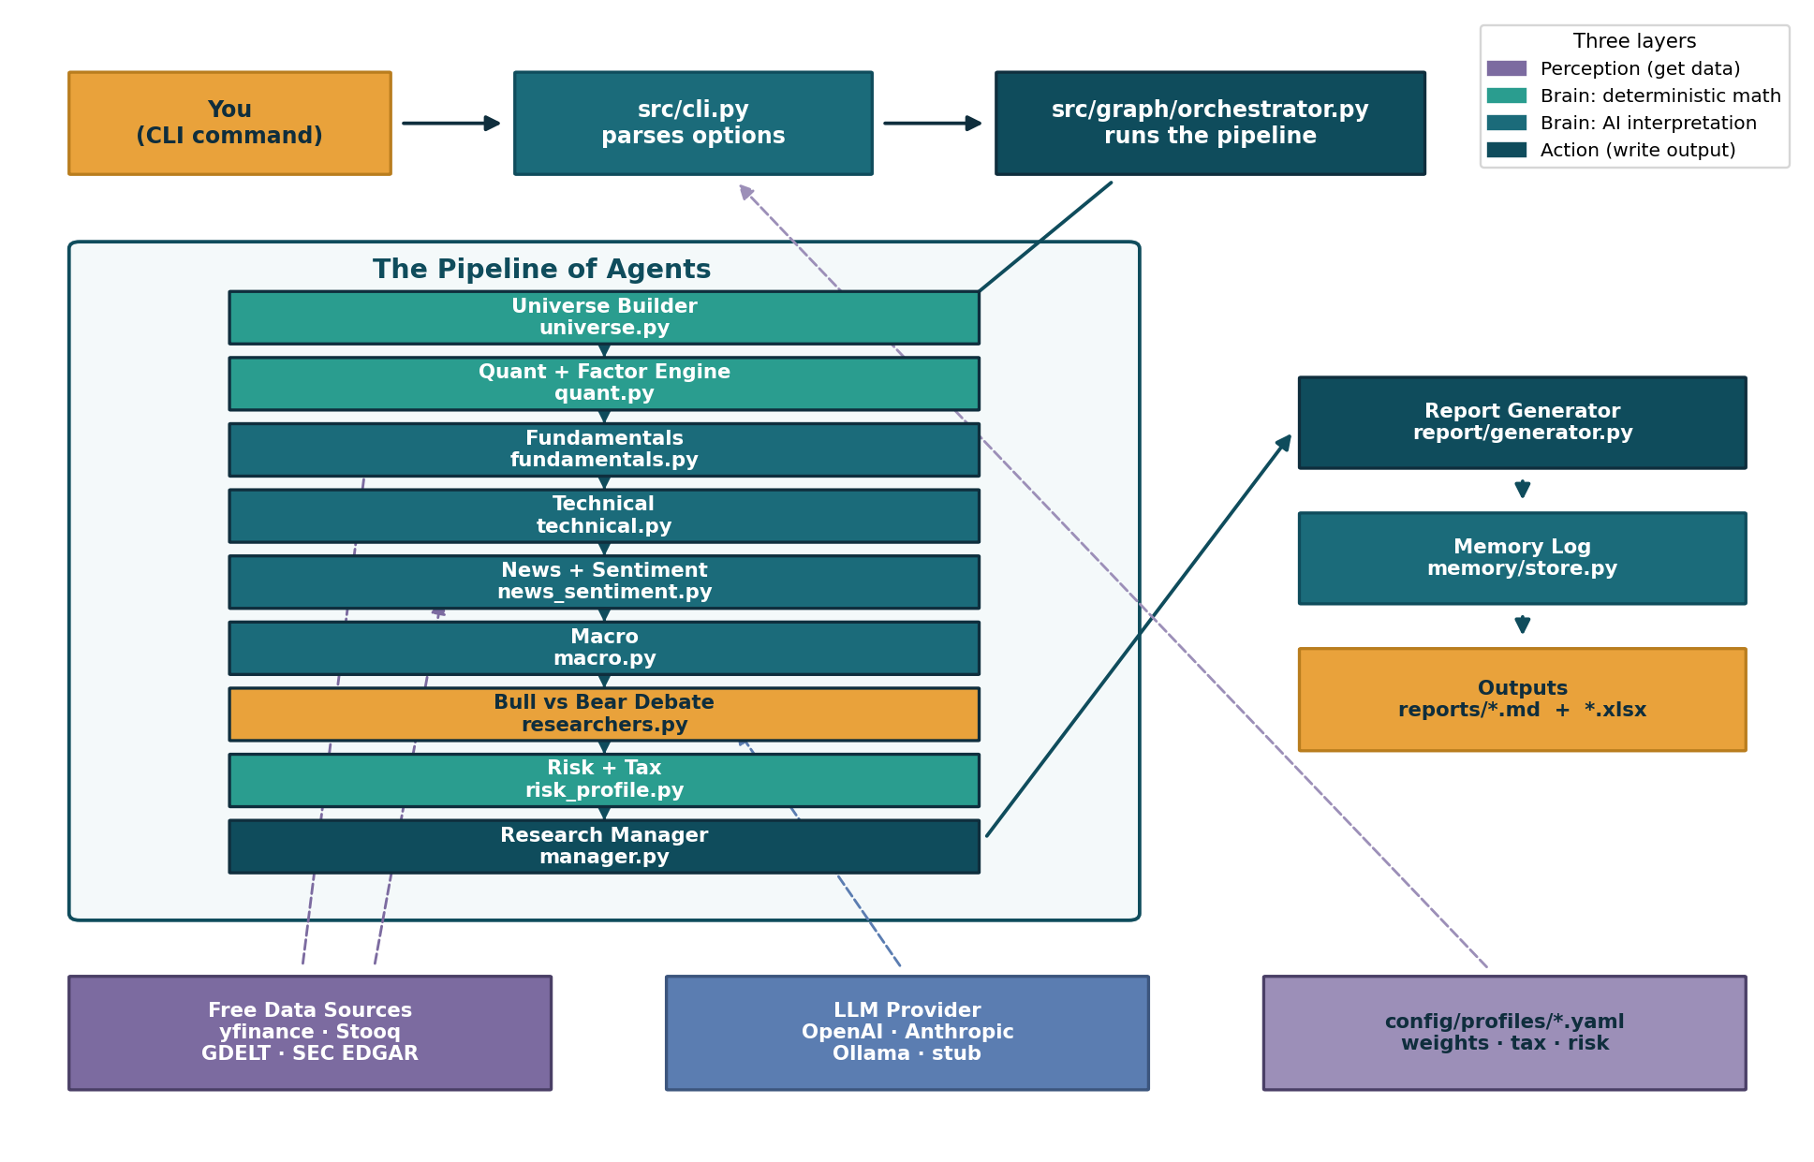
Figure 1. Component architecture — CLI → orchestrator → agent pipeline → outputs, with external data, LLM provider and profile YAMLs feeding in.

Three layers, in plain terms
- Perception (get data): src/data/ — fetches numbers and news from free sources and caches them on disk.
- Brain (think): src/factors/ (deterministic math) + src/agents/ (AI interpretation + debate).
- Action (write it down): src/report/ (Markdown/Excel) + src/memory/ (a running log of past runs).
The whole thing in one line (from the README)
Universe → DataProvider → FactorEngine → Analysts → Bull/Bear Debate → Risk+Profile → Manager → Report

4. The End-to-End Workflow, Stage by Stage
The orchestrator runs the stages below. With LangGraph installed it uses a real graph; otherwise it falls back to a plain sequential runner — both run the exact same stages (see _seq_run and _build_langgraph in src/graph/orchestrator.py).
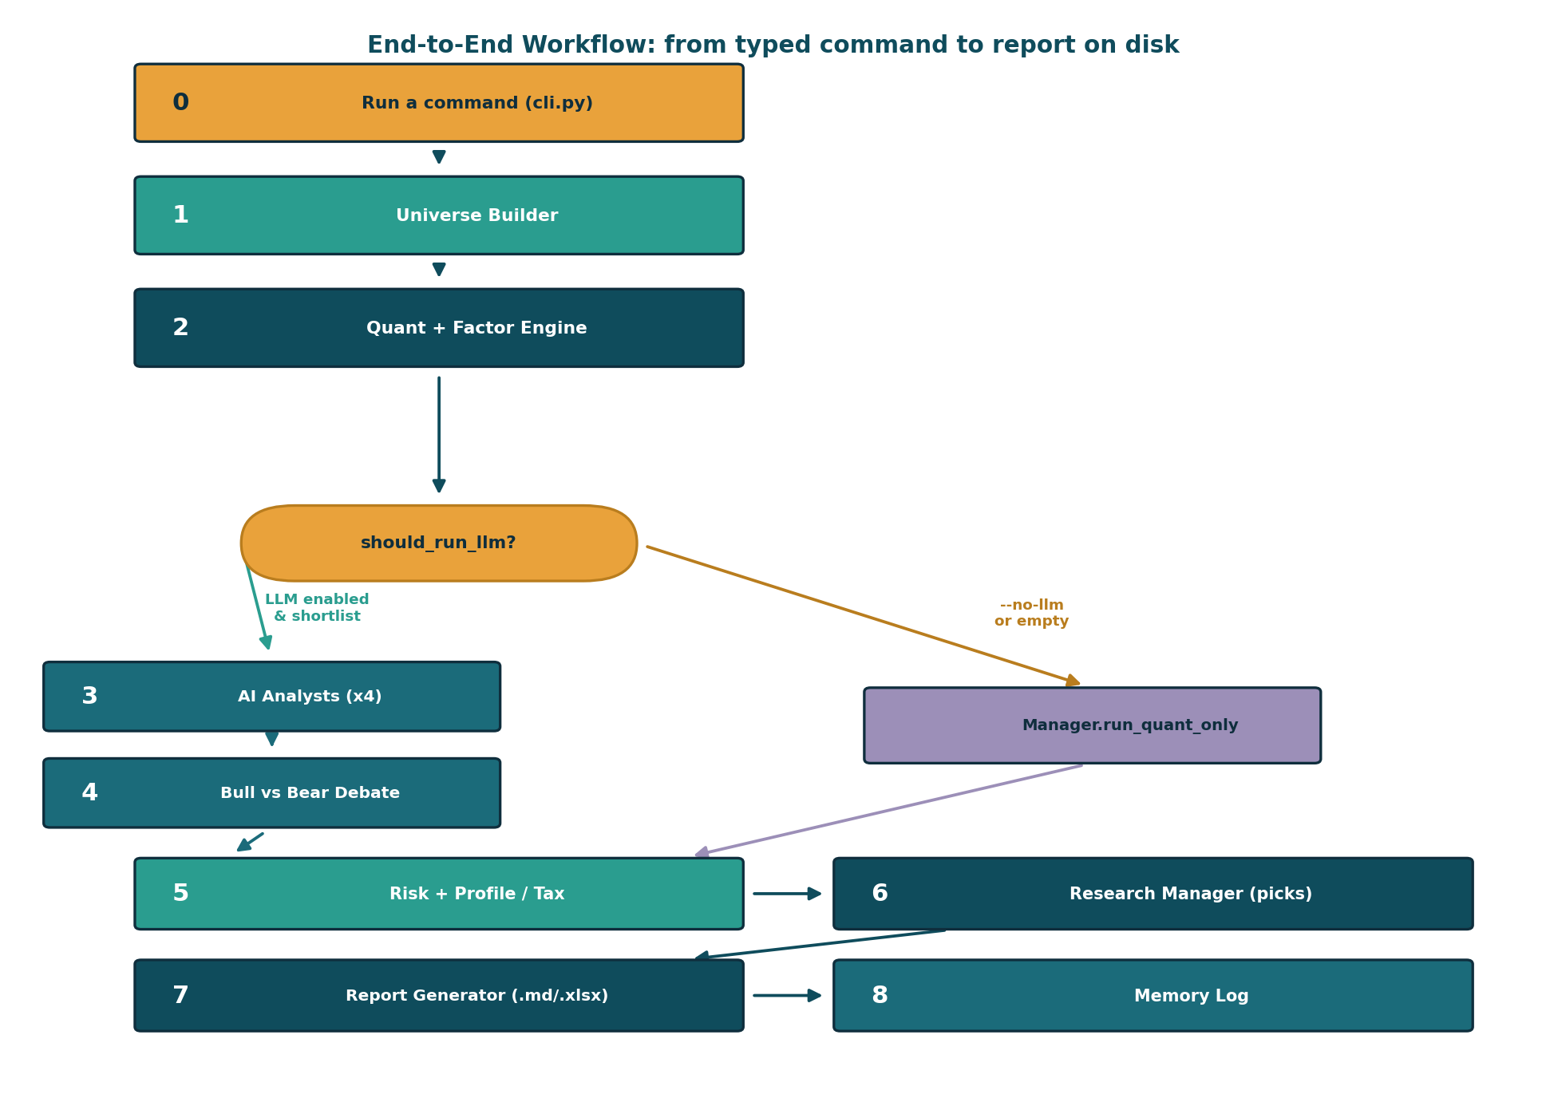
Figure 2. Stage-by-stage workflow with the should_run_llm decision branch (AI path vs deterministic quant-only path).

Stages at a glance
# | Trigger | Input | Action | Output | Implementing file
0 | You type a command | --profile, --target, --top, --no-llm | cli.py parses options, loads profile, builds AgentState | AgentState + console banner | src/cli.py
1 | Orchestrator (first stage) | free-text target, profile | Detect single ticker vs theme; pick sector & constituents (live, then seeded) | candidate_tickers, candidate_meta | src/agents/universe.py
2 | After universe built | candidate tickers + profile | Fetch snapshots, data-health card, run factor engine → composite scores | snapshots, factor_reports, shortlist, data_health, input_hash | src/agents/quant.py, src/factors/engine.py
3 | If LLM enabled & shortlist | shortlist context | 4 analysts (fundamentals, technical, news, macro) interpret numbers only | analyst_signals | src/agents/fundamentals.py, technical.py, news_sentiment.py, macro.py
4 | After analysts | analyst signals + factors | Bull vs Bear personas argue the 2–3 most compelling/concerning names | debate turns | src/agents/researchers.py
5 | After debate (or quant path) | picks + profile | Apply concentration cap, ETF preference, volatility notes, tax notes | risk_notes, tax_notes | src/agents/risk_profile.py
6 | Final reconciliation | factors + signals + debate | Build ranked FinalPicks with thesis, risks, horizon, after-tax estimate | picks | src/agents/manager.py
7 | After manager | full AgentState | Render Markdown (Jinja2) + optional multi-sheet Excel | report_path, excel_path (files on disk) | src/report/generator.py
8 | After report | run summary | Append compact JSON record of the run to history log | .fra_memory/index.jsonl entry | src/memory/store.py

Decision point — should_run_llm
After Stage 2 the orchestrator calls should_run_llm (src/graph/conditional_logic.py). If you passed --no-llm, OR the shortlist is empty, it skips all AI stages and jumps to a deterministic manager (manager.run_quant_only) → risk → report. Otherwise it proceeds through the AI analysts and debate.

Stage details

Stage 2 — Quant + Factor Engine (the deterministic calculator)
This is the analytical heart and the most important stage. For each candidate it:
- Fetches a snapshot via DataProvider.get_snapshot (yfinance primary; cross-checks price against Stooq). All fetches cached in .fra_cache/.
- Flags cross-currency picks (e.g. a US stock for a German investor).
- Applies hard risk constraints from the profile (min market cap, max volatility) via _passes_constraints.
- Builds the Data Health card (build_card in src/data/health.py): tickers fetched, avg coverage, source agreement, OK/WARN/CRITICAL.
- Runs the factor engine (rank_universe): extracts metrics, percentile-ranks each across the universe, averages into factor scores, then combines via profile weights into a composite. Low-coverage composites are shrunk toward 0.5.
- Factor regime check (src/factors/decay.py) flags recently underperforming factors.
- Computes a reproducible input_hash so an identical re-run is verifiable.

Stage 3 — Analyst Agents (AI interprets the numbers)
Four analysts run in sequence. Each builds a compact data bundle (shortlist_context in src/agents/_common.py), asks the LLM to reason only over the provided numbers, and falls back to a deterministic heuristic if the LLM is unavailable. The shared system prompt (SYSTEM_RULES) forbids inventing numbers.
- 3a. Fundamentals: Quality, Value, Financial Health, Earnings Quality; also a best-effort insider-trading signal from SEC EDGAR (US tickers only).
- 3b. Technical: interprets price momentum and volatility into a trend stance.
- 3c. News + Sentiment: headlines from GDELT (falls back to yfinance news), classifies aggregate sentiment.
- 3d. Macro: one short, universe-wide context paragraph for the profile's country/currency.

Stages 4–8 — Debate, Risk, Manager, Report, Memory
- Stage 4 — Bull vs Bear Debate: two LLM personas argue the optimistic vs cautious case, repeated for --rounds rounds (default 1).
- Stage 5 — Risk + Profile/Tax: deterministically applies concentration caps, ETF preference, volatility notes, and verbatim tax notes from the profile YAML.
- Stage 6 — Research Manager: combines everything into ranked FinalPicks with thesis, key risks, confidence, horizon, after-tax estimate; backfills any forgotten shortlisted ticker.
- Stage 7 — Report Generator: renders Markdown via Jinja2 to reports/<timestamp>-<profile>-<target>.md, plus optional .xlsx.
- Stage 8 — Memory Log: appends a compact JSON record to .fra_memory/index.jsonl for the history command.

5. Inputs & Outputs

What you provide
Option | Meaning
--profile (required) | india_adult or germany_student
--target (required) | a ticker (SAP.DE) or a theme (“best IT stocks in India”)
--top | how many picks to return (default 10)
--universe / --domain | narrow the candidate pool
--rounds | number of Bull vs Bear debate rounds (default 1)
--no-llm | deterministic, AI-free run
--no-excel | skip the Excel workbook
--as-of YYYY-MM-DD | evaluate as of a past date

What you get back
- A Markdown report in reports/ and (optionally) an Excel workbook.
- A console summary: a “Top picks” table and a Data Health line.
- A history entry you can later list with python -m src.cli history.
What the report contains (real example)
Header (target, universe, top-N, input hash) + disclaimer; a Data health card (e.g. OK, 6/6 tickers fetched, 82% coverage); factor regime warnings; Final Picks (composite score, profile fit, coverage, factor std-dev, confidence, horizon, after-tax estimate, thesis, key risks, tax notes); a Factor breakdown table; Analyst signals; the Bull vs Bear transcript; Risk + profile notes; Tax notes; and a Methodology section listing factor weights.

6. Configuration & Setup

Prerequisites
- Python 3 (modern, with pydantic>=2.7).
- Dependencies in requirements.txt (typer, rich, yfinance, pandas, numpy, requests, beautifulsoup4, langgraph, jinja2, openpyxl, plus optional openai/anthropic).
- Optional, for local AI: Ollama running a model like llama3.1:8b.

Install & run (Windows / PowerShell)
python -m venv .venv && .venv\Scripts\activate
pip install -r requirements.txt
copy .env.example .env
# Optional local LLM:
ollama pull llama3.1:8b
ollama serve
# Run a research pass:
python -m src.cli research --profile india_adult --target "best IT stocks in India" --top 10
# Offline / deterministic (no AI):
python -m src.cli research --profile india_adult --target "best banks in India" --top 10 --no-llm

Environment variables (.env)
Variable | Purpose | Default
LLM_PROVIDER | openai, anthropic, ollama, or cursor_io | ollama
LLM_MODEL | provider-specific model name | llama3.1:8b
LLM_TEMPERATURE | randomness (0 = deterministic) | 0
OPENAI_API_KEY / ANTHROPIC_API_KEY | keys for hosted LLMs | empty
OLLAMA_HOST | local Ollama endpoint | http://localhost:11434
FRA_CACHE_DIR | where data is cached | ./.fra_cache

No API key? It still runs.
If no LLM is reachable, get_llm() in src/llm/factory.py returns a deterministic stub, and every analyst falls back to its math-based heuristic. You still get a valid factor-based report — just with sparser AI prose.

Where things live (config-as-data)
Profile YAMLs in config/profiles/ control universe defaults, factor weights, tax rules, risk constraints, and currency — so most behavior can be tuned without editing Python. The two shipped profiles:
- india_adult.yaml — INR, NIFTY-based, momentum-tilted, Indian capital-gains tax.
- germany_student.yaml — EUR, DAX/MDAX, quality/health-tilted, lower risk, Abgeltungssteuer.

7. Concrete Walkthrough — One Real Request
python -m src.cli research --profile india_adult --target "best IT companies in India" --top 10
- 1. cli.py loads india_adult.yaml, builds the AgentState, prints the banner, and calls orchestrator.run.
- 2. Universe detects the Information Technology sector from “IT” and yields TCS.NS, INFY.NS, TECHM.NS, WIPRO.NS, HCLTECH.NS, LTIM.NS.
- 3. Quant fetches a snapshot per ticker (+ Stooq cross-check), builds the Data Health card (OK, 6/6 fetched, 82% coverage, single-source), runs the factor engine, computes input hash 1aceed39273729da.
- 4. Analysts read the scores. For TCS: fundamentals bullish (ROE 48.4%, op margin 25.3%, PE 15.3); technical bearish (12-1m momentum −31.9%); news bearish ($70m legal hit). Each claim cites a real number.
- 5. Debate Bull argues “world-class franchises after a reset”; Bear argues “the cycle is still rolling over.”
- 6. Risk + Tax adds “10% per-name cap”, “volatility > 60% filtered”, and Indian LTCG/STCG notes.
- 7. Manager produces ranked picks (TCS #1, Infosys #2, …) each with thesis, risks, >12-month horizon, after-tax estimate (e.g. TCS +8.7%). LTIM.NS had 0% coverage → low-confidence backfilled entry: graceful degradation.
- 8. Report + Memory writes reports/20260619-140733-india_adult-best-IT-companies-in-India.md and logs the run. Console prints the Top-picks table, hash, and path.

8. Extension Points — How to Modify Behavior
You want to… | Change this
Add a new investor profile | Add a YAML in config/profiles/ (copy an existing one); auto-discovered by profiles and load_profile.
Change factor weights / tax / risk limits | Edit the relevant config/profiles/*.yaml. No code change needed.
Add or change a factor | Add an extractor in src/factors/metrics.py (register in FACTORS); the engine picks it up.
Swap the data source (e.g. MCP or paid API) | Re-implement the DataProvider interface in src/data/provider.py; the rest is unchanged.
Add a new analyst | Create a module in src/agents/ exposing run(state), then wire it into _seq_run and _build_langgraph.
Change the report layout | Edit src/report/templates/report.md.j2 (Markdown) or src/report/excel.py (Excel).
Use a different / no LLM | Set LLM_PROVIDER in .env, or pass --no-llm for a deterministic run.
Tune debate depth | Pass --rounds N.
Add CLI options or commands | Edit src/cli.py (it uses typer).

9. Reusable Blueprint Template
This document followed a repeatable skeleton you can reuse for any data-or-agent pipeline:
- TL;DR / ELI5 — one analogy a non-technical reader can grasp.
- Overview — what & why in 2–3 sentences.
- Glossary — define every piece of jargon.
- Architecture — components + a diagram + the 3-layer (perceive/think/act) framing.
- Stage-by-stage workflow — trigger → input → action → output → implementing file + a flow diagram.
- Inputs & Outputs — what the user gives and gets (with a real example).
- Configuration & Setup — prerequisites, env vars, install/run.
- Concrete walkthrough — trace one real request end to end.
- Extension points — a “to change X, edit Y” table.

File map: src/cli.py (entry) · src/graph/orchestrator.py (pipeline) · src/graph/state.py (shared state) · src/agents/* (workers) · src/factors/* (deterministic math) · src/data/* (data + caching) · src/llm/factory.py (LLM providers) · src/report/* (output) · src/memory/store.py (history) · config/profiles/*.yaml (settings).

