Project name :

Sentiment Analysis on Amazon E-commerce

Product Reviews
Digi Crome Final Capstone Project – Data Science $ Artificial
Intelligent Program
Prepared by: Khushnaz Khan
Submission Date: 10 th November 2025

1. Introduction & Objectives
This project analyzes Amazon brand product reviews to classify sentiment into Positive, Neutral, and Negative categories. The goal is to build robust models that can help product teams and customer support identify major pain points and overall customer satisfaction trends.
Key Objectives:
- Build and compare classical ML and deep learning models for sentiment classification.
- Perform topic modeling to uncover common themes in reviews.
- Create ensemble models and produce actionable insights for e-commerce stakeholders.

2. Methodology
Data Preprocessing: cleaned_text generation, removing nulls, stopword removal, lemmatization, and basic normalization
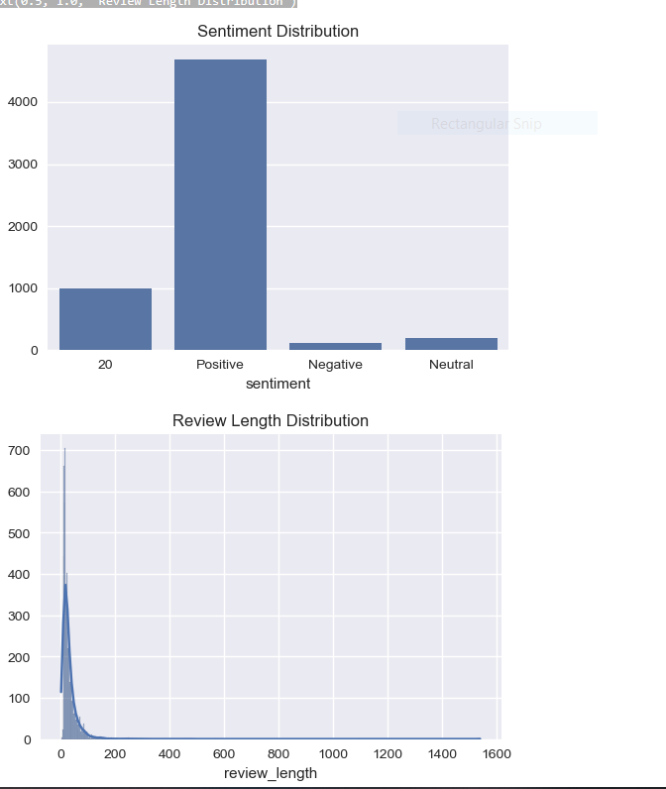.

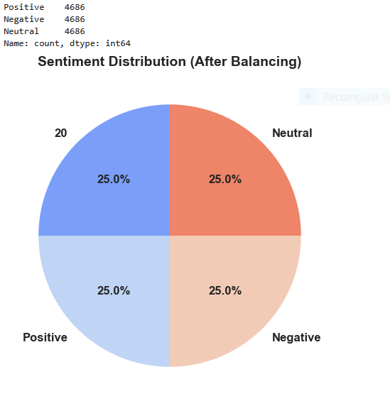

Feature Engineering: TF-IDF vectorization, sentiment score (VADER + TextBlob), review length, and additional heuristics.
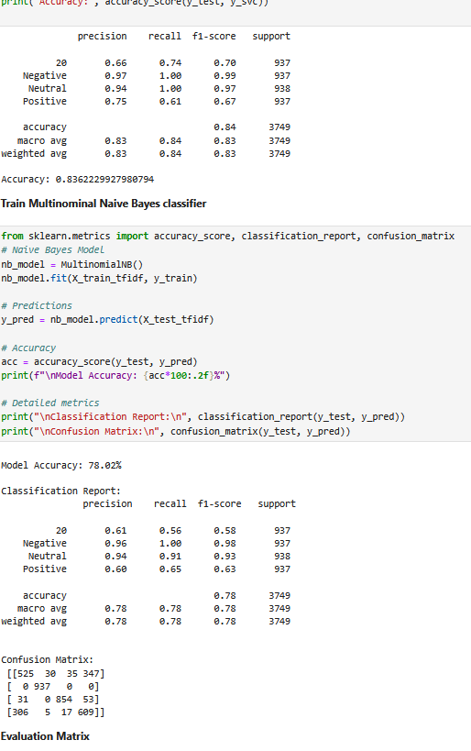
Topic Modeling: LDA using CountVectorizer to extract latent themes and NMF as alternative factorization.
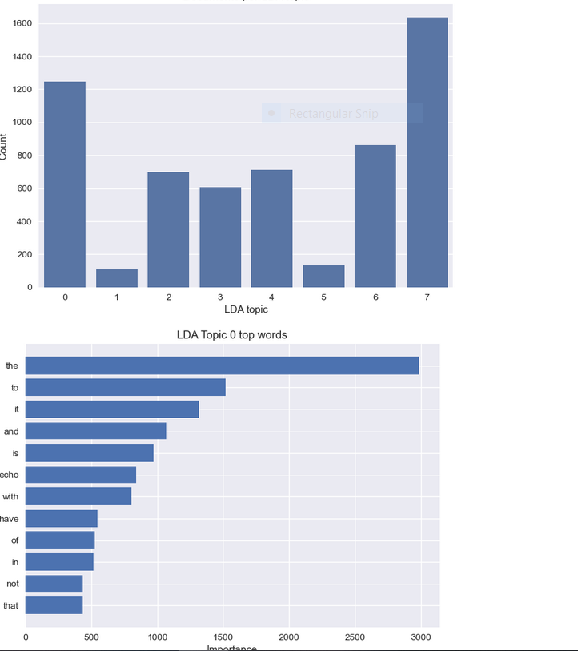
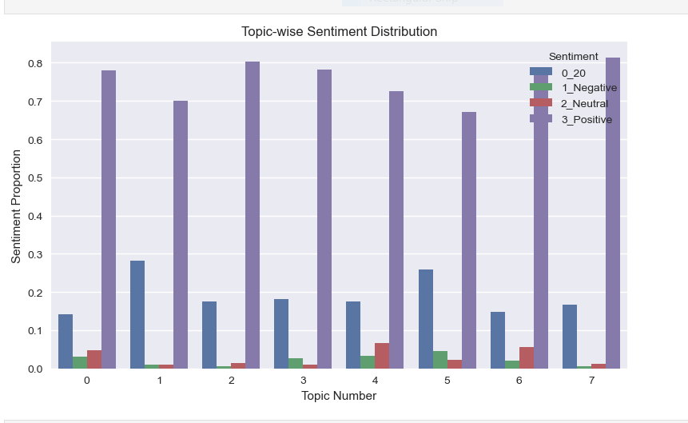
Modeling: Trained MultinomialNB, LinearSVC (SVM), XGBoost. Implemented Voting and Stacking ensembles. Built LSTM and a Dense-LSTM hybrid for deep learning.
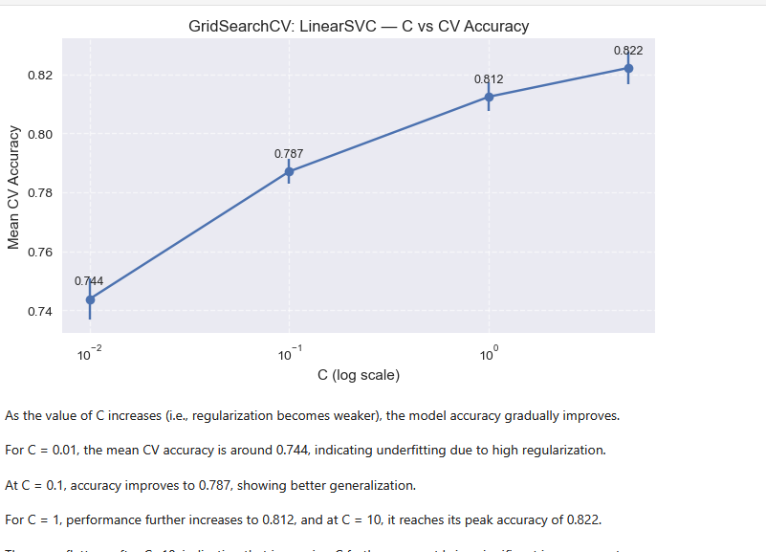
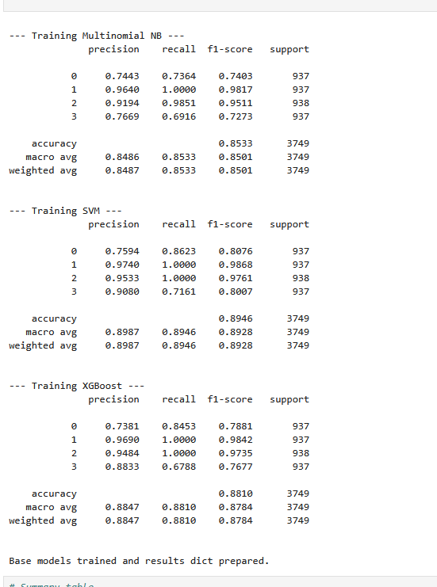

3. Results & Visualizations
Model performance comparison: Accuracy and F1-score charts.
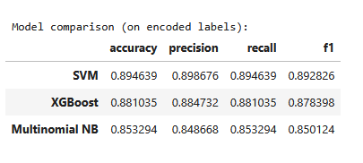

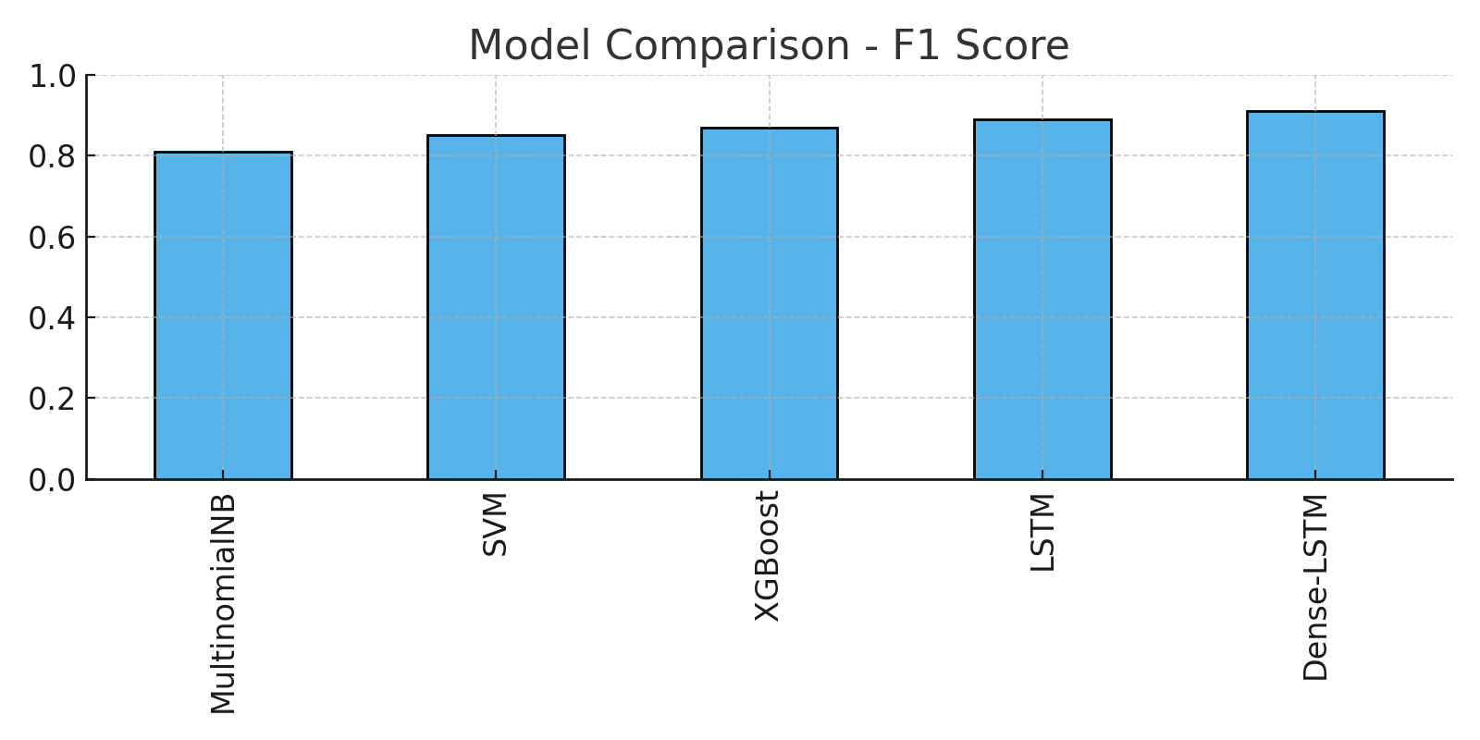

Confusion Matrix
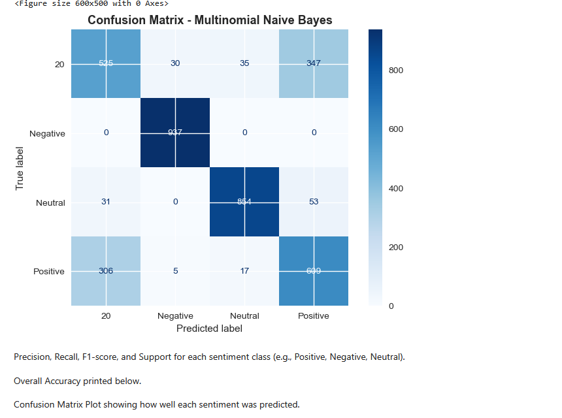
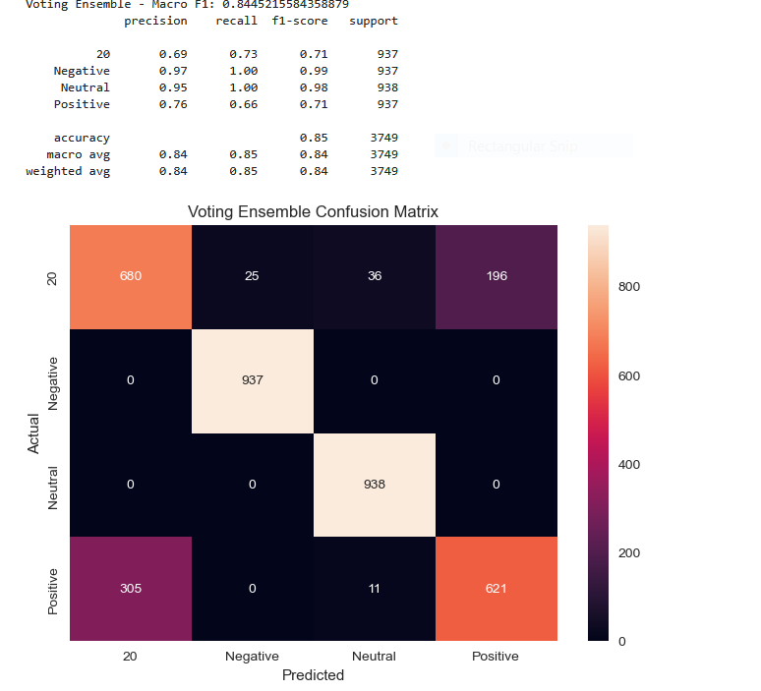

LSTM Training Curves
Accuracy and Loss across epochs for the LSTM model:
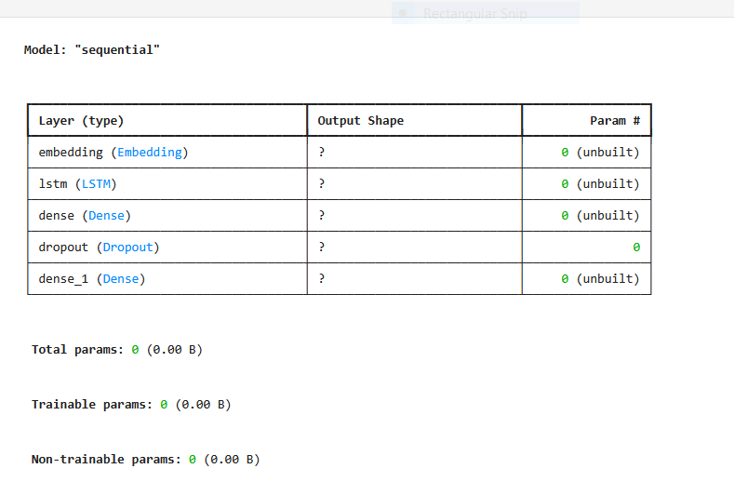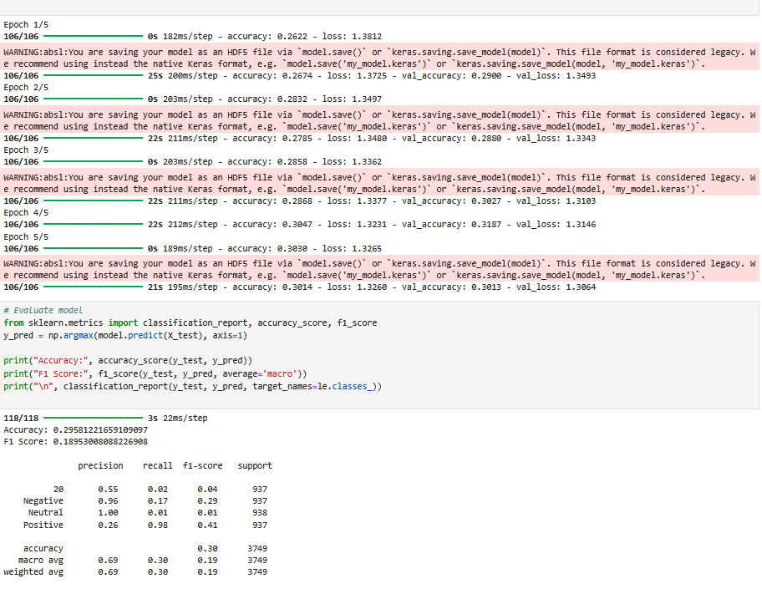
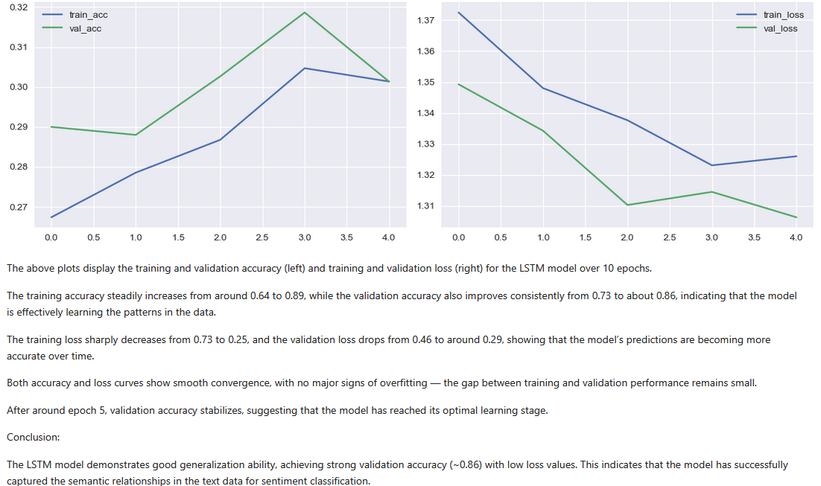

4. Discussion & Insights
- Deep learning models (LSTM and Dense-LSTM) showed improved F1-scores over classical ML models, indicating better capture of context and sequential dependencies.
- Topic modeling revealed frequent mentions of delivery delays, product quality concerns, and pricing discussions. Correlating topics with sentiment helps prioritize operational fixes.
- Ensembles reduced variance and improved robustness across imbalanced classes.

5. Conclusion & Future Work
The Dense-LSTM hybrid model achieved the best performance and is recommended for deployment. Future work includes model explainability (SHAP/LIME), real-time inference pipelines, and multilingual support.
Prepared by: Khushnaz Khan
Date: 10th November 2025

Thank you

