Exploratory Data Analysis (EDA) Report
1. Introduction
This report presents the Exploratory Data Analysis (EDA) performed on the provided e-commerce dataset. The objective of this analysis is to identify patterns, trends, customer behavior, and business insights using statistical methods and visualizations.
2. Dataset Overview
The dataset contains 891 rows and 15 columns after data cleaning. It includes information about products, quantities, prices, payment methods, dates, and order status.
3. Missing Values Analysis
OrderID 0
Date 0
CustomerID 0
Product 0
Quantity 0
UnitPrice 0
ShippingAddress 0
PaymentMethod 0
OrderStatus 0
TrackingNumber 0
ItemsInCart 0
CouponCode 0
ReferralSource 0
TotalPrice 0
Month 0
dtype: int64
4. Statistical Analysis
Date Quantity UnitPrice ItemsInCart \
count 891 891.000000 891.000000 891.000000
mean 2024-03-25 05:34:32.727272704 2.911336 360.596835 5.459035
min 2023-01-01 00:00:00 1.000000 11.390000 1.000000
25% 2023-08-16 00:00:00 2.000000 189.345000 4.000000
50% 2024-03-23 00:00:00 3.000000 371.290000 5.000000
75% 2024-11-10 00:00:00 4.000000 526.445000 7.000000
max 2025-06-30 00:00:00 5.000000 699.930000 10.000000
std NaN 1.414212 196.752386 2.277209
TotalPrice Month
count 891.000000 891.000000
mean 1057.643715 6.032548
min 11.390000 1.000000
25% 415.785000 3.000000
50% 819.500000 6.000000
75% 1581.135000 9.000000
max 3456.400000 12.000000
std 822.703899 3.383379
5. Top Products Analysis
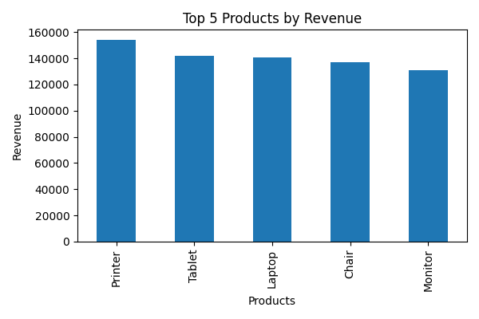
Explanation: The bar chart shows the top 5 products generating the highest revenue. Products with taller bars contribute more to overall business sales. This analysis helps identify the most profitable products.
6. Payment Method Distribution
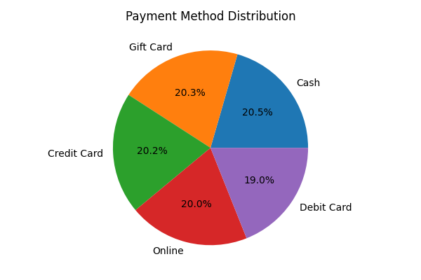
Explanation: The pie chart represents the distribution of payment methods used by customers. It helps understand customer payment preferences and which payment mode is most commonly used.
7. Monthly Sales Trend
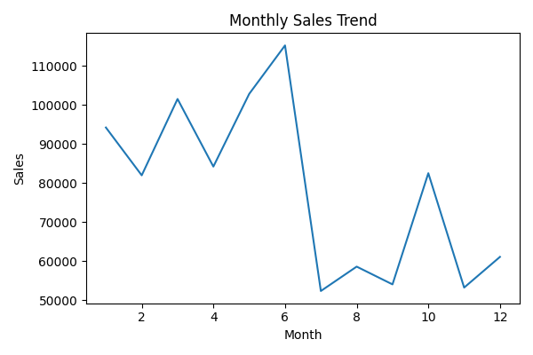
Explanation: The line chart displays monthly sales trends over time. It helps identify growth patterns, seasonal fluctuations, and months with higher sales performance.
8. Correlation Analysis
Quantity UnitPrice ItemsInCart TotalPrice Month
Quantity 1.000000 0.028155 0.644847 0.634515 -0.051527
UnitPrice 0.028155 1.000000 0.021396 0.709612 -0.029337
ItemsInCart 0.644847 0.021396 1.000000 0.413954 -0.031400
TotalPrice 0.634515 0.709612 0.413954 1.000000 -0.044757
Month -0.051527 -0.029337 -0.031400 -0.044757 1.000000
9. Conclusion
The EDA process helped uncover important business insights from the dataset. The analysis identified top-performing products, customer payment preferences, and monthly sales trends. These insights can help businesses make data-driven decisions and improve future strategies.

