Project Radar:

**Project 4: Radar Target Generation and Detection**

Brief summary of the project:

This project is being submitted after successfully completing and testing the following:

1. Well documented code with comments
2. FMCW Waveform Design as per specification
3. Simulation Loop to generate the mix signals
4. Range FFT (1st FFT) working and the target is detected at the right location
5. Doppler  FFT (2nd FFT) (already implemented)
6. 2D CFAR -
   1. The call average dynamic threshold works good, for removing the noise
   2. The object is detected at the correct location without noise
7. Sample Results image below:

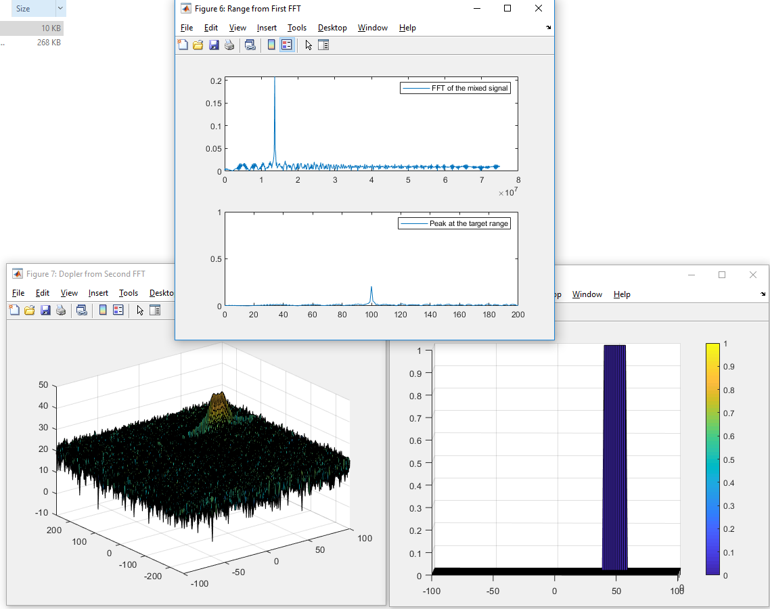

**FMCW Waveform Design:**

Criteria:

Using the given system requirements, design a FMCW waveform. Find its Bandwidth (B), chirp time (Tchirp) and slope of the chirp.

Meets Specifications:

For given system requirements the calculated slope should be around 2e13

Observations and known issues:

FMCW Bandwidth and Slope of Radar signal is correctly calculated, with the given parameters and formula.**Slope = 2.0455e+13**

**Done**

**Simulation Loop:**

Criteria:

Simulate Target movement and calculate the beat or mixed signal for every timestamp

Meets Specifications:

A beat signal should be generated such that once range FFT implemented, it gives the correct range i.e the initial position of target assigned with an error margin of +/- 10 meters.

Observations and known issues:

The mixed signal is calculated for every time stamp with time delay on the received signal and multiplied with the transmitted signal.

**Done**

**Range FFT (1st FFT):**

Criteria:

Implement the Range FFT on the Beat or Mixed Signal and plot the result.

Meets Specifications:

A correct implementation should generate a peak at the correct range, i.e the initial position of target assigned with an error margin of +/- 10 meters.

Observations and known issues:

Range measurement is calculated accurately, the peak is at exactly 100m, which was set during the initialization.

**R = 100 m.**

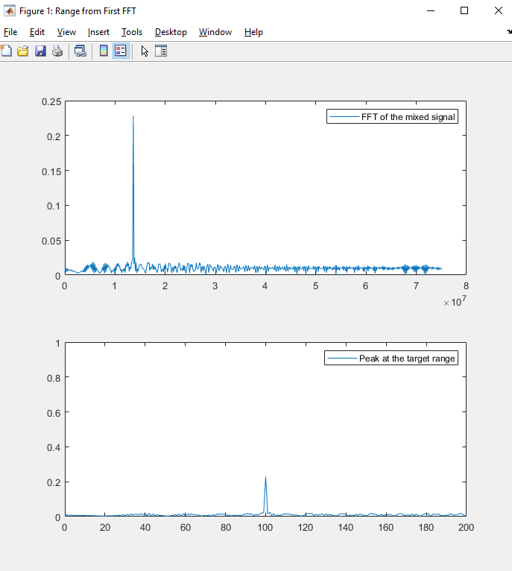

**Done**

**2D CFAR:**

Criteria:

1. Implement the 2D CFAR process on the output of 2D FFT operation, i.e the Range Doppler Map.
2. Create a CFAR README File

Meets Specifications:

1. The 2D CFAR processing should be able to suppress the noise and separate the target signal. The output should match the image shared in walkthrough.
2. In the README file, write brief explanations for the following:

* Implementation steps for the 2D CFAR process.
* Selection of Training, Guard cells and offset.
* Steps taken to suppress the non-thresholded cells at the edges.

**Observations and known issues(README):**

* 2D CFAR dynamic threshold works good, for removing the noise
* The object is detected at the correct location, 100m  away without noise.
* Velocity in the doppler map is not accurate but is almost centered with correct value. Velocity doppler map is spread  across multiple values with an accuracy of  ~+-10 m/s centered around 50 m/s
* **Implementation steps for the 2D CFAR process:**
  + Chose values for Guard cells and Training cells
  + Chose a value for the Offset
  + Made the CFAR signal to all zero to suppress non thresholded values
  + Designed loop to go through the 2D RDM signal to calculate the CFAR signal
    - For each iteration Calculate the indexes of the training cells
    - To calculate the dynamic CFAR threshold from the Rane Doppler Map, convert the signal value from db2pow
    - Average the overall training indexes from RDM (sum of all RDM indexes/total number of cells) for the Cell Under Test (CUT)
    - Since the average is in logarithmic scale, ddd Offset to it and convert it back to db.
    - For each value of RDM Signal for the CUT, perform thresholding based on the calculated CFAR Threshold (0, if < CFAR threshold; else 1)
    - Append the signal to the CFAR signal at the CUT location
  + Plot the result.
* **Selection of Training cells:**
  + If we increase the training doppler, then the spread across velocity increases from +-10 m/s to beyond
  + If we reduce the training cells < 3, then the object splits with multiple peaks in doppler map, but one of them is very close to the actual velocity
  + Overall, this parameter is quite sensitive, and may be limitation of the method to identify the velocity precisely
  + **Tr = 10, Td = 3**
* **Selection of Guard cells:**
  + Guard cell of around 1-4 is a good value
  + If we reduce the guard cell to zero, there are many peaks all over the spectrum, and the algorithm has many false alarms
  + **Gr=2, Gd=1**
* **Selection of Offset value:**
  + Offset value of 9 gives a very good result, with minimal spread in the doppler velocity, < +/- 10m/s
  + Offset of 10 and above results in no output
  + Above 6 and below 9 is good
  + If we reduce the offset < 6, there are many false alarms
  + **Offset = 9**
* Steps taken to suppress the non-thresholded cells at the edges
  + The signal is initialized to zero first and only the thresholded values are allowed to pass through

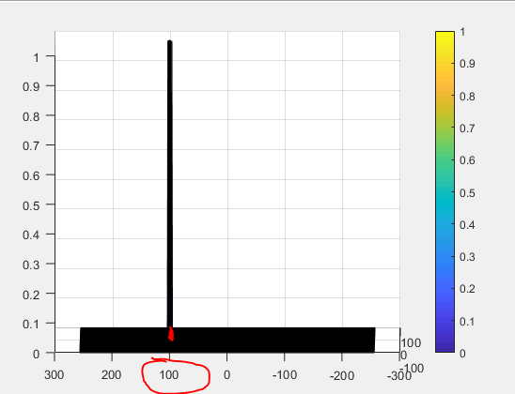

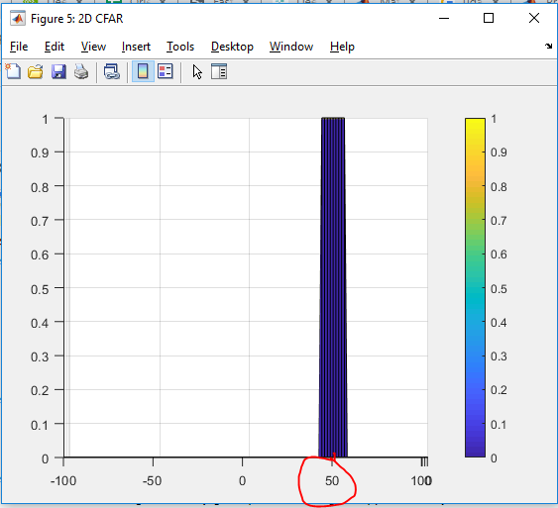

**Done**