WEEK 3
Advanced Cybersecurity Practical Assessment
Network Discovery, Traffic Analysis & Vulnerability Assessment

Prepared by: [KHUSHVEER DHIMAN]

Role: Cybersecurity Intern

Program / Organization: [DG INTERN]

Submission Date: 24 August 2026

Table of Contents

1. Introduction
2. Objectives
3. Lab Environment
4. Network Diagram
5. Tools Used
6. Nmap Methodology
7. Nmap Results
8. Advanced Nmap Analysis
9. Wireshark Methodology
10. Packet Analysis
11. Nmap + Wireshark Investigation
12. Vulnerability Assessment
13. Risk Classification
14. Security Hardening
15. Before/After Comparison
16. Security Recommendations
17. Challenges Faced
18. Conclusion
19. References
20. Screenshots / Evidence

1. Introduction
This report documents the Week 3 advanced cybersecurity practical assessment, covering network discovery, service enumeration, packet-level traffic analysis, vulnerability assessment, and security hardening of an authorized lab environment. All scanning, capture, and hardening activities described in this report were performed exclusively against systems owned by, or explicitly authorized for, the author — including personally administered virtual machines within an isolated lab network.
The assessment follows the standard security-assessment lifecycle: discover assets, enumerate exposed services, capture and analyze traffic, correlate findings, classify risk, remediate, and verify the improvement.

2. Objectives
- Identify all authorized hosts on the lab network using Nmap host discovery.
- Enumerate open ports, running services, and service versions on each host.
- Capture and analyze live network traffic using Wireshark across DNS, TCP, UDP, ICMP, ARP, and HTTP.
- Correlate Nmap scan activity with its corresponding packet-level evidence.
- Investigate traffic for indicators that warrant further review.
- Produce a vulnerability assessment with risk-classified findings.
- Apply and verify at least three security hardening measures.
- Document the complete assessment to a professional standard.

3. Lab Environment
The lab was built using an isolated, host-only virtual network so that no scanning or traffic-generation activity reached production or third-party systems.
Component | Details
Hypervisor | [ VMware — 17]
Attacker / Analyst Machine | [Kali Linux / , 192.168.94.133]
Target VM 1 | [metasploitable,, vm lab, 192.168.94.134]
Target VM 2 | [ubuntu server, lab, 192.168.94.135]
Network Model | [Host-only / Internal network], subnet [e.g. 192.168.94.133/24]
Isolation Controls | host-only adapter

4. Network Diagram

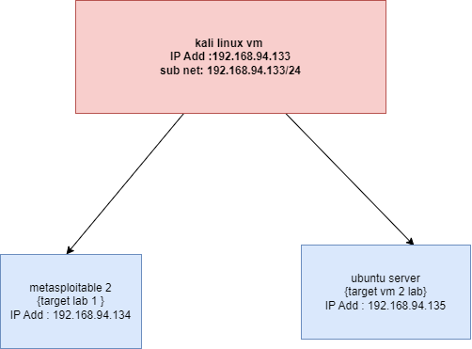

5. Tools Used
Tool | Purpose
Nmap | Host discovery, port scanning, service/version detection, OS fingerprinting, NSE vulnerability scripts
Wireshark | Live packet capture and protocol analysis
VirtualBox / VMware | Isolated virtual lab environment
draw.io / diagrams.net | Network topology diagram
GitHub | Version control and submission of project artifacts

6. Nmap Methodology
Network reconnaissance was performed in stages, moving from broad discovery to targeted, in-depth enumeration:
- Host discovery (ping sweep) to identify live hosts: nmap -sn 192.168.94.134
- Basic port scan against each live host: nmap <192.168.94.134>
- Service and version detection: nmap -sV <192.168.94.134>
- OS fingerprinting where supported: nmap -O <192.168.94.134>
- TCP SYN (stealth) scanning: nmap -sS <192.168.94.134>
- Limited UDP scanning of common ports: nmap -sU --top-ports 20 <192.168.94.134>
- NSE vulnerability scripts against owned/authorized hosts only: nmap --script vuln <192.168.94.134>
Each scan was authorized in advance and limited to the lab's internal subnet.

7. Nmap Results

7.1 Discovered Hosts
IP Address | Status | Notes
192.168.94.134 | Host up | metasploitable
192.168.94.135 | Host up | Ubuntu server

7.2 Open Ports and Services
IP Address | Port | Protocol | Service | Version | Risk | Observation
192.168.94.134 | 21 | TCP | FTP | VSFTP 2.3.4 | HIGH | FTP service was found open.FTP was disabled as it transmits credentials/data without encryption.
192.168.94.134 | 512 | TCP | EXEC | NERKIT-RSH | CRITICAL | Legacy remote execution service was found open. The EXEC service was disabled because it provides insecure
192.168.94.134 | 23 | TCP | TELENET | LINUX TELNET | CRITICAL | Telnet was found open. It was disabled because credentials and communication can be transmitted in plaintext
192.168.94.134 | 513 | TCP | LOGIN | OPENBSD | CRITICAL | Legacy rlogin service was found open. It was disabled because it does not provide secure modern remote authentication
192.168.94.134 | 514 | TCP | TCPWRAPPED | NONE | CRITICAL | Legacy remote-shell service was found open. It was disabled to remove insecure remote access

8. Advanced Nmap Analysis
For each significant open port identified above, the following questions were answered:
- What service is running?
- Why is the service required?
- Is it necessary to expose it?
- What could happen if the service is vulnerable?
- How could it be secured?
- Port 21 – FTP

- * What service is running? FTP (vsftpd 2.3.4).
- * Why is the service required? It is used for transferring files.
- * Is it necessary to expose it? No, if file transfer is not required.
- * What could happen if the service is vulnerable? Credentials could be exposed and unauthorized access may occur.
- * How could it be secured? Disable FTP or use secure SFTP/SSH. Port 21 was closed after hardening.

- Port 23 – Telnet

- * What service is running? Telnet.
- * Why is the service required? It provides remote login access.
- * Is it necessary to expose it? No, because SSH provides a secure alternative.
- * What could happen if the service is vulnerable? Login credentials and session data could be intercepted.
- * How could it be secured? Disable Telnet and use SSH. Port 23 was closed after hardening.

- Port 512 – EXEC

- * What service is running? rexec/EXEC.
- * Why is the service required? It provides remote command execution.
- * Is it necessary to expose it? No, it is a legacy service.
- * What could happen if the service is vulnerable? An attacker could execute commands remotely.
- * How could it be secured? Disable EXEC and use SSH. Port 512 was closed after hardening.

- Port 513 – LOGIN

- * What service is running? rlogin/LOGIN.
- * Why is the service required? It provides remote login.
- * Is it necessary to expose it? No, SSH is a safer alternative.
- * What could happen if the service is vulnerable? Unauthorized remote access or credential exposure could occur.
- * How could it be secured? Disable rlogin and use SSH. Port 513 was closed after hardening.

- Port 514 – RSH

- * What service is running? rsh/remote shell.
- * Why is the service required? It provides remote shell access.
- * Is it necessary to expose it? No, it is an insecure legacy service.
- * What could happen if the service is vulnerable? An attacker could obtain unauthorized remote shell access.
- * How could it be secured? Disable RSH and use SSH. Port 514 was closed after hardening.

9. Wireshark Methodology
A capture was started on the lab's network interface before generating a mix of normal traffic: browsing a website, issuing DNS lookups, pinging the lab VMs, and connecting to an authorized local service. Approximately 5–10 minutes of traffic was captured and saved as a .pcapng file for offline analysis.
Traffic was filtered and reviewed by protocol (dns, tcp, udp, icmp, arp) and by specific conditions of interest, including:
- tcp.flags.syn == 1 (new connection attempts)
- tcp.flags.reset == 1 (refused / torn-down connections)
- dns.flags.response == 0 (outbound DNS queries)

10. Packet Analysis

11. Nmap + Wireshark Investigation
An Nmap SYN scan (nmap -sS <192.168.94.134>) was run against an authorized lab machine while Wireshark captured traffic on the same interface, in order to observe what a scan looks like at the packet level.
Nmap Result | Wireshark Evidence | Interpretation
Port detected open | SYN → SYN/ACK | Service appears reachable
Port detected closed | SYN → RST | Port is not accepting connections
Port not responding | No expected response | Possible filtering / firewall

12. Vulnerability Assessment
Findings below combine evidence from Nmap enumeration (Sections 7–8) and Wireshark traffic analysis (Sections 9–11).
# | Finding | Evidence | Risk | Potential Impact | Recommendation
1 | FTP service exposed on port 21/tcp | Nmap scan identified 21/tcp open – FTP, vsftpd 2.3.4. Post-hardening scan showed the port closed. | High | Unencrypted FTP communication may expose credentials and allow unauthorized file access. | Disable FTP when not required and use SFTP/SSH for secure file transfer.
2 | Telnet service exposed on port 23/tcp | Nmap identified 23/tcp open – Telnet. Telnet was disabled through xinetd and the post-hardening scan confirmed the port closed. | Critical | Plaintext authentication can expose credentials and enable unauthorized remote access. | Disable Telnet and use SSH for secure remote administration.
3 | EXEC service exposed on port 512/tcp | Nmap identified 512/tcp open – exec (netkit-rsh rexecd). The legacy EXEC service was disabled during hardening | Critical | Vulnerability or misuse could allow unauthorized remote command execution | Disable the legacy EXEC service and use SSH instead
4 | rlogin service exposed on port 513/tcp | Nmap identified 513/tcp open – login (rlogind). The LOGIN/rlogin service was disabled during hardening. | Critical | Attackers could exploit insecure remote login mechanisms to gain unauthorized access. | Disable rlogin and use SSH with strong authentication
5 | RSH service exposed on port 514/tcp | Nmap identified 514/tcp open – tcpwrapped/RSH-related service. The legacy remote-shell service was disabled during hardening. | Critical | Insecure remote-shell access could lead to unauthorized command execution or system access | Disable RSH and use SSH as the secure alternative

3. Risk Classification
The identified legacy services were classified as High or Critical based on their security impact.
FTP was classified as High because it can expose authentication information through unencrypted communication.

Telnet, EXEC, rlogin, and RSH were classified as Critical because they provide insecure remote access or remote execution mechanisms. These services were disabled to reduce the attack surface, and Nmap was used to verify the hardening results.

Each finding above was classified using the following criteria:
- Critical — directly exploitable, high-impact exposure (e.g., unauthenticated remote access, known-exploited CVE with public access).
- High — significant weakness with a plausible attack path, but requiring some additional conditions to exploit.
- Medium — a genuine weakness with limited exposure or requiring local/adjacent access.
- Low — a best-practice deviation with minimal realistic impact in this environment.

14. Security Hardening
- Improvement 1: Disabled the unnecessary FTP service (port 21) to reduce the attack surface.
- Improvement 2: Disabled the insecure Telnet service (port 23) and verified that the port was closed using Nmap.
- Improvement 3: Disabled legacy remote-access services EXEC (512), rlogin (513), and RSH (514) to prevent insecure remote command/login access

15. Before/After Comparison
Security Issue | Before | Action Taken | After | Improvement
FTP – Port 21 | Nmap showed 21/tcp open – FTP (vsftpd 2.3.4) | Disabled FTP service through xinetd | Nmap showed 21/tcp closed | Removed unnecessary FTP exposure and reduced risk of plaintext credential/file-transfer attacks.
Telnet – Port 23 | Nmap showed 23/tcp open – Telnet | Disabled FTP service through xinetd | Nmap showed 23/tcp closed | Removed insecure plaintext remote-login access; SSH can be used instead.
EXEC – Port 512 | Nmap showed 512/tcp open – exec/netkit-rsh rexecd | Disabled FTP service through xinetd | Service/port no longer intended to be exposed | Reduced risk of unauthorized remote command execution
rlogin – Port 513 | Nmap showed 513/tcp open – login/rlogind | Disabled the legacy rlogin service | Service/port no longer intended to be exposed | Removed insecure remote-login mechanism and reduced attack surface
RSH – Port 514 | Nmap showed 514/tcp open – tcpwrapped/RSH-related service | Disabled the legacy RSH service | Service/port no longer intended to be exposed | Reduced risk associated with insecure remote-shell access.

16. Security Recommendations
- Disable unnecessary and insecure services such as FTP, Telnet, EXEC, rlogin, and RSH.

- Use SSH instead of Telnet and other plaintext remote-access protocols for secure administration.

- Restrict access to required services using firewall rules and allow only trusted hosts/networks.

- Keep operating-system and network services updated and regularly check for outdated or vulnerable software.

Perform regular Nmap scans and security reviews to identify newly exposed ports and verify that unnecessary services remain disabled

17. Challenges Faced
During the security assessment, some challenges were encountered while configuring the Metasploitable VM. The main challenges included identifying the correct xinetd configuration files, modifying service settings, and verifying whether the ports were successfully closed. Some services did not have separate configuration files, so the main /etc/inetd.conf configuration had to be checked. After making the changes, xinetd was restarted and Nmap was used to verify the results. Another challenge was that the Metasploitable system uses an older Linux environment, so some modern package-management commands such as apt were not available.

18. Conclusion
The security assessment identified several unnecessary and insecure network services on the Metasploitable server, including FTP (21), Telnet (23), EXEC (512), rlogin (513), and RSH-related service (514). These services increased the attack surface and could allow insecure remote access or command execution. As part of the hardening process, the identified services were disabled where appropriate and the results were verified using Nmap. The number of exposed services was reduced, improving the overall security posture of the lab system. Further protection should include firewall restrictions, secure SSH configuration, regular updates, and periodic vulnerability scanning.

19. References
- Nmap — https://nmap.org
- Nmap Reference Guide — https://nmap.org/book/man.html
- Nmap NSE Documentation — https://nmap.org/book/nse.html
- Wireshark — https://www.wireshark.org
- Wireshark User's Guide — https://www.wireshark.org/docs/wsug_html_chunked/
- Wireshark Display Filter Reference — https://www.wireshark.org/docs/dfref/
- MITRE ATT&CK — https://attack.mitre.org
- CVE Program — https://www.cve.org

20. Screenshots / Evidence

Before hardening

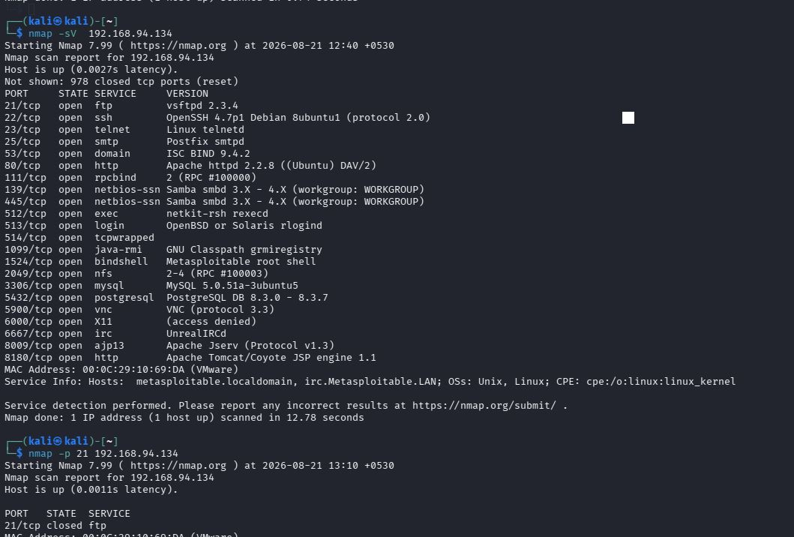
Figure 20.1: Nmap scan results before hardening
The screenshot shows the initial security assessment of the Metasploitable system. Multiple network services and ports were found open, including FTP, SSH, Telnet, SMTP, HTTP, SMB, and other services. These exposed services increased the system's attack surface.

20.3 After Hardening

PORT 512 ,513,514 CLOSED

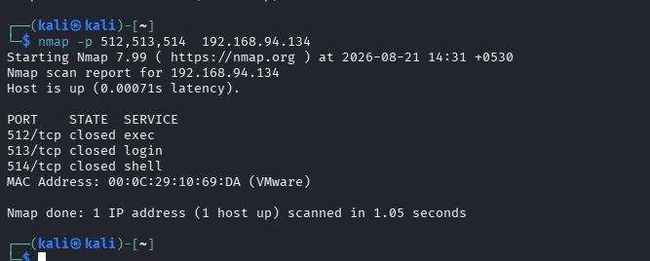

PORT 21 CLOSED

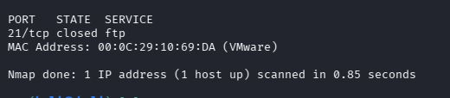

PORT 23 CLOSED

