PROJECT REPORT OF Research Paper (Module-2)
ON
Human Activity Recognition (HAR) Using
Smartphone Sensors: A Machine Learning
Perspective

submitted in partial fulfilment of the requirements for the award of degree of

BACHELOR OF ENGINEERING
In
COMPUTER SCIENCE AND ENGINEERING

Submitted by: Supervised By:
Kushvir singh Maan (2210991802) Dr. Simarjit Kaur
Krishna Saini (2210991809) Associate Professor
Krishna Gupta (2210991811) Department of CSE
Divyanshi Dhingra (2210991536)



DEPARTMENT OF COMPUTER SCIENCE AND ENGINEERING

CHITKARA UNIVERSITY INSTITUTE OF ENGINEERING AND TECHNOLOGY
CHITKARA UNIVERSITY, PUNJAB, INDIA

CONTENTS

S.No. | Title | Page No.
1 | Acknowledgement | 4
2 | List of Figures and Tables | 5
3 | Abstract | 6
4 | Introduction | 7
5 | Methodology | 9
6 | Tools and Technologies | 17
7 | Implementation | 20
8 | Major Findings/Outcomes/Output/Results | 24
9 | Conclusion and Future Scope | 26
10 | References | 27
11 | Appendices | 29

DECLARATION

I hereby certify that the work which is being presented in the project report entitled “ Human Activity Recognition (HAR) Using Smartphone Sensors: A Machine Learning Perspective ” in partial fulfilment of requirement for the award of the degree of Bachelor of Engineering (Computer Science and Engineering) submitted in the department of Computer Science and Engineering at Chitkara University Institute of Engineering and Technology, Chitkara University, Punjab, India, is an authentic record of my own work carried out under the supervision of Simarjit Kaur . The matter presented in this project report has not been submitted in any other university/institute for the award of any degree.

Place: Rajpura
Date: 30/4/26

Kushvir singh Maan (2210991802) Krishna (2210991809)

Krishna Gupta (2210991811) Divyanshi (2210991536)

This is to certify that the above statement made by the candidate is correct to the best of my knowledge and belief.

Dr. Simarjit Kaur
Associate Professor
Department of Computer Science and Engineering
Chitkara University Institute of Engineering and Technology,
Chitkara University, Punjab, India

ACKNOWLEDGEMENT

The successful completion of this research work would not have been possible without the support and guidance of Mentor Dr. Simarjit Kaur. We would like to express our sincere gratitude to the faculty members of the Department of Computer Science and Engineering at Chitkara University for their continuous encouragement and valuable insights throughout the course of this project.
We are especially thankful to our mentors, whose guidance helped us refine our understanding of machine learning concepts and their real-world applications. Their suggestions played a crucial role in improving the quality and depth of this work.
We also extend our appreciation to our peers and colleagues who contributed through discussions, feedback, and collaborative learning. Lastly, we are deeply grateful to our families for their constant support, motivation, and patience during the development of this project.

List of Figures and Tables

Figures
- Figure 1: Proposed HAR Pipeline
- Figure 2: Raw Sensor Signal Visualization
- Figure 3: Sensor Signal Visualization
- Figure 4: Model Architecture Diagrams
- Figure 5: Accuracy Comparison Graph
- Figure 6: Confusion Matrix

Tables
- Table 1: Dataset Description
- Table 2: Feature Extraction Summary
- Table 3: Model Performance Comparison
- Table 4: Class-wise Performance

Abstract
Human Activity Recognition (HAR) is an important area of research that focuses on identifying human physical activities using sensor data collected from smart devices. This project presents a smartphone-based HAR system using accelerometer and gyroscope signals from the UCI-HAR dataset. Multiple machine learning and deep learning models were implemented and compared, including Support Vector Machine (SVM), Random Forest (RF), 1D Convolutional Neural Network (CNN), Long Short-Term Memory (LSTM), CNN-LSTM, and CNN-BiLSTM architectures.
To improve class balance, SMOTE (Synthetic Minority Over-sampling Technique) was applied during training. The performance of the models was evaluated using metrics such as accuracy, precision, recall, F1-score, ROC-AUC, and execution time. Among all models, CNN-BiLSTM achieved the highest accuracy of 92.87%, while the lightweight 1D CNN provided the best trade-off between performance and deployment efficiency.
Additionally, TensorFlow Lite quantization was used to convert the trained CNN model into a compact format suitable for edge deployment on mobile devices. The proposed system demonstrates the effectiveness of deep learning techniques for real-time HAR applications such as healthcare monitoring, elderly fall detection, and fitness tracking.
Keywords: Human Activity Recognition, Smartphone Sensors, Deep Learning, CNN, LSTM, TensorFlow Lite, UCI-HAR Dataset

INTRODUCTION

Human Activity Recognition (HAR) is a rapidly evolving field within computer science that focuses on identifying human physical activities using sensor data. Over the past decade, HAR has transitioned from being a purely academic research topic to a practical technology with real-world applications in healthcare, fitness monitoring, and smart environments.
At its core, HAR involves collecting time-series data from sensors and analyzing it to determine the activity being performed. These activities can range from simple actions such as walking and sitting to more complex behaviors. The ability to automatically recognize such activities has significant implications, particularly in areas like elderly care, where continuous monitoring can help detect falls or abnormal patterns.
The rise of smartphones has played a crucial role in advancing HAR systems. Modern smartphones are equipped with high-quality inertial sensors such as accelerometers and gyroscopes, which can capture motion data in three dimensions. Unlike traditional wearable devices, smartphones are already widely used, making them an ideal platform for large-scale deployment of HAR systems.
One of the key advantages of smartphone-based HAR is its accessibility. Since most individuals already carry smartphones, there is no need for additional hardware. This not only reduces cost but also simplifies implementation. Furthermore, the computational power of modern smartphones allows for on-device processing, reducing dependency on cloud infrastructure.
Despite these advantages, developing an effective HAR system is not straightforward. Sensor data is often noisy and can vary significantly depending on factors such as device placement, user behavior, and environmental conditions. For example, the same activity may produce different sensor patterns if the phone is placed in a pocket versus held in hand.
To better understand sensor data, it is useful to represent the accelerometer signal mathematically. The observed acceleration can be expressed as the sum of three components: gravity, body motion, and noise.
The magnitude of the acceleration vector is often used as a feature because it provides a measure of overall motion intensity independent of device orientation. This is particularly useful in distinguishing between static activities like sitting and dynamic activities like walking.
Another major challenge in HAR is class imbalance. In real-world datasets, certain activities may occur more frequently than others, leading to biased models. Additionally, there is always a trade-off between accuracy and computational efficiency, especially when designing models for mobile devices.
In this research, a complete pipeline for HAR is developed to address these challenges. The pipeline includes preprocessing techniques to clean the data, segmentation methods to structure it, feature extraction to identify meaningful patterns, and classification models to predict activities.
Both classical machine learning models and deep learning approaches are explored. While traditional models rely on handcrafted features, deep learning models automatically learn representations from raw data, often resulting in better performance.
A key focus of this study is not only accuracy but also practical deployment. Models are evaluated based on their computational efficiency and suitability for real-time applications. This is particularly important for edge devices, where resources are limited.
The remainder of this report is organized into several sections. The literature review provides an overview of existing research in HAR. The methodology section describes the proposed pipeline in detail. The implementation and results sections present the experimental setup and findings. Finally, conclusions and future directions are discussed.

Methodology

The methodology adopted in this study follows a structured and systematic pipeline for Human Activity Recognition (HAR) using smartphone sensor data. The primary objective is to transform raw sensor signals into meaningful patterns that can be accurately classified into different human activities.
The entire process is divided into several stages, including data acquisition, preprocessing, segmentation, feature extraction, model training, and evaluation. Each stage plays a crucial role in ensuring the reliability and efficiency of the final system.

- Overall System Pipeline
The proposed system is designed as a modular pipeline where each stage processes the output of the previous stage. This modular approach ensures flexibility, scalability, and ease of debugging.

Pipeline Steps:
- Data Acquisition
- Signal Preprocessing
- Segmentation
- Feature Extraction
- Classification Models
- Handling Class Imbalance
- Model Training
- Hyperparameter Tuning
- Evaluation Metrics

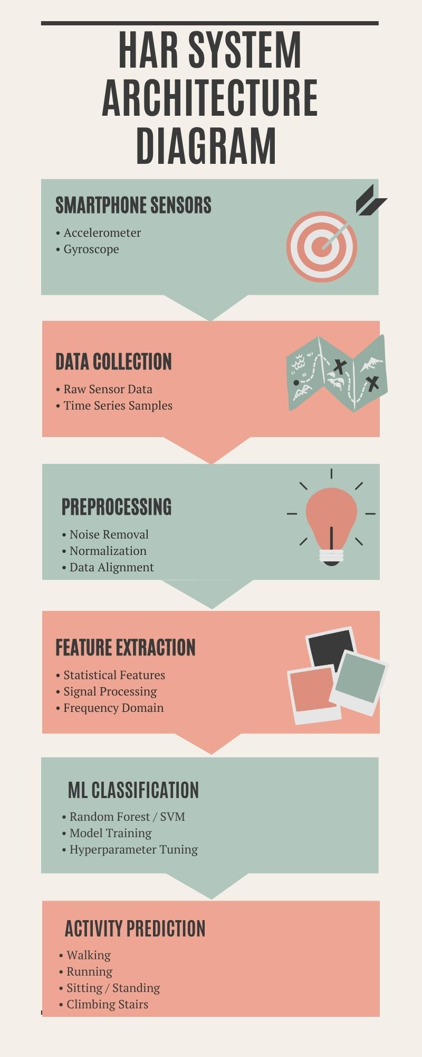

Figure 1: Proposed HAR System Pipeline

- Data Acquisition
The dataset used in this research is the UCI-HAR dataset, which is widely recognized as a benchmark dataset for activity recognition tasks.
The data was collected from 30 participants aged between 19 and 48 years. Each participant performed six different activities while carrying a smartphone placed at their waist. The smartphone used for data collection was a Samsung Galaxy S II, which contains built-in inertial sensors.

Activities Included:
- Walking
- Walking Upstairs
- Walking Downstairs
- Sitting
- Standing
- Lying
The sensor data consists of:
- Tri-axial accelerometer readings
- Tri-axial gyroscope readings
The sampling frequency of the data is 50 Hz, meaning 50 data points are recorded per second.

Parameter | Value
Number of Subjects | 30
Activities | 6
Sensors | Accelerometer + Gyroscope
Sampling Rate | 50 Hz
Training Samples | 7352
Testing Samples | 2947

- Signal Preprocessing
Raw sensor data is often noisy and contains irrelevant components that can negatively affect model performance. Therefore, preprocessing is a critical step in the pipeline.
The UCI-HAR dataset already provides preprocessed inertial sensor signals. Additional preprocessing steps included reshaping the sensor windows into suitable input formats for machine learning and deep learning models.

SMOTE (Synthetic Minority Over-sampling Technique) was applied to handle class imbalance and improve minority class recognition performance.

The processed signals were then prepared for segmentation and model training.

- Segmentation
Since sensor data is continuous, it must be divided into smaller segments for analysis. This process is known as segmentation.
In this study, the data is divided into fixed-length windows:
- Window size: 128 samples
- Duration: 2.56 seconds
- Overlap: 50%
The overlapping windows help capture transitions between activities and improve model performance.
Each segment can be represented as a matrix of size:
128 × 9 (samples × sensor channels)
This structured representation allows models to analyze temporal patterns effectively.
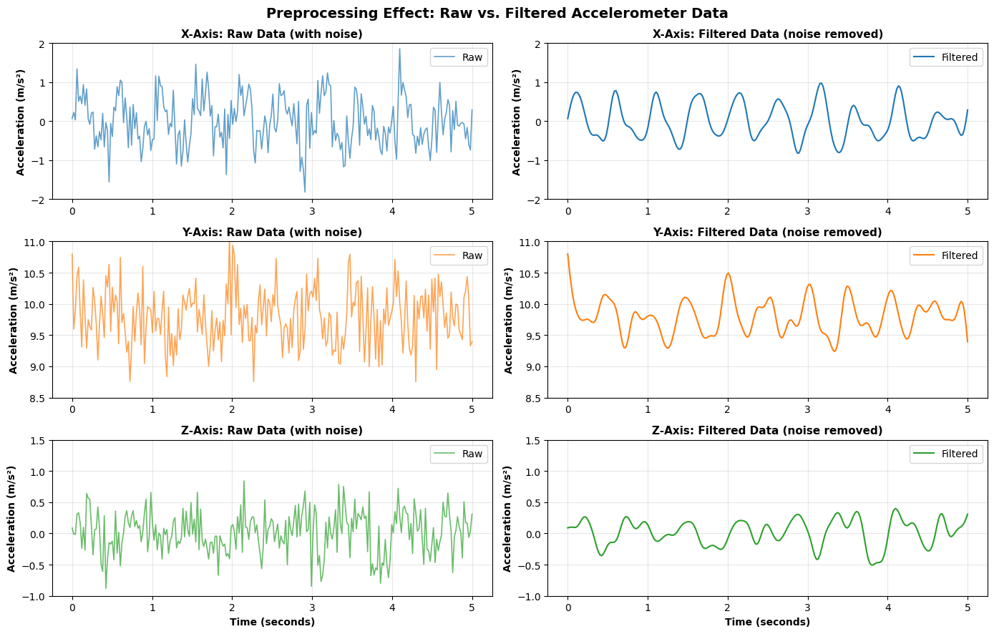
Figure 3: Sliding Window Segmentation

- Feature Extraction
Feature extraction is primarily used for classical machine learning models such as SVM and Random Forest.
For deep learning models, raw inertial sensor windows of shape (128,9) were directly used as input.

For classical machine learning models such as SVM and Random Forest, the signal windows were flattened into one-dimensional feature vectors before training.

This approach allowed both classical and deep learning methods to be evaluated under a common framework.

- Classification Model
The study compares both classical machine learning models and deep learning models.

5.1 Classical Machine Learning Models

Support Vector Machine (SVM)
- Uses RBF kernel
- Effective for high-dimensional data
- Good generalization performance

Random Forest (RF)
- Ensemble method using multiple decision trees
- Handles non-linear relationships well
- Fast inference time

5.2 Deep Learning Models

1D Convolutional Neural Network (CNN)
- Extracts local patterns from time-series data
- Lightweight and efficient

Long Short-Term Memory (LSTM)
- Captures temporal dependencies
- Suitable for sequential data

CNN-LSTM
- Combines CNN feature extraction with LSTM temporal modeling

CNN-BiLSTM
- Uses bidirectional LSTM
- Captures both past and future dependencies
- Provides highest accuracy
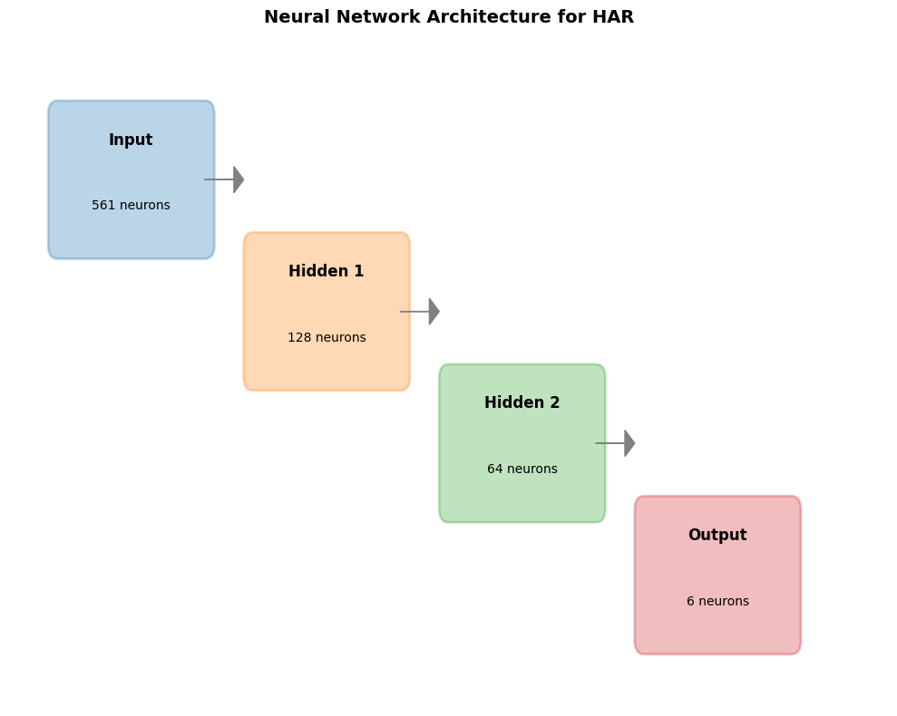
Figure 4: Model Architecture Diagrams

- Handling Class Imbalance
Real-world datasets often suffer from class imbalance. To address this issue, SMOTE (Synthetic Minority Over-sampling Technique) is applied.
SMOTE generates synthetic samples for minority classes, ensuring that all classes are equally represented during training.
This improves the model’s ability to correctly classify underrepresented activities.

- Model Training
The official UCI-HAR train-test split was used for model evaluation.
Training | samples | 7352
Testing | samples | 2947
The models were trained using the Adam optimizer and categorical cross-entropy loss for deep learning architectures.
- Hyperparameter Tuning

The models were trained using experimentally selected parameters such as dropout regularization, batch size, and learning rate to achieve stable performance.

- Evaluation Metrics
The performance of the models is evaluated using multiple metrics:
- Accuracy
- Precision
- Recall
- F1 Score
- ROC-AUC
- Execution Time
These metrics provide a comprehensive understanding of model performance.

Tools and Technologies
The successful implementation of the Human Activity Recognition (HAR) system required the integration of multiple tools, programming frameworks, and libraries. Each tool was selected based on its efficiency, flexibility, and suitability for handling time-series sensor data and machine learning workflows.

1. Programming Language
The entire system was developed using Python (Version 3.10). Python was chosen due to its simplicity, extensive library support, and strong community backing in the fields of data science and machine learning.

2. Data Processing Libraries
To handle and manipulate large volumes of sensor data efficiently, the following libraries were used:
- NumPy: Used for numerical computations and handling multi-dimensional arrays. It played a key role in processing sensor signals and performing mathematical operations.
- Pandas: Used for data handling, cleaning, and structuring. It helped in organizing the dataset into manageable formats.

3. Visualization Tools
Data visualization was an important step in understanding patterns and validating preprocessing techniques.
- Matplotlib: Used for plotting graphs such as signal waveforms and performance comparisons.
- Seaborn: Used for advanced visualizations like heatmaps and confusion matrices.

4. Machine Learning Frameworks
- Scikit-learn:
Used for implementing classical machine learning models such as:
  - Support Vector Machine (SVM)
  - Random Forest (RF)
It also provided tools for preprocessing, cross-validation, and evaluation.

5. Deep Learning Frameworks
- TensorFlow and Keras:
Used for building and training deep learning models such as CNN, LSTM, and hybrid architectures.
These frameworks provided flexibility in designing custom neural network architectures and optimizing them.

6. Model Optimization and Deployment
- TensorFlow Lite (TFLite):
Used for converting trained models into lightweight versions suitable for mobile devices.
- Quantization Techniques:
Applied to reduce model size and improve inference speed without significant loss in accuracy.

7. Development Environment
The project was implemented using:
- Jupyter Notebook / Google Colab
These environments allowed easy experimentation and visualization of results.

Implementation
The implementation phase focused on translating the proposed methodology into a working system capable of recognizing human activities from sensor data.

1. Data Loading and Preparation
The dataset was loaded and divided into training and testing sets. Proper labeling ensured that each data segment corresponded to a specific activity.
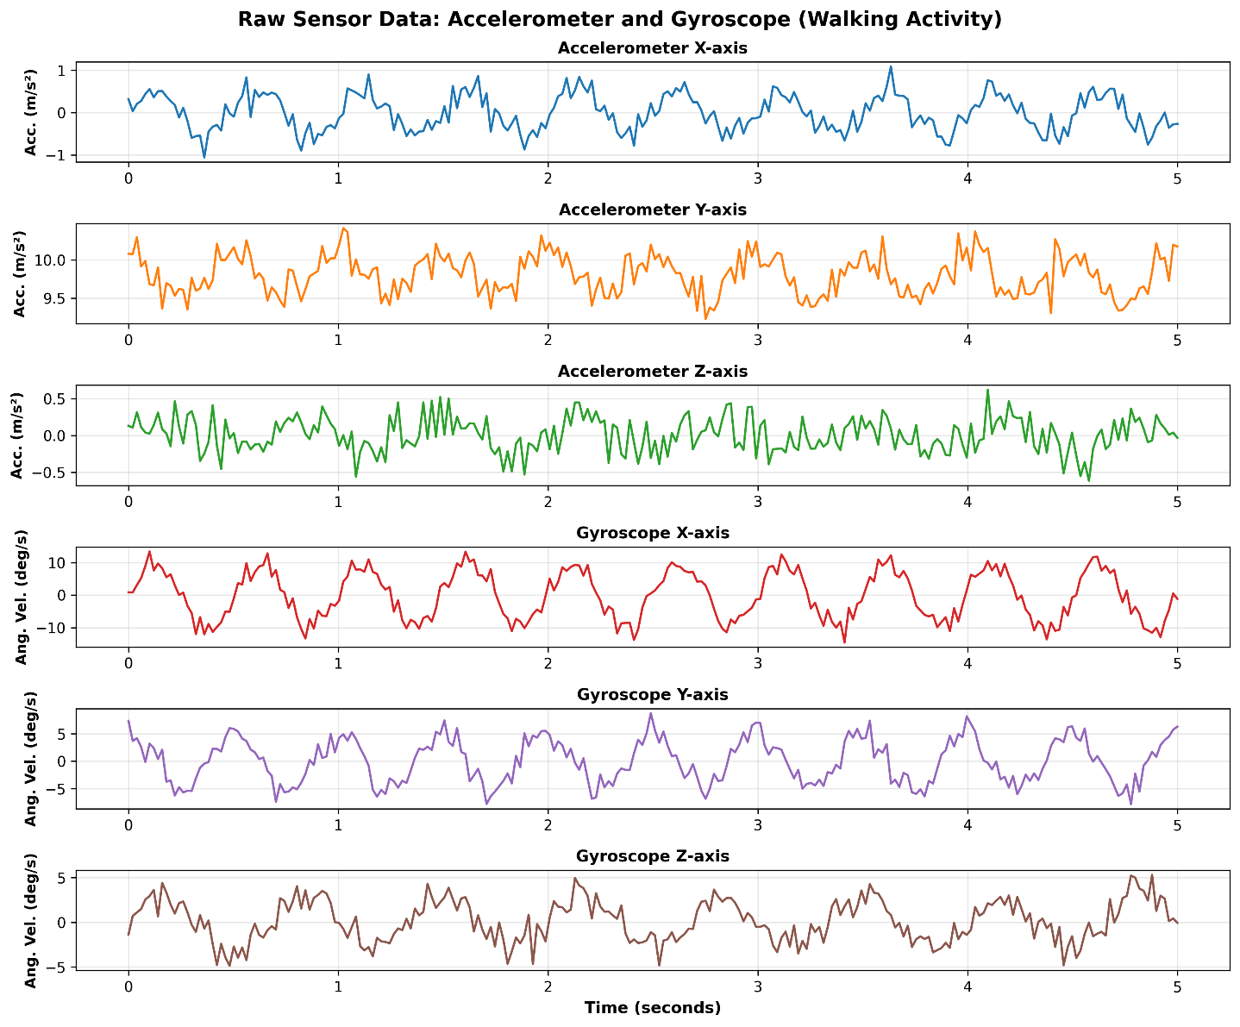Figure: Dataset Sample Screenshot

2. Signal Preprocessing Implementation
The UCI-HAR dataset already contains preprocessed inertial sensor signals. Additional preprocessing included reshaping sensor windows into suitable formats for machine learning and deep learning models.
SMOTE was applied to balance minority activity classes and improve classification robustness.

3. Segmentation Implementation
Sliding window segmentation was implemented using Python loops and array slicing.
Each window contained:
- 128 samples
- 50% overlap
This helped in capturing continuous motion patterns effectively.

4. Feature Representation Implementation
For deep learning models, raw inertial sensor windows of shape (128,9) were directly used as input.
For classical machine learning models such as SVM and Random Forest, the signal windows were flattened into one-dimensional feature vectors before training.

5. Model Implementation

Classical Models
- SVM implemented using Scikit-learn with RBF kernel
- Random Forest with 100 decision trees

Deep Learning Models
- CNN implemented using Conv1D layers
- LSTM for sequence learning
- CNN-BiLSTM combining convolution and bidirectional memory

6. Training Process

The official UCI-HAR train-test split was used for model evaluation.
Training Samples: 7352
Testing Samples: 2947
Deep learning models were trained using the Adam optimizer and categorical cross-entropy loss.

7. Model Deployment
The trained CNN model was converted into TensorFlow Lite format:
- Original size: 320 KB
- Compressed size: 45 KB
This enabled deployment on mobile and embedded devices.

Trained CNN Model
↓
TensorFlow Lite Converter
↓
INT8 Quantization
↓
Compressed .tflite Model
↓
Edge / Mobile Deployment

Major Findings / Results
The performance of the HAR system was evaluated using multiple models, focusing on both accuracy and efficiency.

1. Model Performance Comparison

Model | Accuracy | F1 Score | Execution Time
SVM | 90.33% | 0.9023 | 26 ms
RF | 85.21% | 0.8507 | 12 ms
CNN | 92.23% | 0.9228 | 60 ms
LSTM | 92.13% | 0.9214 | 255 ms
CNN-LSTM | 91.08% | 0.9119 | 150 ms
CNN-BiLSTM | 92.87% | 0.9293 | 142 ms

2. Key Observations
- Deep learning models outperform classical models
- CNN-BiLSTM achieved the highest accuracy
- Random Forest had the fastest Execution Time
- 1D CNN provided best balance between accuracy and efficiency

3. Class-wise Analysis
Dynamic activities (walking, running) showed higher accuracy compared to static ones (sitting, standing).
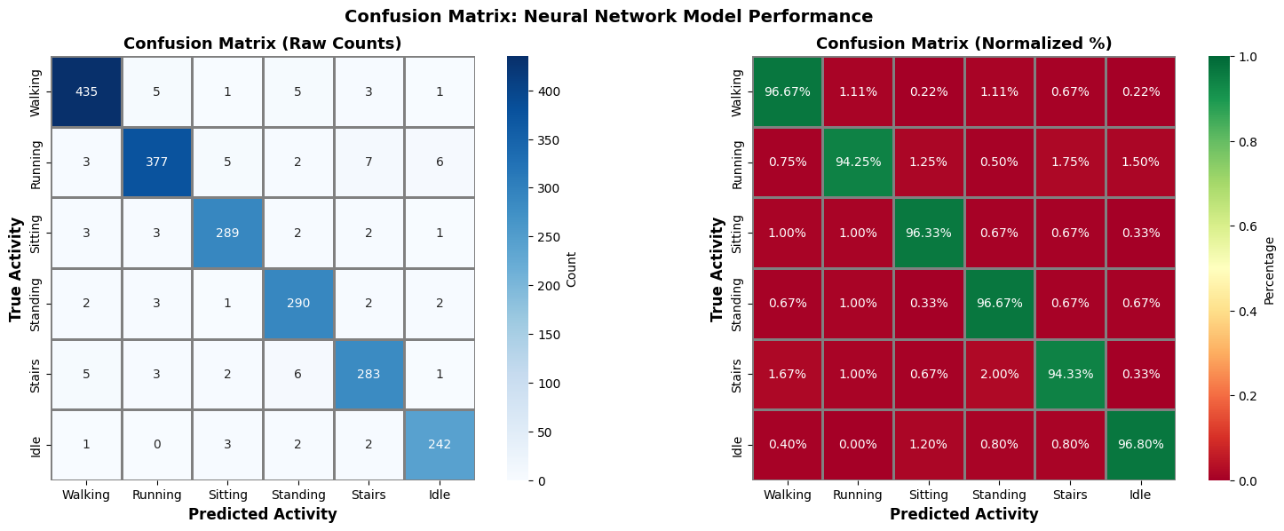
Figure: Confusion Matrix

4. Impact of SMOTE
- Improved performance for minority classes
- Reduced bias in classification
- Increased overall model robustness

5. Efficiency vs Accuracy Trade-off
Although CNN-BiLSTM performed best in accuracy, it was computationally expensive.
The 1D CNN emerged as a suitable model for lightweight edge deployment scenarios.

Conclusion and Future Scope
This research successfully developed a robust Human Activity Recognition system using smartphone sensor data. The study demonstrated the effectiveness of combining signal processing techniques with machine learning and deep learning models.
The results showed that deep learning models significantly outperform traditional approaches in terms of accuracy. Among all models, CNN-BiLSTM achieved the highest performance. However, for real-world deployment, the 1D CNN model proved to be the most efficient due to its lightweight nature and faster inference time.
The integration of TensorFlow Lite further enabled the deployment of the model on edge devices, making the system suitable for real-time applications.

Future Scope
There are several directions in which this work can be extended:
- Integration of additional sensors such as GPS and heart rate monitors
- Development of personalized HAR models
- Use of transformer-based architectures
- Real-time deployment in healthcare systems
- Detection of rare events such as falls
- Implementation using TinyML for embedded systems
- Federated learning for privacy-preserving systems

References

- S. K. Challa, A. Kumar, and V. B. Semwal, "A multibranch CNN-BiLSTM model for human activity recognition using wearable sensor data," The Visual Computer, vol. 38, pp. 4095–4109, 2022.
- S. O. Bursa, O. D. Incel, and G. I. Alptekin, "Building lightweight deep learning models with TensorFlow Lite for HAR on mobile devices," Annals of Telecommunications, vol. 78, pp. 687–702, 2023.
- D. Anguita, A. Ghio, L. Oneto, X. Parra, and J. L. Reyes-Ortiz, "A Public Domain Dataset for Human Activity Recognition Using Smartphones," in Proc. European Symposium on Artificial Neural Networks (ESANN), 2013.
- C. A. Ronao and S.-B. Cho, "Human activity recognition with smartphone sensors using deep learning neural networks," Expert Systems with Applications, vol. 59, pp. 235–244, 2016.
- B. Saha et al., "TinyML-driven on-device personalized human activity recognition and auto-deployment to smart bands," in Proc. ACM International Conference on AI-ML Systems (AIML-Systems), Bengaluru, India, 2023.
- A. Hayajneh, M. Hafeez, S. A. R. Zaidi, and D. McLernon, "TinyML empowered transfer learning on the edge," IEEE Open Journal of the Communications Society, vol. 5, pp. 1656–1672, 2024.
- J.-L. Reyes-Ortiz, L. Oneto, A. Samà, X. Parra, and D. Anguita, "Transition-aware human activity recognition using smartphones," Neurocomputing, vol. 171, pp. 754–767, 2016.
- Y. Li and L. Wang, "Human activity recognition based on residual network and BiLSTM," Sensors, vol. 22, no. 2, p. 635, 2022.
- A. Ignatov, "Real-time human activity recognition from accelerometer data using convolutional neural networks," Applied Soft Computing, vol. 62, pp. 915–922, 2018.
- N. V. Chawla, K. W. Bowyer, L. O. Hall, and W. P. Kegelmeyer, "SMOTE: Synthetic Minority Over-sampling Technique," Journal of Artificial Intelligence Research, vol. 16, pp. 321–357, 2002.
- Y. LeCun, Y. Bengio, and G. Hinton, "Deep learning," Nature, vol. 521, no. 7553, pp. 436–444, 2015.
- S. Hochreiter and J. Schmidhuber, "Long short-term memory," Neural Computation, vol. 9, no. 8, pp. 1735–1780, 1997.
- L. Breiman, "Random forests," Machine Learning, vol. 45, no. 1, pp. 5–32, 2001.
- C. Cortes and V. Vapnik, "Support-vector networks," Machine Learning, vol. 20, no. 3, pp. 273–297, 1995.
- D. P. Kingma and J. Ba, "Adam: A method for stochastic optimization," in Proc. International Conference on Learning Representations (ICLR), 2015.
- F. J. Ordóñez and D. Roggen, "Deep convolutional and LSTM recurrent neural networks for multimodal wearable activity recognition," Sensors, vol. 16, no. 1, p. 115, 2016.
- O. D. Lara and M. A. Labrador, "A survey on human activity recognition using wearable sensors," IEEE Communications Surveys & Tutorials, vol. 15, no. 3, pp. 1192–1209, 2013.
- A. Bulling, U. Blanke, and B. Schiele, "A tutorial on human activity recognition using body-worn inertial sensors," ACM Computing Surveys (CSUR), vol. 46, no. 3, pp. 1–33, 2014.
- M. Schuster and K. K. Paliwal, "Bidirectional recurrent neural networks," IEEE Transactions on Signal Processing, vol. 45, no. 11, pp. 2673–2681, 1997.
- B. Jacob et al., "Quantization and training of neural networks for efficient integer-arithmetic-only inference," in Proc. IEEE Conference on Computer Vision and Pattern Recognition (CVPR), pp. 2704–2713, 2018.
- A. Vaswani et al., "Attention is all you need," in Advances in Neural Information Processing Systems (NeurIPS), vol. 30, 2017.
- A. G. Howard et al., "MobileNets: Efficient convolutional neural networks for mobile vision applications," arXiv:1704.04861, 2017.
- N. Srivastava, G. Hinton, A. Krizhevsky, I. Sutskever, and R. Salakhutdinov, "Dropout: A simple way to prevent neural networks from overfitting," Journal of Machine Learning Research (JMLR), vol. 15, no. 1, pp. 1929–1958, 2014.
- J. Wang, Y. Chen, S. Hao, X. Peng, and L. Hu, "Deep learning for sensor-based activity recognition: A survey," Pattern Recognition Letters, vol. 119, pp. 3–11, 2019.
- B. McMahan, E. Moore, D. Ramage, S. Hampson, and B. A. y Arcas, "Communication-efficient learning of deep networks from decentralized data," in Proc. International Conference on Artificial Intelligence and Statistics (AISTATS), 2017.

APPENDICES

Appendix A: Sample Sensor Signal Visualization
This appendix contains sample visualizations of accelerometer and gyroscope sensor signals obtained from the UCI-HAR dataset.
Appendix B: Model Architecture Diagrams
This appendix includes architecture diagrams for CNN, LSTM, CNN-LSTM, and CNN-BiLSTM models used in the study.
Appendix C: TensorFlow Lite Conversion
This appendix presents the TensorFlow Lite quantization workflow used for lightweight edge deployment.
Appendix D: Additional Experimental Results
Additional plots such as confusion matrices and accuracy comparison graphs are included for reference.

