**AMCENGINEERINGCOLLEGE**



**(Affiliated to VTU, Belagavi, Karnataka)**

**18thK.M, Bannerghatta Main Road, Bengaluru-560083**

**DEPARTMENT OF CSE-AIML**

**LABORATORY MANUAL COMPUTERNETWORKS/BCS502**

(Effectivefromtheacademicyear2024-2025)

# Preparedby,

**Prof.Kavya P**

**Assistant Professor**

Department of CSE-AIML

**AMC Engineering College**

**VISVESVARAYATECHNOLOGICALUNIVERSITY**

**“JnanaSangama”,BELAGAVI–590018 KARNATAKA**

**Vision and Mission of the Institution**

**VISION**

“To be leader in Impacting Value Based Technical Education and Research for the benefit of Society”

**MISSION**

|  |  |
| --- | --- |
| **M1** | Provide state-of-the art infrastructure and facilities. |
| **M2** | Implement modern pedagogical methods in delivering academic programs with an experienced and committed faculty. |
| **M3** | Create a vibrant ambience that promotes Learning, Research,Invention and Innovations |
| **M4** | Enhance Institute-Industry interface through collaborative research and consultancy. |
| **M5** | Generate and disseminate knowledge through startups, training programs, workshops, seminars, conferences and publications. |

**DEPARTMENT OF CSE-AIML ENGINEERING**

**Vision of the Department**

***“BeapremierdepartmentinthefieldofArtificialIntelligence&MachineLearning Engineering to meet the future needs of the society”.***

**Mission of the Department**

|  |  |
| --- | --- |
| **M1** | To provide state of art infrastructure , academic excellence facilities and research with innovative ICT in CSE-AI & ML. |
| **M2** | To provide hands on experience in the advanced tools andt echnologies in the fieldof expert systems and neural networks. |
| **M3** | To collaborate industry institute interaction and prepare students ready for the next generation technological needs of the society. |
| **M4** | Tomouldstudentsintoprofessionallycompetent,sociallyResponsibleandethically correct CSE-AIML professional. |

lOMoARcPSD|27793530

AMC ENGINEERING COLLEGE

**(Affiliated to VTU, Belagavi,Karnataka)**

# DEPARTMENTOF CSE-AIML ENGINEERING

|  |  |
| --- | --- |
| **ProgramOutcomes** | |
| **a.** | **Engineering Knowledge:** Apply knowledge of mathematics, science, engineering fundamentals and an engineering specialization to the solution of complexengineering problems. |
| **b.** | **ProblemAnalysis:Identify,**formulate,researchliteratureandanalyze complexengineering  problemsreachingsubstantiatedconclusionsusingfirstprinciplesofmathematics,natural sciences and engineering sciences |
| **c.** | **Design/DevelopmentofSolutions**:Designsolutionsforcomplexengineeringproblems anddesignsystemcomponentsorprocessesthatmeetspecifiedneedswithappropriate  consideration for public health and safety, cultural, societaland environmental considerations. |
| **d.** | **Conduct investigations of complex problems** using research-basedknowledge and research methods including design of experiments, analysis and interpretation of data and synthesis of information to provide valid conclusions. |
| **e.** | **Modern Tool Usage**: Create, select and apply appropriate techniques, resourcesandmodern engineeringand ITtools includingpredictionand modelingtoComplex engineeringactivities with an under- standing of the limitations. |
| **f.** | **TheEngineerandSociety**: Applyreasoning informed bycontextualknowledgeto assess societal, health, safety, legal and cultural issues and theConsequent responsibilities relevant to professionalengineering practice. |
| **g.** | **Environmentand Sustainability**: Understandtheimpact of professional Engineeringsolutionsinsocietalandenvironmentalcontextsanddemonstrateknowledge of and need forsustainable development. |
| **h.** | **Ethics**:Apply ethical principles and commit to professionalethics andResponsibilitiesand norms of engineering practice. |
| **i.** | **IndividualandTeamWork:** Functioneffectivelyasanindividual,andasamemberor  leaderindiverse teamsandinmultidisciplinarysettings. |
| **j.** | **Communication:** Communicate effectively on complex engineering activities with the engineeringcommunityandwithsocietyatlarge,suchasbeingabletocomprehendand write effective reports and design documentation,make effective  presentationsandgiveandreceiveclearinstructions**.** |
| **k.** | **Life-long Learning:** Recognize the need forand have thepreparation and ability to engageinindependentandlife-longlearninginthebroadestcontextoftechnological change. |
| **l.** | **Project Management andFinance:**Demonstrateknowledgeandunderstandingof engineering andmanagementprinciplesand apply these to  one’sownwork, asamemberandleaderinateam,tomanageprojects andinMulti- disciplinary environments. |
| **ProgramSpecificOutcomes** | |
| **m.** | **PSO1**:Abilityofapplyingsoftcomputingtechniques,Deeplearning,Datastructures, Computational Intelligence Algorithms, Expert Systems and NeuralNetworks. |
| **n.** | **PSO2**:Softwareskillsandabilityofdevelopingadvancedtrainingmodulesusingmachine learning techniques and evolutionary algorithms |

lOMoARcPSD|27793530

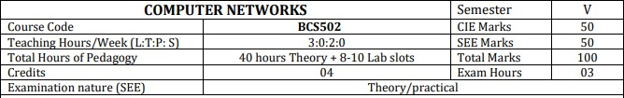

|  |  |
| --- | --- |
| **Sl. No** | **Experiment s** |
| 1 | Implementthreenodes point– to– pointnetworkwithduplex linksbetween them.Set the  queuesize, vary thebandwidth, and find thenumberof packets dropped. |
| 2 | Implementtransmissionofpingmessages/tracerouteoveranetwork topologyconsistingof6 nodes and find the number of packets dropped due to congestion. |
| 3 | ImplementanEthernetLANusingnnodesandsetmultipletrafficnodesandplotcongestion window for different source / destination |
| 4 | DevelopaprogramforerrordetectingcodeusingCRC-CCITT(16-bits). |
| 5 | Developa programto implementa slidingwindow protocolin thedata link layer. |
| 6 | DevelopaprogramtofindtheshortestpathbetweenverticesusingtheBellman-Fordandpath vector routing algorithm. |
| 7 | UsingTCP/IPsockets,writeaclient–serverprogramtomaketheclientsendthefilenameand to make the server send back the contents of the requested file if present. |
| 8 | Developaprogramonadatagramsocketforclient/servertodisplaythemessagesonclient side, typed at the server side. |
| 9 | Developaprogramfora simpleRSAalgorithmtoencryptanddecryptthedata. |
| 10 | Developaprogramforcongestioncontrolusingaleakybucketalgorithm |
| **Courseoutcomes(CourseSkillSet):**  Attheendofthecourse,thestudentwillbeableto:  CO1:Explainthefundamentalsofcomputer networks.  CO2:Applytheconceptsofcomputernetworkstodemonstratetheworkingofvariouslayersand protocols in communication network.  CO3:Analyzetheprinciplesofprotocollayering inmoderncommunication systems  CO4:DemonstratevariousRoutingprotocolsandtheirservicesusingtoolssuchasCiscopackettracer. | |

lOMoARcPSD|27793530

### AssessmentDetails(bothCIE andSEE)

The weightage of Continuous Internal Evaluation (CIE) is 50% and for Semester End Exam (SEE) is 50%. Theminimumpassing mark forthe CIE is40% ofthemaximum marks(20 marksout of 50) and forthe SEE minimumpassing mark is 35% of the maximum marks (18 out of 50 marks). A student shall be deemed to have satisfied the academic requirements and earned the credits allotted to each subject/ course if the student secures a minimum of 40% (40 marks out of 100) in the sum total of the CIE (Continuous Internal Evaluation) and SEE (Semester End Examination) taken together.

### CIEforthe theory component oftheIPCC(maximummarks 50)

* IPCCmeanspracticalportionintegratedwiththetheoryofthecourse.
* CIEmarksforthetheorycomponent are**25marks** andthatforthepracticalcomponent is**25marks**.
* 25 marks for the theory component are split into **15 marks** for two Internal Assessment Tests (Two Tests, each of 15 Marks with 01-hour duration, are to be conducted) and **10 marks** for other assessment methods mentioned in 22OB4.2. The first test at the end of 40-50% coverage of the syllabus and the second test aftercovering 85-90% of the syllabus.
* Scaled-down marks of the sum of two tests and other assessment methods will be CIE marks for the theorycomponent of IPCC (that is for **25 marks)**.
* The studenthastosecure40%of25markstoqualifyintheCIEof thetheorycomponentofIPCC.

### CIEforthepracticalcomponentof theIPCC

* **15 marks** for the conduction of the experiment and preparation of laboratory record, and **10 marks** for the test to be conducted after the completion of all the laboratory sessions.
* On completion of every experiment/program in the laboratory, the students shall be evaluated including viva- voce and marks shall be awarded on the same day.
* The CIE marks awarded in the case of the Practical component shall be based on the continuous evaluationof the laboratory report. Each experiment report can be evaluated for 10 marks. Marks of all experiments’ write-ups are added and scaled down to **15 marks**.
* The laboratory test **(duration 02/03 hours)** after completion of all the experiments shall be conducted for 50 marks and scaled down to **10 marks.**
* Scaled-down marks of write-up evaluations and tests added will be CIE marks for thelaboratory componentof IPCC for **25 marks**.

lOMoARcPSD|27793530

|  |
| --- |
| * Thestudent hastosecure40%of25markstoqualifyintheCIEofthe practicalcomponent ofthe IPCC.   **SEEforIPCC**  TheorySEEwillbeconductedbyUniversityasperthescheduledtimetable,withcommonquestion papers forthe course (**duration 03 hours**)   1. Thequestionpaperwillhavetenquestions.Eachquestionissetfor20marks. 2. There will be2 questionsfromeach module.Eachofthe twoquestions undera module(witha maximumof 3 sub-questions), **should have a mix of topics** under that module. 3. Thestudentshavetoanswer5fullquestions, selecting onefullquestionfromeachmodule. 4. Marksscoredbythestudentshall beproportionallyscaleddown to50 Marks   **ThetheoryportionoftheIPCCshallbeforbothCIEandSEE,whereasthepracticalportion**  **will have aCIE component only. Questions mentioned in the SEE paper may include questions from the practical component**. |
| **SuggestedLearning Resources:**  **TextBooks**  1. BehrouzA.Forouzan,DataCommunicationsandNetworking,5thEdition,TataMcGraw Hill,2013.  **ReferenceBooks:**   1. LarryL.PetersonandBruceS.Davie:ComputerNetworks –ASystemsApproach,4thEdition, Elsevier, 2019. 2. 2.Nader F.Mir:ComputerandCommunicationNetworks,2ndEdition,PearsonEducation,2015. 3. 3.WilliamStallings,DataandComputerCommunication10thEdition,PearsonEducation,Inc., 2014. |
| **ActivityBasedLearning(SuggestedActivitiesinClass)/PracticalBasedlearning**   1. Implementationofvariousprotocols usingopensourcesimulationtools.(5 marks) 2. Simulationof Personalareanetwork,Homeareanetwork,achieve QoSetc. (5 marks) |

## EXPERIMENTNO:1

**Implementthreenodespoint–to–pointnetworkswithduplexlinksbetweenthem.Setthequeuesize, vary the bandwidth, and find the number of packets dropped.**

## SOURCECODE:

#Create Simulator

set ns **[new** Simulator**]**

#OpenTracefileandNAMfile set ntrace [open prog1.tr w]

$nstrace-all $ntrace

set namfile **[**open prog1.nam w**]**

$nsnamtrace-all$namfile #Finish Procedure

proc Finish {} {

global ns ntrace namfile

#Dump all the trace data and close the files

$nsflush-trace close $ntrace close $namfile

#Executethenamanimationfile exec nam prog1.nam &

#Show the number of packets dropped

exec echo "The number of packet drops is "**&**

exec grep -c "^d" prog1.tr **&**

exit 0

**}**

#Create 3 nodes setn0[$nsnode] setn1[$nsnode] setn2[$nsnode] #Label the nodes

$n0 label "TCP Source"

$n2label"Sink"#Set the color

$ns color 1 blue

#Create Links between nodes

#You need to modify the bandwidth to observe the variation inpacket drop

$ns duplex-link $n0 $n1 1Mb 10ms DropTail

$nsduplex-link$n1$n21Mb10msDropTail #Make the Link Orientation

$ns duplex-link-op $n0 $n1 orient right

$nsduplex-link-op$n1$n2orientright #Set Queue Size

#Youcanmodifythequeuelengthaswelltoobservethevariationinpacket drop

$nsqueue-limit $n0 $n1 10

$nsqueue-limit $n1 $n2 10

#SetupaTransportlayerconnection. set tcp0 [new Agent/TCP]

$ns attach-agent $n0 $tcp0 setsink0**[new**Agent/TCPSink**]**

$ns attach-agent $n2 $sink0

$ns connect $tcp0 $sink0

#Set up an Application layer Traffic setcbr0**[new**Application/Traffic/CBR**]**

$cbr0 set type_ CBR

$cbr0 set packetSize_ 100

$cbr0 set rate_ 1Mb

$cbr0 set random_ **false**

$cbr0 attach-agent $tcp0

$tcp0setclass_1 #Schedule Events

$ns at 0.0 "$cbr0 start"

$nsat5.0"Finish"#Run the Simulation

$ns run

OUTPUT:

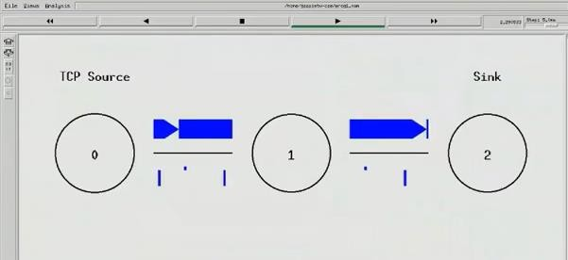

Thenumberof packet drop is:8

## EXPERIMENTNO:2

### Implementtransmissionofpingmessages/tracerouteoveranetworktopologyconsistingof6nodes and find the number of packets dropped due to congestion

#Create Simulator

set ns [new Simulator]

#Use colors to differentiate the traffic

$ns color 1 Blue

$ns color 2 Red

#OpentraceandNAMtracefile set ntrace [open prog3.tr w]

$nstrace-all $ntrace

set namfile [open prog3.nam w]

$nsnamtrace-all$namfile #Finish Procedure

proc Finish {} {

global ns ntrace namfile

#Dump all trace data and close the file

$nsflush-trace close $ntrace close $namfile

#Executethenamanimationfile exec nam prog3.nam &

#Find the number of ping packets dropped

puts "The number of ping packets dropped are "

execgrep"^d"prog3.tr|cut-d""-f5|grep-c"ping"& exit 0

}

#Create six nodes

for{seti0}{$i<6}{incri}{ set n($i) [$ns node]

}

#Connect the nodes

for {set j 0} {$j < 5} {incr j} {

$ns duplex-link $n($j) $n([expr ($j+1)]) 0.1Mb 10ms DropTail

}

#Definetherecvfunctionfortheclass'Agent/Ping'Agent/Ping instproc recv {from rtt} {

$self instvar node_

puts "node [$node_ id] received ping answer from$from with round trip time

$rtt ms"

}

#Createtwopingagentsandattachthemton(0)andn(5) set p0 [new Agent/Ping]

$p0 set class_ 1

$nsattach-agent$n(0)$p0 set p1 [new Agent/Ping]

$p1 set class_ 1

$ns attach-agent $n(5) $p1

$ns connect $p0 $p1

#Set queue size and monitor the queue

#Queue size is set to 2 to observe the drop in ping packets

$nsqueue-limit $n(2) $n(3) 2

$nsduplex-link-op$n(2)$n(3)queuePos0.5 #Create Congestion

#GenerateaHugeCBRtrafficbetweenn(2)andn(4) set tcp0 [new Agent/TCP]

$tcp0 set class_ 2

$ns attach-agent $n(2) $tcp0 set sink0 [new Agent/TCPSink]

$ns attach-agent $n(4) $sink0

$ns connect $tcp0 $sink0 #ApplyCBRtrafficoverTCP

set cbr0 [new Application/Traffic/CBR]

$cbr0 set packetSize_ 500

$cbr0 set rate_ 1Mb

$cbr0attach-agent$tcp0 #Schedule events

$ns at 0.2 "$p0 send"

$ns at 0.4 "$p1 send"

$ns at 0.4 "$cbr0 start"

|  |  |  |  |
| --- | --- | --- | --- |
| $ns | at | 0.8 | "$p0 send" |
| $ns | at | 1.0 | "$p1 send" |
| $ns | at | 1.2 | "$cbr0 stop" |
| $ns | at | 1.4 | "$p0 send" |
| $ns | at | 1.6 | "$p1 send" |
| $ns | at | 1.8 | "Finish" |

#Run the Simulation

$ns run

## OUTPUT:

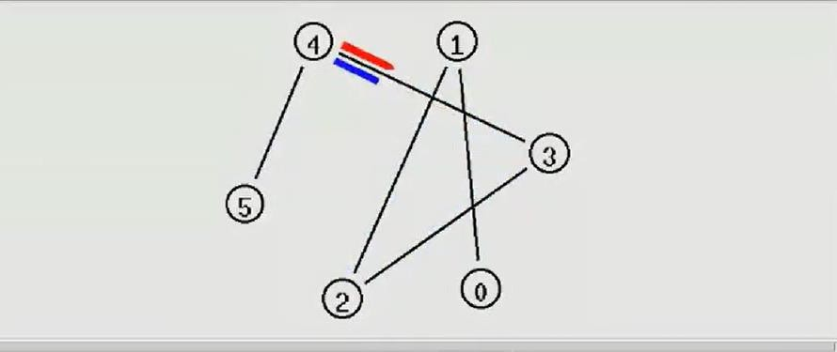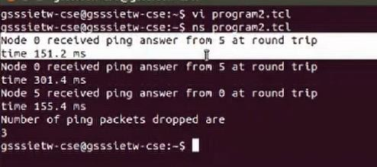

**EXPERIMENTNO:3**

### ImplementanEthernetLANusingnnodesandsetmultipletrafficnodesandplotcongestionwindow for different source / destination

Step1:Opentext editor,typethe belowprogramand savewithextention .tcl(prog5.tcl )

set ns [new Simulator] setnf[openprog5.namw]

$ns namtrace-all $nf

set nd [open prog5.trw]

$nstrace-all $nd

$ns color 1 Blue

$ns color 2 Red procfinish{}{ global ns nf nd

$nsflush-trace close$nfclose $nd

execnamprog5.nam& exit 0

}

setn0[$nsnode] setn1[$nsnode] setn2[$nsnode] setn3[$nsnode] setn4[$nsnode] setn5[$nsnode] setn6[$nsnode] setn7[$nsnode] set n8 [$ns node]

$n7 shape box

$n7 color Blue

$n8 shape hexagon

$n8 color Red

$ns duplex-link $n1 $n0 2Mb 10ms DropTail

$ns duplex-link $n2 $n0 2Mb 10ms DropTail

$ns duplex-link $n0 $n3 1Mb 20ms DropTail

$ns make-lan "$n3 $n4 $n5 $n6 $n7 $n8" 512Kb 40ms LL Queue/DropTail Mac/802_3

$ns duplex-link-op $n1 $n0 orientright-down

$ns duplex-link-op $n2 $n0 orientright-up

$ns duplex-link-op $n0 $n3 orient right

$nsqueue-limit$n0$n320 settcp1[newAgent/TCP/Vegas]

$ns attach-agent $n1 $tcp1 setsink1[newAgent/TCPSink]

$ns attach-agent $n7 $sink1

$ns connect $tcp1 $sink1

$tcp1 set class_ 1

$tcp1 set packetsize_ 55

set ftp1 [new Application/FTP]

$ftp1 attach-agent $tcp1

set tfile [open cwnd.tr w]

$tcp1 attach $tfile

$tcp1 trace cwnd_

set tcp2 [new Agent/TCP/Reno]

$ns attach-agent $n2 $tcp2 setsink2[newAgent/TCPSink]

$ns attach-agent $n8 $sink2

$ns connect $tcp2 $sink2

$tcp2 set class_ 2

$tcp2 set packetSize_ 55

set ftp2 [new Application/FTP]

$ftp2attach-agent$tcp2 settfile2[opencwnd2.trw]

$tcp2 attach $tfile2

$tcp2 trace cwnd_

$ns at 0.5 "$ftp1 start"

$ns at 1.0 "$ftp2 start"

$ns at 5.0 "$ftp2 stop"

$ns at 5.0 "$ftp1 stop"

$ns at 5.5 "finish"

$ns run

Step2:Opentexteditor, typethebelow programandsavewith extention.awk(prog5.awk)

BEGIN {

}

{

if($6=="cwnd_") { printf("%f\t%f\n",$1,$7);

}

}

END {

}

Step3:Run thesimulation program

[root@localhost~]# ns prog5.tcl

(Here“ns”indicatesnetworksimulator.Wegetthetopologyshown inthesnapshot.)

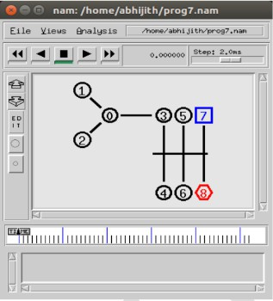

Step4:Nowpresstheplaybuttoninthesimulationwindowandthesimulationwillbegins. Step 5: After simulation is completed run awk file and generate the graph , [root@localhost~]# awk –f prog5.awk cwnd.tr > a1 [root@localhost~]# awk –f prog5.awk cwnd2.tr > a2 [root@localhost~]#xgraph a1 a2

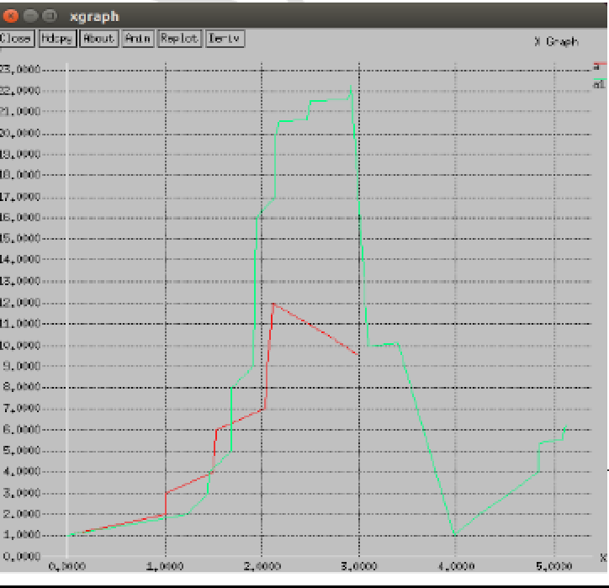

Step6:Toseethetracefilecontentsopenthefile as ,

[root@localhost~]# vi prog5.tr

## EXPERIMENT-4

### Developaprogram forerrordetectingcodeusingCRC-CCITT(16-bits)

importjava.util.Scanner; import java.io.*;

publicclassCRC1{

publicstaticvoidmain(Stringargs[]){ Scanner sc = new Scanner(System.in);

//Input Data Stream System.out.print("Entermessagebits:"); String message = sc.nextLine(); System.out.print("Enter generator: "); String generator = sc.nextLine();

intdata[]=newint[message.length()+generator.length() -1]; int divisor[] = new int[generator.length()];

for(inti=0;i<message.length();i++)

data[i]=Integer.parseInt(message.charAt(i)+""); for(int i=0;i<generator.length();i++)

divisor[i]=Integer.parseInt(generator.charAt(i)+"");

//CalculationofCRC

for(inti=0;i<message.length();i++)

{

if(data[i]==1)

for(intj=0;j<divisor.length;j++) data[i+j] ^= divisor[j];

}

//DisplayCRC

System.out.print("Thechecksumcodeis:"); for(int i=0;i<message.length();i++)

data[i]=Integer.parseInt(message.charAt(i)+""); for(int i=0;i<data.length;i++)

System.out.print(data[i]); System.out.println();

//Check for input CRC code System.out.print("Enterchecksumcode:");

message = sc.nextLine(); System.out.print("Entergenerator:");

generator=sc.nextLine();

data=newint[message.length()+generator.length() -1]; divisor = new int[generator.length()];

for(inti=0;i<message.length();i++)

data[i]=Integer.parseInt(message.charAt(i)+""); for(int i=0;i<generator.length();i++)

divisor[i]=Integer.parseInt(generator.charAt(i)+"");

//Calculationofremainder

for(inti=0;i<message.length();i++){ if(data[i]==1)

for(intj=0;j<divisor.length;j++) data[i+j] ^= divisor[j];

}

//Displayvalidityofdata boolean valid = true;

for(inti=0;i<data.length;i++) if(data[i]==1){

valid=false; break;

}

if(valid==true)

System.out.println("Datastreamisvalid");

else

}

}

System.out.println("Datastreamisinvalid.CRCerroroccurred.");

**OUTPUT**

Entermessagebits:1101011011 Enter generator: 10011

Thechecksumcodeis:11010110111110 Enter checksum code: 11010110111110 Enter generator: 10011

Datastreamisvalid

Entermessagebits:1101011011 Enter generator: 10011

Thechecksumcodeis:11010110111110 Enter checksum code: 11010110111111 Enter generator: 10011

Datastreamisinvalid.CRCerroroccurred.

## EXPERIMENT-5

### Developaprogramtoimplementaslidingwindowprotocolinthedatalinklayer.

Theory:

Incomputernetworksslidingwindowprotocolisamethodtotransmitdataonanetwork.Slidingwindow protocol isapplied on theDataLinkLayerofOSI model.Atdata link layer datais inthe form of frames. In Networking, Window simply means a buffer which has data frames that needs to be transmitted.

Bothsenderandreceiveragreesonsomewindowsize.Ifwindowsize=wthenaftersendingwframes sender waits for the acknowledgement (ack) of the first frame.

As soonas sender receives theacknowledgementof a frame itis replaced by the nextframes to be transmittedbythesender.Ifreceiversendsacollectiveorcumulativeacknowledgementtosenderthenitunderstandsthatmorethanoneframesareproperlyreceived,foreg:-ifackofframe3is received it understands that frame 1 and frame 2 are received properly.

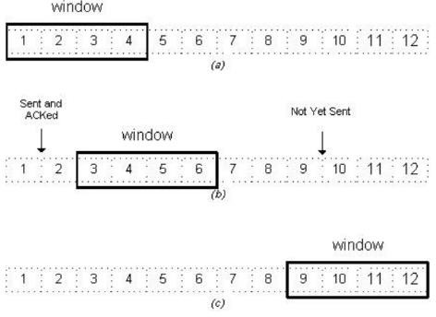

Inslidingwindowprotocolthereceiverhastohavesomememorytocompensateanylossintransmissionor if the frames are received unordered.

EfficiencyofSlidingWindowProtocol η = (W*tx)/(tx+2tp)

W=Window Size

tx=Transmissiontime tp=Propagationdelay

Slidingwindow worksinfullduplex mode

Itisoftwotypes:-

1. SelectiveRepeat:Sendertransmitsonlythat framewhichiserroneousoris lost.
2. Gobackn:Sendertransmitsallframespresentinthewindowthatoccursaftertheerrorbitincludingerror bit also

SOURCECODE

#include<stdio.h> int main()

{

int w,i,f,frames[50]; printf("Enterwindowsize:"); scanf("%d",&w);

printf("\nEnternumberofframestotransmit:"); scanf("%d",&f);

printf("\nEnter%dframes:",f); for(i=1;i<=f;i++) scanf("%d",&frames[i]);

printf("\nWithslidingwindowprotocoltheframeswillbesentinthe following manner (assuming no corruption of frames)\n\n");

printf("Aftersending%dframesateachstagesenderwaitsfor acknowledgement sent by the receiver\n\n",w);

for(i=1;i<=f;i++)

{

if(i%w==0)

{

printf("%d\n",frames[i]);

printf("Acknowledgementofaboveframessentisreceivedby sender\n\n");

}

else

printf("%d ",frames[i]);

}

if(f%w!=0)

printf("\nAcknowledgementofaboveframessentisreceivedby sender\n");

return 0;

}

OUTPUT

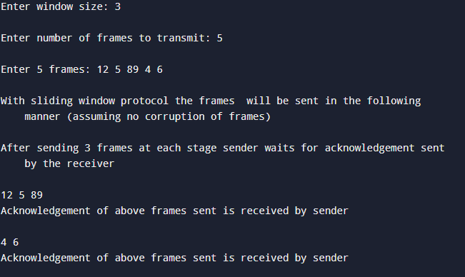

## EXPERIMENT-6

### DevelopaprogramtofindtheshortestpathbetweenverticesusingtheBellman-Fordandpathvector routing algorithm.

importjava.util.Scanner; public class ford

{

private int D[]; privateintnum_ver;

publicstaticfinalintMAX_VALUE=999; public ford(int num_ver)

{

this.num_ver = num_ver;

D = new int[num_ver + 1];

}

public void BellmanFordEvaluation(int source, int A[][])

{

for (int node = 1; node <= num_ver; node++)

{

D[node] = MAX_VALUE;

}

D[source] = 0;

for (int node = 1; node <= num_ver- 1; node++)

{

for (int sn = 1; sn <= num_ver; sn++)

{

for (int dn = 1; dn <= num_ver; dn++)

{

if (A[sn][dn] != MAX_VALUE)

{

if (D[dn] > D[sn]+ A[sn][dn])

D[dn] = D[sn] + A[sn][dn];

}

}

}

}

for (int sn = 1; sn <= num_ver; sn++)

{

for (int dn = 1; dn <= num_ver; dn++)

{

if (A[sn][dn] != MAX_VALUE)

{

if (D[dn] > D[sn]+ A[sn][dn])

System.out.println("The Graph contains negative egde cycle");

}

}

}

for (int vertex = 1; vertex <= num_ver; vertex++)

{

System.out.println("distance of source"+source+"to"+vertex+"is" + D[vertex]);

}

}

public static void main(String[ ] args)

{

intnum_ver=0; int source;

Scanner scanner = new Scanner(System.in); System.out.println("Enterthenumberofvertices"); num_ver = scanner.nextInt();

int A[][] = new int[num_ver + 1][num_ver + 1]; System.out.println("Enter the adjacency matrix"); for (int sn = 1; sn <= num_ver; sn++)

{

for (int dn = 1; dn <= num_ver; dn++)

{

A[sn][dn]=scanner.nextInt(); if (sn == dn)

{

A[sn][dn]=0; continue;

}

if (A[sn][dn] == 0)

{

A[sn][dn] = MAX_VALUE;

}

}

}

System.out.println("Enterthesourcevertex"); source = scanner.nextInt();

ford b = new ford (num_ver); b.BellmanFordEvaluation(source,A); scanner.close();

}

}

## OUTPUT

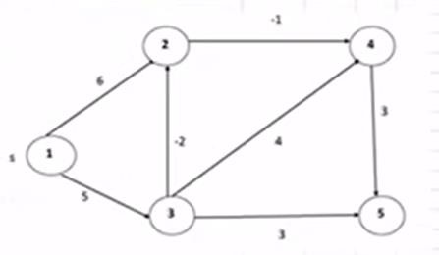

Enterthenumberofvertices: 5

Entertheadjacencymatrix

0 6500

00 0-10

0-2 043

0 0 0 03

0 0 0 00

Enterthesourcevertex:

1

Distanceof source1 to 1: 0

Distanceof source1 to 2:3

Distanceof source1 to 3:5

Distanceof source1 to 4:2

Distanceofsource1 to 5:5

## EXPERIMENTNO:7

### UsingTCP/IPsockets,writeaclient–serverprogramtomaketheclientsendthefilenameandto make the server send back the contents of the requested file if present.

**TCP program server side**import java.net.*; import java.io.*; publicclassserver1

{

public static void main(String args[]) throws Exception

{

// establishing the connection with the server ServerSocket ss = new ServerSocket(4000); System.out.println("Serverreadyforconnection"); Socket = ss.accept(); // binding with port: 4000

System.out.println("Connection is successful and waiting for chatting");

// reading the file name from client InputStreamistream=sock.getInputStream();

BufferedReaderbr=newBufferedReader(newInputStreamReader(istream)); String fname = br.readLine( );

// reading file contents

BufferedReader contentRead = new BufferedReader(new FileReader(fname) );

// keeping output stream ready to send the contents OutputStream ostream = sock.getOutputStream( ); PrintWriterpwrite=newPrintWriter(ostream,true); String str;

while((str=contentRead.readLine())!=null)//readingline-by-linefrom file

{

pwrite.println(str);// sending each line to client

}

// closing network sockets

sock.close();

ss.close(); pwrite.close(); fileRead.close(); br.close();

}

}

**TCP program client side**import java.net.*; import java.io.*; publicclassclient1

{

public static void main( String args[ ] ) throws Exception

{

Socketsock=newSocket("127.0.0.1",4000); System.out.print("Enter the file name");

BufferedReaderbr=newBufferedReader(newInputStreamReader(System.in)); String fname = br.readLine();

//sendingthefilenametoserver.UsesPrintWriter OutputStream ostream = sock.getOutputStream( ); PrintWriterpwrite=newPrintWriter(ostream,true); pwrite.println(fname);

//receivingthecontentsfromserver.Usesinputstream InputStream istream = sock.getInputStream();

BufferedReadersocketRead=newBufferedReader(newInputStreamReader(istream)); String str;

while((str = socketRead.readLine()) !=null) // readingline-by-line

{

System.out.println(str);

}

pwrite.close(); socketRead.close(); br.close();

}

}

## OUTPUT

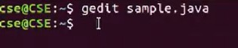

**Atserverside**



**Atclientside**



## EXPERIMENT-8

### Developaprogramonadatagramsocketforclient/servertodisplaythemessagesonclientside,typed at the server side

//UDP Sever

import java.net.*;

importjava.net.InetAddress; class UDPServer

{

public static void main(String args[])throws Exception

{

DatagramSocketserverSocket=newDatagramSocket(9876); byte[] receiveData=new byte[1024];

byte[]sendData=newbyte[1024]; while(true)

{

System.out.println("Server is Up"); DatagramPacket receivePacket=new DatagramPacket(receiveData,receiveData.length);

serverSocket.receive(receivePacket);

Stringsentence=newString(receivePacket.getData()); System.out.println("RECEIVED:"+sentence);InetAddress IPAddress=receivePacket.getAddress(); int port=receivePacket.getPort();

StringcapitalizedSentence=sentence.toUpperCase(); sendData=capitalizedSentence.getBytes();

DatagramPacket sendPacket=new DatagramPacket(sendData,sendData.length,IPAddress,port); serverSocket.send(sendPacket);

}

}

}

//UDP Client

import java.io.*; import java.net.*;

importjava.net.InetAddress; class UDPClient

{

public static void main(String[] args)throws Exception

{

BufferedReaderinFromUser=newBufferedReader(newInputStreamReader(System.in)); DatagramSocket clientSocket=new DatagramSocket();

InetAddress IPAddress=InetAddress.getByName("localhost");

byte[] sendData=new byte[1024]; byte[]receiveData=newbyte[1024];

System.out.println("EnterthestingtobeconvertedintoUppercase"); String sentence=inFromUser.readLine();

sendData=sentence.getBytes(); DatagramPacket sendPacket=new

DatagramPacket(sendData,sendData.length,IPAddress,9876);

clientSocket.send(sendPacket); DatagramPacketreceivePacket=new

DatagramPacket(receiveData,receiveData.length); clientSocket.receive(receivePacket);

String modifiedSentence=new String(receivePacket.getData());

System.out.println("FROMSERVER:"+modifiedSentence); clientSocket.close();

}

}

## OUTPUT:

At server side:

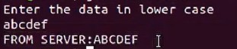At client side:

## EXPERIMENT-9

**DevelopaprogramforasimpleRSAalgorithmtoencryptanddecryptthedata.**

importjava.io.DataInputStream; import java.io.IOException; import java.math.BigInteger; importjava.util.Random;public class RSA

{

privateBigIntegerp,q,N,phi,e,d; private int bitlength=1024; private Random r;

public RSA()

{

r=new Random(); p=BigInteger.probablePrime(bitlength,r); q=BigInteger.probablePrime(bitlength,r); System.out.println("Primenumberpis"+p); System.out.println("primenumberqis"+q); N=p.multiply(q);

phi=p.subtract(BigInteger.ONE).multiply(q.subtract(BigInteger.ONE)); e=BigInteger.probablePrime(bitlength/2,r); while(phi.gcd(e).compareTo(BigInteger.ONE)>0&&e.compareTo(phi)<0)

{

e.add(BigInteger.ONE);

}

System.out.println("Public key is"+e); d=e.modInverse(phi); System.out.println("Privatekeyis"+d);

}

public RSA(BigInteger e,BigInteger d,BigInteger N)

{

this.e=e; this.d=d; this.N=N;

}

publicstatic void main(String[] args)throwsIOException

{

RSA rsa=new RSA();

DataInputStreamin=newDataInputStream(System.in); String testString;

System.out.println("Enter the plain text:"); testString=in.readLine(); System.out.println("Encryptingstring:"+testString);

System.out.println("stringinbytes:"+bytesToString(testString.getBytes())); byte[] encrypted=rsa.encrypt(testString.getBytes());

byte[] decrypted=rsa.decrypt(encrypted); System.out.println("DcryptingBytes:"+bytesToString(decrypted)); System.out.println("Dcrypted string:"+new String(decrypted));

}

private static String bytesToString(byte[] encrypted)

{

String test=""; for(byteb:encrypted)

{

test+=Byte.toString(b);

}

return test;

}

public byte[]encrypt(byte[]message)

{

return(new BigInteger(message)).modPow(e,N).toByteArray();

}

public byte[]decrypt(byte[]message)

{

return(new BigInteger(message)).modPow(d,N).toByteArray();

}

}

OUTPUT

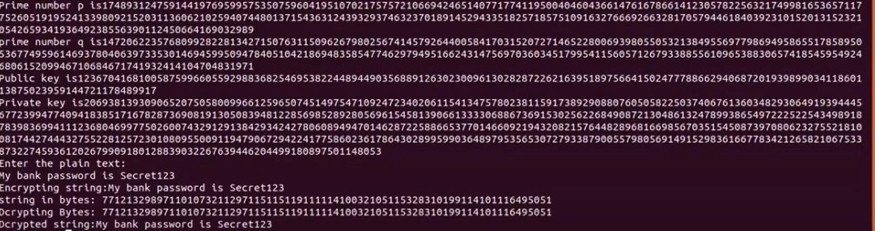

## EXPERIMENT-10

### Developaprogram forcongestioncontrolusingaleakybucketalgorithm

importjava.util.Scanner; import java.lang.*; public class lab7 {

public static void main(String[] args)

{

int i;

int a[]=new int[20];

int buck_rem=0,buck_cap=4,rate=3,sent,recv; Scanner in = new Scanner(System.in); System.out.println("Enterthenumberofpackets"); int n = in.nextInt();

System.out.println("Enterthepackets"); for(i=1;i<=n;i++)

a[i]= in.nextInt();

System.out.println("Clock\tpacketsize\taccept\tsent\tremaining"); for(i=1;i<=n;i++)

{

if(a[i]!=0)

{

if(buck_rem+a[i]>buck_cap) recv=-1;

else

{

recv=a[i]; buck_rem+=a[i];

}

}

else recv=0;

if(buck_rem!=0)

{

if(buck_rem<rate)

{sent=buck_rem; buck_rem=0;

}

else

{

sent=rate; buck_rem=buck_rem-rate;

}

}

else sent=0;

if(recv==-1)

System.out.println(+i+"\t\t"+a[i]+"\tdropped\t"+sent+"\t"+buck_rem); else

System.out.println(+i+ "\t\t" +a[i] +"\t\t" +recv +"\t" +sent +"\t"

+buck_rem);

}

}

}

OUTPUT:

