**Requirements Specification Document**

# **1. Project Summary**

## **1.1 Project Overview**

This Blood Bank Management System is a solution for all staff and administrators involved in managing blood donations and inventory. It allows users to efficiently record and manage blood donations using a computer or any smart device. This web-based application will streamline the blood management process, reduce paperwork, and improve the overall efficiency of blood bank operations.

## **1.2 Project Scope**

Target Users and Responsibilities:

The target users of the Blood Bank Management System include staff members and administrators responsible for managing blood donations and inventory. Their responsibilities may include:

- Staff Members:

- Recording blood donations and updating donor information.

- Managing blood inventory, including storage, categorization, and expiration

tracking.

- Facilitating blood transfusions and maintaining proper documentation.

- Administrators:

- Managing user accounts and access permissions.

- Generating reports and analytics related to blood donations and inventory.

- Overseeing the overall operation and coordination of the blood bank.

Login and Authentication Process:

The system will implement a login and authentication process to ensure secure Blood Bank Management System access. Users will be required to enter their unique username and password to access the system. The system should also support password recovery/reset functionality to assist users in case of forgotten passwords.

Blood Donation Recording Options:

The Blood Bank Management System will provide various options for recording blood donations, including:

- Donor Information:

Capture and store donor details such as name, contact information, blood

type, and medical history.

- Donation Date and Time:

Record the date and time of each blood donation.

- Blood Unit Details:

Track the unique identification number, blood type, storage location, and

the expiration date for each blood unit

- Donation Categories:

Categorize blood donations based on factors such as whole blood, plasma,

platelets, or specific components.

Blood Inventory Management:

The system will enable staff members to efficiently manage blood inventory based on various criteria, including:

- Storage Location:

Maintain information about the physical location of blood units within the

blood bank storage facility.

- Expiration Tracking:

Monitor and alert staff members about approaching expiration dates of

blood units to ensure timely utilization or disposal.

- Availability Tracking:

Keep track of the availability of different blood types and components in

real-time to facilitate efficient blood transfusions.

User Registration and Data Upload:

The Blood Bank Management System should provide a feature for administrators to add and manage user accounts for staff members. Additionally, the system should support bulk uploading of donor information and blood unit details using comma-separated files or other compatible formats. This feature will help populate the system with existing data and facilitate efficient data entry.

Administrator Role and Staff Management:

The system's administrator will have the following responsibilities:

- Managing User Accounts:

Create, modify, and deactivate user accounts for staff

members.

- Access Permissions:

Assign appropriate access permissions to each user based on their roles

and responsibilities.

- Course Allocation:

Allocate specific tasks or responsibilities to staff members, such as blood

donation recording, inventory management, or report generation.

- Staff Performance Monitoring:

Monitor and track the performance of staff members in terms of their

duties and responsibilities within the blood bank.

## **2.0 General Description**

## **2.1 Product Functions Overview**

Three types of users/actors:

1. Staff Member

2. Donor

3. Administrator

A high-level overview of the features for each type of user:

Staff Member:

* Record blood donations and update donor information.
* Manage blood inventory, including storage, categorization and expiration tracking.
* Facilitate blood transfusions and maintain proper documentation.

Donor:

* Register as a blood donor and provide personal and medical information.
* Schedule blood donation appointments.
* View personal donation history and upcoming appointments.

Administrator:

* Manage user accounts and access permissions for staff members.
* Generate reports and analytics related to blood donations and inventory.
* Oversee the overall operation and coordination of the blood bank.

2.**2 User Interface Design**

Home Page:

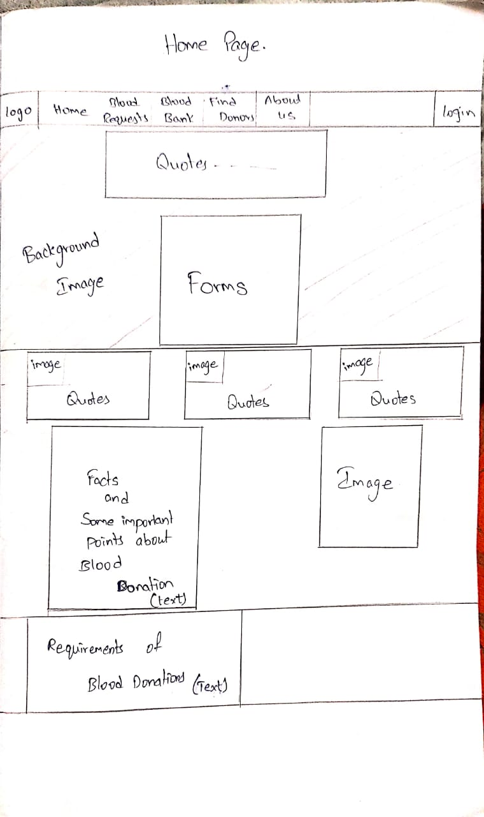

Blood Request Page:

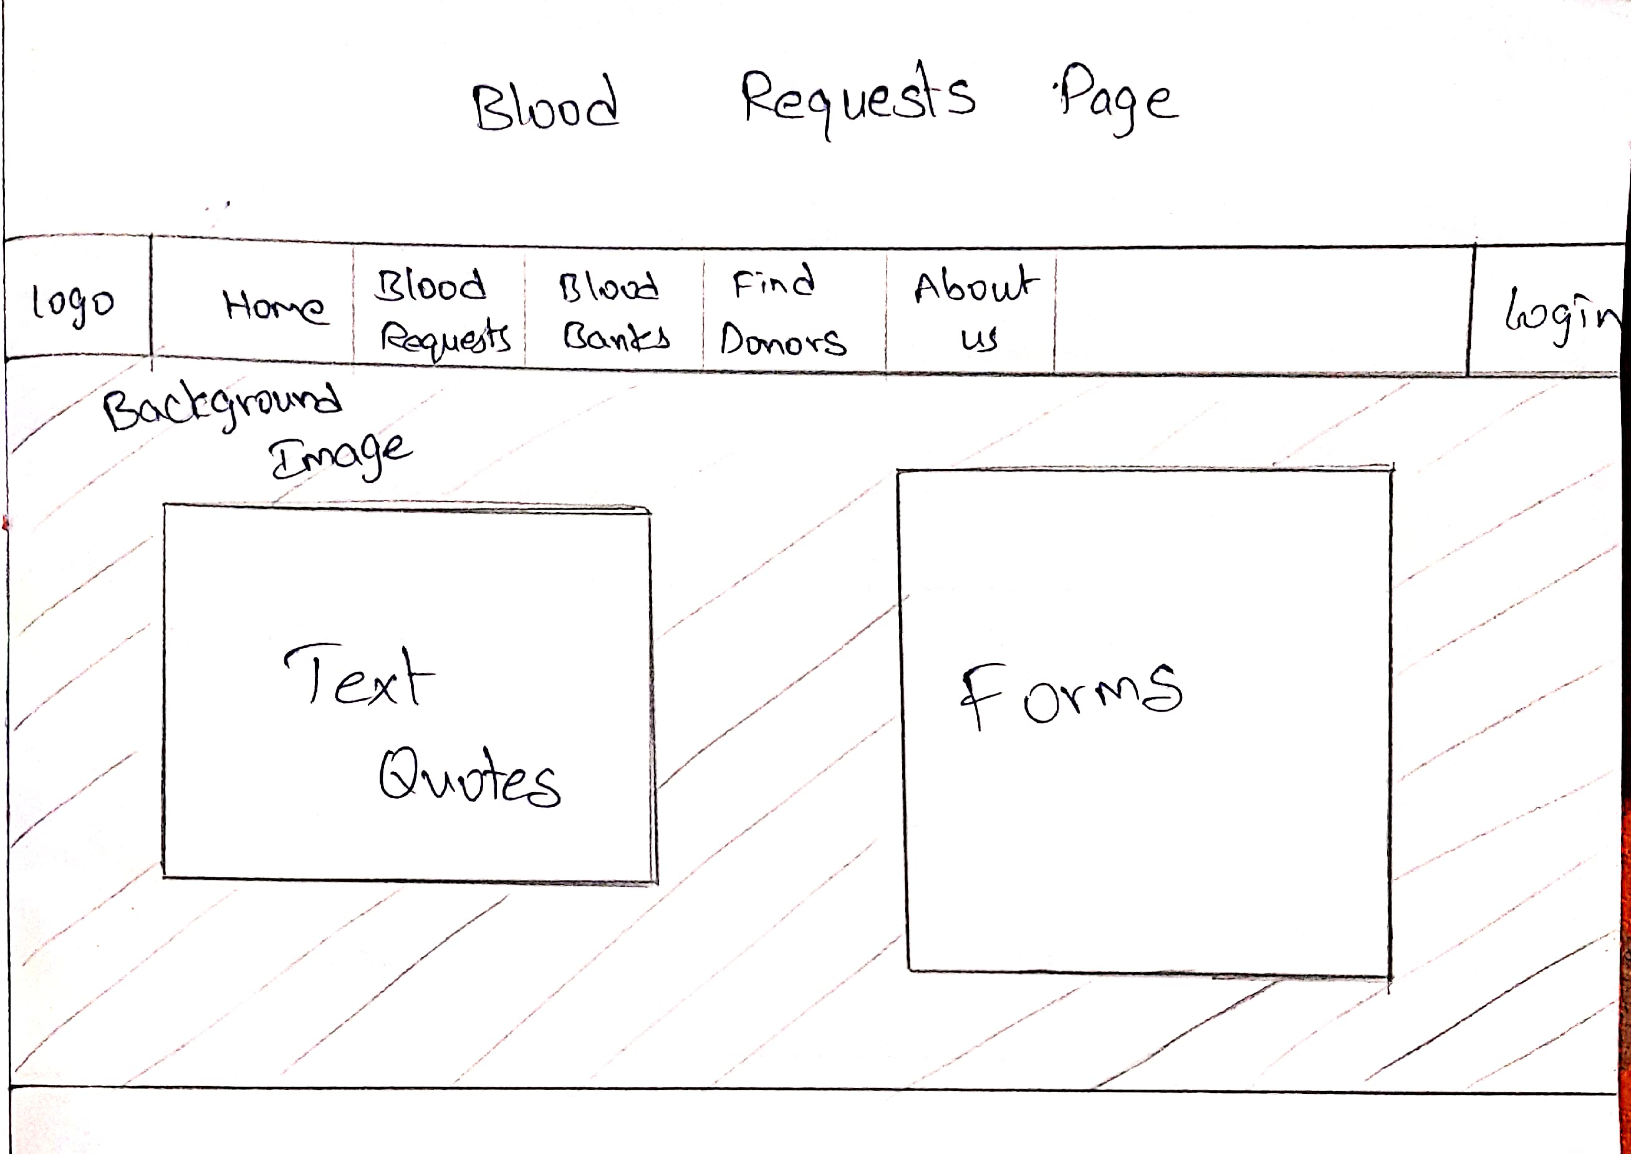

Blood Bank Page:

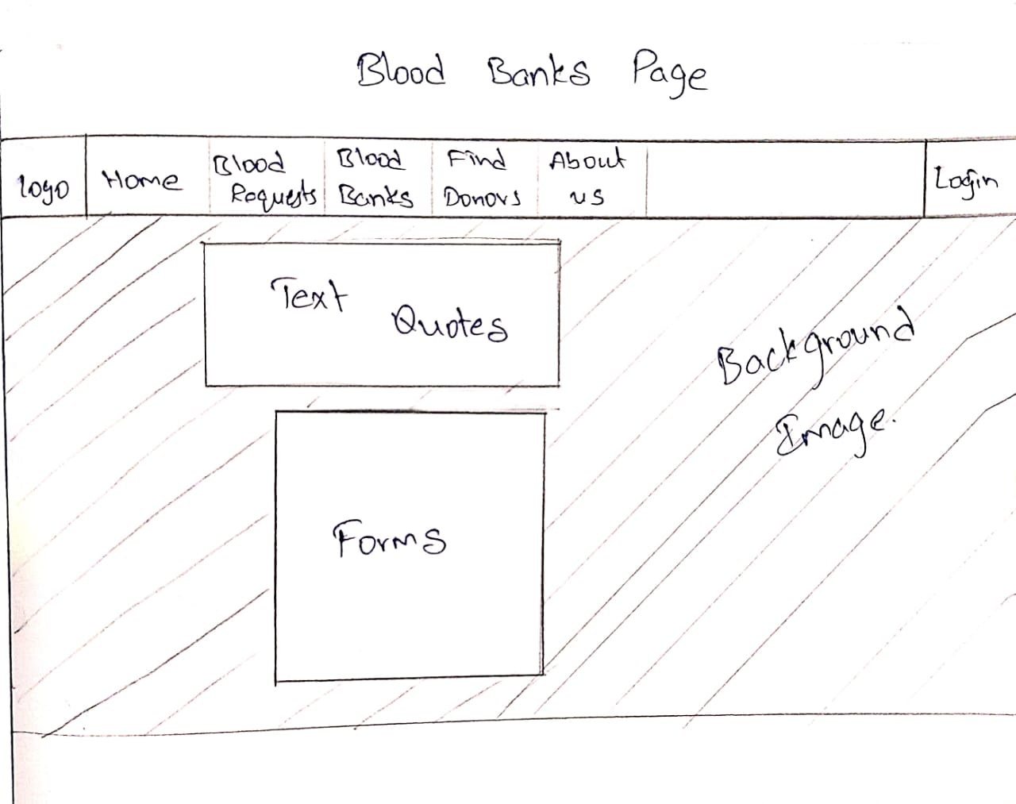

Find Donor page:

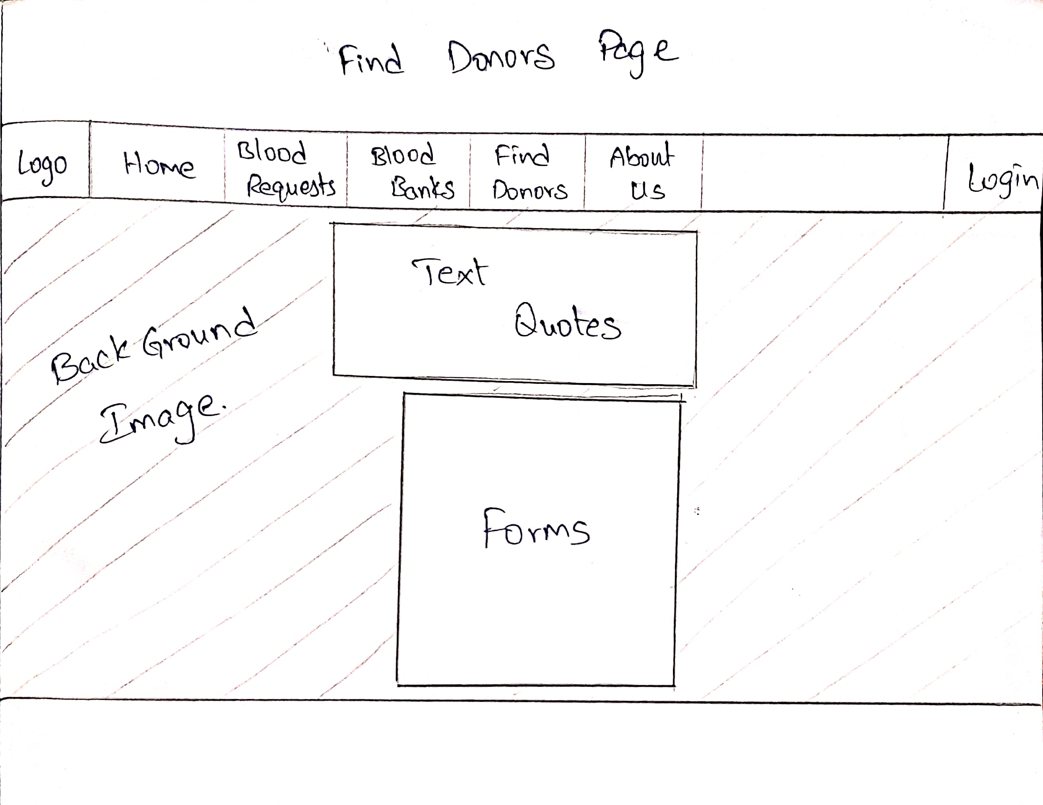

About and Contact page:

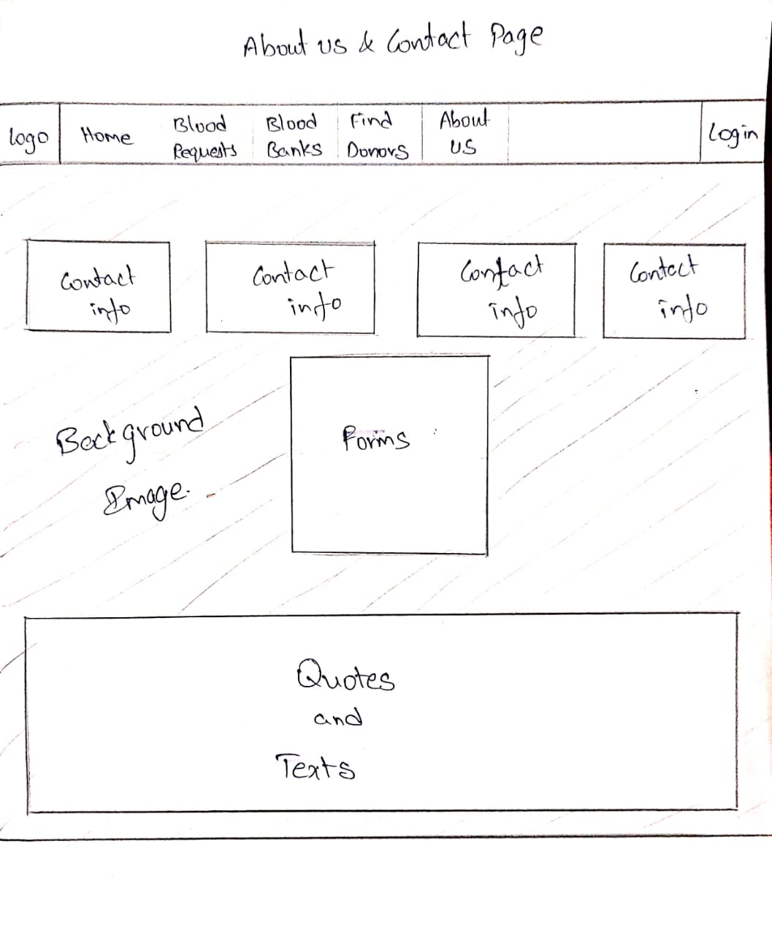

2.3 **Link to the developer’s website**

This is your personal website and should have your resume designed well