**Frontend Documents**

The general work description will be elaborated through the following points:

1. UI design 2.Code writing 3.Late-stage adjustment

# Overview of the project

This project is a web-based chatbot designed to be a supporting tool for the AI in Society course at Technical University of Munich (TUM). It provides users with easy-to-access information and an interactive experience through a navigation bar, a search box, an Frequently asked questions (FAQ) function, and a live chat window.

# Overview of the project

## 2.1 Project Structure

The following are the main structure of the frontend sections of this project and their functions:

**①HTML file**

1. This file contains the main structure of the project, which defines the navigation bar, Hero section, FAQ section, Chat window and Footer section.

2. External CSS and JavaScript files are used to implement styles and dynamic interactions.

**②CSS file**

1. Manage colors based on the TUM official website color(such as tum-blue，tum-light-blue).
2. Provides responsive design to adapt to the screen size adapt to different devices.
3. Defines the styles of components such as navigation bar, FAQ section, chat window, etc.

**③JavaScript file**

1. Responsible for implementing dynamic functions, including search box, FAQ section, and chat window.

**④UI design file**

1. Contains interface design drafts, and the main design inspiration refers to the design style of TUM official website.

## 2.2 Main functions

**①Navigation bar**

1. Fixed at the top of the page to facilitate users to quickly navigate to related resource links.

**②Hero section**

1. Display the title and search box of the course assistant.

2. Users can ask questions by keyboard input or voice search.

**③FAQ section**

1. Contains a list of frequently asked questions. Clicking on a question can trigger a chat window to display detailed information.

**④Chat function**

1. The chat window is hidden by default and appears after user interaction.

2. Simulates the sending, receiving and "typing" indicators of messages.

3. Supports voice recognition, converts voice to text and performs searches.

**⑤Footer**

The footer of the image includes:

1. Logo and Contact: TUM logo, address (Arcisstraße 21, 80333 München), phone (+49 (0)89-289-01), and fax (+49 (0)89-289-22000).
2. Tagline: "Let's shape the future together" with a link to "Support us."
3. Study Coordinator: Enkeleda Thaqi (Email: [ais@sot.tum.de](mailto:ais@sot.tum.de)).
4. Schools: Lists TUM's schools, including Engineering, Natural Sciences, Life Sciences, and Management.
5. Quicklinks: Navigation to TUM services like TUMonline, IT Services, Calendar, MyTUM, and Library.
6. Partners: Includes companies like Airbus, BMW, Google, Huawei, and Siemens.
7. Additional Links: Jobs, Feedback, Privacy Policy, Legal Notice, etc.
8. Social Media: Icons for Instagram, LinkedIn, Twitter, Facebook, YouTube, and RSS feeds.

It’s a well-structured, professional layout showcasing essential contacts, schools, partners, and links.

**⑥Responsive design**

1. Page components (such as navigation bars and chat windows) adapt to different screen sizes to ensure a good experience on mobile devices.

**⑦Animation and interaction**

1. Provide hover effects (such as enlargement of FAQ items) and button click feedback.

## 2.3 Development process

### 2.3.1 UI design process

Druing the desgin process,firstly,we use the tum official website as referance,use the school's signature blue color was used as the theme color, with different contrasting shades of blue used as the background color for different sections.

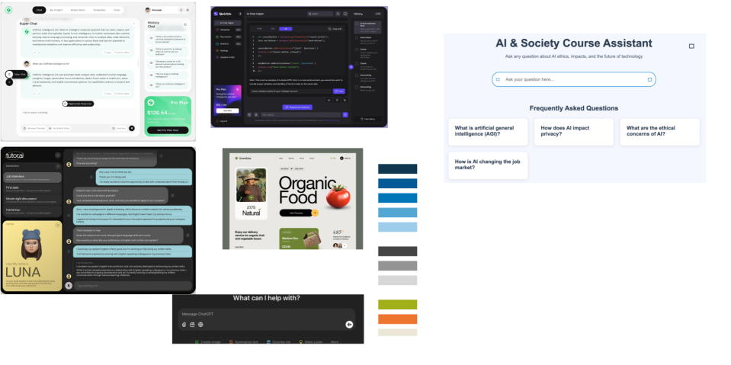

Figure 1 UI example

Meanwhile, regarding the design of the chat window, there were two options in the beginning, the first one was a pop-up chat window ,and the next one was embedded.

In the end, we chose the embedded design solution because it makes the whole system look more like a whole.

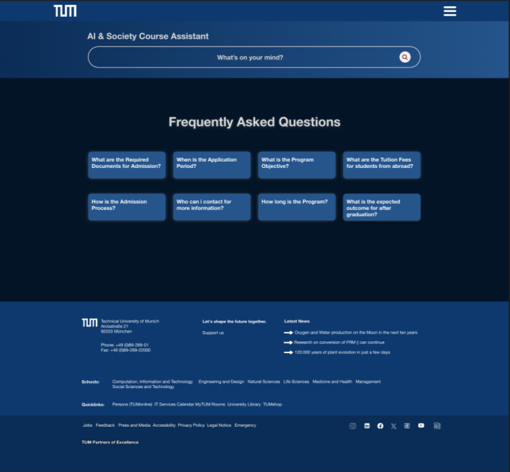

Figure 2 UI design draft

Regarding the design of the menu button, we chose a burger menu instead of displaying all the contents of the catalog horizontally on the main page of the website navigation bar, because this way of designing will make the whole interface more beautiful and concise.

### **2.3.2 Code writing**

The code section was first distinguished into four parts to be written,like the he navigation bar, Hero section, FAQ section and Footer section，then assign each part to a different team member.