StudentManagementSystem
Program:
import java.util.ArrayList;
import java.util.Scanner;
class Student {
String id;
String name;
int age;
String course;
// Constructor to initialize a student object
Student(String id, String name, int age, String course) {
this.id = id;
this.name = name;
this.age = age;
this.course = course;
}
// Display method
void display() {
System.out.println("--------------------------------");
System.out.println("ID : " + id);
System.out.println("Name : " + name);
System.out.println("Age : " + age);
System.out.println("Course : " + course);
}
}
public class StudentManagementSystem {
static ArrayList<Student> students = new ArrayList<>();
static Scanner sc = new Scanner(System.in);
public static void main(String[] args) {
while (true) {
System.out.println("\n===== STUDENT MANAGEMENT SYSTEM =====");
System.out.println("1. Add Student");
System.out.println("2. View Students");
System.out.println("3. Update Student");
System.out.println("4. search student by ID");
System.out.println("5. Delete Student");
System.out.println("6. Exit");
System.out.print("Enter your choice: ");
int choice = sc.nextInt();// For read user choice
sc.nextLine();
switch (choice) {
case 1:
addStudent();
break;
case 2:
viewStudents();
break;
case 3:
updateStudent();
break;
case 4:
searchStudent();
break;
case 5:
deleteStudent();
break;
case 6:
System.out.println("Exiting Program...");
return;
default:
System.out.println("Invalid Choice!");
}
}
}
// ADD
static void addStudent() {
System.out.print("Enter ID: ");
String id = sc.nextLine();
System.out.print("Enter Name: ");
String name = sc.nextLine();
System.out.print("Enter Age: ");
int age = sc.nextInt();
sc.nextLine();
System.out.print("Enter Course: ");
String course = sc.nextLine();
students.add(new Student(id, name, age, course));
System.out.println("Student Added Successfully!");
}
// VIEW
static void viewStudents() {
if (students.isEmpty()) {
System.out.println("No Students Found.");
return;
}
for (Student s : students) {
s.display();
}
}
// UPDATE
static void updateStudent() {
System.out.print("Enter ID to update: ");
String id = sc.nextLine();
for (Student s : students) {
if (s.id.equals(id)) {
System.out.print("Enter New Name: ");
s.name = sc.nextLine();
System.out.print("Enter New Age: ");
s.age = sc.nextInt();
sc.nextLine();
System.out.print("Enter New Course: ");
s.course = sc.nextLine();
System.out.println("Student Updated Successfully!");
return;
}
}
System.out.println("Student Not Found!");
}
// SEARCH BY ID
static void searchStudent() {
if (students.isEmpty()) {
System.out.println("No Students Available.");
return;
}
System.out.print("Enter ID to search: ");
String id = sc.nextLine();
boolean found = false;
for (Student s : students) {
if (s.id.equals(id)) {
System.out.println("Student Found:");
s.display();
found = true;
break;
}
}
if (!found) {
System.out.println("Student Not Found!");
}
}
//DELETE
static void deleteStudent() {
System.out.print("Enter ID to delete: ");
String id = sc.nextLine();
for (int i = 0; i < students.size(); i++) {
if (students.get(i).id.equals(id)) {
students.remove(i);
System.out.println("Student Deleted Successfully!");
return;
}
}
System.out.println("Student Not Found!");
}
}
Output:
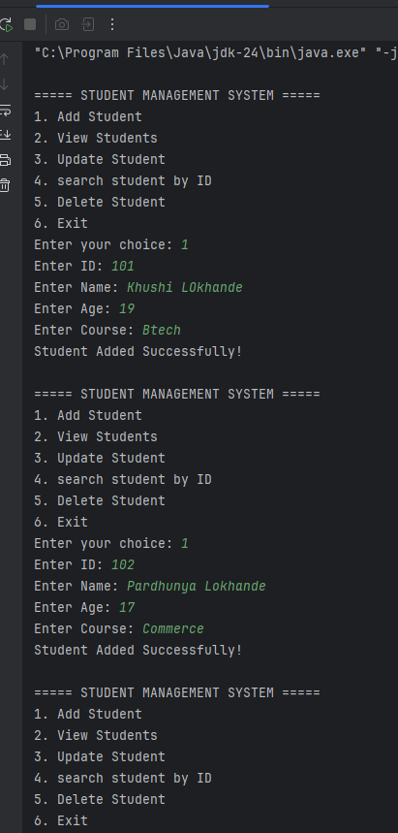
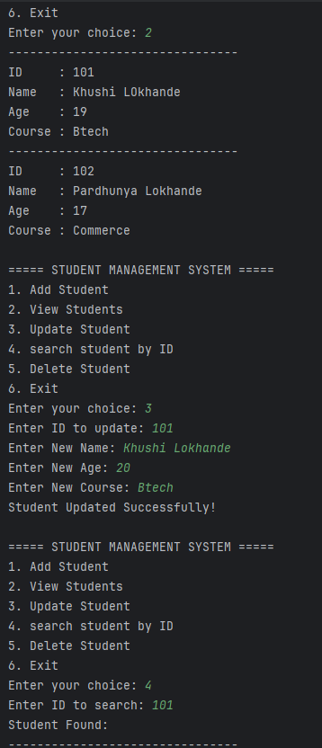

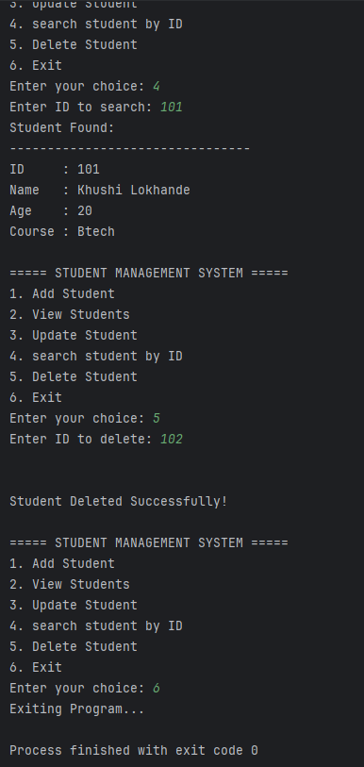

Short Explanation:
In this task, I developed a Console-Based Student Management System using Java. The main purpose of this project is to manage student records efficiently using Object-Oriented Programming concepts.
I created a Student class containing attributes such as ID, name, age, and course. The program uses an ArrayList to store multiple student objects dynamically.
The system provides the following functionalities:
- Add a new student
- View all students
- Update student details using ID
- Search for a student by ID
- Delete a student record
The application is menu-driven and runs continuously using a while loop until the user selects the exit option.
This task helped me understand the practical implementation of OOP concepts, ArrayList, loops, conditional statements, and CRUD operations in Java.

