# Created by: Khuteja B | Email: khutejab3@gmail.com

# JS Mart Sales Dashboard

An interactive Power BI dashboard designed to analyse sales performance, profit trends, and regional insights for IS Mart, using data visualization and advanced analytical techniques.

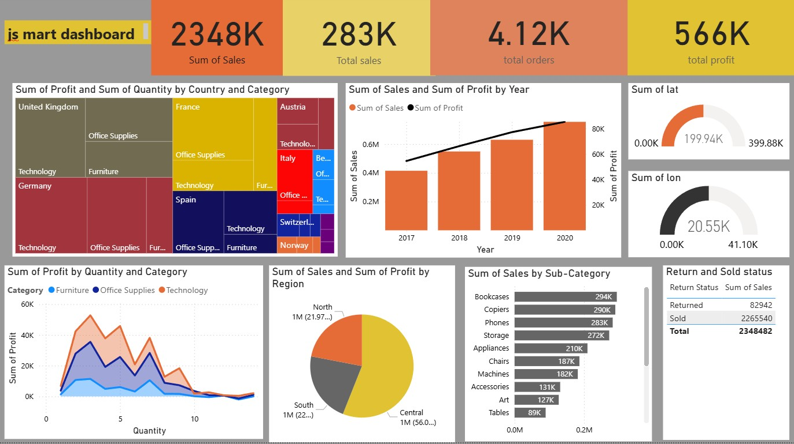

# Project Overview

Objective: To analyse and visualize JS Mart’s sales performance and profitability across years, regions, and categories. Goal: Provide management with clear insights on sales growth, profit trends, and product performance to support data-driven decisions.

# Insights & Analysis

• Sales and profit increased consistently from 2017 to 2020 . • Central region contributed the highest to total sales and profit. • Technology and Office Supplies are top-performing categories

• Bookcases, Copiers, and Phones lead in sub-category sales. • Low return rate (~3.5%) indicates strong customer satisfaction.

# Tools & Techniques

• Tools Used: Power BI, DAX, Power Query, Data Modelling, MS Excel

Techniques Applied: - Power Query for data cleaning and transformation - DAX for calculated measures (Total Profit, Sales Growth) - Visualizations: Bar Chart, Tree

Map, Pie Chart, Line Chart, Gauge, Table

# Business Impact & Skills Highlight

• Outcome: Improved understanding of sales trends and category performance, helping stakeholders make strategic decisions. • Skills Highlight: Power BI | DAX |

Power Query | Data Modelling | Advanced Excel | Data Visualization | Business

Analysis