# Business Analyst Portfolio - Sales Dashboard

Power BI Project: SULTHAN SALES Dashboard

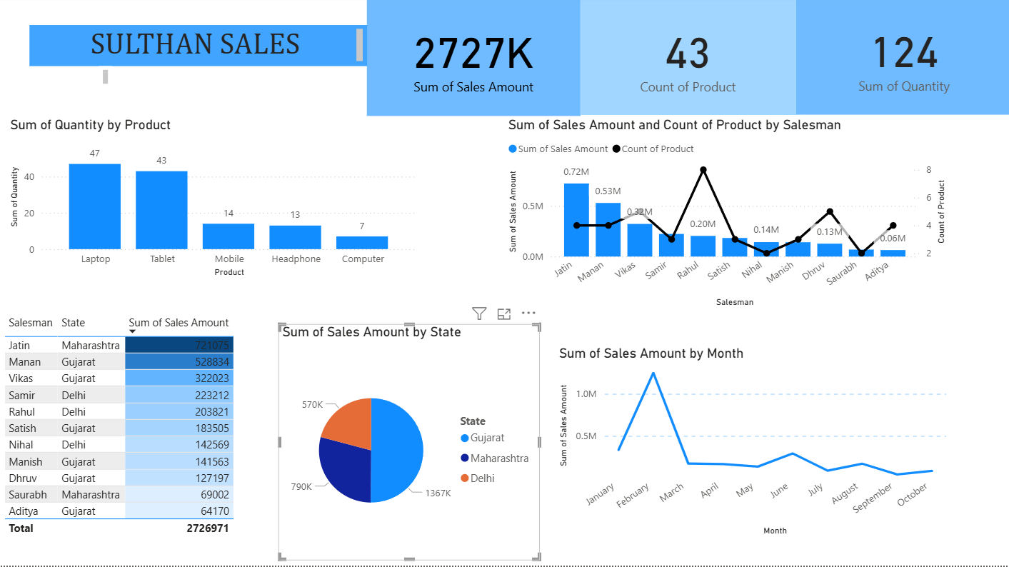

# 📊 Project Overview

* Developed an interactive Power BI dashboard to analyze sales performance of SULTHAN SALES.
* Key metrics visualized: Total Sales Amount, Quantity Sold, and Product Count.
* Analyzed top-performing Salesmen, States, and Product categories.
* Created monthly trend charts and comparative insights using bar and line visuals.
* Tools used: Microsoft Power BI, Excel (Data Cleaning & Preprocessing).

# 💡 Key Insights & Findings

* Total Sales Amount: ₹2.7M+ with 43 Products sold.
* Jatin (Maharashtra) recorded the highest sales (₹721K).
* Gujarat contributed the highest regional sales (₹1.36M).
* Laptops and Tablets were the most sold products.
* Peak sales observed during March indicating seasonal trends.

# 🎯 Conclusion & Impact

* Enabled management to track real-time sales performance.
* Helped identify top-performing products and salespeople.
* Provided actionable insights for regional sales planning.
* Enhanced decision-making using data-driven visuals.

# 📞 Contact Information

Name: Khuteja B

Email: khutejab3@gmail.com

Project Tools: Power BI, Excel

Role: Business Analyst (Project-based)