**The Development of Cardinal Extension: From Counting to Exact Equality**

**Supplemental Material**

**Experiment 1.**

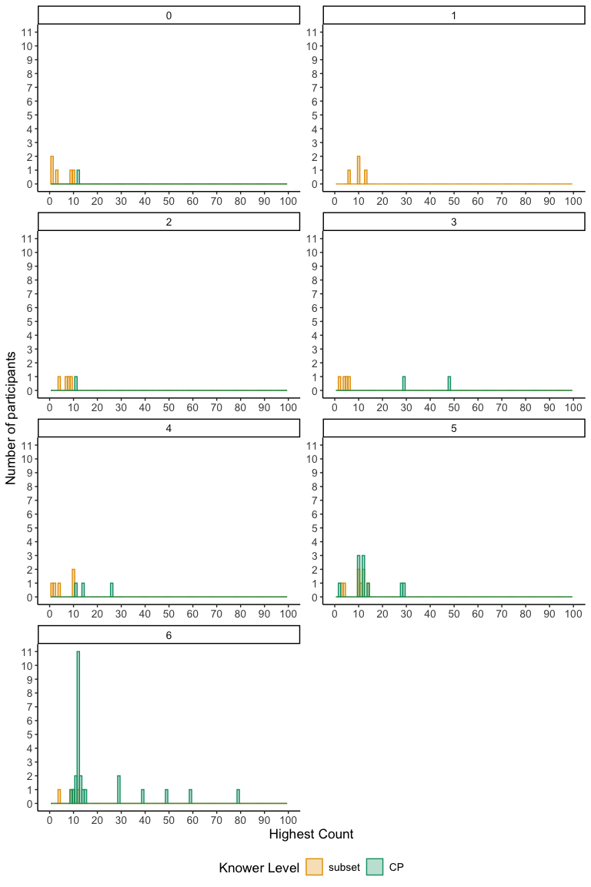

Figure S1: Experiment 1: Histogram of participants’ performance in the Highest Count task, faceted by number of trials correct on the Correct Set Choice measure.

**Experiment 2.**

Figure S2: Experiment 2: Histogram of participants’ performance in the Highest Count task, faceted by number of trials correct on the Correct Set Choice measure.