Bài 1
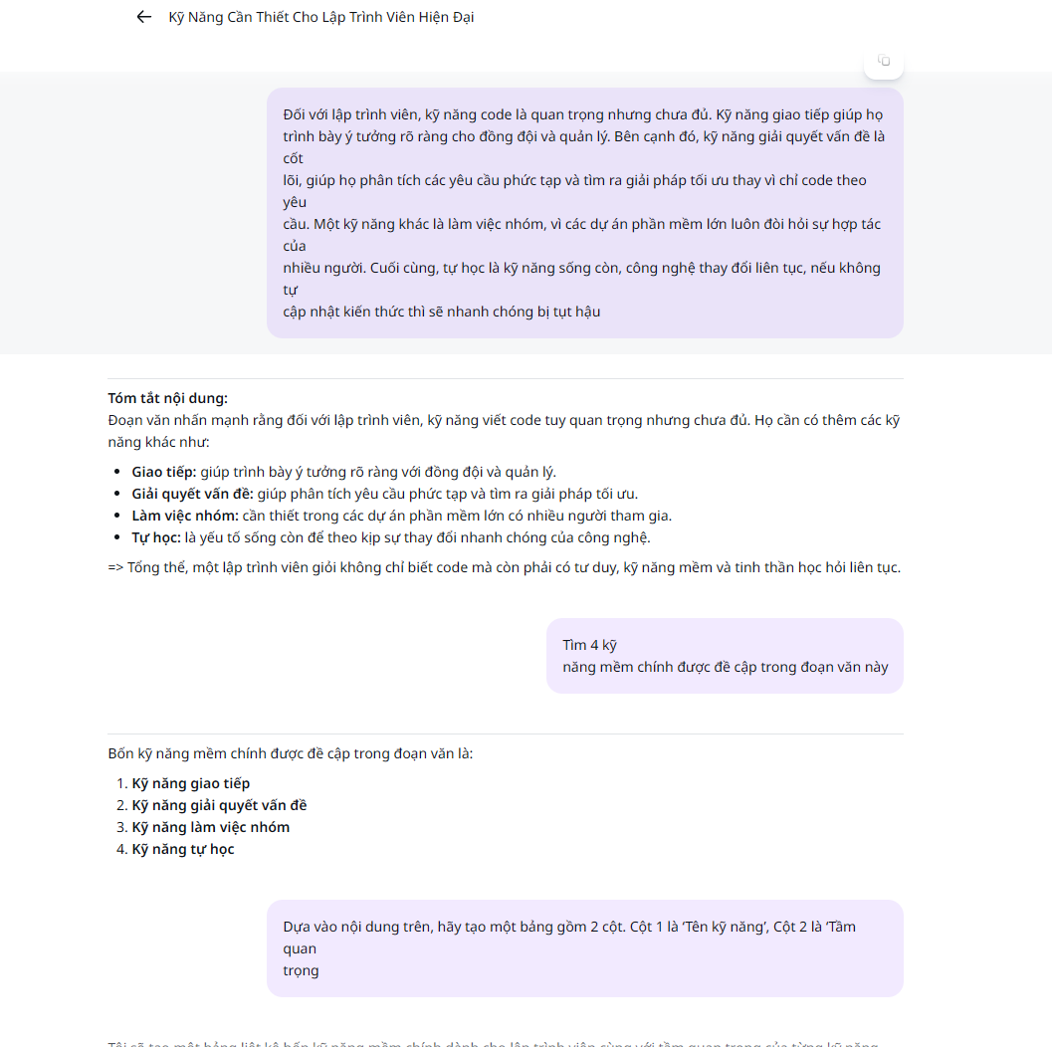
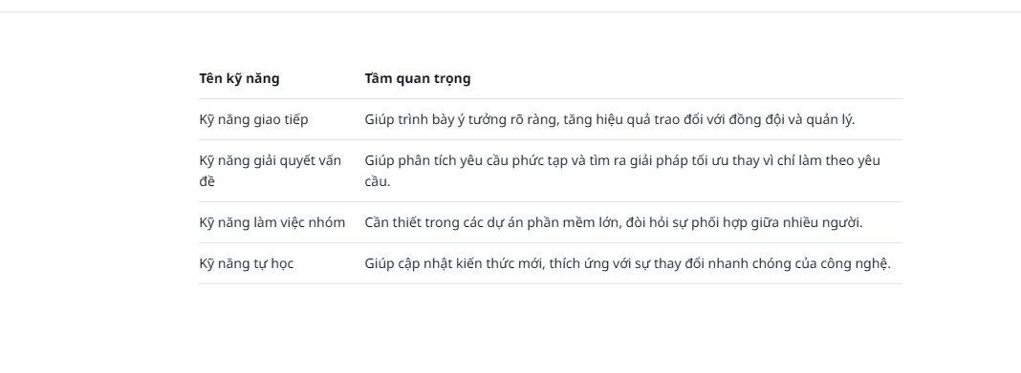
Bài 2

Bài 3
https://gamma.app/docs/Deepfake-Cong-Nghe-Thuc-Hay-Ao-wm68ahxl4bifm4m?mode=present#card-3ks8mh324ta561d

