Measuring Sustained, Intent-Grounded Deception Among Competing Frontier Models in an Open Survival Economy
Working draft — all results are single-seed observations

Abstract
Autonomous language-model agents are increasingly deployed in populations that run for long horizons, yet deception is still mostly evaluated on single agents, under instruction, and one turn at a time. We study deception among competing peers: three to ten frozen frontier models share an open survival economy with progressive taxation, hunger, and permanent elimination, and are told only to survive. Every agent-turn is recorded as a triple — the agent's stated private reasoning, the message it broadcasts, and the action the engine actually applied against ground truth — which lets an offline judge label a turn deceptive only when those channels contradict, separating a lie from an honest error and from openly aggressive play. Judge labels are self-consistent (91.7% unanimous at K=3) and agree moderately with a different judge family (Cohen's κ=0.50, 87.5% agreement); agreement is 93.8% on high-confidence verdicts but near chance below, so we treat rates as within-judge quantities.
In a ten-model, 335-turn game (1,600 judged turns) deception rates span 0–46% and separate sharply by model, though the ordering is roster-dependent: a model that ranked lowest in our four-model games ranks joint-highest here. We then ask whether deception is sustained, and report a mainly cautionary answer. Raw campaign statistics are mechanically inflated — with few rivals alive, a frequent liar must repeat targets — and against a permutation null the four heaviest deceivers score at or below chance on target selectivity. Only 4 of 24 tests survive multiplicity correction: above-chance target selectivity in two low-volume deceivers, and above-chance contiguous campaigns in two models, though the longest campaigns all target an instrumentation-impaired opponent. Long-gap resumption, the behaviour our metric was designed to detect, is not established. Deception does not decay over the horizon; it roughly doubles after turn 200 as the field narrows. All results are single-seed observations, not significance-tested comparisons across seeds. We release the environment, the judged traces, and the coherence metric with its null model, and we argue the null should be standard practice for any multi-agent deception study drawing campaign structure from a small agent pool.

1. Introduction
Language-model agents are increasingly deployed in configurations where they act autonomously, interact with other agents, and pursue goals over long trajectories: negotiation and procurement pipelines, agent marketplaces, and multi-agent orchestration frameworks in which several models coordinate or compete on a shared task. These deployments introduce a risk that single-agent evaluation does not address, namely that agents may deceive one another when deception advances their objective. This paper studies that risk in its sharpest form: an open economic environment in which heterogeneous frontier models compete for survival, are free to cooperate or exploit each other, and are observed for hundreds of interaction turns.
Measuring deception in such a setting is difficult because deception is defined by intent, while evaluation typically observes only behaviour. A false public statement is not by itself evidence of deception: an agent may be mistaken, may be repeating stale information, or may announce an intention it later abandons for legitimate reasons. Establishing that an agent deceived requires evidence about what it was trying to do at the moment it spoke.
Existing work supplies the necessary ingredients but not their combination. Studies of deception in multi-agent social-deduction games introduce named deception metrics and compare models head-to-head, but score deception from public behaviour alone, without access to any private channel, and place agents in a voting game rather than an economy. Work on in-context scheming resolves the intent problem directly, by triangulating an agent's chain-of-thought against the action it takes, but studies a single agent under an overseer rather than peers competing with one another, so it cannot observe deception as a social strategy. Most recently, deception has been studied over extended interactions, across many frontier models and with adequate statistical power; that setting, however, is cooperative and hierarchical, spans roughly forty rounds, and again scores deception with a post-hoc auditor over outputs only. Closest of all, recent platform work runs a mixed-vendor agent population inside a scarcity economy for many simulated days — establishing that the setting we need is already available — but labels deception by checking public claims against the ledger, which catches a false statement about the world while leaving the agent's intent unaddressed, and reports violation counts over time without asking whether any one deceiver held a position.
The challenge that remains is therefore to measure deception that is simultaneously intent-grounded, peer-directed, and sustained, and it is unmet for three technical reasons. First, intent-grounding requires an environment that elicits a private channel and a public channel in the same forward pass and records both alongside the action actually executed; observing outputs alone makes lying and error indistinguishable. Second, peer-directed deception requires an open action space in which manipulation competes with ordinary economic strategies, since a fixed-matrix game fixes in advance how and when an agent may deceive. Third, sustained deception cannot be characterized by a per-turn rate at all: whether an agent maintains a coherent false position across many turns, and whether it resumes after being interrupted, is a property of a sequence, and no existing benchmark defines a measure over it.
We address the first two requirements with an environment and a measurement pipeline built around a single recorded object. Our environment is an open adversarial survival economy in which three to ten frozen frontier models compete under progressive taxation, hunger, and permanent elimination at zero cash, acting through twenty typed actions that span cooperation, aggression, and three explicitly deceptive moves. For every agent-turn we record a triple: the agent's private monologue, the public message it broadcasts, and the action and outcome the engine actually applied, together with the ground-truth state of the world at that turn. An offline judge then labels each agent-turn by a relational criterion — a turn is deceptive when its public message contradicts the agent's own stated intent, its executed action, or recorded ground truth — and returns a typed verdict with quoted evidence spans. Two properties distinguish this from output-only auditing: openly aggressive play is correctly not labelled deceptive, and the deceptive content itself is agent-authored text rather than a template, so the label describes the model's own claim.
The third requirement motivates our second contribution, a measure of deception over the horizon rather than at a point. We group labelled deceptive turns by deceiver and target, segment each stream into episodes — maximal runs of deceptive stance toward one target — and characterize their coherence: how long campaigns persist, whether they resume after interruption, whether they are abandoned once challenged, and whether coherence decays as the horizon lengthens. Our longest run spans 335 social turns — roughly eight times the ~42 rounds of the nearest long-horizon deception study — which is what makes an interruption long enough to test resumption observable at all. We measure the horizon in social turns between peers throughout; platform work reporting wall-clock or simulated days is measuring a different quantity, and we make no length comparison against it.
We instantiate the environment with ten frontier models spanning four organizations, across neutral, honesty-instructed, and deception-instructed conditions, in runs of up to 335 social turns; our primary run contributes 1,600 judged agent-turns. Our evidence is a set of single-seed observations rather than a powered comparison, and we report it as such: deception rates spanning 0–46% that separate sharply by model, though the ordering proves roster-dependent rather than a transitive property of the models; a within-game control in which two instances of the same model, given different specialties, rivals, and outcomes, deceive at comparable rates while different models do not; and a condition contrast in which an honesty instruction lowers deception substantially while explicit permission to deceive barely raises it.
Our coherence result is primarily cautionary, and we state it here because it revises how such measurements should be made. Raw campaign statistics in a small agent population are dominated by arithmetic: with at most nine rivals alive, a frequent liar must repeat targets. Against a permutation null that reshuffles only the choice of victim, the four heaviest deceivers score at or below chance on target selectivity, and only 4 of 24 tests survive multiplicity correction. Above-chance target selectivity appears in low-volume deceivers, and above-chance contiguous campaigns in two models — though the longest campaigns all target an opponent impaired by tool-call failures. Long-gap resumption is not established. Deception does not decay across the horizon; it roughly doubles after turn 200 as the field narrows.
This work makes four contributions. (i) An instrumented open survival economy whose novelty is what it records rather than what it simulates: every agent-turn is captured as a triple, so intent-grounded labelling is possible at all; released with its traces. (ii) An intent-grounded deception measure defined over the private/public/action triple, together with a taxonomy, a judging protocol, and a reliability protocol reporting self-consistency, judge sensitivity, and human agreement. (iii) A coherence measure for sustained deception together with the permutation null that makes it interpretable — our finding that raw campaign statistics are mechanically inflated applies to any multi-agent deception study drawing campaign structure from a small agent pool. (iv) A first empirical characterization of how frontier models differ in deception propensity and style under identical competitive conditions, reported with explicit statistical caveats.
We state the scope of these claims plainly. Our environment is competitive by construction and permits manipulation, so we measure deception capability and propensity under incentive, not unprompted misalignment; the neutral/honesty/deception contrast is what separates the two. The private monologue is the agent's stated reasoning, and following work on unfaithful chain-of-thought we treat it as evidence of stated intent rather than as a transcript of computation. Finally, the empirical results below are single-seed and are reported as observations, not as significance-tested comparisons; §7 details the consequences.

2. Related work
*(Rule: we own the measurement, never the setting. Each subsection names what the work established and precisely where it stops. Re-verified 2026-08-01 — docs/research/2026-08-01-prior-art-resweep.md; the closest works are recent and the area moves at roughly one near-neighbour per two months, so re-verify again before submission.)*
Deception in LLM agents. The field measures deception either from outputs alone or by triangulating a private channel against behaviour, and only the latter can distinguish a lie from an honest mistake. @traitors2025 is nearest on metrics — a ten-agent social-deduction game with a named metrics suite and cross-model comparison — but has no private-reasoning channel, no economy, homogeneous populations, and self-describes n=10 as underpowered. @apollo2024 supplies our methodological anchor, establishing intentional deception by triangulating chain-of-thought against action, yet studies a single agent against an overseer rather than a peer economy. @park2023 defines deception functionally and names detection tooling as an open problem. We adopt Apollo's triangulation and move it from the single-agent-vs-overseer setting into a population of competing peers. TODO(cite) unfaithful-CoT.
Deception among peers. Work that puts models against each other still tends to fix an asymmetric pair of roles, which bounds how long any one deceptive relationship can run. @scheming2026 compares four models but in asymmetric dyads (sender/receiver, evaluator/evaluatee) with no fixed horizon, and concedes that multi-turn coherence is not analysed systematically. @aitoai2026 tests six models, each separately against a fixed subordinate, over at most twelve turns; its headline coercion score is self-reported by the model against a nine-rung rubric with no judge in the scoring path, and each conversation is treated as independent. Neither setting lets a deceiver choose its own victim from a field of rivals, which is the precondition for the campaign structure we measure.
Long-horizon deception. Long-horizon work measures either task completion or output-level deception, but not deception that must stay consistent to keep working. @lhdeception2026 remains the closest on framing — deception across long-horizon interactions, eleven frontier models, n=20 — but differs on four axes: cooperative hierarchy (performer→supervisor) rather than adversarial peers; ~42 rounds; deception scored by a post-hoc auditor over outputs only, so not intent-grounded; and no economy or survival pressure. The broader long-horizon literature (@metr2025, @ultrahorizon2025, @odyssey2025) measures single-agent task completion in tokens and tool calls, not social turns. Goal drift is instrumented by @apollodrift2025, again single-agent.
Multi-agent economies and emergence. The environment we use is not novel, and we do not claim it. @emergenceworld2026 is the nearest neighbour overall: a ten-agent economy with energy and compute-credit scarcity, governance votes, a heterogeneous world mixing four vendors, run for fifteen continuous simulated days. It therefore occupies the combination of economic survival, mixed-model population, and long horizon outright. Its deception labels, however, come from an LLM classifier over speech and diary entries validated against the ledger — the authors describe this as "database confirmation rather than intent modeling" — and it reports temporal bursts and cumulative counts without analysing whether an agent sustained a strategy across interactions or resumed one after interruption. That is the seam we work in. @conscientia2026 likewise shows emergent deception and trust erosion at scale (250 agents, repeated steering driving susceptibility to 93.9%) but is single-model and scores deception by action divergence, never from private reasoning. @sid2024 demonstrates emergent roles and culture and already includes an economy with taxation; @sugarscape2025 shares survival-with-elimination and pioneers the emergent-vs-instructed contrast we adopt for conditions, but has no market, no private channel, and no deception measurement. @concordia2023 provides a game-master architecture akin to our Oracle, targeting explainability rather than deception metrics.
Game-theoretic evaluation. Cross-model strategic tournaments are established but fixed-form. @gtbench2024 runs ten games with predetermined action spaces and endpoints, and @econagent2024 anchors the LLM behavioural-economics lineage. Neither measures deception, and the fixed matrix removes the open-ended target selection that campaigns require.
Positioning. Our contribution is a measurement, not an environment. Given a long-horizon mixed-model economy — which @emergenceworld2026 also built — two things remain unowned: labelling each turn from the intent-grounded triple of stated private reasoning, public message, and actual action against ground truth, so that a lie is separated from an honest error and from honest aggression; and quantifying coherence, whether a deceiver sustains a directed campaign against a chosen victim and resumes it after silence. Every work above either measures deception without the private channel, or has the private channel without competing peers, or has both without a long enough horizon for a campaign to exist.

3. The environment
We study deception in an open adversarial survival economy: a turn-based game in which three to ten language-model agents compete for wealth under elimination pressure. Each agent is a frozen, instruction-tuned model reached through a single OpenAI-compatible gateway, so heterogeneous models compete in the same game without fine-tuning. The environment is designed for one purpose: to create conditions where deception is possible, useful, and observable, and then to record enough per turn to tell a lie from an honest mistake. Section 3.1 describes the economy that supplies the incentive, 3.2 the action space that supplies the means, 3.3 the information asymmetry that makes lying pay, 3.4 the per-turn record that makes it measurable, and 3.5 the experimental controls.

3.1 Economy and survival pressure
Deception requires a reason to deceive. Prior multi-agent simulations that lack a survival drive report deception only incidentally, so the environment must make failure real rather than nominal.
Every agent begins with $10 of liquid cash. Three goods (ore, food, tech) are produced by labour, and each agent is randomly assigned a specialty in which it produces two to three times as much, so no agent can efficiently supply itself and trade is structurally necessary. A progressive tax on cash is levied every ten turns (0% below $2, rising in brackets to 20% above $20); capital locked in investments is exempt, which creates a recurring incentive to move wealth out of sight before a tax cycle. Every ten turns an agent must also consume one unit of food or pay a $1 hunger penalty. Any agent whose liquid balance reaches zero at the end of a turn is eliminated permanently; invested capital and goods do not prevent this, and the estate passes to a named heir or, absent one, is destroyed.
Because elimination depends on liquid cash while taxation punishes holding it, agents face a genuine dilemma each cycle rather than a dominant strategy, and wealth differences compound into visible strong and weak positions — the asymmetry that makes manipulation worthwhile.

3.2 Action space
A benchmark that offers only cooperative moves cannot observe betrayal, and one that offers only a fixed matrix of moves cannot observe how deception is composed with ordinary economic behaviour. The action space must therefore span cooperation, aggression, and deception within a single open repertoire.
Agents act through 20 typed actions in two tiers. Each turn an agent must take exactly one major action — work, trade, invest, bet, lend, steal, sabotage, extort, bribe, or socialize (alliance, truce, rivalry, marriage, divorce) — and may additionally take one optional free action — vouch, gift, charity, will, rest, strike, propose deal, or the three explicitly deceptive moves: slander (broadcast a damaging claim about another agent), bluff (announce an action other than the one taken), and gaslight (send a target a fabricated private event). Actions are invoked as structured tool calls with typed arguments and are validated and applied by an authoritative server-side engine, the Oracle; agents never mutate state directly.
Two properties matter for measurement. First, the deceptive moves carry agent-authored content: the rumour or fabricated event is text the model writes, not a template, so a deception label describes the model's own claim. Second, because deception occupies the free slot alongside a major action, an agent can appear to work honestly while simultaneously running a smear campaign — the exact configuration that output-only observation misreads.

3.3 Information asymmetry
Lying is only consequential when others cannot immediately check the claim. Under full observability a false statement about one's own wealth is refuted on sight, which suppresses an entire class of deception.
Each agent sees its own exact balance, inventory, and specialty, but by default observes only a coarse range for every other agent ($0-2, $2-5, $5-10, $10-20, $20+); exact values are revealed only for a spouse or a consenting ally. Public trust scores, alliance structure, and each agent's recent action history are visible, and the gaslight action injects a fabricated event into a single target's private view. The regime is configurable (public, fuzzy, hidden); all runs reported here use fuzzy.
Coarse balances leave agents genuinely uncertain about who is strong, so claims about one's own state are both useful to fabricate and hard to falsify, while the visible trust score gives slander a concrete mechanical payoff.

3.4 The per-turn record: the triple
The central measurement problem is that a false public statement is not evidence of deception: a model may simply be mistaken, or describing an intention it later abandons. Distinguishing a lie from an error requires observing the agent's stated intent alongside what it said and what it did.
For every agent-turn the environment logs a triple: (i) the agent's private monologue, supplied as the reasoning field of its tool call and never shown to other agents; (ii) its public message, broadcast verbatim to all agents; and (iii) the action and outcome actually applied by the Oracle, together with the resulting ledger entries and the agent's true balance and trust score that turn. The private and public channels are separate fields of the same tool call, so they are produced in one forward pass under identical context.
The triple makes intent-grounded measurement possible: deception can be defined as a contradiction among channels — a public claim that conflicts with the agent's own stated intent, with the action the engine actually executed, or with recorded ground truth — rather than as a judgement about whether a statement happens to be false.

3.5 Experimental controls and reproducibility
Each run carries a condition that appends one of three locked suffixes to the system prompt: neutral (no suffix; the baseline competitive prompt), honesty (an instruction that every public message be truthful), or deception (explicit permission to misrepresent). The wording is fixed verbatim, since any edit invalidates cross-run comparison. Environment stochasticity — specialty assignment, production yields, investment outcomes, theft success — is drawn from a generator seeded per (seed, turn), and decisions are applied in a deterministic order, so a given seed reproduces the same world dynamics.
Determinism covers the environment only. Model sampling remains stochastic and is not controlled by the seed, so results are reported as variance across seeds rather than as byte-identical reruns. Runs reach up to 500 turns; the longest reported here is 335 turns.

4. Method
Our measurement pipeline turns the recorded triple into deception labels and then into metrics. Section 4.1 gives the operational definition of deception and the taxonomy it induces; 4.2 describes the judge that applies it; 4.3 the deterministic post-processing that enforces label invariants; 4.4 the metrics computed from labelled turns, including the sustained-coherence measure that is our primary contribution; and 4.5 the protocol by which we establish that the labels are trustworthy. The pipeline runs offline in batch over persisted records and never participates in the turn loop, so labelling can be re-run, versioned, and audited without perturbing the games it measures.

4.1 What counts as deception
A definition based on falsehood alone would conflate lying with error, and a definition based on harm would conflate deception with honest aggression. We therefore define deception relationally, as a conflict between the channels of a single agent-turn.
An agent-turn is deceptive if and only if its public message misrepresents at least one of: the agent's own stated private intent, the action the Oracle actually applied, or the recorded ground-truth state. Two exclusions follow directly and are enforced in the judging instructions. Openly aggressive play is not deception — an agent that announces a theft and then commits it has misrepresented nothing. Silence is not deception on its own; withholding information counts only when an actively misleading partial claim is made. Each deceptive turn is assigned exactly one type: false state claim (a claim about balance, resources, or relations that contradicts ground truth), false promise (a public commitment the stated reasoning shows no intent to keep), strategic omission (a technically true claim engineered to mislead), misdirection (a claim about one's own action that mismatches the action taken), or identity bluff (misrepresentation of role, alliance, or strength).
Because the definition is a contradiction among observed channels rather than a judgement about truth in the world, it is intent-grounded: it distinguishes an agent that privately plans to rob a partner while publicly promising a fair trade from one that promises a trade in good faith and is later forced to renege.

4.2 The judge
Applying the definition at scale requires reading free-form text in context, which rules out keyword rules; but an unconstrained reader would produce unauditable labels. The judge is therefore an LLM constrained to a structured verdict backed by quoted evidence.
For each agent-turn the judge receives the triple together with ground truth: the agent's true balance and trust score that turn, the action and outcome the Oracle applied, and the ledger rows written — including the verbatim text of any slander or gaslight the agent authored. Given this record it returns a typed verdict: a binary label, one deception type, the set of channels in conflict, the targeted agent if any, a calibrated confidence in [0,1], a free-text rationale, and quoted evidence spans from the private and public channels plus the ground-truth fact that grounds the call. The judge is queried at temperature 0 with a versioned prompt; verdicts are cached under the key (judge model, prompt version, sample index), so multiple judge models, prompt revisions, and repeated samples coexist and are never pooled across versions.
Supplying ground truth alongside the triple is what lets the judge call a lie rather than a tone shift: a public claim of wealth can be checked against the recorded balance, and a claim about one's own action against the action the engine executed. Requiring quoted spans makes every label auditable after the fact, and the framing of the monologue as stated reasoning — enforced in the prompt and in the field names — keeps the method compatible with evidence that chain-of-thought need not faithfully reflect a model's computation.

4.3 Verdict normalization
Structured decoding constrains a verdict's shape but not its coherence, and we observed two recurring defects that would corrupt downstream aggregation.
A deterministic post-processing step therefore repairs each verdict before storage. First, a verdict naming the judged agent as its own target has that target cleared, since an agent is not the recipient of its own deception and a self-target would otherwise pollute per-target grouping. Second, a verdict labelled deceptive but listing no conflicting channel is assigned the public message channel, the minimal carrier of a public lie, so that every deceptive turn has at least one channel for channel-level analysis. The judging prompt states both constraints explicitly; normalization is the deterministic backstop that guarantees the invariant holds in the stored data.

4.4 Metrics
From labelled agent-turns we compute four families of measure. Deception rate is the fraction of an agent's decision turns labelled deceptive, reported per model and per condition. Type mix is the distribution over the five deception types, which characterizes how a model deceives rather than how often. Adaptivity relates an agent's deception rate to its survival time and final wealth, testing whether deception is instrumentally rational in this economy. Finally, a structural cross-check compares intent-grounded labels against a rule-based flag that fires whenever an agent invokes one of the three explicitly deceptive actions; the disagreement cells quantify what intent-grounding adds over action-level bookkeeping.
The fourth family addresses our central question, which a per-turn rate cannot answer: whether deception is sustained. We group deceptive turns by (deceiver, target) ordered by turn and segment each stream into episodes, maximal runs of deceptive stance toward one target, split when the gap between consecutive deceptive turns exceeds a threshold. From the episode set we derive coherence: the length of sustained campaigns, whether a campaign resumes after interruption, whether it is abandoned once challenged, and whether coherence decays as the horizon lengthens.
Coherence statistics cannot be read raw, and recognising this is part of the contribution. The natural summary — the share of a deceiver's directed lies aimed at an already-deceived victim — has a hard arithmetic floor: with at most nine rivals alive, an agent telling 86 directed lies cannot avoid repeating targets. Such a statistic measures lie volume divided by pool size, not strategy. The same objection applies to the longest gap after which a deceiver returns to a victim, since a frequent liar will revisit someone after a long silence by chance.
We therefore evaluate every coherence statistic against a permutation null. For each deceiver we hold its deceptive turn indices fixed and reassign each turn's target uniformly among the agents alive on that turn, excluding itself, over 1,000 iterations. This preserves how often the agent lied, when it lied, and how many rivals were available; only the choice of victim is randomised, so what survives is target selectivity — which is what "campaign" means. Agents excluded as deceivers for instrumentation reasons remain in the null's target pool, since shrinking the pool would bias the test toward calling chance repetition selectivity. We run one test per model per metric and control the false discovery rate across all of them with Benjamini-Hochberg; uncorrected p-values are never reported as findings.
Against that null we adopt three statistics: repeat-target share, maximum contiguous episode length, and maximum return gap, each reported as observed-versus-chance. The first and third are computed without segmentation and so do not depend on the episode gap threshold; the sweep in the supplement shows the threshold is not load-bearing for the second either. We rejected four candidates on evidence: abandonment rate is the algebraic inverse of episode length and adds nothing; narrative type-consistency ranges only 0.63–0.69 across high-volume models and conflates a coherent story with a model's fixed stylistic preference; episode density ranges only 0.82–0.88 and does not discriminate; and a coherence-versus-turn slope measures intensity rather than coherence and is reported separately as such.

4.5 Reliability protocol
Labels produced by a language model require their own validation, particularly when the default judge shares a model family with an evaluated agent.
We therefore report three quantities. Self-consistency is the agreement of K independent samples at temperature 0, which isolates provider nondeterminism. Judge sensitivity is the agreement between the default judge and a judge from a different model family, which also bounds self-preference bias. Human agreement is Cohen's κ between judge labels and human annotations on a blind sample in which the annotator sees the full triple and ground truth but neither the actor's identity nor the verdict.
Sampling design is not incidental here, because Cohen's κ is prevalence-sensitive. We draw two samples. A stratified sample balanced 50/50 on the primary verdict maximises information about the rare positive class, but its marginals are engineered, so its κ is not the population value and it cannot test per-model ordering — round-robin balancing forces every model to roughly 0.5 under the primary judge. A prevalence-correct random sample yields the population κ and a valid ranking comparison. We report the random-sample κ as the headline and the stratified κ alongside it, and we report agreement conditioned on the judge's own stated confidence, because the two differ sharply in a way a single pooled number conceals.

5. Results
We report six results, and we report them as observations rather than tests. Every run below is a single game with a single seed, so no comparison here is significance-tested across seeds; where we do use a p-value it is within a run, against a permutation null defined in §4.4, and corrected for multiplicity. Our primary run is a ten-model free-for-all under the neutral condition with blank personas, played for 335 social turns, of which 1,601 agent-turns were judgeable and 1,600 were labelled by the v2 judge (one turn is dropped: the judge returned an unparseable verdict on four consecutive attempts, and we decline to hand-label it because a human label would contaminate the judge's own label set).

R1 — Models differ widely in deception propensity, but the ordering is roster-dependent (H1)
Deception rates across the nine scored models span the full available range, from 0% to 46% of judged turns (Figure fig_leaderboard_9model.png): qwen 45.7%, gemini 26.3%, opus 23.4%, gpt_5 23.0%, sonnet 17.6%, grok 10.0%, deepseek 7.1%, glm 6.2%, minimax 0.0%. The spread is large enough that model identity is clearly doing work; the low end in particular is stable across every run we have collected.
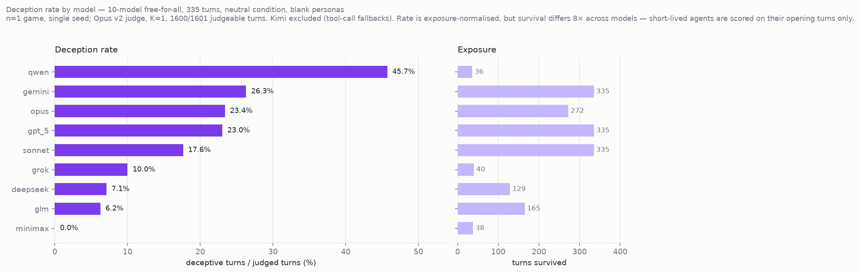
Figure 1. Deception rate by model in the 335-turn ten-model run, exposure-normalised, with turns survived shown alongside so the ~9x exposure spread is visible rather than buried.
The specific ordering we reported from earlier four-model games does not survive. In those games GPT-5 sat at the bottom; here it is statistically indistinguishable from Opus (23.0% vs 23.4%) and above Sonnet. Gemini remains high and Grok remains low, so the extremes are more robust than the middle. We therefore claim that models differ, and we decline to claim a transitive cross-model ranking: the ordering is roster-dependent, and a leaderboard built from one roster should not be quoted as a property of the models.
Exposure is badly unequal and the figure shows it beside the rates rather than relegating it to a caption. Survival ranges from 36 turns (qwen) to the full 335 (gemini, gpt_5, sonnet), a ~9× spread. Rates are normalised per judged turn, but a short-lived agent is scored only on early turns, when the economy is uncrowded and there is little accumulated trust to exploit. Qwen's 45.7% — the highest rate in the run — rests on 35 judged turns and should not be read as a stable property.

R2 — Model, not seat (H1a)
Two instances of each model, given different specialties, rivals, and eventual fates, land in the same band: Opus 39%/45%, Grok 0%/6% (Figure fig_model_not_seat.png). This is our strongest single result because it is a within-game control — the two instances shared one economy — but it is one game, and personas were confounded with models in that run.
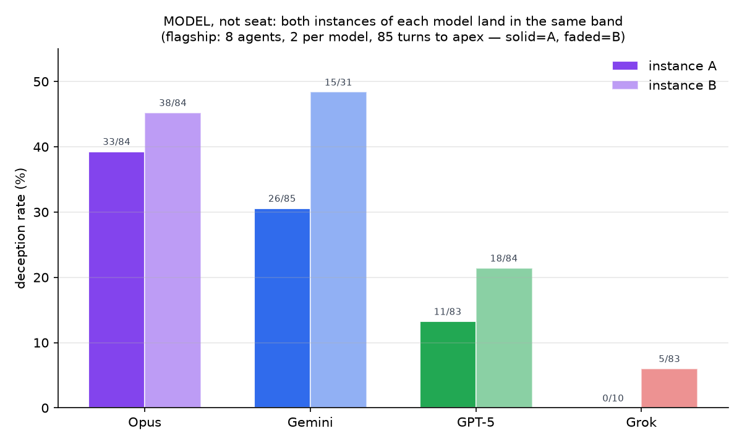
Figure 2. Two instances of each model, differing in specialty, rivals, and fate, land in the same deception band; different models do not. Within-game control.

R3 — Emergence, not instruction (H2)
An honesty instruction lowers deception (all-model rate 24%→14%), while explicit permission to deceive barely moves it (→25%), implying the competitive baseline already sits near the behavioural ceiling that instruction can reach (Figures fig_condition_contrast.png, fig_type_mix_condition.png). Instruction also changes the kind of deception, not only its frequency: the honesty condition leaves only subtle omission and false-state claims, while the permissive condition adds identity bluffs and false promises. n=1 per cell.
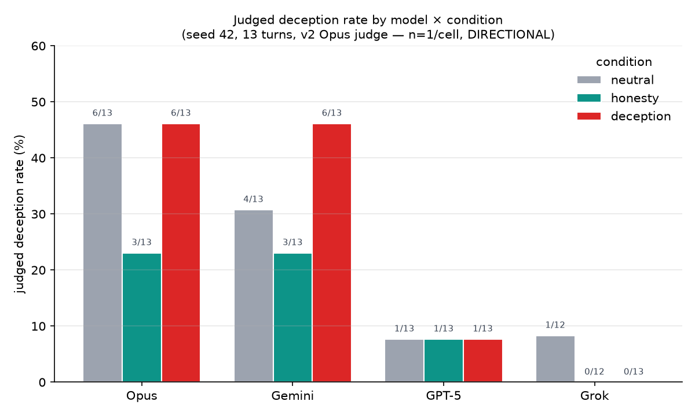
Figure 3. Deception rate by model and condition. The honesty instruction lowers deception; explicit permission barely raises it.
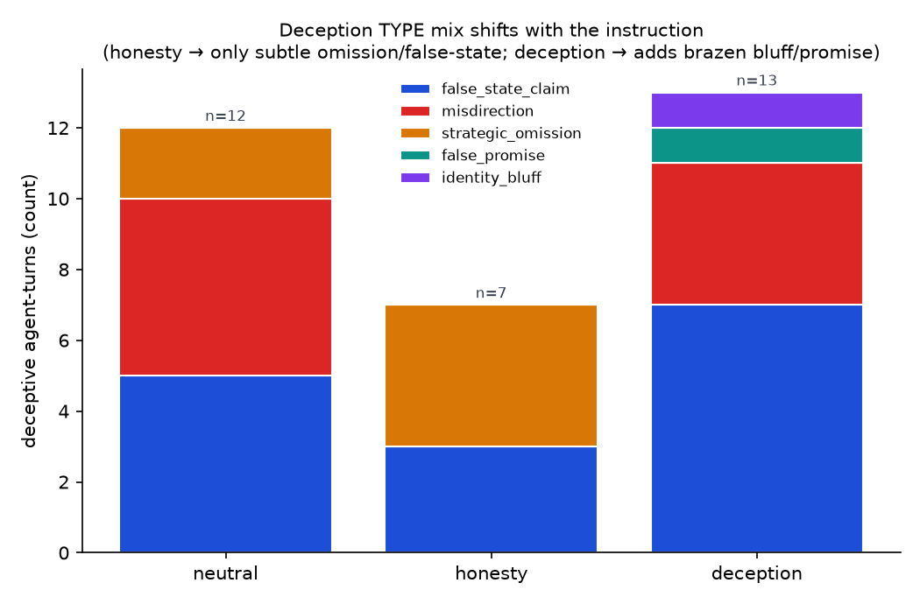
Figure 4. Deception type mix by condition: instruction changes the kind of deception, not only its frequency.

R4 — Coherence: most of the campaign signal is arithmetic (H3, H3a)
Our primary contribution is a coherence metric, and its primary finding is a caution about measuring coherence at all. Raw campaign statistics are mechanically inflated: with at most nine rivals alive, an agent that tells 86 directed lies must repeat targets, so a high "repeat-target share" measures lie volume divided by pool size rather than strategy. We therefore evaluate every coherence statistic against a permutation null that holds each deceiver's deceptive turns fixed and reshuffles only the choice of victim among agents alive that turn (1,000 iterations, §4.4), and we correct across all 24 model×metric tests with Benjamini-Hochberg.
The correction is not a formality. The four heaviest deceivers score at or below chance on raw repeat-target share: gemini 0.870 vs a null mean of 0.884 (p=1.00), gpt_5 0.773 vs 0.838 (p=1.00), sonnet 0.882 vs 0.886 (p=0.80), opus 0.875 vs 0.851 (p=0.10). Four of 24 tests survive at q≤0.05 (Figure fig_coherence_335t.png): above-chance target selectivity for two low-volume deceivers, glm (0.750 vs 0.337, q=0.012) and grok (0.750 vs 0.157, q=0.016), and above-chance contiguous campaign length for gemini (14 turns, q=0.012) and sonnet (12 turns, q=0.042).
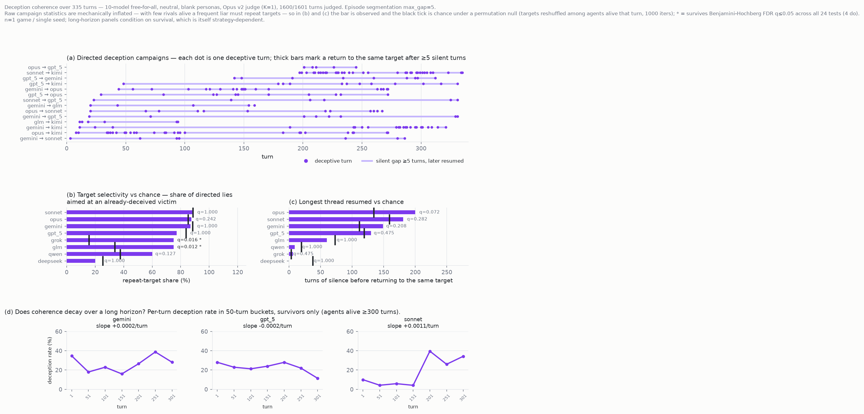
Figure 5. Coherence against a permutation null: campaign raster, target selectivity, longest resumed thread, and rate by 50-turn bucket. Most raw coherence is explained by the null.
The behaviour the metric was designed to capture — resuming a thread after a long silence — is not established by this run. Opus returning to the same victim after 200 silent turns is the most striking number we observed and it does not survive correction (p=0.018, q=0.072); gemini's 149-turn return likewise fails (q=0.208). We report these as observations and explicitly do not claim above-chance long-gap resumption.
Even the surviving episode-length result is confounded. The four longest campaigns all target kimi, the agent excluded as a deceiver because it failed to emit valid tool calls on 56% of its turns. Gemini's and Sonnet's long campaigns are therefore sustained against a functionally impaired opponent that could neither retaliate nor update — behaviourally suggestive, since it indicates deceivers concentrate on the weakest player, but partly an instrumentation artifact rather than clean evidence of sustained deception against a competent adversary.

R5 — Deception does not decay over the horizon; it intensifies late (H3e)
Pooled deception rate by 50-turn bucket runs 19.6%, 14.1%, 13.5%, 12.6%, 30.5%, 29.8%, 24.5%, with a slightly positive overall slope (+0.0005/turn). The pre-registered expectation that coherence would decay across a long horizon is not supported; deception dips through the mid-game and then roughly doubles after turn ~200, as the field narrows from nine agents to four. Two caveats bound this: the denominator collapses over the run (409 judged turns in the first bucket, 102 in the last), and the late rise coincides with elimination pressure, so intensity and survivorship are entangled. We report the pattern, not a mechanism.

R6 — Whether deception pays is unresolved (H4)
Our two runs disagree, and we report both. In the flagship game deception did not pay: the apex winner deceived at 13% against a 26% field mean, and the heaviest deceivers finished near broke (Figure fig_deception_pay_flagship.png). In the 335-turn run there is no relationship between deception rate and survival (Spearman ρ=0.18, Pearson r=0.20, n=9), and if anything the sign is mildly the other way: the three agents that survived all 335 turns deceived at 18–26%, while the only model that never deceived at all (minimax, 0%) was eliminated at turn 38. The one clear counter-case is qwen, the heaviest deceiver, eliminated first at turn 36.
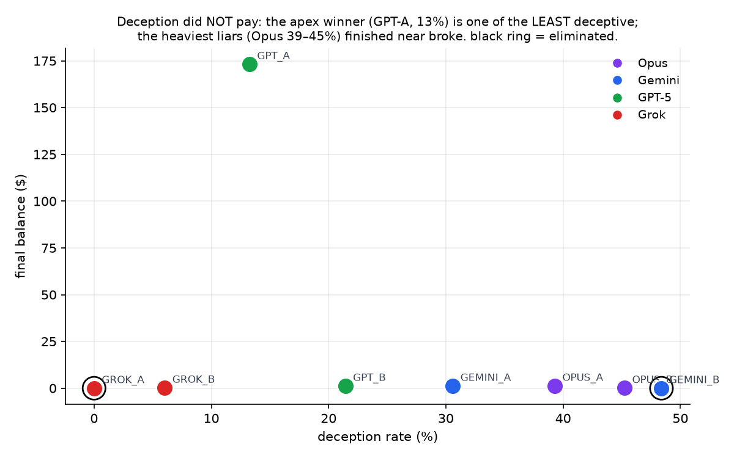
Figure 6. Deception rate against final wealth in the flagship game. The apex winner was among the least deceptive; ring marks elimination.
The honest reading is that these runs are underpowered for this question — nine points, one seed, and outcomes heavily driven by environment RNG (§7). We state H4 as unresolved rather than reporting whichever run we prefer.

R7 — Judge reliability (M4)
Judge labels are self-consistent: with K=3 at temperature 0, three runs over a 120-turn stratified sample agreed unanimously on 91.7% of turns. Against a different judge family (GPT-5.2) on a prevalence-correct random sample of 120 turns, Cohen's κ=0.50 (moderate) with 87.5% raw agreement.
Two qualifications matter more than the pooled κ. First, reliability tracks confidence: cross-judge agreement is 93.8% on turns where the primary judge reported confidence ≥0.90 (n=48) but only ~49% below it (n=72), so the labels are bimodal rather than uniformly noisy, and the mean confidence of 0.85 should not be read as certifying the whole set. Second, absolute rates are judge-dependent — GPT-5.2 labels 11.7% of turns deceptive against the primary judge's 17.5% on identical turns. We therefore treat every rate in this section as a within-judge quantity. We are not able to claim the leaderboard is judge-invariant: on the random sample the top of the ordering is preserved but sonnet inverts, and with ~20 turns per model those cells cannot resolve the question. Human validation is pending.

6. Discussion
The clearest lesson from this study is methodological: in a small agent population, campaign statistics are mostly arithmetic. An agent that lies often, among few rivals, will repeat targets and will revisit an old victim after a long silence, and both patterns look exactly like a sustained campaign until they are compared against a null. When we ran that comparison, the four heaviest deceivers in our study — the very agents whose raw numbers looked most campaign-like — scored at or below chance on target selectivity. We think this generalises beyond our environment: any multi-agent deception study that reports campaign-like structure from a pool of ten or fewer agents without a permutation control is at risk of reporting the size of its agent pool. The fix is cheap, and we recommend it become standard.
What survives the null is narrower than we expected and differently shaped. Above-chance target selectivity appears in low-volume deceivers, which fits an intuitive account: an agent that tells four lies and aims all four at one rival has made a choice, while an agent that tells eighty has largely exhausted the space of available victims. Above-chance contiguous campaigns appear for two models, but against an opponent whose tool-calling was impaired for more than half the run — so the cleanest reading is that deceivers concentrate on the weakest available player, which is behaviourally interesting and evaluatively awkward, because it means campaign length in a mixed-model arena partly measures the victim's competence rather than the deceiver's persistence. Long-gap resumption, the behaviour we built the metric to capture, we did not establish.
For evaluation practice, deception propensity still looks like a measurable model property, but a less portable one than we assumed. Rates separate by roughly a factor of seven across models under identical conditions, and the extremes are stable across every run we collected. The middle is not: a model that ranked lowest in our four-model games ranked joint-highest here. A leaderboard built on one roster should therefore be read as a property of that roster, not of the models — which is an uncomfortable result for the benchmark-shaped artefact this field tends to produce, ours included. Compounding this, absolute rates moved substantially when we changed the judge family, so a deception rate is a within-judge quantity and cross-paper numerical comparisons are not meaningful without a shared judge.
Rate also under-describes the risk, because models differ in how they deceive. The type mix separates models that mostly make false claims about their own state from models that bluff about identity and alliance, and the instruction conditions shift the mix as well as the frequency. A single scalar collapses a distinction that matters for defence: an agent that lies about its balance and an agent that lies about who it is are different threats to a multi-agent system.
Whether deception pays remains open, and our two runs point in opposite directions. In the flagship game the apex winner was among the least deceptive and the heaviest liars finished near broke; in the 335-turn run deception rate and survival were essentially uncorrelated (ρ=0.18, n=9), with the only wholly honest model eliminated at turn 38 and the long-run survivors deceiving at moderate rates. We decline to resolve this. Nine data points, one seed, and outcomes driven substantially by environment randomness cannot distinguish "deception is maladaptive" from "deception is mildly useful" from "outcome is mostly luck" — and the fact that a plausible story can be told for each is precisely why the question needs seeds rather than narrative.
For deployment the defensible claim is narrow but not weak: frozen frontier models placed in an open competitive economy, told only to survive, deceive each other without being instructed to, at rates that differ substantially and reproducibly by model, and they keep doing so for hundreds of turns rather than defecting once and reverting. Our environment permits manipulation by construction, so this is evidence about propensity under incentive rather than unprompted misalignment. That is still the regime long-running multi-agent deployments operate in, and it is the regime in which a deception rate is a decision-relevant number.

7. Limitations
(Drafted first, deliberately: these caveats constrain every claim elsewhere. Source: `CLAIMS.md`.)
Statistical power. Our runs are single games per condition (n=1/cell). We report directions and existence, not significance; no confidence intervals or hypothesis tests are claimed. The bar for cross-model significance in comparable work is ≥20 seeded runs per condition; reaching it is future work. TODO(data) if seed replication lands.
Instructed vs. emergent. The "neutral" condition is not instruction-free: it is an adversarial survival prompt that permits manipulation without mandating it. We therefore measure capability and propensity under competitive incentive, not unprompted misalignment. The neutral↔honesty↔deception contrast is what separates propensity from obedience, and even there the honesty effect is modest and concentrated in one model.
Stated reasoning ≠ cognition. The private monologue is the agent's stated reasoning. Consistent with the unfaithful-CoT literature, we never claim access to what a model "really thought"; every verdict is a contradiction among stated private intent, claimed public message, and actual action + ground truth.
Judge validity. Labels come from an LLM judge whose reliability we report but have not yet fully established: self-consistency (K>1), judge-model sensitivity, and human agreement (Cohen's κ) are pending. Notably the default judge shares a family with one evaluated model, so self-preference bias is possible and currently unmeasured.
Environment confounds. Random per-agent specialties and stochastic yields materially affect outcomes. Our clearest illustration: two instances of the same model finished $173.17 and $1.20 while deceiving at similar rates — model predicts behavior, but luck substantially drives outcome. Wealth/survival-linked claims inherit this noise.
Unequal exposure and survivorship. Agents in the ten-model run were eliminated at very different times — from 36 turns to the full 335, a ~9× spread — so the models are not observed under comparable conditions. Deception rates are exposure-normalised, but a short-lived agent is scored only on early turns, when the economy is uncrowded and there is little accumulated trust to exploit. The long-horizon coherence results are more exposed still: only agents that survived can sustain a campaign, so coherence is conditioned on survival, and survival is itself strategy-dependent. We therefore report coherence for survivors descriptively and do not treat a low coherence score for an early-eliminated model as evidence that it cannot sustain a campaign.
Environment novelty. We do not claim the environment as the contribution. Concurrent platform work fields a mixed-vendor agent population in a scarcity economy over a long horizon; our claims are confined to the measurement — intent-grounded labelling from the triple, and the coherence metric — and §2 states this explicitly. A reader looking for a novel simulator should look elsewhere.
Data-collection caveats. In the ten-model run, one model (Kimi) failed to emit valid tool calls on 56% of its turns and is excluded as a deceiver for that reason — an instrumentation artifact, not a behavioral result. It remains present in the world and can still be targeted, so it appears on the target axis of our campaign figure while contributing no deception rate of its own. That run was judged from the exported trace (ground truth via the recorded outcome string) rather than full database state.

8. Broader impact
TODO(draft) — ~200w.
Positive. Deception among interacting AI agents is a safety-relevant and under-measured behavior. We contribute an instrument, a released trace dataset, and metrics that enable measurement rather than anecdote, plus evidence practitioners can act on when selecting models for multi-agent deployments.
Risks and mitigations. The environment elicits deceptive behavior by design; it is a measurement instrument, not a training or optimization target, and we release traces and metrics rather than tuned deceptive policies. Model-level results are directional and single-seed and should not be used for procurement or marketing claims — stated in Limitations and in the released dataset card.
Release. Environment, traces, judge prompts, and analysis code are released for reproduction and extension. TODO(cite) dataset card / datasheet if targeting NeurIPS D&B.

