NEXUS POS
Portfolio Case Study

A Full-Stack Point of Sale Web Application
2025

PROJECT OVERVIEW

Nexus POS — Reimagining the Point of Sale

Nexus POS is a fully functional, web-based Point of Sale application designed for modern small businesses — cafes, retail shops, and multi-category stores. The project was built entirely from scratch, focusing on three core principles: speed, clarity, and professional-grade user experience.

In most business environments, billing and checkout software is slow, cluttered, and unintuitive. Staff spend valuable time navigating complicated menus instead of serving customers. Nexus POS was conceived to solve this: a system that any team member can learn in minutes, that works reliably under real-world conditions, and that gives business owners meaningful insight into their daily performance.

Project Highlights
- 4 fully designed and functional application screens
- Complete sales workflow — from product browsing to cart checkout
- Live analytics dashboard with interactive sales charts and product rankings
- Fully customizable settings: animation speed, input behavior, and keyboard shortcuts
- Professional dark UI theme with a starfield background for a premium look and feel

PROBLEM STATEMENT

What Was Wrong with Existing POS Systems?

Shopkeepers and cafe owners interact with POS software for hours every single day. Despite this, the majority of available solutions have not meaningfully evolved in design or usability over the past decade. The result is a daily experience marked by frustration, slow workflows, and a complete absence of useful business data.

SLOW | Too many clicks to complete a single sale. Cashiers lose time — and customers lose patience.
COMPLEX | Features buried in nested menus. New staff require hours of training before they can operate the system independently.
NO DATA | Business owners have no clear view of which products perform best, when peak hours occur, or how revenue trends over time.

SCREEN 01 OF 04

The Selling Screen

Where every transaction begins

This is the primary workspace — the screen a cashier interacts with throughout their entire shift. Every design and layout decision on this page was made with one question in mind: how do we get a product from the shelf to a completed sale in the fewest possible steps?

The screen is divided into two clear zones. On the left, every available product is displayed as a visual card complete with an image, name, and price. Products are grouped into category tabs — Drinks, Snacks, Electronics, Clothing, Food — so a staff member can locate any item in seconds. A search bar at the top allows instant lookup by name or by a product's unique shortcode (e.g., typing #esp immediately brings up Espresso). On the right side, a live cart panel shows every item currently selected, running quantities, individual prices, and a grand total — all updating in real time with every tap.

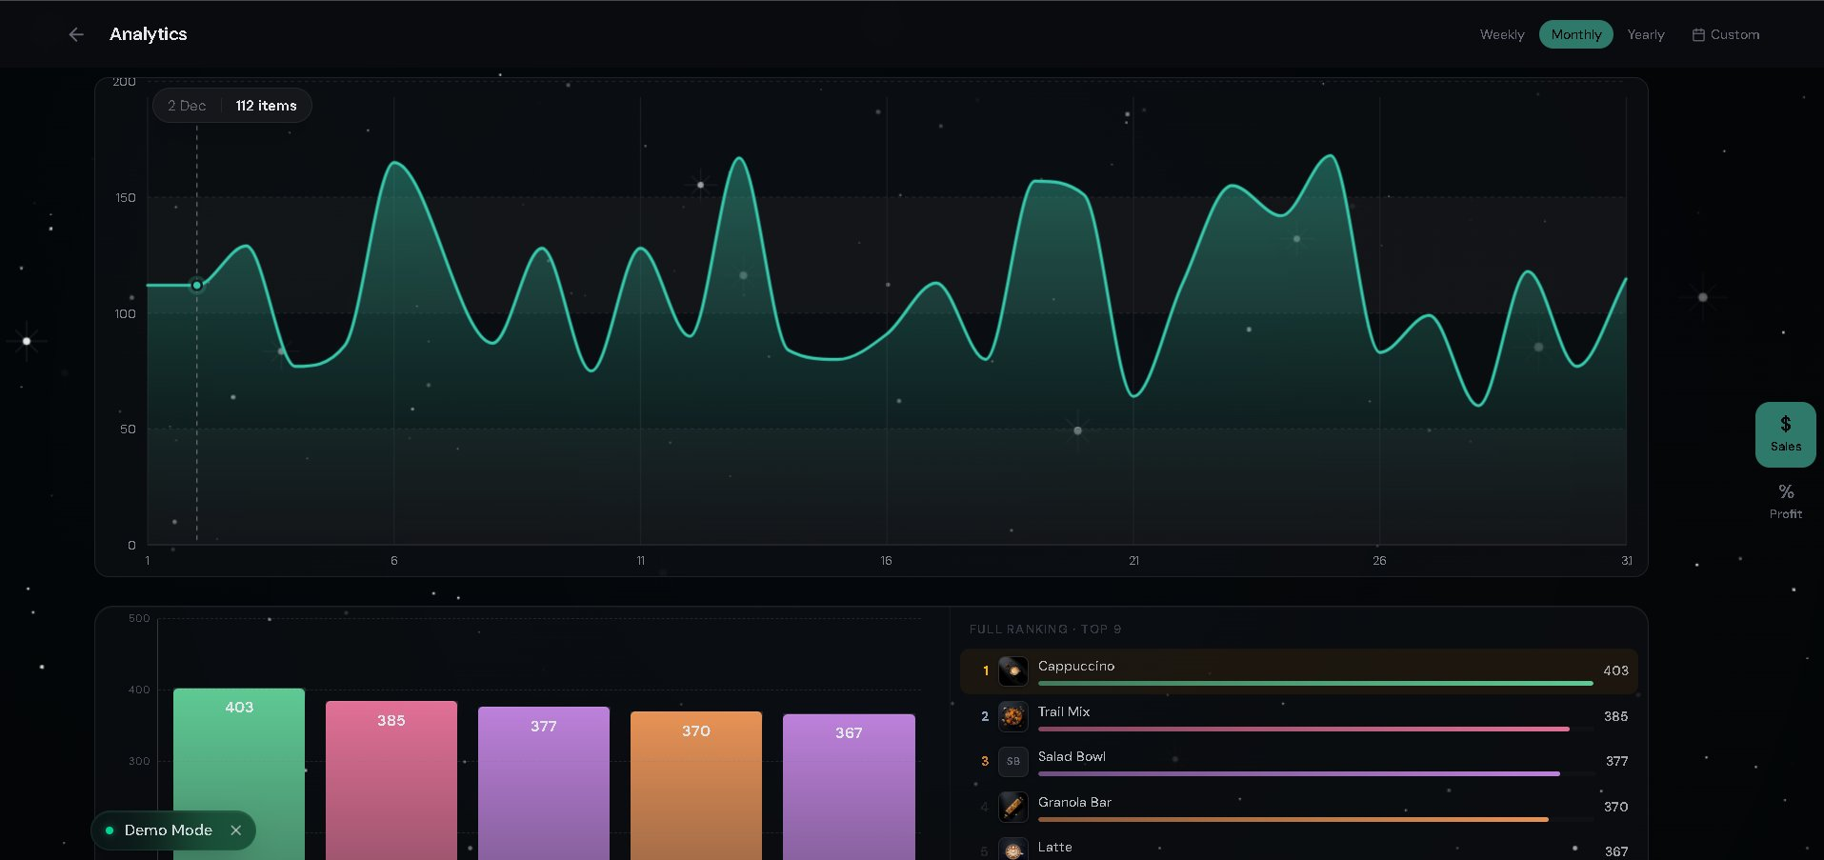
Figure 1: Main POS Screen — Product grid (left) with category tabs and search, live cart panel (right) with real-time totals and checkout button

Key Features
✓ One-click add to cart | ✓ Category filter tabs (Drinks, Snacks, Electronics…)
✓ Quick-code search (#esp, #lat, #cap…) | ✓ Live cart with quantity controls
✓ Real-time total calculation | ✓ Stock count displayed per product
✓ Full-width checkout button always visible | ✓ Notification bell for system alerts

SCREEN 02 OF 04

Analytics Dashboard

Data that drives smarter business decisions

After the day's selling is done, business owners need answers. Which products are performing? When was the busiest period this month? Is revenue trending up or down? The Analytics Dashboard was built to provide these answers visually and instantly — no spreadsheets, no manual counting.

The upper half of the screen features a large, interactive sales curve — a wave-shaped chart that plots item volumes across the entire selected time period. Hovering over any date on the chart reveals an exact tooltip showing the count for that day. The lower half presents two complementary views: a color-coded vertical bar chart ranking the top-selling products, and a numbered leaderboard on the right listing the Top 9 items by total units sold. This dual-view approach allows both a quick visual scan and precise ranking at the same time.

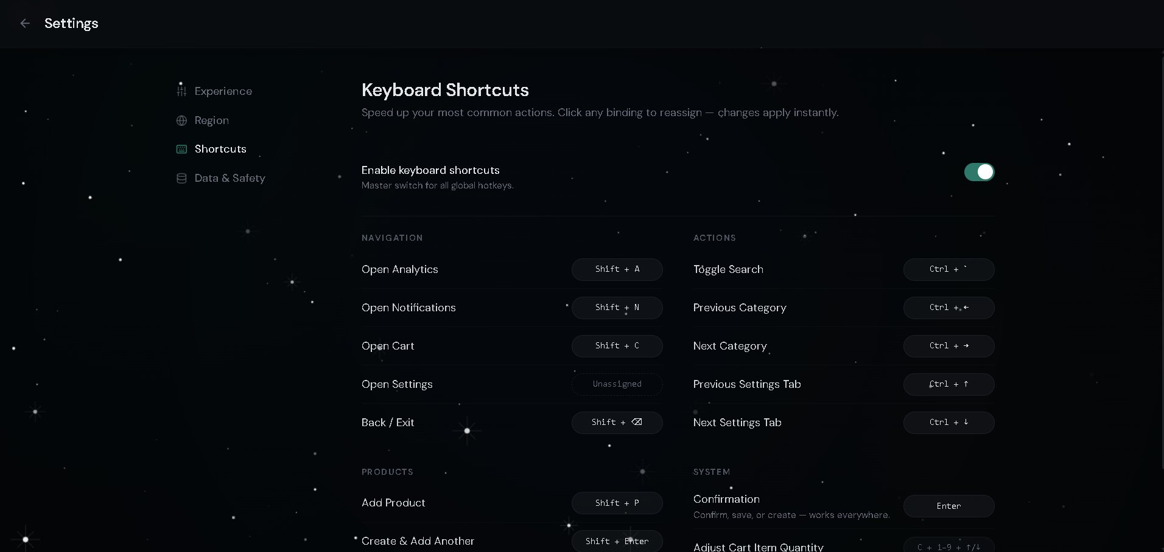
Figure 2: Analytics Dashboard — Interactive monthly sales curve, top-product bar chart, and live leaderboard ranking with unit counts

Key Features
✓ Interactive area chart with hover tooltips | ✓ Weekly / Monthly / Yearly view modes
✓ Custom date range picker | ✓ Top 9 product leaderboard
✓ Color-coded bar chart comparison | ✓ Sales vs. profit toggle (sidebar)
✓ Demo mode for safe presentation | ✓ Real-time data reflection

SCREEN 03 OF 04

Settings — Experience

Adaptive performance for every environment

No two businesses operate the same way. A fast-paced urban coffee shop needs snappy, instant transitions — every millisecond of animation is time a cashier could be serving the next customer in line. A boutique clothing store, on the other hand, may prefer fluid, polished motion that reflects their brand. The Experience settings page was built to accommodate both — and everything in between.

The left panel offers three distinct animation speed modes: Smooth (full motion with all transitions), Fast (reduced, lighter animations), and Ultra Fast (no motion at all — pure functional speed). On the right, a set of input behavior toggles gives fine-grained control over how the app responds during data entry: whether pressing Enter jumps the cursor to the next field, whether the system auto-focuses on the active fill area, whether a rejected input triggers a haptic vibration, and whether validation errors appear directly beneath the relevant field.

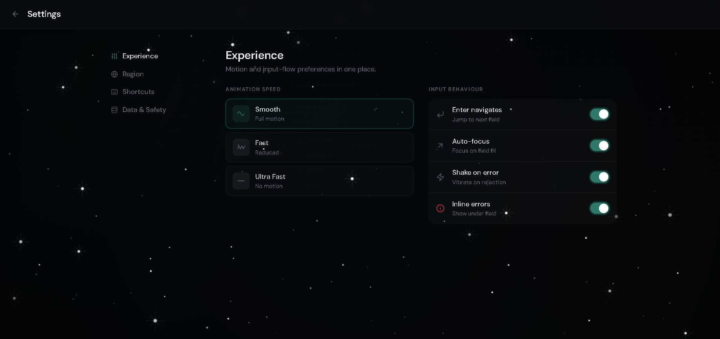
Figure 3: Settings → Experience — Animation speed selector with three modes and four smart input behaviour toggles

Key Features
✓ Smooth mode — full fluid motion | ✓ Fast mode — reduced transitions
✓ Ultra Fast mode — zero animation | ✓ Enter key navigates to next field
✓ Auto-focus on active field fill | ✓ Haptic vibration on input rejection
✓ Inline error display under field | ✓ Changes apply instantly

SCREEN 04 OF 04

Settings — Keyboard Shortcuts

Built for power users and high-volume environments

For cashiers and operators who work at speed, mouse-dependent workflows create a ceiling on efficiency. Nexus POS addresses this with a complete, application-wide keyboard shortcut system — a level of control normally associated with enterprise-grade software, made accessible here to any user.

The shortcuts settings page is organized into four categories: Navigation (opening analytics, the cart, notifications), Actions (searching, switching product categories), Products (adding items, creating duplicates), and System (confirmation, adjusting cart quantities). Every single shortcut in each category can be customized — a user simply clicks any key binding and reassigns it instantly. A master toggle at the top of the page enables or disables the entire shortcut system with a single switch. The combination of discoverability, flexibility, and range makes this one of the most sophisticated elements of the application.

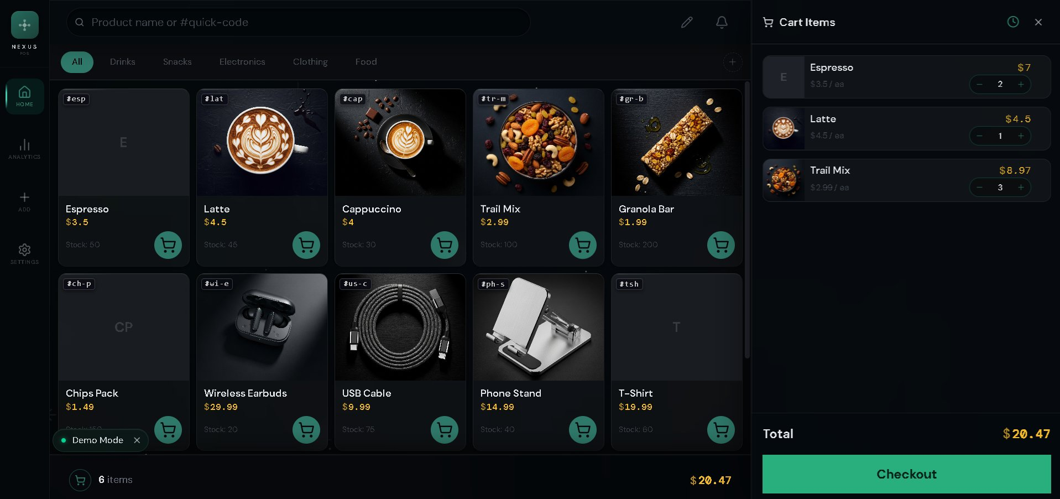
Figure 4: Settings → Keyboard Shortcuts — Full shortcut map across four categories with click-to-reassign bindings and global master toggle

Key Features
✓ Global master on/off toggle | ✓ Navigation shortcut group
✓ Actions shortcut group | ✓ Products shortcut group
✓ System shortcut group | ✓ Click-to-reassign any key binding
✓ Unassigned state for optional keys | ✓ Changes apply instantly

DESIGN & TECHNICAL DIRECTION

Philosophy and Approach

The overarching design philosophy of Nexus POS can be summarized simply: great software should be invisible. The cashier should never have to think about the system — only the customer in front of them. Every design decision, from the dark theme to the single-accent color scheme, was made in service of this goal.

Visual Design
The application uses a deep dark theme throughout — not merely as an aesthetic choice, but as a practical one. Dark interfaces reduce eye strain significantly during long shifts under bright commercial lighting. A subtle animated starfield background lends the product a premium, distinctive identity without competing with functional UI elements. A single accent color — teal/green — is used consistently across all interactive and call-to-action elements, training the user's eye to know exactly where to look.

Information Architecture
The application is organized into four distinct screens, each with a single, clear purpose. Navigation is immediate — the sidebar provides one-click access to every major area. This flat structure eliminates the nested menus that make traditional POS systems disorienting, and ensures any feature is reachable within two clicks from anywhere in the application.

Performance and Responsiveness
The product was engineered to be fast by default. The animation speed settings exist not as decorative options, but as genuine performance controls — allowing a shop owner to tune the application to their hardware and workflow requirements. The keyboard shortcut system further removes friction for high-volume environments.

4  Core Application Screens | 1-Click  Cart Checkout Flow | 9+  Configurable Shortcuts

SUMMARY

Project Outcome

Nexus POS demonstrates full-cycle product development — from identifying a real-world usability problem to delivering a polished, production-ready solution. The project covers four interconnected application screens and addresses the complete user journey: discovering products, managing a cart, completing a sale, reviewing business performance, and customizing the system to personal workflow preferences.

The result is a professional-grade web application that prioritizes user focus, operational speed, and visual quality — qualities that matter both to the end user in a shop environment and to any organization evaluating the capabilities of the developer who built it.

What This Project Demonstrates
- End-to-end product thinking — from problem identification through interface design to implementation
- Attention to professional UX detail — animations, error states, input flows, and shortcut systems
- Data visualization capabilities — interactive charts, leaderboards, and time-series analytics
- Modular settings architecture — a flexible, scalable system that adapts to different user needs
- Consistent visual identity — a cohesive design language maintained across all four screens

Nexus POS · Full Portfolio Case Study · 2025

