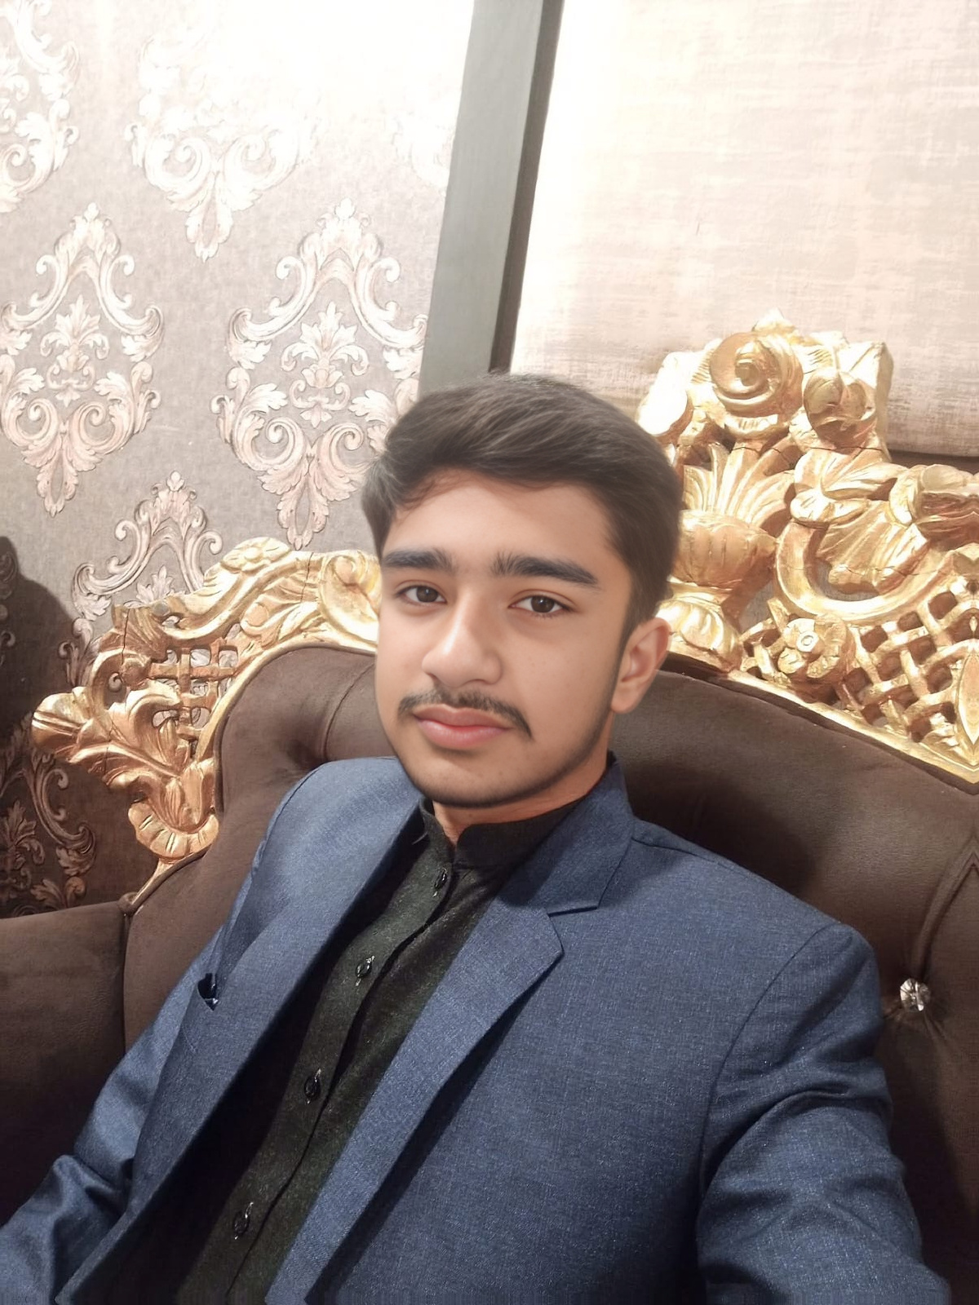
KHUZEMA AKHTAR
Frontend Web Developer | BS Computer Science Student

Professional Summary
Motivated and passionate Computer Science student with a strong interest in Frontend Web Development. Skilled in HTML, CSS, and JavaScript with hands-on experience in designing responsive web pages, portfolio websites, registration forms, and academic projects. Seeking internship opportunities to gain practical experience and contribute to professional projects.

Contact
Phone: +92 309 7740929
Email: khuzemaakhtar056@gmail.com
Location: Muridke, Punjab, Pakistan

Education
BS Computer Science (Undergraduate), University of Engineering and Technology (UET)
GPA: 2.85
F.Sc. Pre-Engineering, Degree College (2021–2023)
Matriculation, Vision School System (2019–2021)

Technical Skills
- HTML
- CSS
- JavaScript
- Git
- Github
- Frontend Web Development
- Responsive Web Design

Projects
• Personal Portfolio
• Restaurant Landing Page
• Netflix Home Page Clone
• Amazon Home Page Clone
• Digital Clock
• To-Do App
• Quiz App
• Weather App
• E-commerce Website
• Blog Website

Languages
Urdu - Native
English - Intermediate

