YMIR
COMBAT

Table of Contents
Table of Contents 2
Combat 3
Aiming 4
Example of Combat 5
Combat Actions 5
Positioning 10
Distance 10
Generic Weapons and Attacks 11
Wounds, Healing and Recovery 12
Damage 12
Penalties 12
Soul Damage 13
Stats Degradation 13
Suffocation 13

Combat
Action Points determine the number of Actions that can be taken by each participant in one round of Combat.
Each Action has a cost in Action Points. Each character can take a maximum of three actions every Combat Round, unless he has access to talents that grant him more actions per round.
Each participant secretly writes down Actions for each round, and then Actions are revealed and take effect simultaneously and interact with each other as per description.
Casting spells during combat requires Power Points in addition to Action Points.
Action Points and Power Points can be gained during Combat by performing a Concentration Action, Action Points are re-set at the end of each combat round while Power Points and are re-set at the end of Combat

Starting Combat
Whenever things go wrong, combat can start in three ways

Declare
The classic way to start combat: angry looks are given, heavy words are spat out, weapons are drawn and everybody knows who’s foe of who when the combat starts.

Sudden Attack
The attacker can surprise his enemy:
- After he got to combat range undetected or shoots from a hidden position (Stealth vs Perception)
- After he lured the foe into a false sense of safety (Influence vs Resistance – Mental or Influence vs Influence).
- During combat, by attacking someone that thinks he is an ally (Influence vs Resistance – Mental)
The attacker has one full round of action while the defender can take no active action because of the surprise.

Charge
The attacker can just charge into its foe and attack him wildly. The only possible attacker’s action for the round is an All-Out Attack, and the foe is aware of that.

Combat Actions

Initiative
Initiative determines whose Action takes effect first during combat. Initiative is determined at the beginning of each round as follows
- Round Initiative: 1d10 + DES or INT + Initiative Modifiers
Initiative Modifiers can be determined by weapon used, armor worn, special talents, spells and so on.

Combat of Actions per Round
Each participant can take a 1 action plus 1 for each 10 full points of the sum of DES and INT during each round of combat.
- Combat Actions per Round: 1 + (DES + INT)/10 (round down)

Action Declaration and Resolution
Each participant to combat must secretly take note of his first Combat Action. Then the first Actions are resolved in order of initiative.
Then whoever has a second Action takes note, and the second Action pass is resolved, and so on.

Attack/Defense
“A boxing straight with good footwork and coverage”
Perform the Action as follows:
- Split the Combat skill bonus in an Offense Base Bonus amount and an Defense Base Bonus amount. You have the right to perform an Attack – Offense roll only if devolving at least 1 point to your Offense bonus.

- Determine the Total Attack – Offense for this Action as follows:
Attacker’s Offense Base Bonus +/- Attacker’s Weapon Offense modifier +/- Aiming modifier +/- Positioning Modifier + Attacker’s Attack Roll (1d100 open roll)

- Determine the Total Attack – Defense for this Action as follows:
Defender’s Defense Base Bonus +/- Defender’s Weapon Defense modifier + Defender’s Physical Defense modifier (Armor + Shield + Other) + Defender’s Defense Roll (1d100 open roll)

- If Total Attack – Offense is greater than Total Attack – Defense, the difference is the Damage that is inflicted to the aimed part of the defender.

Anticipating Attack
“The quick jab in boxing or the front kick in Thai boxing”
Anticipating Attacks are done to maximize a speed advantage by scarifying power of the blow for speed, in order to be able to go past defenses.
If a Snap Attack has higher Initiative, it ignores the defense from Attack/Defense. Snap Attacks deal half damage.

All-Out Attack
“Looping overhead punches in a brawl”

All-Out Defense
“Full covering-up in boxing, or the struggle with stabbing villains in movies”
It works even against attacks that come with higher Initiative than the defender’s

Feint
Cost: 3AP
Perform a General-Perception against General-Perception roll, if successful the opponent is at -20 for the next 5 Actions.
Feint rolls can be cumulative.

Dodge
Cost: 3AP
Only works against incoming attack. Perform a General-Acrobatics roll versus the incoming attack roll.
If the Acrobatics roll is equal or higher than the attack roll, the attack has no effect. Otherwise the attack has full effect.

Cast a Spell
Cost: 3AP
Each spell cast during combat also costs a number or Power Points based on its League
- Mundane spells cost 2 Power Points
- Heroic spells cost 5 Power Points
- Exemplary spells cost 7 Power Points
- Lordly spells cost 10 Power Points
- Epic spells cost 20 Power Points

Concentrate
Cost: 1AP
Concentrating is used to gain more Power Points or Action Points during Combat. A character gains points based on his own League
- Mundane characters gain 3 Power Points or Action Points
- Heroic characters gain 4 Power Points or Action Points
- Exemplary characters gain 5 Power Points or Action Points
- Lordly characters gain 7 Power Points or Action Points
- Epic characters gain 10 Power Points or Action Points

Calm Down
Cost: 5AP
A character can try to calm down when frightened or frenzied to regain full control.
Perform a Resistance – Mental roll against Mundane (100) difficulty plus 10 for each Action spent frenzied or frightened.
If the roll is successful the character exits the frightened or frenzied status.

Move
Cost: 2AP
Attacks made against somebody who is moving have full effect
Choose one of the following:
- Facing <->Flanking <-> Behind
- Below foe <-> Same Level <-> Elevated
- Supine/Prone <-> Crouching <-> Standing
Moving and engaging in melee combat:
- +1 Action Out of Melee <-> 1 Action Out of Melee <-> Short Range <->Medium Range <-> Long Range

Assess
Cost: 1 AP
A character can use the Assess Action to study her opponents, look for an unprotected spot, plan her next move, and so on.
Assess grant a +20 bonus to a character’s next Action. This bonus is not cumulative.
If scripted against a successful Feint, Assess has no effect.

Reload
Cost:
- Blowpipe: 1AP
- Sling: 2AP
- Short Bow: 3AP
- Light Crossbow: 4AP
- Long Bow: 5AP
- Heavy Crossbow: 6AP

Other Actions
Cost for a Minor Action: 2 AP
Cost for a Major Action: 4 AP
Other Actions can be taken during Combat. A Minor Action consists in something quickly and easily performed, like drawing or folding a weapon or another small object, or using or manipulating a simple object, for example pulling a lever. Major Actions are more complex, like taking an object out of one’s own backpack, using or manipulating complex objects or performing actions involving a skill, such as pickpocketing somebody.

Aiming
Aimed Part
[Aiming Modifier] [Crippling Damage] [Destroying Damage]

Aimed Part | Attack Modifier | Crippling Damage | Destroying Damage
Big Target (Torso, Big Limb) | 0 | CO | CO x 2
Medium Target (Head, Arm, Small limb) | -25 | CO/2 | CO
Small Target (Hand, Foot, Eye, Nose, Neck, Finger, Joint, Groin) | -50 | CO/4 | CO/2
Vital Spot (Brain, Heart, Windpipe, Jugular, Femoral Artery) | -100 | CO/4 | CO/2

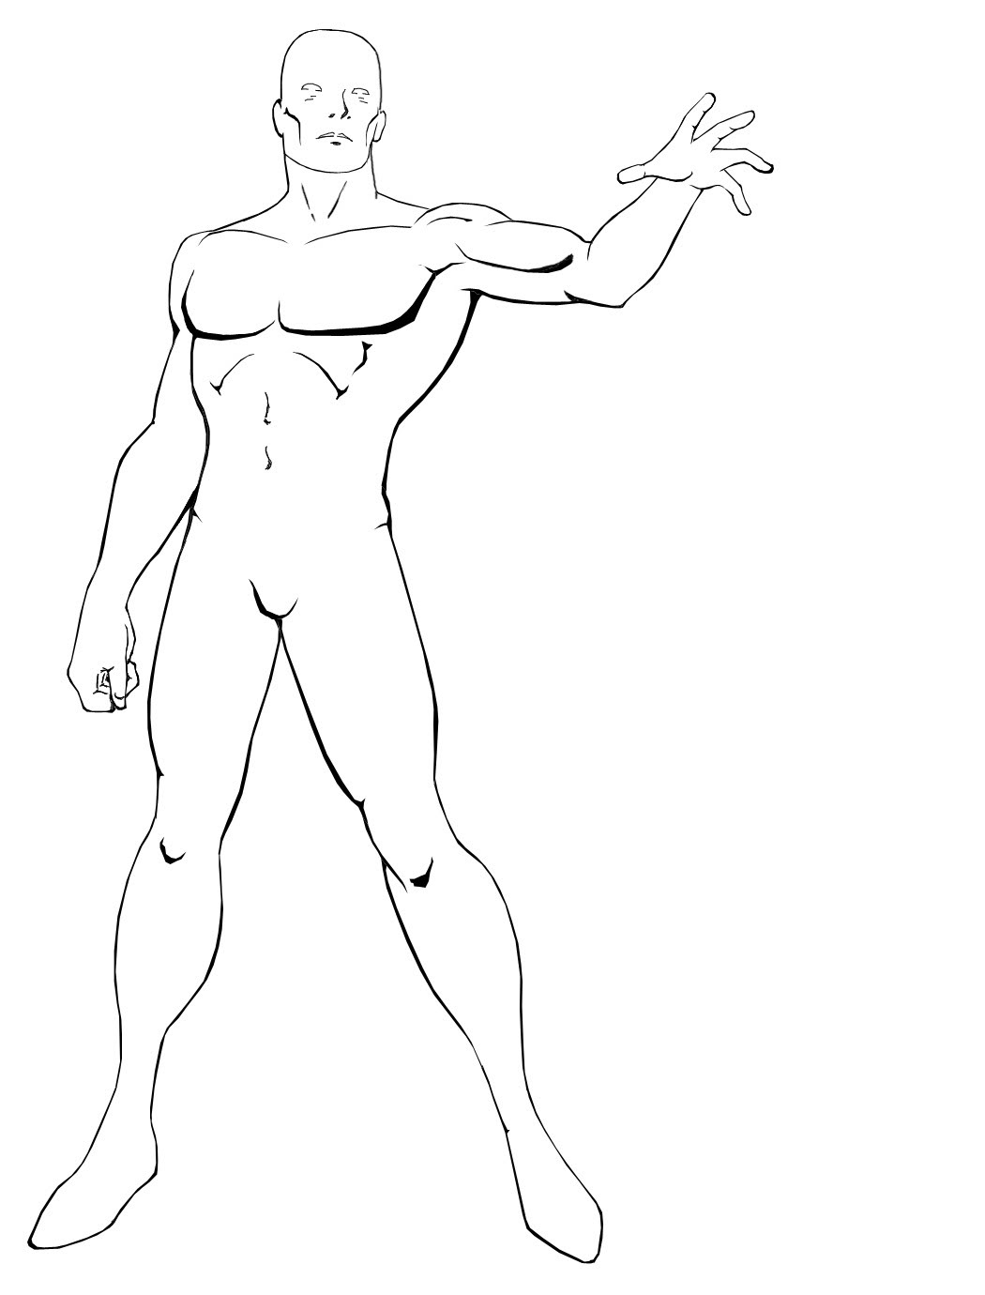
Eye
[-100] [Co/4] [Co/2]
Head
[-25] [Co/2] [Co]
Neck
[-100] [Co/4] [Co/2]

Hand
[-50] [Co/4] [Co/2]

Foot
[-50] [Co/4] [Co/2]

Torso
[0] [Co] [Co x2]
Leg
[0] [Co] [Co x2]

Arm
[-25] [Co/2] [Co]

Groin
[-50] [Co/4] [Co/2]
Finger
[-100] [Co/4] [Co/2]

Example of Combat
After losing a beer drinking contest with Amoth, Groll decides it’s time to wash humiliation away with blood.

Damage and Penalties
Damage is inflicted to body parts targeted by Attacks.
Whenever Damage is inflicted, it is immediately converted in an equal amount of Penalty that stacks on each body part separately.
At the end of each round each body part’s Penalty is lowered by the Constitution total bonus of the wounded character.
Whenever Damage is inflicted, it also produces other effects depending on the amount and on the type of weapon that caused that damage.

Positioning
A Character may find itself or maneuver in order to gain an advantage in positioning.
- Being behind the target grants a +50 bonus to melee and ranged attacks.
- Flanking the target grants a +25 bonus to melee and ranged attacks.
- Being in an elevated position grants a +25 bonus to melee and ranged attacks.
- Attacking a prone or supine target grants a + 50 bonus to melee attacks and a -50 malus to ranged attacks.
- Attacking a crouching target grants a +25 bonus to melee attacks and a -25 malus to ranged attacks.

Distance
Distance between characters involved in a Combat is measured by the number of Actions that it takes to get to Melee range.
Melee Range is divided in three sub-ranges:
Short Range
Medium Range
Long Range

Effects of Battle Fields
Alcuni CdB potrebbero avere degli effetti speciali sullo svolgersi del combattimento. Per esempio, un CdB molto ristretto potrebbe imporre uno Svantaggio a tutti i combattenti che utilizzano armi ingrombranti. Oppure, un CdB avvolto da una cortina di gas velenoso potrebbe attaccare i suoi occupanti ogni round. O ancora, un CdB coperto da una fitta vegetazione potrebbe offrire riparo contro gli attacchi a distanza a chi lo occupa.

Ogni pezzo di armatura indossato da un Personaggio aggiunge un certo valore alla sua TA naturale (che è 0, se non specificato diversamente). Un Personaggio non può indossare più di 6 pezzi di armatura diversi (2 bracciali, 2 gambali, un elmo e una corazza), più uno scudo e non può indossare più di un pezzo di armatura per coprire la stessa parte del suo corpo.
Alcuni pezzi di armatura sono considerati Pesanti ed impongono uno Svantaggio in tutte le azioni in cui potrebbero risultare d'impiccio a chi le indossa (come arrampicarsi o saltare), oltre a rendere del tutto impossibile nuotare.
Armatura | TA | Note
Pelle: Corazza | 2
Pelle: Gambale/Bracciale/Elmo | 1
Pelle: Completa | 7
Cuoio: Corazza | 3
Cuoio: Gambale/Bracciale/Elmo | 1,5 | Arrotonda il totale per difetto
Cuoio: Completa | 10
Cuoio Rinforzato: Corazza | 4
Cuoio Rinf.: Gambale/Bracciale/Elmo | 2
Cuoio Rinforzato: Completa | 14
Cotta di Maglia: Corazza | 6 | Pesante
Cotta di Maglia: Gambale/Bracciale/Elmo | 3 | *
Cotta di Maglia: Completa | 21 | Pesante
Scaglie/Lamellare: Corazza | 8 | Pesante
Scaglie: Gambale/Bracciale/Elmo | 4 | *
Scaglie/Lamellare: Completa | 28 | Pesante
Piastre: Corazza | 10 | Pesante
Piastre: Gambale/Bracciale/Elmo | 5 | *
Piastre: Completa | 35 | Pesante
Buckler/Arma da Parata | +1
Scudo Piccolo | +2
Scudo Medio | +3
Scudo a Torre | +4 | Pesante
* Se un Personaggio indossa più di due pezzi combinati di questi tipi di armatura, essi vengono considerati Pesanti.

Generic Weapons and Attacks
Arma | Esempi | Damage | Min ST | ST 1-Handed
Medium Unarmed | Calcio, Pugno, Presa | 1d10 | - | -
Small Weapon | Pugnale, Shuriken, Fionda, Arma Improvvisata | 2d10 | - | 1
Light Weapon | Stocco, Sciabola, Spada Corta, Arco Corto | 3d10 | 1 | 2
Medium Weapon | Spada, Mazza, Arco Lungo, Balestra Leggera | 4d10 | 3 | 5
Large Weapon | Claymore, Morning Star, Balestra Pesante | 5d10 | 6 | 12
Heavy Weapon | Maglio, Spadone, Mazzafrusto, Ascia da Guerra | 6d10 | 8 | 16

Wounds, Healing and Recovery

Soul Damage
Molti non morti, demoni ed alcuni effetti magici danneggiano l'anima di un personaggio, piuttosto che il suo corpo. I Danni all'Anima funzionano come normali danni e vengono sottratti al totale dei PV disponibili del Personaggio. Al contrario delle ferite comuni, tuttavia, essi possono essere curati solamente attraverso appositi incantesimi, composti alchemici, miracoli o erbe sacre.

Stats Degradation
Alcuni incantesimi o effetti magici riducono temporaneamente o permanentemente le caratteristiche dei personaggi. Se una o più caratteristiche di un Personaggio scendono a zero punti o meno per un qualsiasi effetto, egli muore a meno che non venga specificato diversamente dall'effetto.

Suffocation
in situazioni normali i personaggi possono trattenere il fiato per un numero di minuti pari al proprio punteggio di COS, più uno ogni 5 ranghi nell'Abilità Ateltica, dopodiché perdono i sensi e muoiono soffocati in 1d10 minuti. In situazioni di stress e intensa attività, (come il combattimento) al termine di ogni round in cui effettuano un attacco o subiscono dei danni devono eseguire una Manovra Media di Atletica come azione gratuita. Se la Manovra non ha successo, perdono i sensi e cominciano a morire soffocati.

