Fall 2025
Arshdeep Kaur
Harsh Pahurkar
Harsimranjit Kaur
Khwahish Vaid
Paras Singh

Paras Singh
Dermoscanners

Software Requirements Specification
Team DERMOSCANNERS | GROUP 5

Executive Summary

In today’s world, the skincare market is continuously growing and becoming very competitive. With new skincare products being launched every day, consumers want tailored solutions to their skin problems. To solve this problem, our team has come up with a solution—DermoScanners, which will use barcode scanning to identify skincare products, analyze ingredients, and compare them based on user preferences, dermatological compatibility, and prices. We will also introduce a built-in chatbot to provide skincare recommendations based on users’ skin problems.
Through this application, consumers will be able to easily compare skincare products, learn more about them, and buy products that suit their needs. This will also save consumers’ money as they will not need to buy skincare products and use them on their skin and find out whether that product works or suits their skin. Our app will assist them in buying the correct products.
DermoScanners empowers skincare customers by providing barcode-based comparisons of various skincare products, helping them gain knowledge about the ingredients of products and providing skincare recommendations tailored to their skin problems, making them confident about their skin and money.
Team members and roles
Arshdeep Kaur- Developer and UX designer
Harsh Pahurkar- Lead Developer
Khwahish Vaid- Project Manager and AI Lead
Paras Singh- Database Developer
Harsimranjit Kaur- User Testing Lead

Background
The skincare industry is expanding fast, introducing plenty of new products every year, making the choice for consumers quite confusing. Often, buyers must deal with ingredient names that use technical terms, lots of mixed online reviews, and not enough tools that fit their personal skin type. Because of this, people become uncertain about their purchases. DermoScanners provides an online assistant that makes it easier for people to research and find the right skincare products for themselves. To learn about what’s in a product, users can scan the barcode or upload it to see brief explanations, fast reviews, and a simple comparison with gas for similar new cars. The platform provides users with customized suggestions depending on their skin type, issues, and ambitions, taking a straightforward, evidence-based approach to shopping for skincare products.

Description
DermoScanners enables users to scan a product barcode or search by name to instantly retrieve detailed information, including ingredient explanations, safety ratings, user reviews, and product comparisons. The platform’s AI chatbot provides skincare advice tailored to individual skin profiles, while its review analysis system summarizes public feedback into clear, actionable insights. Additional features include side-by-side product comparison, profile management, scan history tracking, and a feedback submission system for continuous improvement.

Company Value Add
DermoScanners creates opportunities for skincare retailers and brands to connect with highly targeted consumers. By showcasing products to users who match their intended demographic and needs, brands can increase conversion rates and customer loyalty. The platform’s data analytics also offer valuable insights into consumer preferences, enabling better product positioning, inventory planning, and marketing strategies.

End-User Value Add
For consumers, DermoScanners eliminates guesswork when shopping for skincare products. It saves time by providing instant, easy-to-understand ingredient explanations and consolidated review summaries. Personalized recommendations help users choose products that fit their skin type, goals, and sensitivities, reducing the risk of bad purchases or adverse reactions. The ability to compare products and track personal skincare history ensures a smarter, more efficient shopping experience.

Scope

What is Included
The following are in the scope of the project:
- Web-based application accessible on desktop and mobile browsers.
- Barcode scanning functionality using device cameras.
- Ingredient explanations in plain language.
- Sentiment analysis and summarization of user reviews.
- Product comparison by price, ratings, and compatibility.
- AI chatbot for skincare advice based on user profiles.
- User registration, login, and profile management.
- Scan history tracking for logged-in users.
- Feedback form for user suggestions.

What is Not Included
The following are out of scope:
- Native mobile apps for iOS and Android.
- Real-time dermatologist consultations.
- Direct e-commerce purchasing or physical product sales.

Justification

Table of Contents
Executive Summary 1
Background 1
Description 1
Company Value Add 1
End-User Value Add 1
Scope 1
What is Included 1
What is Not Included 1
Justification 1
Section 1 4
1.1 Document Authors 4
1.2 Document Revision History 4
1.3 Document Purpose 5
1.4 Audience 5
1.5 Group Agreement 5
Team # 5
Project Title 5
Project Time Frame 5
Team Members 5
Team Leadership 5
Team Functions/Roles 5
Team Meetings 5
Team Problems 5
Team Commitment 5
Section 2 6
2.1 Project Proposal 6
2.1.1 Project Background 6
2.1.2 Problem Statement 6
2.1.3 Product Vision 6
2.2 Stakeholders and Users 6
2.3 Project Scope 6
2.4 System Rosks 6
2.5 Operating Environment 6
2.6 Functional Requirements 6
2.7 Nonfunctional Requirements 6
2.8 UI/UX Interface Mock-ups 6
Section 3 7
3.1 Workflow Diagrams 7
3.2 Data Modelling and Flow 7
3.3 Use Case Scenarios 7
3.4 Activity Diagrams 7
3.5 Business Rules 7
Section 4 – Domain Class 8
Section 5 – Database 8
Section 6 – Project Management 8
6.1 Work Breakdown Structure 8
6.2 Milestones & Acceptance Criteria 8
Section 7 – Product Backlog & Implementation Schedule 8
Section 8 – Client/Faculty Sign-off 8

Section 1

1.2 Document Revision History

WEEK | DATE | Revisions
1 | September 23, 2025
2 | September 24, 2025
3 | September 25, 2025 | Revision before submission
4 | September 28, 2025 | Revision before submission
5 | October 7, 2025 | Section 2.6 and 2.7
6 | October 8, 2025 | Revision before submission
7 | October 15, 2025 | Revision before submission
8 | October 29, 2025 | Revision before submission
9 | November 6, 2025 | Revision before submission
10 | November 13, 2025 | Revision before submission
11 | November 20, 2025 | Revision before submission
12 | November 27, 2025 | Revision before submission
13 | December 3, 2025 | Revision before submission
14 | December 10, 2025 | Revision before final submission.

1.1 Document Authors

1.3 Document Purpose
This Software Requirements Specification (SRS) defines the complete set of requirements for the DermoScanners project. It is intended to serve as a comprehensive and reliable reference for all stakeholders involved in the project, including the development team, supervising faculty, and prospective users. Its primary objective is to properly communicate the system's intended functionality, scope, and expected behavior throughout the development process.
The SRS explains the system's major characteristics, anticipated reactions in various instances, and the performance criteria that the application is expected to meet. This document lays the groundwork for a disciplined and efficient development process by ensuring that all stakeholders share a common comprehension of the system's capabilities and limitations. It is crucial for maintaining team alignment and reducing the likelihood of misunderstanding or errors throughout the execution phase.
This document is valuable for project planning and oversight, in addition to its technical content. It outlines primary deliverables, development milestones, and success criteria, as well as a framework for monitoring progress and assessing outcomes. By explicitly expressing the desired outcomes of the system, the SRS helps guarantee that the final product remains consistent with the initial project vision and satisfies the demands of its end users.
In essence, this document functions as both a planning tool and a reference guide, supporting the project from its inception through to completion. It fosters clarity, encourages accountability, and helps ensure that the final solution is both dependable and aligned with user expectations.

1.4 Audience
The audience for this document includes:
- Project Management Team
The Project Manager will use the document to track progress of the project, ensuring deadlines are met and all requirements are addressed during the development process.
- Software Development Team
The Software Developers Team will need this document. Software Developers team are responsible for coding the application. This document will guide the team regarding the functionality of the application.
- UX/UI Designers Team
The UX/UI Designers will need the document to understand the design specifications and make sure the users get the best user experience.
- Quality Assurance and Testing Team
The QA and Testing team will refer to this document to understand the requirements and develop appropriate test cases, ensuring the software is well-tested and robust.
- Stakeholders and Supervising Faculties
This document will be read by the Supervising Team and Stakeholders to evaluate the project’s scope, track milestones and ensure the project is progressing according to the plan. This includes the professor, project sponsors and academic advisors.
- End Users
The end users of DermoScanners may refer to this document to understand the working of the application and exploring various functionalities.

1.5 Group Agreement

Team # 05

Project Title - DermoScanners

Project Time Frame - September 2025 – December 2025

Team Members

- Arshdeep Kaur- Developer and UX designer
- Harsh Pahurkar- Lead Developer
- Khwahish Vaid- Project Manager and AI Lead
- Paras Singh- Database Developer
- Harsimranjit Kaur- User Testing Lead

Team Leadership

Khwahish Vaid (Project Manager and AI Lead)

Team Functions/Roles

  - Research & Technical Feasibility – Harsh Pahurkar.
  - Frontend/UI Design – Arshdeep Kaur.
  - Timeline & Milestone Tracking – Harsimranjit Kaur and Paras Singh.
  - Documentation & Testing – Shared responsibility.

Team Meetings

Meetings will be held virtually through Google Meets on every Tuesday at 5 PM.
Additional meetings will be held in-person or virtually as per required.
Agenda:
  - Review of previous week’s tasks.
  - Discussion of upcoming deliverables.
  - Identification of any technical or design challenges.
  - Task assignments for the next milestone.

Team Problems

The team may face certain challenges during the project such as:
  - Scheduling Conflicts – Due to various personal and academic timetables.
  - Task Confusion – Unclear roles can lead to duplicate work.
  - Technical Issues – Integrating features like barcode reader and chatbot may be complex.
  - Communication Gaps – Delays or miscommunication in updates.
To address the difficulties, the team will maintain a common Google Calendar to coordinate availability and avoid scheduling conflicts. Key tools and data sources will be identified and piloted early in the project to reduce technical risks. Weekly meetings will be held regularly to review progress, resolve issues, and ensure everyone remains on the same page.

Team Commitment

The undersigned members agree to work together on the project until the end of the PRJ666 next Semester. They recognize that as a team and individually they are equally responsible for the quality of all deliverables.

Name | Date | Signature
 |  | arshdeep
  Arshdeep Kaur
  September 9, 2025
 |  | harsh
  Harsh Pahurkar
  September 9, 2025
Harsimranjit Kaur | September 9, 2025 | harsimranjitkaur
 |  | khwahishvaid
  Khwahish Vaid
  September 9, 2025
Paras Singh | September 9,2025 | paras

Section 2

2.1 Project Proposal

2.1.1 Project Background

The skincare industry is expanding rapidly, with hundreds of new products being introduced annually.
However, consumers are generally overwhelmed while selecting products due to complex ingredient labels, contradictory online reviews, and the lack of personalized recommendations. DermoScanners aims to address this gap by providing a digital platform through which barcode scanning, ingredient filtering, and personalized skincare recommendations are enabled, assisting users in making more informed decisions.

2.1.2 Problem Statement

Consumer skin-care customers are faced with a dilemma in choosing suitable products.
Firstly, ingredient complexity bewilders consumers in understanding product labels, which have scientific or unfamiliar language.
Second, information is scattered—product reviews, ratings, and user experiences are spread across multiple platforms, making it time-consuming and inconsistent to research effectively.
Finally, no customized guidance since most shopping websites do not recommend products based on an individual's skin type, concern, or preference.
Consequently, the public loses time and money on wrong products. There is a tremendous demand for a smart, centralized platform that makes reading ingredients simple, consolidates review ratings, and delivers evidence-based, tailored recommendations for skincare.

2.1.3 Product Vision
DermoScanners will be a web application that allows the user to make educated choices in the selection of skincare products suitable for them. The website will offer:
  - Barcode scanning for instant product identification
  - Clear explanations of ingredients in plain language
  - Summarized product reviews with sentiment analysis
  - Side-by-side product comparisons (price, rating, compatibility)
  - AI-powered chatbot for skincare recommendations based on skin type and concern

The goal is to transform how consumers discover and evaluate skincare—reducing waste, improving results, and saving money.

2.2 Stakeholders and Users
Internal:
- Project Team (Developers, Designers, QA):
Involved in developing, testing, and iterating the DermoScanners web application. This includes developing key features for the app like barcode scanning, ingredient analysis, AI chatbot, and review aggregation.
- Project Manager (Khwahish Vaid):
Responsible for planning, scheduling, and coordinating all the development activities. Accountable for deliverables being met on time, and quality of the deliverables probably meets university standards.

- Academic Supervisors and Faculty Advisors:
Relate to all the students in the project experience. They provide guidance to the students, evaluate the actions being undertaken by the students, and ensure that academic discipline is adhered to. They also have input on the acceptance of oversized elements, in addition to the final project submission.
External:
- End Users (Skincare Consumers):
User group that is looking for a reliable tool with confidence to help them make decisions about which skincare products to choose. Since skincare consumers of enrol and participate financially, they also see value in personalized recommendations and easier explanations for ingredients.

- Skincare Product Retailers:
Potential partnerships in the future, who can see their products to be promoted through the platform and gain exposure through reviews and potentially see beam measure of customer preferences.

- Healthcare and Dermatology Professionals:
May use or recognized ability to recommend or utilize to recommend/point their patients to something voluntary to make more informed over-the-counter decisions about skincare attributes each person may see on their skin.

- Investors/Sponsors:
They fund, support, or provide goods/services, are interested in seeing the market for the app, scalability possibilities, and options to create revenue engagement/monetization.

2.3 Project Scope

The scope for DermoScanners includes tasks such as planning, designing, building, testing and delivering a web-based skincare tool that helps shoppers choose products intelligently.
In Scope:
- Building a web application that loads and functions on any device and browser.
- Use of a barcode scanner so information about skincare products can be found immediately.
- Using straightforward terms to label each ingredient in the breakdown.
- Use of review summarization through the method of sentiment analysis.
- Creation of side-by-side comparison tools (using price, ratings and user compatibility) to help users decide.
- An AI chatbot can be set up to recommend skincare routines based on the input the user provides (e.g., type of skin and worries).
- Simple user login and the ability to manage their profile.
- Tracking what is accomplished every week, updating technical documents and collecting feedback from users during testing.
Out of scope:
- Projects made for iOS and Android devices.
- Dermatologist consultation that takes place instantly.
- Options for both physical product sales and the use of e-commerce.

2.4 System Risks

As with most software development initiatives, the DermoScanners project faces a range of potential risks that may affect its design, functionality, and timely completion. These risks are grouped into five major categories, each representing a different area of impact: the use of unfamiliar or evolving technologies, uncertainties in capturing user and functional needs, structural and architectural complexities, system performance concerns, and organizational or team-based challenges. A thorough analysis of each risk category is provided below.

- Use of Emerging or Unfamiliar Technologies -
Considering the nature of this project, it is necessary to incorporate sophisticated features like dynamic product information retrieval and barcode recognition. The development team may need to use third-party services or more recent tools that they are unfamiliar with to implement these components. The risk exists that these technologies might not work as planned or might not have the required documentation, support, or stability. Technical difficulties, development hold-ups, or the requirement to modify features in the middle of a project might result from these difficulties. Reliability problems may also arise from any external services used, particularly if they alter or become unavailable during development.

- User and Functional Requirement Ambiguities -
Particularly during the early phases of development, it might be difficult to comprehend and precisely define what the end users expect from the system. Certain user requirements could not be clear, be poorly defined, or change over time in response to feedback or unforeseen demands. If these modifications are not properly recorded and handled, the finished product can either have extra features or not have any necessary ones. These disparities have the potential to impact the application's quality and delivery schedule by causing user discontent, scope creep, and lost development effort.

- Challenges in System and Application Architecture -
A robust system depends heavily on sound architectural planning. If the application is not well-structured from the outset, it may lead to inefficient data handling, tightly coupled components, or limited scalability. In this project, multiple modules—such as scanning, data display, and review analysis—must function together smoothly. A poorly conceived architecture may hinder performance, complicate maintenance, or obstruct future upgrades. Additionally, incorrect architectural decisions could introduce redundancies or technical constraints that are difficult to reverse later in the development cycle.

- Performance-Related Risks -
The DermoScanners platform's primary goal is to provide a smooth and responsive experience. Real-time barcode scanning, large-scale data retrieval, and speedy result display do, however, come with performance risks. Runtime problems may arise in the program, particularly when accessing or processing external data. This might cause delayed replies and have a negative impact on usability. These problems could compromise the entire user experience, deter participation, and lower the system's perceived quality in the absence of proper testing and optimization.

- Organizational and Team-Based Risks -
Effective communication is essential because this is a team assignment. Progress may be hampered by imprecise work delegation, irregular communication, or schedule difficulties. Consistent involvement may also be hampered by personal commitments or other course duties. Delays, uneven contributions, and lower-quality outputs might arise from a lack of shared accountability or inadequate coordination. Regular team meetings, candid interactions, and a strong feeling of commitment from all team members to stay on course and support one another are necessary to address these risks.

2.5 Operating Environment

DermoScanners will be a web app that works on most modern devices like phones, tablets, and laptops. Users just need internet access and a browser like Chrome, Safari, or Firefox. No downloads or installations required.
We’re planning to build the backend using Node.js and host it on a cloud platform like AWS. The data, such as product info and user preferences, will be stored in MongoDB. For scanning barcodes, we’ll use a JavaScript library that works in the browser.
To analyze reviews, we’ll either use a simple built-in tool or connect to an external API. For building and managing the project, we’re using GitHub for version control, Visual Studio Code to write our code, and Figma for UI design. We also plan to make the app mobile-friendly and scalable in the future.

2.6 Functional Requirements
Registration and Verification of Users -

1. Users should be allowed to register an account using a valid email address and a chosen password.
2. It is ensured that users can log in and out in a secure manner.
3. Users should be able to reset the password they have forgotten.
4. User logging into the system will require verification of credentials before they access personal features.

Barcode Scanner -

1. It should be possible for users to scan the barcodes of skincare products by using their device camera.
2. When scanning occurs, the details of the product will be found from the database or API.
3. Should a barcode be missing, the software will tell the user in a suitable way.

Being responsive and accessible -

1. It is designed so that the app can be used on desktop, tablets, and mobile phones.
2. You can reach all our features using the most common browsers such as Chrome, Firefox, Safari.

Artificial Intelligence Chatbot providing Skincare Tips -

1. The system comes with an AI-based chatbot for users to talk with.
2. Input will be required about your skin type, your skin issues, and themed or un-themed nails.
3. Thanks to the input you provide, the chatbot will offer suitable skincare products to you.
4. It will also give basic answers to skincare questions thanks to its pre-programmed knowledge.
Product Comparison
- The system must allow users to compare multiple products side by side based on various factors like price, reviews, user needs and many more.
- With the help of these comparisons, the users should find the best products suitable for their skin types and needs.
Feedback and Testing Integration
- The app must provide feedback forms to users.
- During the testing phase, the system must allow users to submit their feedback on product results and app usability.
- The development team must track this feedback for iterative improvement.

Profile Management
The users of the app must be able to manage their profile, including
- Their name, phone number, email address and address (and/ or personal information),
- Skin type
- Skincare goals.
- Previously used products
- Preferred brands, ingredients and products.

2.7 Nonfunctional Requirements
1. Operational Requirements
- Availability
With the exception of planned maintenance times, the system must be available to users around-the-clock and have a minimum monthly uptime of 99%. As long as reliability is concerned, we want the app to be available almost all the time. If an external API goes down, the app should show a helpful message instead of just crashing.
- Device Compatibility
The platform should support both Android and iOS environments and function properly with current desktop and mobile browsers (Chrome, Firefox, Safari, Edge).
- Ease of Use
Without technical support, customers should be able to scan goods, get information, and examine suggestions because of the system's simple and user-friendly interface.
- Maintainability
To enable updates, bug fixes, and additions to be implemented without affecting the system as a whole, the program should be structured in a modular form. A clean, well-organized code will make it easier to add new features or fix bugs later.

2. Performance Requirements
- Response Time
The web app should load quickly, ideally within 2 seconds on a stable internet connection. Similarly barcode results should show up in around 3 seconds. The system should work smoothly on phones, tablets, and laptops, without needing any downloads. Within two seconds of barcode scanning or a manual search, the system must present product details and suggestions.
- Concurrent Users
At least 100 users must be able to access the system at once without experiencing any performance issues.
- Data Retrieval
Under normal internet conditions, all API requests for product data and review analysis must finish in three seconds.
- Load Handling
Traffic spikes, like those that occur during marketing campaigns, should not cause the program to crash or lag.

3. Security Requirements
- User Data Privacy
Any personal user information, including skin preferences and recorded history, must be safely maintained and safeguarded in accordance with applicable privacy regulations.
- Secure Authentication (If Account-Based Features Are Used)
To avoid unauthorized access, every login or account system must use encrypted sessions and secure authentication techniques. For security, users should have to log in with a password, and their personal info should be kept safe and not shared without permission.
- API Security
To avoid data tracking, secure HTTPS protocols must be used for any connections with external product databases or APIs.

4. Cultural and Political Requirements
- Language and Localization
Future internationalization should guide the system's architecture, making it simple to incorporate numerous languages and product data particular to a given location.
- Inclusive Design
Accessibility concerns for users with visual or movement impairments must be incorporated into the interface design in order to accommodate users from a variety of backgrounds.
- Ethical Data Use
Products shouldn't be promoted by the system through biased or sponsored agreements. Recommendations ought to be open and grounded only in data integrity and user feedback.

Requirement | Priority | Justification
24/7 availability with 99% uptime | Must | Ensures system reliability and user access
Cross-platform compatibility | Must | Critical for widespread usability
Response time < 2 seconds | Must | Directly impacts user experience
API response within 3 seconds | Must | Ensures fast, seamless product lookups
Personal data protection | Must | Legal and ethical requirement
HTTPS communication | Must | Standard for secure data transmission
Ethical recommendation logic | Must | Builds trust and ensures transparency
Support 100+ concurrent users | Should | Prepares for future scale
Maintainability/modular design | Should | Supports ongoing development
Secure authentication | Should | Important if user accounts are implemented
Accessibility compliance | Should | Ensures inclusivity and public usability
Localization readiness | Could | Enables global expansion in future

2.8 UI/UX Interface Mock-ups

- Home Page - Introduces the app and its features and directs users to utilize the features.
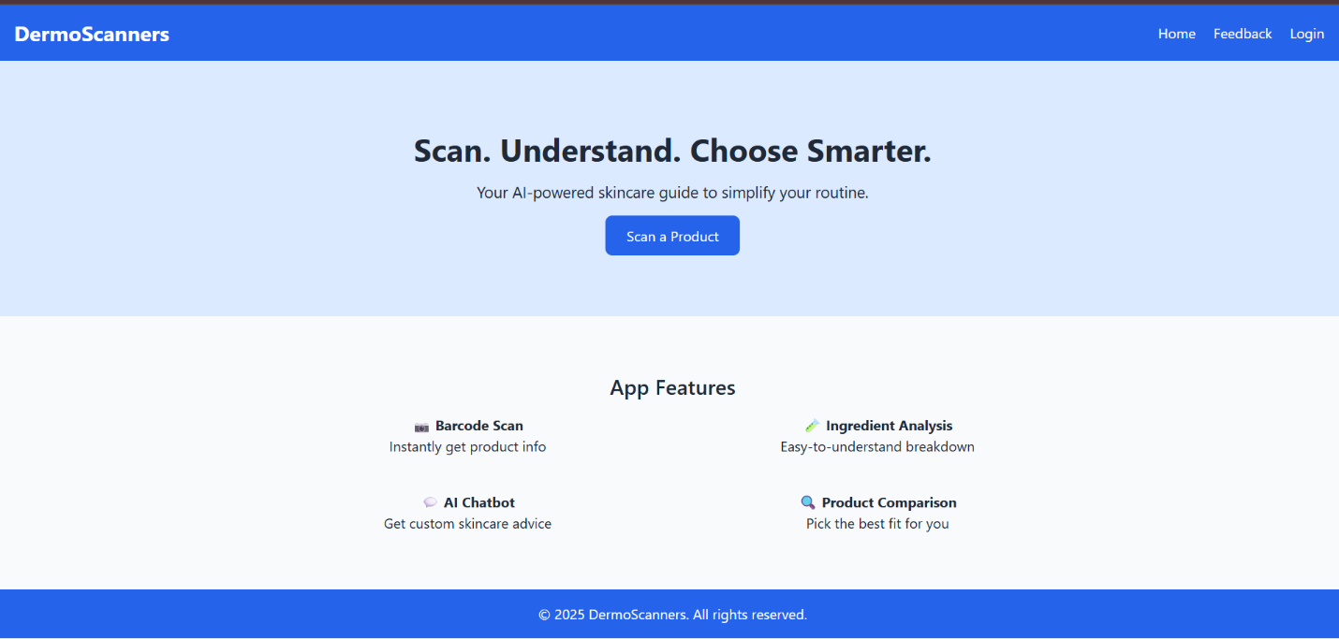
- Login Page - Allows users to access their personalized profile and safeguard their information.
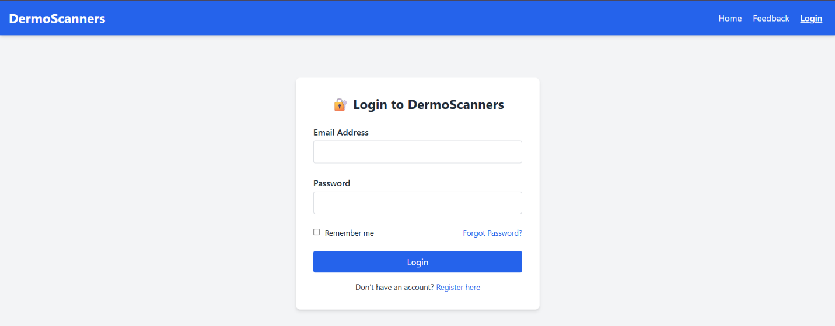
- Feedback Page - collects user feedback and suggestions to improve the app's experience.

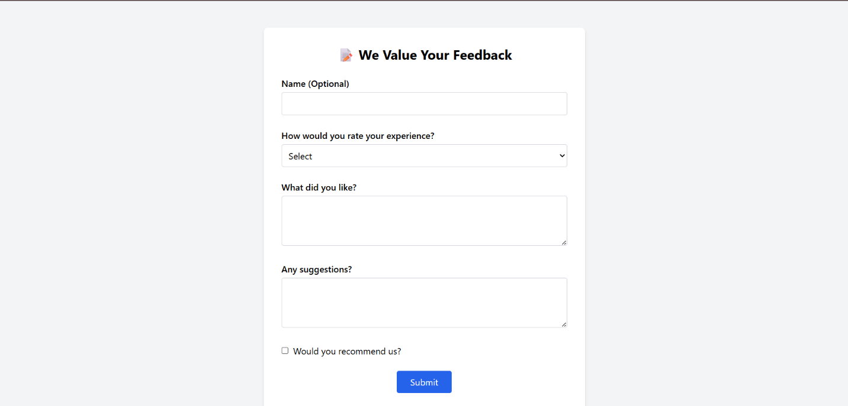
https://www.loom.com/share/efa9e7fb17604ed3925f8e5dfc5b1841?sid=e88b2647-0591-44df-9b35-b06da54a4398
- Scanner Page - enables users to scan skincare product barcodes.
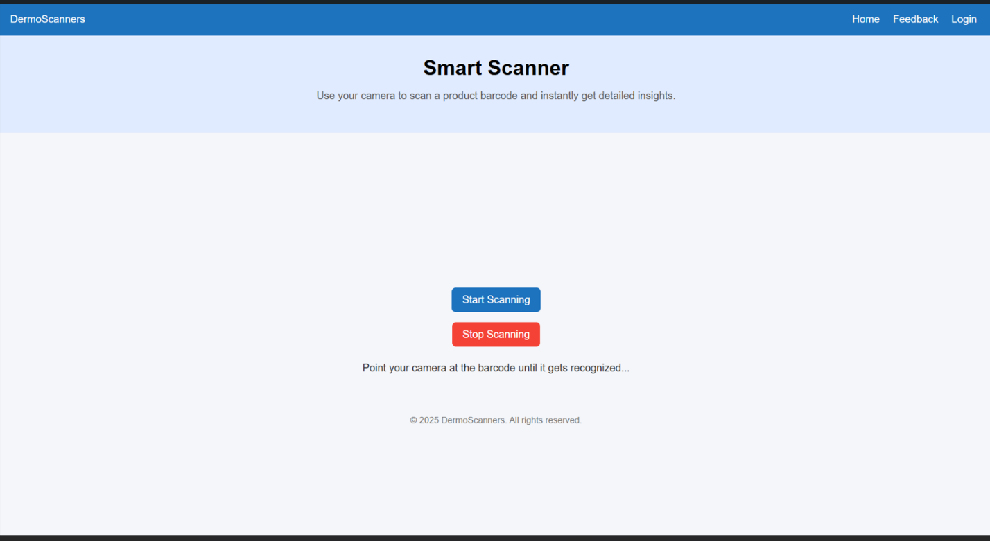
https://www.loom.com/share/c4bcd7b0c089495a8ff17a0db51f510e?sid=175bd7ea-723e-4c15-9fe1-f035518603ce
- AI Chatbot Advisor page - provides personalized skincare advice based on user input.
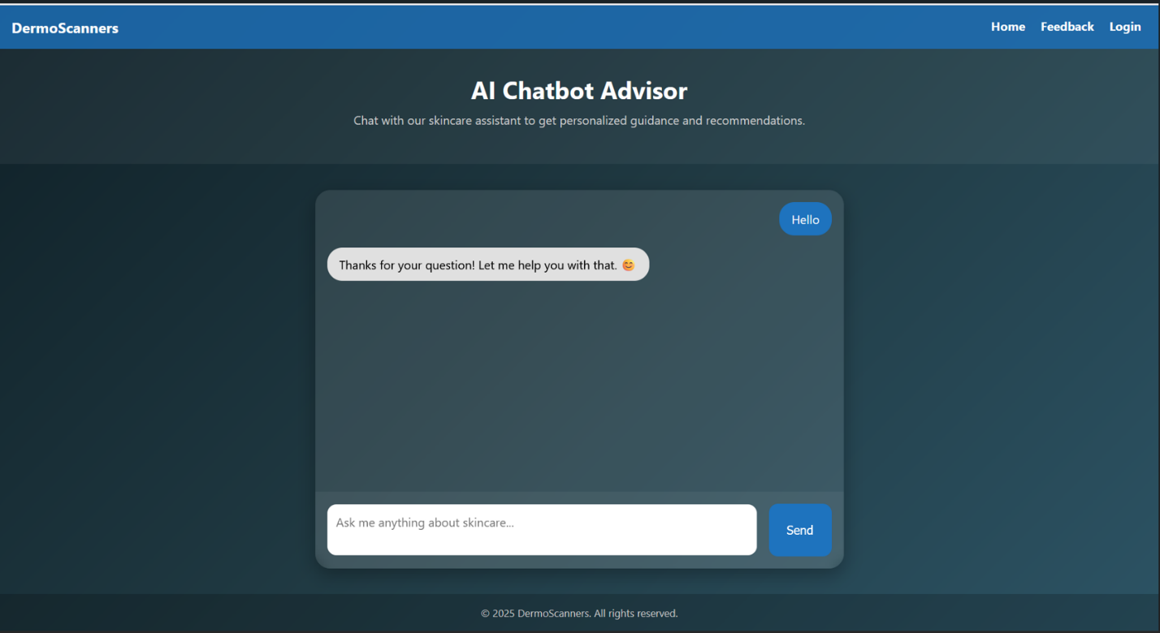
https://www.loom.com/share/50466672195a4847b9f6cae067c88d74?sid=a82bf43d-779a-4423-bc80-ab85776d8d63

- Product Description page - displays detailed product information.
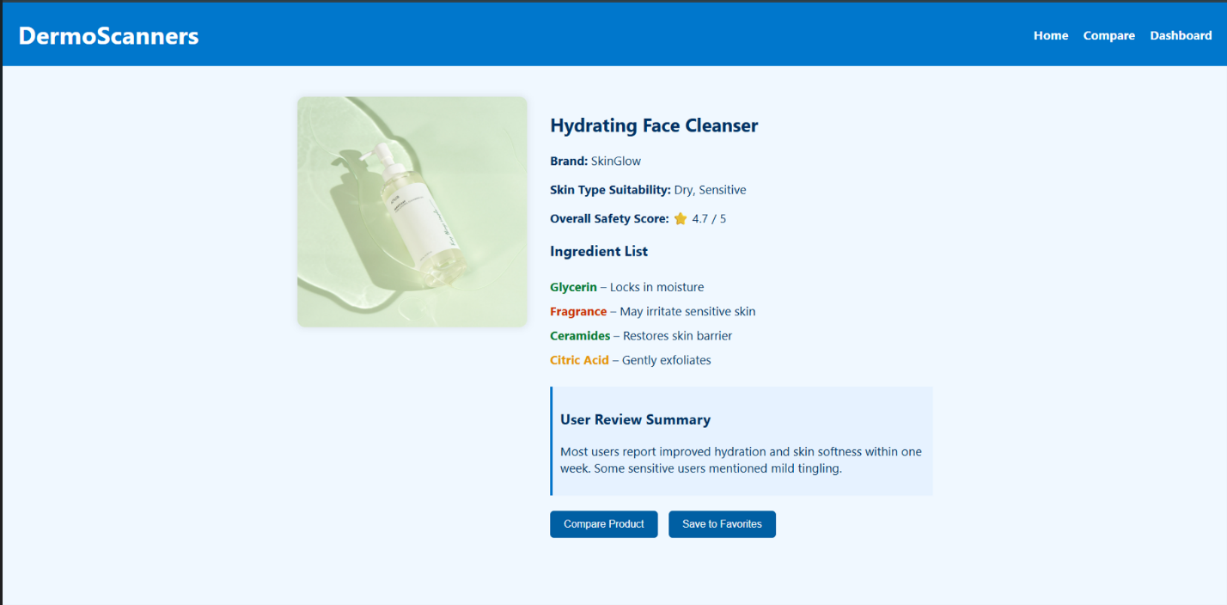
- Compare Products Page - lets users compare multiple products based on various factors.
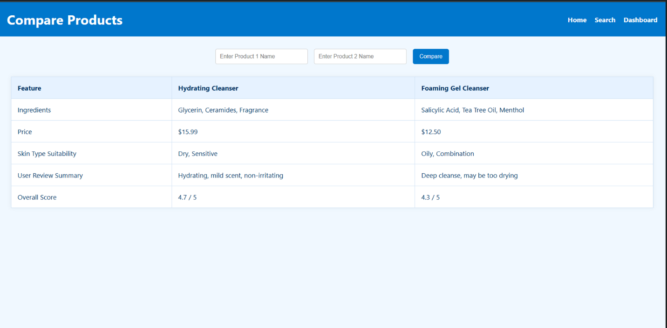
https://www.loom.com/share/512c5ad303aa4bf6a033fc38a64e3865?sid=52b556e3-10cc-43e7-90cf-08cce10845f8

Section 3

3.1 Data Flow Diagrams
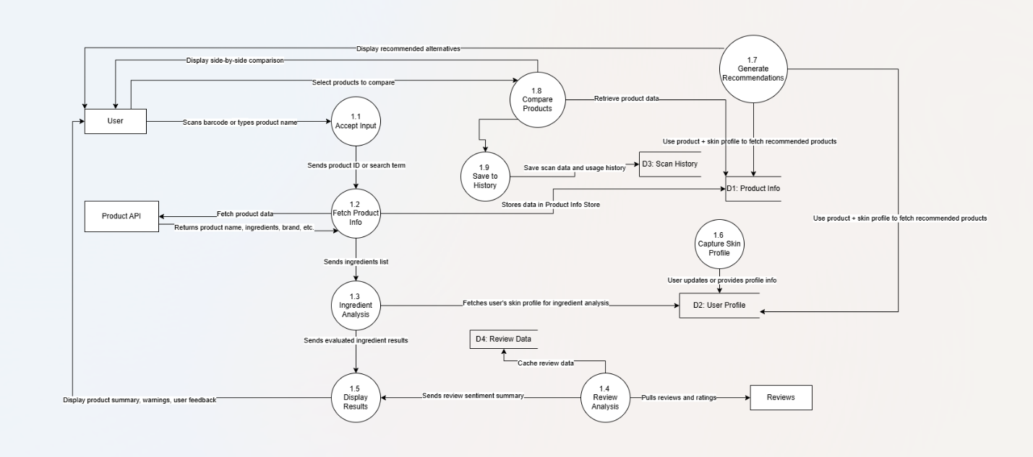

3.2 User Stories and related Use Case Scenarios

USE CASE 1: Scan Skincare Product
User Story:
As a skincare user,
I want to scan a product barcode or search by name, so that I can receive detailed and personalized information about its ingredients, reviews, and compatibility with my skin type.
Use Case Name: Scan Product
ID: DS1
Level: High Primary Actor: End User
Use Case Type: Detail, Essential

Stakeholders and Interests:
- Skincare End User - wants to scan a product and receive quick, personalized ingredients and safety information.
- System - wants to process the barcode or input and deliver accurate and helpful product details to the user.

Brief Description:
This case describes how a user scans or searches for a product to retrieve information such as ingredients, reviews, and suitability based on their skin profile.
Trigger:
The user launches the app and scans a product barcode or types in the product name.

Type: External

Relationships:
- Association: Skincare User
- Include: Ingredient Analysis, Review Analysis
- Extend: Save to History
- Generalization: Search for Product Info

Normal Flow of Events:

- The user opens the app and accesses the scanner.
- The user either scans a product barcode or enters a product name.
- The system calls the Product API using the barcode/keyword.
- The API returns product data including name, brand, ingredients, and ratings.
- The system performs Ingredient Analysis and pulls Review data.
- The system fetches the user's skin profile for matching ingredients.
- The product info and personalized feedback are displayed.
- The system optionally saves the product to the user's scan history.

Sub Flows:
S-1: Barcode Not Found
- The system displays a message: "Product not found. Try manual search or report this product."
- The user can manually enter the product name to continue.
S-2: Ingredient Analysis
- System cross-references ingredients against harmful/allergy-prone lists.
- Matches results with the user's skin profile (e.g., sensitive, oily).
- Provides red/yellow/green indicators based on risk.
S-3: Review Analysis
- System fetches user reviews from trusted sources.
- Performs sentiment analysis.
- Summarizes feedback in bullet points or rating bars.

Alternate Flows:
S-1.1a: Barcode unreadable - Prompt to retry or type manually.
S-1.2a: API partial response - Show available info only.

USE CASE 2: Generate Personalized Recommendations
As a skincare user, I want to receive product suggestions based on my skin profile and history, so that I can find products that are safer and more effective for my skin.
ID: DS2
Level: High Primary Actor: Skincare User
Use Case Type: Detail, Essential

Stakeholders and Interests:
- Skincare User - wants to receive skincare suggestions suited to their needs
- Healthcare Professionals - want users to make informed OTC skincare decisions

Brief Description:
This case describes how users receive recommendations that match their skin profile and history.

Trigger:
User scans a product or opens "Recommendations".

Type: External

Relationships:
- Association: Skincare User
- Include: Retrieve Skin Profile
- Extend: Compare Products, Save to History
- Generalization: Recommendation Engine

Normal Flow of Events:

- The user scans a product or opens the “Recommendations” tab.

- The system retrieves the user’s skin profile.

- The system fetches matching or similar products based on skin type, concern, and previously used products.

- System evaluates ingredients, reviews, and compatibility.

- Recommended products are sorted and shown with comparison features.

- User views side-by-side comparisons or saves suggestions for later.

Sub Flows:
S-1: No Profile Found
- The system prompts the user to fill out or update their skin profile.
- Once updated, recommendations are generated.
S-2: Compare with Scanned Product
- Recommendations are displayed side-by-side with the product just scanned.
- Ratings, prices, and ingredients are compared.

Alternate Flows:
S-1a: User skips profile - Show general advice.
S-2a: No match found - Show best-reviewed alternatives

USE CASE 3: Compare Skincare Products
As a skincare user, I want to compare multiple products side-by-side, so that I can choose the best one based on ratings, ingredients, and price.
ID: DS3
Level: High Primary Actor: Skincare User
Use Case Type: Detail, Essential

Stakeholders and Interests:
- Skincare User – wants to easily evaluate multiple skincare options side-by-side
- System – wants to help users make informed choices using comparison data

Brief Description:
Describes comparing two or more skincare products by features like price, safety, and ratings.

Trigger:
User selects products and clicks "Compare".

Relationships:
- Include: Fetch Product Info, Review Analysis
- Extend: Generate Recommendations

Normal Flow of Events:

- User browses or scans multiple skincare products.

- User marks/selects products to be compared.

- System retrieves all product data from the database or API.

- System performs ingredient and review analysis.

- System displays a visual comparison (side-by-side) of price, safety, suitability, and rating.

- User views comparison results and decides.

Sub Flows:
S-1: Highlight Best Option
- System highlights the most compatible or highest-rated product for the user.
- Displays a “recommended” badge or summary.

Alternate Flows:
S-1a: Only one product - Prompt user to add another.

USE CASE 4: Save Product History
As a skincare user, I want to have my scanned or viewed products saved, so that I can revisit or compare them later without scanning again.
ID: DS4
Level: Medium Primary Actor: Skincare User Use Case Type: Detail, Essential
Stakeholders and Interests:
- Skincare User – wants to keep track of previously viewed or scanned items
- System – wants to create better recommendations and user continuity

Brief Description:
Captures scanned/viewed products so users can revisit them later.

Trigger:
User scans or views a product.

Relationships:
- Include: Scan Product
- Extend: Profile Management

Normal Flow of Events:

- User scans or compares a product.
- System stores product ID, time/date, and any review/interaction data.
- System links this data to the logged-in user profile.
- User can later access history under “My History” or “Previously Viewed”.

Sub Flows:
S-1: Anonymous History
- If the user is not logged in, history is stored temporarily in browser cache.
- Upon logout or refresh, anonymous history may be cleared.

Alternate Flows:
S-1a: Storage or offline error - Alert user.

USE CASE 5: User Login and Registration
As a new or returning user, I want to sign up or log in securely, so that I can access personalized features and track my history.
ID: DS5
Level: High Primary Actor: Skincare User
Use Case Type: Detail, Essential

Stakeholders and Interests:

- Skincare User – wants secure access to their profile and personalized features

- System – wants to authenticate users and secure their data

Brief Description:
Allow user registration, login, and secure access.

Trigger:
User attempts to log in or sign up.

Relationships:
- Include: Manage Profile
- Extend: Personalized Features

Normal Flow of Events:

- User chooses to log in or register.

- System prompts for email and password.

- For new users, a verification email is sent.

- Upon success, user is logged in.

- System grants access to profile-based features.

Sub Flows:
S-1: Forgot Password
- User clicks “Forgot Password”.
- System sends password reset link.
- User resets password and logs in.

Alternate Flows:
S-1a: Incorrect login - Retry message.

USE CASE 6: Submit Feedback
As a user or tester, I want to submit my feedback and suggestions, so that the developers can improve the app’s usability and functionality.
ID: DS6
Level: Medium Primary Actor: User or Tester Use Case Type: Detail, Essential
Stakeholders and Interests:
- Users/Testers – want to share feedback or issues to improve app quality
- Developers/Team – want user input for continuous improvement

Brief Description:
Describes how a user gives feedback to improve the app.

Trigger:
The user accesses the feedback form.

Relationships:
- Extend: App Improvement Cycle

Normal Flow of Events:

- User accesses the Feedback page.

- User fills in form with comments, issue types, or suggestions.

- User submits the form.

- System stores the feedback in the database.

- Team reviews feedback periodically for improvements.

Sub Flows:

S-1: Rate a Product Feature
- User provides star-rating or emoji-based reaction.
- System stores with timestamp and user ID.

Alternate Flows:
S-1a: Guest feedback - System marks anonymous.

3.3 Activity Diagrams
1. Scan Skincare Product
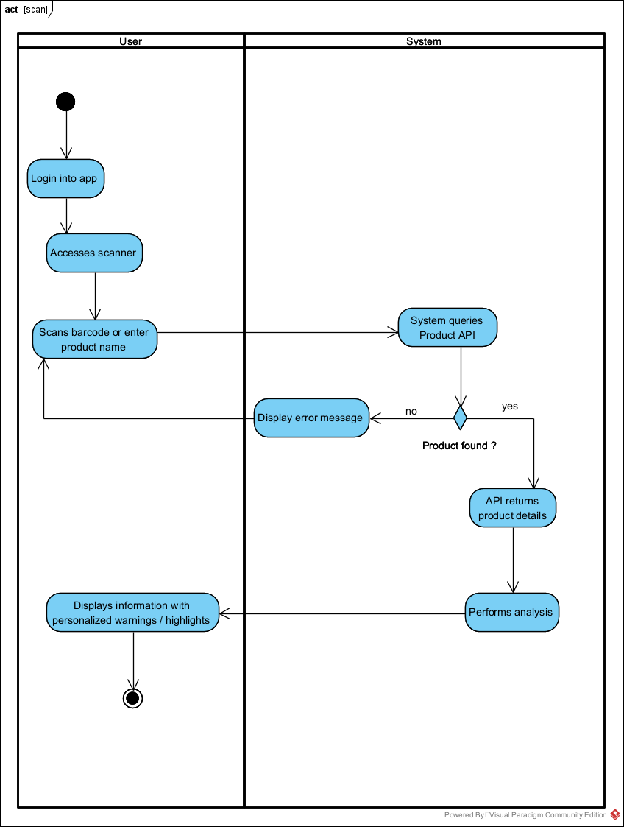

2. Generate Recommendations
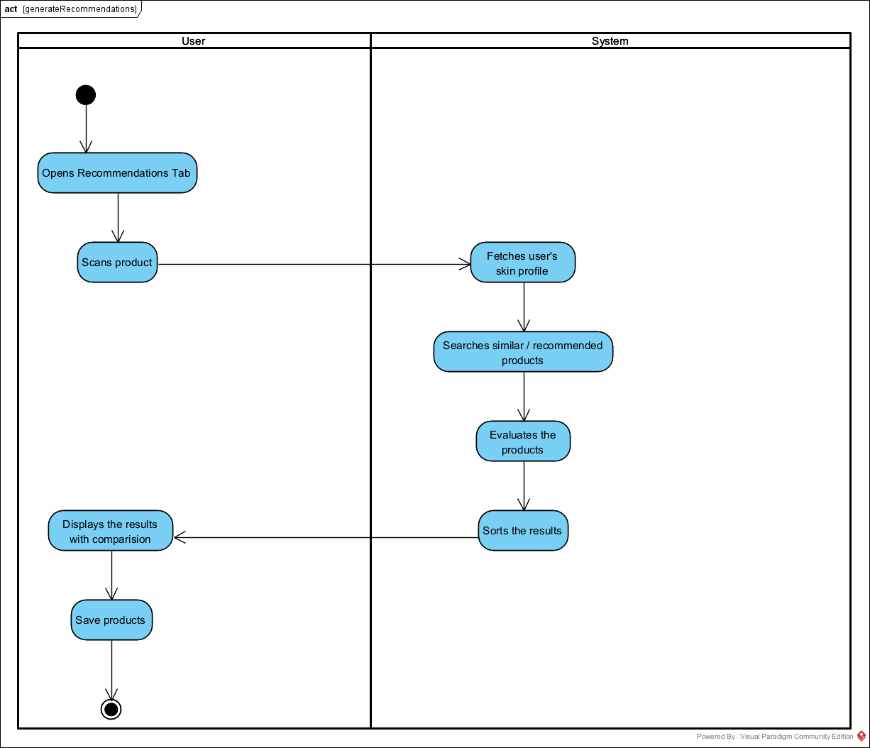

3. Compare Products
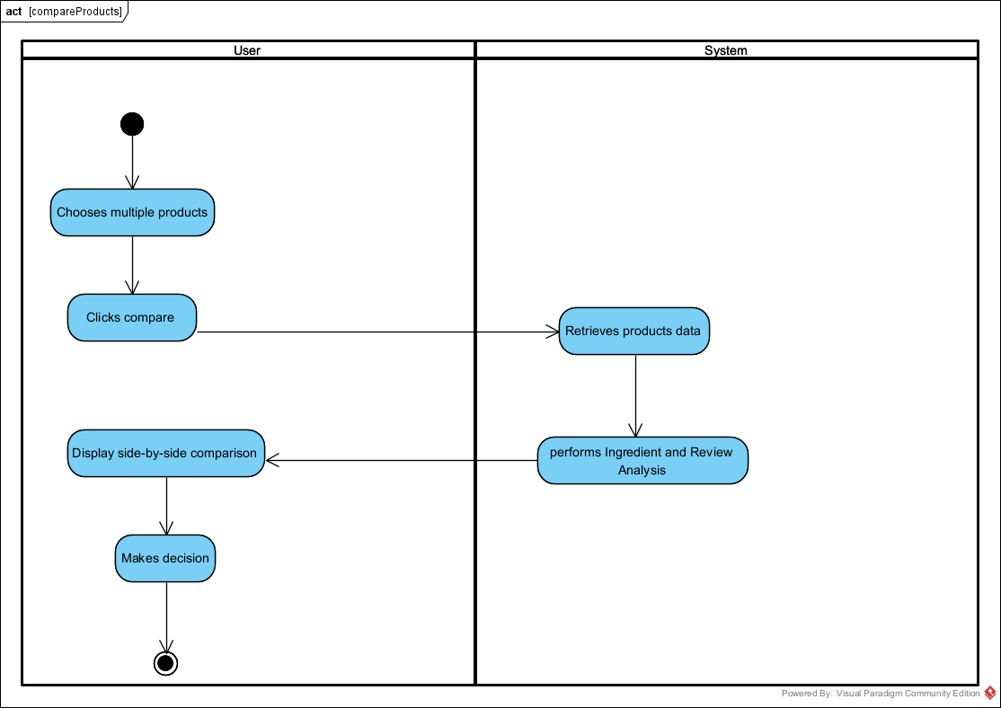

4. Save Product History
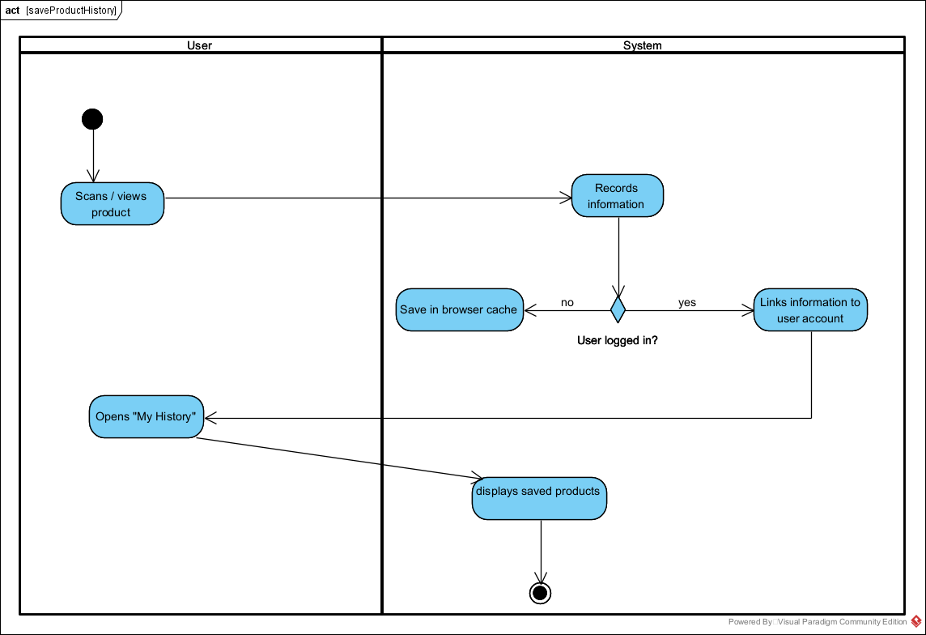

5. User Login
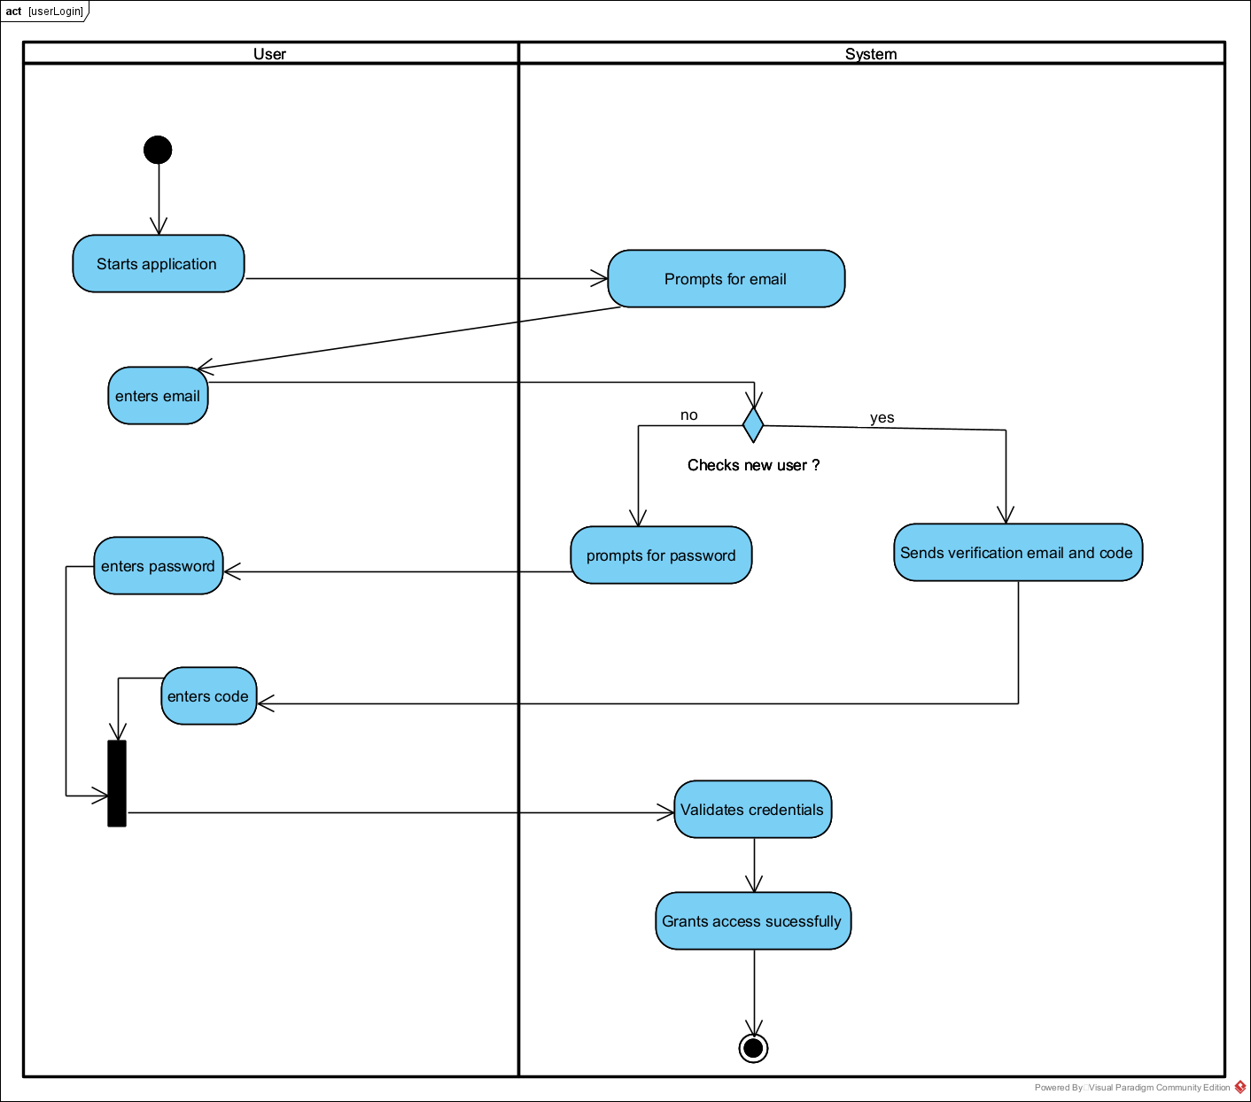

6. User Feedback
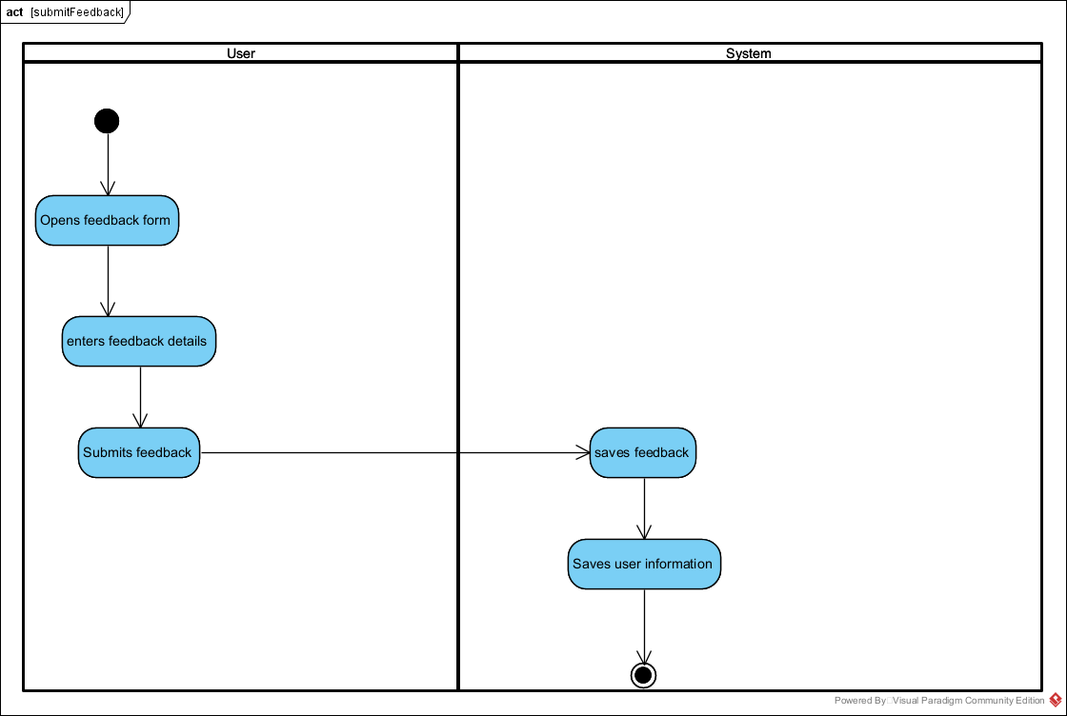

3.4 Business Rules

Business Rule # | Description | Activity Diagram | Related UCS | UI  Mock-up
BR1 | The system must support barcode scanning using a mobile or webcam device. | AD1 | DS1 | UI 2.8.1
BR2 | If the barcode is invalid or unreadable, the user is prompted to retry or enter product name manually. | AD1 | DS1 | UI 2.8.1
BR3 | The system must connect to a product API to fetch product data (name, ingredients, ratings, etc.). | AD1 | DS1 | UI 2.8.1
BR4 | Ingredient details must be simplified using plain, understandable language. | AD1 | DS1 | UI 2.8.1
BR5 | Ingredient safety must be assessed using a predefined database of allergens and harmful chemicals. | AD1 | DS1 | UI 2.8.1
BR6 | The product must be evaluated against the user's skin profile to display personalized warnings or suitability. | AD1 | DS1 | UI 2.8.1
BR7 | System must show ingredients with risk indicators. | AD1 | DS1 | UI 2.8.1
BR8 | System must perform review sentiment analysis and summarize in charts or bullet points. | AD1 | DS1 | UI 2.8.1
BR9 | The system must optionally save the scanned product to the user's history (if logged in). | AD1 | DS1 | UI 2.8.1
BR10 | The system must retrieve the user’s skin profile before generating any recommendations. | AD2 | DS2 | UI 2.8.4
BR11 | If no profile is available, user is prompted to complete or update one before continuing. | AD2 | DS2 | UI 2.8.4
BR12 | Recommendations must be based on previously scanned/viewed products and ingredient compatibility. | AD2 | DS2 | UI 2.8.4
BR13 | The system must evaluate new recommendations using user skin type, skincare goals, and allergies. | AD2 | DS2 | UI 2.8.4
BR14 | Recommendations must be displayed with rating, ingredient safety, price, and skin compatibility. | AD2 | DS2 | UI 2.8.4
BR15 | If no exact matches are found, top-rated or trending alternatives must be shown. | AD2 | DS2 | UI 2.8.4
BR16 | User must be able to save recommended products to their list for later access. | AD2 | DS2 | UI 2.8.4
BR17 | The system must allow the user to select at least two products for comparison. | AD3 | DS3 | UI 2.8.7
BR18 | Each selected product must be fetched from the same API and include detailed ingredient and review info. | AD3 | DS3 | UI 2.8.7
BR19 | The comparison view must include name, brand, price, rating, ingredient safety, and suitability. | AD3 | DS3 | UI 2.8.7
BR20 | Products must be shown in a side-by-side visual table or card format. | AD3 | DS3 | UI 2.8.7
BR21 | The system must highlight the most compatible or highest-rated product with a badge | AD3 | DS3 | UI 2.8.7
BR22 | If only one product is selected, the system prompts the user to select another. | AD3 | DS3 | UI 2.8.7
BR23 | When a user scans or views a product, the system must log the product ID, time, and interaction type. | AD4 | DS4 | UI 2.8.6
BR24 | Product history must be stored under the logged-in user's account and accessible under “My History” | AD4 | DS4 | UI 2.8.6
BR25 | For anonymous users, history must be saved temporarily using browser local/session storage. | AD4 | DS4 | UI 2.8.6
BR26 | On logout or expiration, temporary history must be cleared. | AD4 | DS4 | UI 2.8.6
BR27 | Users must be able to revisit and re-analyze products from history without scanning again. | AD4 | DS4 | UI 2.8.6
BR28 | New users must register with a valid email and a strong password. | AD5 | DS5 | UI 2.8.2
BR29 | The system must securely store user credentials using hashed and salted encryption. | AD5 | DS5 | UI 2.8.2
BR30 | Existing users must be able to log in with their registered email and password. | AD5 | DS5 | UI 2.8.2
BR31 | Users must receive a verification email upon registration. | AD5 | DS5 | UI 2.8.2
BR32 | The Forgot Password feature must send a secure reset link to the user's email. | AD5 | DS5 | UI 2.8.2
BR33 | All authenticated sessions must be secured using HTTPS and session/token-based methods. | AD5 | DS5 | UI 2.8.2
BR34 | Only logged-in users can access personalized features (like history, profile, recommendations). | AD5 | DS5 | UI 2.8.2
BR35 | Users must be able to submit feedback through a structured form | AD6 | DS6 | UI 2.8.3
BR36 | Feedback must be stored with a timestamp and user ID if logged in or marked as anonymous. | AD6 | DS6 | UI 2.8.3
BR37 | Users can optionally provide ratings for features or experiences. | AD6 | DS6 | UI 2.8.3
BR38 | Submitted feedback must be reviewed by the development team on a scheduled basis. | AD6 | DS6 | UI 2.8.3
BR39 | Users must receive a brief confirmation after successful submission. | AD6 | DS6 | UI 2.8.3

Section 4 – Domain Class

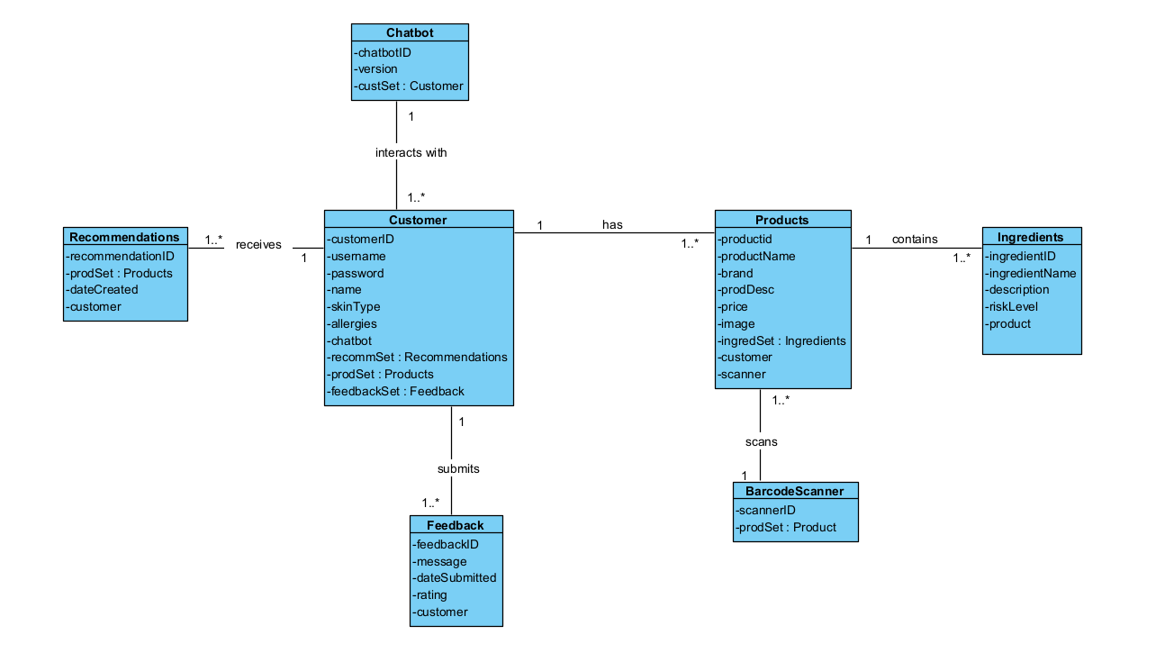

Section 5 – Database
-- Step 1: Create the database and select it
-- CREATE DATABASE IF NOT EXISTS dermoscanners_db;
-- USE dermoscanners_db;

-- Step 2: Create Genres table
CREATE TABLE IF NOT EXISTS Genres (
GenreID INT PRIMARY KEY AUTO_INCREMENT,
Name VARCHAR(100),
Description TEXT
) ENGINE=InnoDB;

-- Step 3: Create Customer table
CREATE TABLE IF NOT EXISTS Customer (
customerID INT PRIMARY KEY AUTO_INCREMENT,
Name VARCHAR(100),
Email VARCHAR(100) UNIQUE,
Password VARCHAR(255),
Phone VARCHAR(15),
Address VARCHAR(255),
SkinType VARCHAR(50),
SkinGoals TEXT
) ENGINE=InnoDB;

-- Step 4: Create Products table
CREATE TABLE IF NOT EXISTS Products (
ProductID INT PRIMARY KEY AUTO_INCREMENT,
Name VARCHAR(100),
Brand VARCHAR(100),
Barcode VARCHAR(100),
Price DECIMAL(10,2),
Rating DECIMAL(3,2),
Description TEXT,
GenreID INT,
FOREIGN KEY (GenreID) REFERENCES Genres(GenreID)
) ENGINE=InnoDB;

-- Step 5: Create Ingredients table
CREATE TABLE IF NOT EXISTS Ingredients (
IngredientID INT PRIMARY KEY AUTO_INCREMENT,
Name VARCHAR(100),
Description TEXT,
SafetyLevel VARCHAR(20)
) ENGINE=InnoDB;

-- Step 6: Create Reviews table
CREATE TABLE IF NOT EXISTS Reviews (
ReviewID INT PRIMARY KEY AUTO_INCREMENT,
ProductID INT,
customerID INT,
ReviewDate TIMESTAMP DEFAULT CURRENT_TIMESTAMP,
Rating INT CHECK (Rating BETWEEN 1 AND 5),
Comment TEXT,
SentimentScore DECIMAL(3,2),
FOREIGN KEY (ProductID) REFERENCES Products(ProductID),
FOREIGN KEY (customerID) REFERENCES Customer(customerID)
) ENGINE=InnoDB;

-- Step 7: Create Recommendations table
CREATE TABLEIF NOT EXISTS Recommendations (
RecommendationID INT PRIMARY KEY AUTO_INCREMENT,
customerID INT,
ProductID INT,
Date TIMESTAMP DEFAULT CURRENT_TIMESTAMP,
CompatibilityScore DECIMAL(3,2),
FOREIGN KEY (customerID) REFERENCES Customer(customerID),
FOREIGN KEY (ProductID) REFERENCES Products(ProductID)
) ENGINE=InnoDB;

-- Step 8: Create ScanHistory table
CREATE TABLE IF NOT EXISTS ScanHistory (
HistoryID INT PRIMARY KEY AUTO_INCREMENT,
customerID INT,
ProductID INT,
ScanDate TIMESTAMP DEFAULT CURRENT_TIMESTAMP,
FOREIGN KEY (customerID) REFERENCES Customer(customerID),
FOREIGN KEY (ProductID) REFERENCES Products(ProductID)
) ENGINE=InnoDB;

-- Step 9: Create Feedback table
CREATE TABLE IF NOT EXISTS Feedback (
FeedbackID INT PRIMARY KEY AUTO_INCREMENT,
customerID INT,
SubmissionDate TIMESTAMP DEFAULT CURRENT_TIMESTAMP,
Comments TEXT,
FeatureRating INT CHECK (FeatureRating BETWEEN 1 AND 5),
FOREIGN KEY (customerID) REFERENCES Customer(customerID)
) ENGINE=InnoDB;

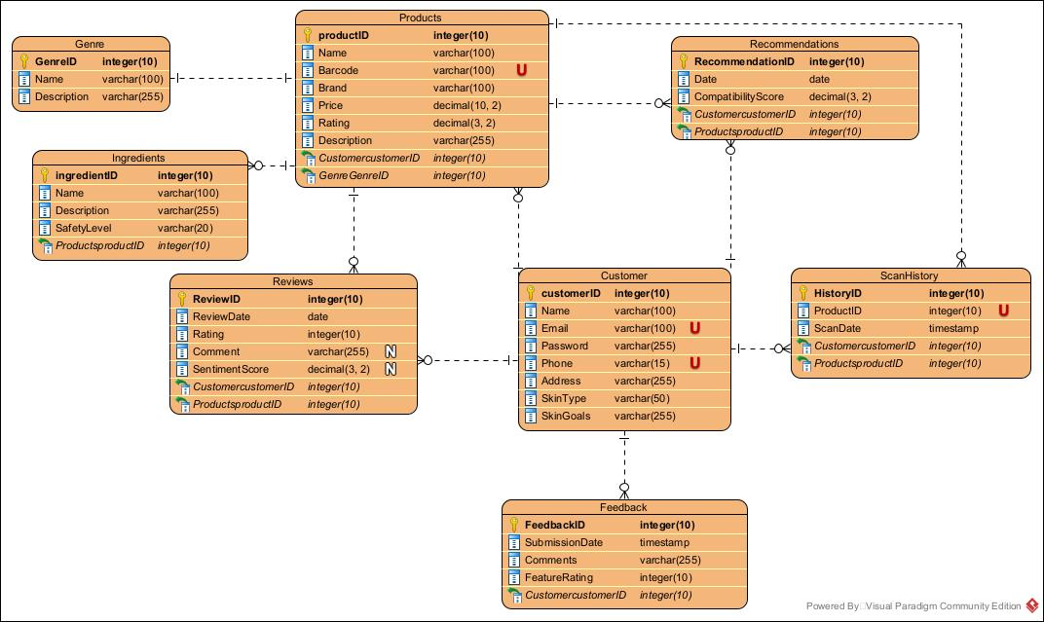

Data Dictionary
Table- Customer
Field Name | Data Type | Description
customerID | INT (PK) | Unique identifier for the user
name | VARCHAR(100) | Full name of the user
email | VARCHAR(100) | Email address
password_hash | VARCHAR(255) | Encrypted user password
skin_type | VARCHAR(50) | Skin type of the user
skin_goals | VARCHAR(255) | Skincare goals/preferences
preferred_brands | TEXT | Comma-separated list of preferred brands
created_at | TIMESTAMP | Registration date

Table- Products
Field | Type | Description
ProductID | INT (PK) | Unique identifier for product
Name | VARCHAR(100) | Product name
Brand | VARCHAR(100) | Product brand
Barcode | VARCHAR(100) | Barcode number
Price | DECIMAL(10,2) | Product price
Rating | DECIMAL(3,2) | Average product rating
Description | TEXT | Product description
GenreID | INT (FK) | Genre identifier

Table- Ingredients
Field | Type | Description
IngredientID | INT (PK) | Unique identifier for ingredient
Name | VARCHAR(100) | Ingredient name
Description | TEXT | Ingredient description
SafetyLevel | VARCHAR(20) | Safety level of ingredient

Table- Reviews
Field | Type | Description
ReviewID | INT (PK) | Unique identifier for review
ProductID | INT (FK) | Reviewed product identifier
UserID | INT (FK) | Reviewing user identifier
ReviewDate | TIMESTAMP | Date of review
Rating | INT | Rating (1 to 5)
Comment | TEXT | Review comment
SentimentScore | DECIMAL(3,2) | Sentiment analysis score

Table- Recommendations
Field | Type | Description
RecommendationID | INT (PK) | Unique identifier
UserID | INT (FK) | Recommended for user
ProductID | INT (FK) | Recommended product
Date | TIMESTAMP | Recommendation date
CompatibilityScore | DECIMAL(3,2) | User-product compatibility score
Table- Genres
Field | Type | Description
GenreID | INT (PK) | Unique genre identifier
Name | VARCHAR(100) | Genre name
Description | TEXT | Genre description

Table-ScanHistory
Field | Type | Description
HistoryID | INT (PK) | Unique identifier
UserID | INT (FK) | Scanning user identifier
ProductID | INT (FK) | Scanned product identifier
ScanDate | TIMESTAMP | Scan date

Table- Feedback
Field | Type | Description
FeedbackID | INT (PK) | Unique feedback identifier
UserID | INT (FK) | User providing feedback
SubmissionDate | TIMESTAMP | Feedback submission date
Comments | TEXT | User comments
FeatureRating | INT | Rating (1 to 5)

Section 6 – Project Management

6.1 Work Breakdown Structure
Level 1: Product Goal (Epic Level)
- DermoScanners – AI-Powered Skincare Recommendation Web Platform to aid people with their skincare needs.

Level 2: Major Deliverables (Epics / High-Level Features)
1.1 User Registration, Login & Profile Management
1.2 Product Scanning & Barcode Recognition
1.3 Skincare Product Detail Viewer
1.4 Review Sentiment Analysis & Comparison Engine
1.5 Personalized Recommendation System
1.6 Chatbot Interaction for Skincare Queries
1.7 Admin Dashboard & Feedback Management
1.8 Frontend Design, Deployment & Maintenance

Level 3: User Stories (Backlog Features per Epic)
1.2 Product Scanning & Barcode Recognition
- 1.2.1 As a user, I can scan or input a product barcode to retrieve product details.
- 1.2.2 As a user, I receive an alert if a product barcode is not found.
- 1.2.3 As a user, I can manually search for products if the barcode fails.
- 1.2.4 As a user, I can view matched skincare categories based on the product type.
1.4 Review Sentiment Analysis & Comparison
- 1.4.1 As a user, I can view average rating and key review insights for a scanned product.
- 1.4.2 As a user, I can compare multiple skincare products based on review quality and sentiment.
- 1.4.3 As a user, I can sort comparison results by ingredients, price, or user satisfaction.
1.6 Chatbot Interaction for Skincare Queries
- 1.6.1 As a user, I can ask product questions through a chatbot interface.
- 1.6.2 As a user, I receive personalized product suggestions from the chatbot.
- 1.6.3 As a user, I can follow up questions for more refined recommendations.

Level 4: Sprint-Level Task Breakdown (Example for 1.2.1)
1.2.1 Scan/Input Barcode to Retrieve Product Details
- 1.2.1.1 Design UI screen for barcode scanning and manual entry
- 1.2.1.2 Integrate barcode scanning library/API
- 1.2.1.3 Develop backend API to fetch product data from DB
- 1.2.1.4 Connect frontend input with backend API
- 1.2.1.5 Test barcode detection on desktop and mobile
- 1.2.1.6 Create fallback flow for failed scans
- 1.2.1.7 Demo feature in sprint review and gather feedback

Summary
Level | Purpose
Level 1 | Product Goal (Epic) – What are we building?
Level 2 | Major Modules/Features
Level 3 | User Stories to go in the backlog
Level 4 | Sprint tasks that go into sprints and tracking

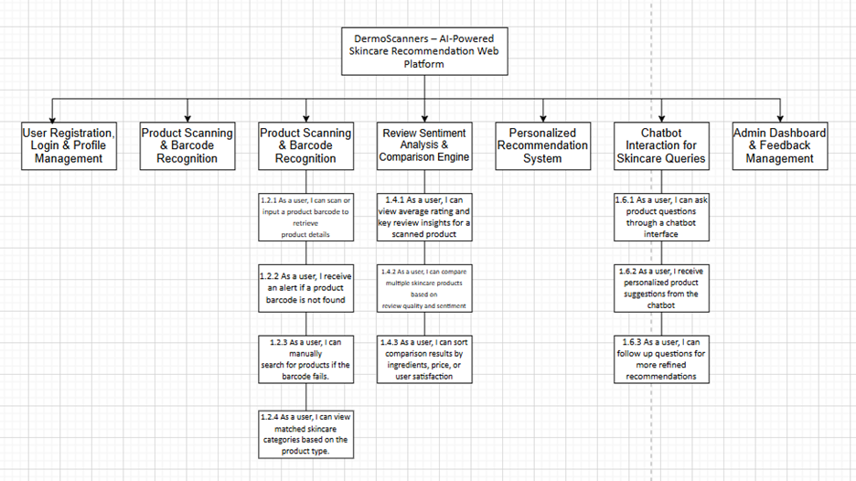

6.2 Milestones & Acceptance Criteria
Milestone 1: Initial Setup & Stakeholder Alignment (Week 2)
Purpose: Define clear project scope, initial requirements, and team alignment.
Acceptance Criteria:
- Approved SRS by stakeholders.
- Project backlog created with initial user stories.
- Roles and responsibilities clearly documented.
- Agile planning meetings scheduled.
Milestone 2: Database & ERD Establishment (Week 4)
Purpose: Establish foundational database architecture and ERD implementation.
Acceptance Criteria:
- Final ERD and Data Dictionary approved.
- Database created using provided SQL scripts.
- Initial domain classes and schema verified.
- Basic CRUD operations tested successfully.
Milestone 3: User Authentication & Profile Features (Week 7)
Purpose: Enable secure user authentication and personalized profile management.
Acceptance Criteria:
- Registration, login/logout, and password management operational.
- Profile creation/editing functions (skin type, preferences) verified.
- Secure authentication mechanisms tested (encryption, session handling).
Milestone 4: Barcode Scanner & Product Identification (Week 9)
Purpose: Implement barcode scanning and product retrieval capabilities.
Acceptance Criteria:
- Functional barcode scanner integrated into the app.
- Accurate retrieval of product data upon scanning.
- Error handling in place for unreadable/missing barcodes.
- Demo performed successfully, and feedback integrated.
Milestone 5: Ingredient Safety & Sentiment Review Analysis (Week 11)
Purpose: Provide ingredient safety assessment and product reviews summarized with sentiment analysis.
Acceptance Criteria:
- Ingredient database integrated; risk indicators accurate.
- Sentiment analysis module tested and integrated for product reviews.
- Product details page clearly displays ingredients and review summaries.
Milestone 6: AI Chatbot & Personalized Skincare Advice (Week 12)
Purpose: Introduce AI chatbot functionality to deliver personalized skincare recommendations.
Acceptance Criteria:
- AI chatbot responds correctly to user inquiries.
- Personalized recommendations align with user skin profiles and goals.
- Initial user testing demonstrates chatbot accuracy and usability.
Milestone 7: Product Comparison & History Tracking (Week 14)
Purpose: Allow product comparison and maintain user interaction history.
Acceptance Criteria:
- Product comparison features fully functional and user-friendly.
- User interaction history (product scans, views, comparisons) accurately recorded and retrievable.
- User testing confirms feature usefulness and stability.
Milestone 8: Feedback & Continuous Improvement Loop (Week 16)
Purpose: Collect and incorporate user feedback to enhance application quality.
Acceptance Criteria:
- User feedback forms accessible and easy to use.
- Usability testing with real users conducted; at least 15 participants involved.
- Feedback analyzed, documented, and improvement backlog items prioritized.
Milestone 9: Final Integration & Deployment Readiness (Week 18)
Purpose: Prepare final app version integrating all functionalities and ready it for deployment.
Acceptance Criteria:
- All modules (authentication, scanning, ingredients, reviews, chatbot, comparisons) fully integrated.
- Application meets defined performance (response times) and security standards.
- Regression testing confirms no critical issues remain.
- Comprehensive stakeholder demo completed and approved.
Milestone 10: Production Deployment & Project Retrospective (Week 20)
Purpose: Successfully deploy the final product and conduct project closure activities.
Acceptance Criteria:
- Application deployed to live production environment successfully.
- Final stakeholder approval and sign-off achieved.
- Project retrospective meeting held; lessons learned documented for future projects.
- Final documentation and handover completed.
Milestone | Timeframe | Purpose | Acceptance Criteria
1. Project Kickoff &  Requirements  Alignment | Week 2 | Define clear scope and requirements | - Stakeholders approve SRS and UX/UI wireframes.  - Project backlog created and prioritized.  - Agile ceremonies scheduled.
2. Database & ERD  Establishment | Week 4 | Set up foundational database & ERD | - ERD finalized and approved.  - Database tables created and tested.  - Domain classes confirmed.
3. User Authentication  & Profile Management | Week 6 | Secure user registration and profile management | - Users can register, login/logout, reset passwords.  - Profiles (skin type, preferences) editable.  - Feature demo approved.
4. Barcode Scanning &  Product Data Retrieval | Week 8 | Enable product identification through scanning | - Functional barcode scanner integrated.  - Accurate product data retrieval.  - Robust error handling implemented.
5. Ingredient &  Sentiment Review  Analysis | Week 10 | Integrate ingredient safety and review sentiment | - Ingredient risks displayed (High, Medium, Low).  - Reviews accurately summarized with sentiment analysis.  - QA testing passed.
6. AI Chatbot &  Personalized  Recommendations | Week 12 | Implement AI chatbot functionality | - Chatbot delivers personalized skincare advice.  - Recommendations based on user profiles accurate.  - User testing conducted.
7. Product Comparison  & User History | Week 14 | Allow product comparisons & history tracking | - Side-by-side product comparisons functional.  - User interaction history logged accurately.  - Feature testing and approval.
8. Feedback Integration  & Usability Loop | Week 16 | Gather user feedback for continuous improvement | - Feedback form accessible.  - Minimum 15 user feedback sessions.  - Feedback analyzed, improvements documented.
9. Final Release  Candidate &  Deployment | Week 18 | Prepare final app for launch | - All features fully integrated and tested  .- Performance and security benchmarks met.  - Stakeholder demo and approval.
10. Project Closure &  Retrospective | Week 20 | Official project closure & final deployment | - Application deployed to production  - Stakeholder sign-off achieved.  - Retrospective and documentation completed.

Section 7 – Product Backlog & Implementation Schedule

User Story 1: Registration of users
User Story:
I would like as a new user to create an account, because I would like to have a possibility to save my skincare choice and have personal recommendations to the products.
Description:
A registration form will provide a means of creating a new user account, where the user will enter their name, email, password, skin type and goal. The system will also be validating inputs, have strong password regulations and will not allow a duplicate registration of email. A successful registration process records user information and directs the user to the dashboard or log in page.
Acceptance Criteria:
- The form for registration includes fields for name, email, password, skin type, and skincare goals fields.
- Strong password policy, the passwords must meet certain requirements.
- Duplication of emails is prevented.
- When they have successfully registered, they are redirected to dashboard or login.
Testing Scenarios:
- Valid input and register should redirect to create an account
- Sign up with old email should show duplicate warning
- Sign up with poor password should show error message
- empty fields in the form should show error
Technical Notes:
- Frontend: HTML form with React and validation
- Backend: Node.js or PHP

User Story 2: Barcode Scan Product Info
User Story:
As a skincare consumer, I would like to scan the barcode of a product, and obtain detailed information about the product, easy to read and understand so that I can quickly know the information about that product before purchasing it.
Description:
This factor enables the users to easily source information about a product by either scanning a barcode with a camera or typing the barcode manually. When the correct barcode is scanned then proper product details will be taken and displayed such as brand name, the overall rating, ingredient list, product category. When barcode is not in the database, a user receives a simple message, that this product is not known. This improves the shopping experience as the users are now informed to make the decisions on the transparency of product content, and reputation.
Acceptance Criteria:
- A camera at the back of the tool or manual typing of the barcode is possible for the users.
- Proper barcodes will give details about the entire product details including brand, ingredients and ratings.
- The barcodes that are invalid or not recognized yield a clear message of Products not found
- In case of failure in scanning or when it is not supported, there is the manual entry option.
- Runs on both mobile and desktop.
Testing Scenarios:
- Use a barcode scanner with a camera to scan barcode to display information
- Manually providing an effective barcode to display information
- A fake or invalid barcode is entered should result in product not found
- Analyzing through a mobile and desktop device
- Poor lighting results in reading failures
Technical Notes:
- Frontend: JavaScript barcode scanning library to use a camera and a backup text field to manually type.
- Backend: API endpoint accepts barcode

User Story 3: Product Comparison User Story
User Story:
Being a user of skincare products, I am interested in comparing at least two or more products to be able to decide on which to use on my skin.
Description:
Customers are also able to browse through various goods and compare the main parameters of such goods to make informed choices about ingredients, prices, ratings, safety ratings, etc.
Acceptance Criteria:
- At least two products must be compared.
- Rating, price, ingredients, and safety should be displayed
- The choice of either clearing the comparison or returning to the list of products.
Testing Scenarios:
- Comparing 2 products through comparison chart
- Selecting one product and comparing with a list
- Comparing 3 products
Technical Notes:
Frontend: Comparison table (JavaScript/HTML/CSS)

User Story 4: Reviews based Product Recommendations
User Story:
As a skincare avid I would prefer the system to advise me on products regarding reviews and sentiment analysis and get to find well rated and well-reviewed products.
Description:
Sentiment analysis on user reviews is applied in the system to help recommend skincare products with a greater satisfaction rate and negative reviews.
Acceptance Criteria:
- Sentiment is analyzed against review text.
- Recommended products are provided with sentiment rating and score.
- The compatibility factor is taken with regard to the skin types.
Testing Scenarios:
- Write product ratings to look at the sentiment analysis outcome.
- See relevant suggestions in list view
- Enter bogus reviews or go blank
Technical Notes:
- Frontend: Show recommended product card
- Backend: Python
User Story 5: Chatbot
User story:
As a user, I want to chat with a skincare assistant chatbot, so that I can get instant product suggestions tailored to my needs.
Description:
The chatbot provides real-time recommendations based on user inputs like “best moisturizers for dry skin” and guides them through follow-up questions.
Acceptance Criteria:
Accepts natural language queries.
Recommends at least 3 products with ratings and pricing.
Offers follow-up prompts for clarification or next steps.
Testing Scenarios:
Ask about acne-friendly cleanser to get results.
Ask unclear question - Chatbot asks clarifying question.
Ask random input - Chatbot handles with fallback response.
Technical Notes:
Frontend: Chat interface (HTML/CSS, JavaScript event handling)
Backend: Python Flask or Node.js chatbot logic
Integration: Possible use of OpenAI API or custom NLP logic
Database: Products, Customer, Genres
User Story 6: History
User story:
As a returning user, I want to view my past scanned products, so that I can revisit the ones I liked or researched earlier.
Description:
This feature shows a history of all scanned products per user session or account, with timestamps and links back to their details.
Acceptance Criteria:
Logged-in users can view scan history in profile.
Clicking a product opens its full detail page.
Users can clear individual items or entire history.
Testing Scenarios:
Scan 2 or more products - History updates accordingly.
Click product - Navigates correctly to product detail.
Clear history - Confirms and removes list.
Technical Notes:
Frontend: History UI (React/list component)
Backend: API to query ScanHistory by customerID
Database: ScanHistory, Products

Section 8 – Client/Faculty Sign-off

TEAM MEMBER | SIGNATURE | DATE
Khwahish Vaid (Project Manager and AI Lead) | harsimran | 10.8.2025
Arshdeep Kaur ( Developer and UX/UI Designer) | arshdeep | 10.8.2025
Pranjal Sethi (Lead Developer) | pranjal | 10.8.2025

