**Mini Project Report on**



**Shopping Mart Management System**



**Submitted in partial fulfilment of the requirement for the award of the degree of**

**BACHELOR OF TECHNOLOGY**

**IN**

**COMPUTER SCIENCE & ENGINEERING**

**Submitted by:**

**Khwaish** **2021277**

***Under the Mentorship of***

**Dr. Rishi Kumar**

**Associate Professor**



**Department of Computer Science and Engineering**

**Graphic Era (Deemed to be University)**

**Dehradun, Uttarakhand**

**January-2024**



**CANDIDATE’S DECLARATION**

I hereby certify that the work which is being presented in the project report entitled **“Shopping Mart Management System”** in partial fulfillment of the requirements for the award of the Degree of Bachelor of Technology in Computer Science and Engineeringof the Graphic Era (Deemed to be University), Dehradun shall be carried out by the under the mentorship of **Dr. Rishi Kumar, Associate Professor**, Department of Computer Science and Engineering, Graphic Era (Deemed to be University), Dehradun.

Khwaish 2021277

**Table of Contents**

|  |  |  |
| --- | --- | --- |
| **Chapter No.** | **Description** | **Page No.** |
| Chapter 1 | Introduction | 1-5 |
| Chapter 2 | Literature Survey | 6-16 |
| Chapter 3 | Methodology | 17-29 |
| Chapter 4 | Result and Discussion | 30-32 |
| Chapter 5 | Conclusion and Future Work | 33 |
|  | References | 34 |

**Chapter 1**

**Introduction**

**1.1. Overview of the Shopping Mart Management System**

**1.1.1 Introduction**

The Shopping Mart Management System stands as a sophisticated software solution meticulously crafted to optimize and automate various operations within a shopping mart. In today’s dynamic business environment, the integration of technology-driven systems has become indispensable for enhancing efficiency, improving customer service, and ultimately boosting profitability.

**1.1.2 Features and Functionalities**

Delving into a more detailed exploration of the system's capabilities:

**1.1.2.1 Inventory Management**

Efficiency in inventory management is achieved through streamlined tracking, automated stock replenishment, and real-time visibility into product availability. These features ensure that the shopping mart can maintain optimal stock levels and respond swiftly to market demands.

**1.1.2.2 Sales Tracking**

The system facilitates seamless sales transactions, generating real-time sales reports and analytics. Monitoring sales performance enables the shopping mart to identify trends, capitalize on opportunities, and adapt strategies for improved profitability.

**1.1.2.3 Customer Relationship Management (CRM)**

Enhancing customer satisfaction is a priority through the system's CRM functionalities. It involves managing customer profiles, implementing loyalty programs, and executing targeted promotions. These aspects collectively contribute to an enriched shopping experience.

**1.1.2.4 Financial Reporting**

Comprehensive financial reporting is a cornerstone, encompassing the generation of detailed financial reports, tracking expenses and revenue, and facilitating efficient financial decision-making. These features empower decision-makers with the insights needed to ensure fiscal responsibility.

**1.2. Benefits of the Shopping Mart Management System**

**1.2.1 Operational Efficiency**

The operational efficiency gained through the Shopping Mart Management System is transformative. By automating routine tasks, such as inventory tracking and sales transactions, the system allows employees to focus on more strategic aspects of customer service and business improvement. The minimization of manual errors further contributes to a smoother operation, ensuring that the shopping mart can meet customer demands with precision.

**1.2.2 Cost Reduction**

A significant advantage of the system lies in its ability to optimize costs. Through the optimization of inventory levels, efficient resource allocation, and reduction in unnecessary expenditures, shopping marts can achieve a more sustainable and cost-effective operation. This not only improves the financial health of the business but also positions it competitively in the market.

**1.2.3 Data Accuracy**

Ensuring the accuracy and reliability of data is paramount in retail operations. The Shopping Mart Management System minimizes discrepancies in sales and inventory records, providing a trustworthy foundation for decision-making. Accurate data not only improves operational decision-making but also enhances the overall integrity of the business processes.

**1.2.4 Reporting and Analytics**

The reporting and analytics feature of the system offer a strategic edge. By providing valuable insights into customer behavior, sales trends, and overall business performance, the system empowers decision-makers to adopt a data-driven approach. This, in turn, enables shopping marts to adapt swiftly to changing market conditions and capitalize on emerging opportunities.

**1.3. Key Functionalities and Modules**

**1.3.1 Inventory Management**

**1.3.1.1 Features**

Barcode scanning for easy tracking ensures accuracy in inventory management. Automated restocking alerts keep the shopping mart informed about stock levels, enabling proactive replenishment. Vendor management features streamline procurement processes, fostering efficient relationships with suppliers.

**1.3.2 Point-of-Sale (POS) System**

**1.3.2.1 Features**

The POS system ensures quick and secure payment processing, improving the overall customer checkout experience. Integration with inventory for real-time updates helps in maintaining accurate stock levels. Sales analytics features provide insights into performance metrics, aiding in strategic decision-making.

**1.3.3 Customer Relationship Management (CRM)**

**1.3.3.1 Features**

The CRM module establishes a comprehensive customer database for personalized interactions. Loyalty program management enhances customer retention, and the integration with sales allows for targeted promotions, ultimately building lasting relationships with customers.

**1.3.4 Employee Management**

Effective employee management is a crucial aspect facilitated by the system. The features related to shift scheduling and attendance tracking contribute to a well-organized workforce. Performance evaluation and incentives management ensure a motivated and productive team. Access control features enhance the security of sensitive data, aligning with modern data protection standards.

**1.3.5 Financial Reporting**

In the financial reporting module, the system’s features extend to providing income statements, balance sheets, and expense tracking for a comprehensive financial overview. The budget management feature allows for strategic financial planning, and tax reporting functionalities ensure compliance with regulatory requirements, reducing the risk of financial penalties.

**1.3.5.1 Features**

The financial reporting module includes features such as income statements and balance sheets for a comprehensive view of the financial health. Expense tracking and budget management contribute to financial stability, while tax reporting features ensure compliance with regulatory requirements.

**1.4. Implementation Challenges**

**1.4.1 Integration Hurdles**

While implementing the system, shopping marts may encounter challenges related to data migration, employee training, and system compatibility. Data migration challenges involve transferring existing data to the new system seamlessly. Employee training and adaptation are crucial to ensure that staff can utilize the system effectively. System compatibility issues may arise when integrating the new system with existing technologies.

**1.4.2 Strategies for Smooth Transition**

Addressing these challenges requires strategic planning. Comprehensive training programs for staff help in overcoming the learning curve. Implementing the system in gradual phases allows for a smoother transition, minimizing disruptions. Collaboration with a dedicated support team during and after implementation ensures ongoing assistance and issue resolution.

**1.4.3 User Adoption Challenges**

User adoption can be a potential hurdle during system implementation. Employees may face resistance to change, especially if the new system significantly alters their daily workflows. To overcome this challenge, fostering a culture of continuous learning and providing ongoing support can be instrumental in ensuring a smooth transition.

**1.4.4 Customization Complexity**

Another challenge lies in the customization complexity of the system. Meeting the specific needs of a shopping mart may require intricate configurations, and achieving this without disrupting existing processes can be challenging. Collaborating closely with system developers and vendors can mitigate this challenge.

**1.5. Recommendation**

In conclusion, the Shopping Mart Management System proves not only to be an indispensable tool for modern retail operations but also a catalyst for continuous improvement. Its multifaceted features contribute to enhanced operational efficiency, cost reduction, data accuracy, and strategic decision-making. Shopping mart owners and managers are strongly recommended to not only adopt this technology-driven solution but also invest in ongoing training and support mechanisms to maximize the benefits and stay ahead in the competitive retail landscape.

**Chapter 2**

**Literature Survey**

**2.1 Introduction to Supermarket**

A supermarket is a large form of the traditional grocery store, it is a self-service shop offering a wide variety of food and household products, organized into aisles. It is larger in size and has a wider selection than a traditional grocery store, but is smaller and more limited in the range of merchandise than a hypermarket or big- box market.

The concept of an inexpensive food market relying on large economies of scale was developed by Vincent Astor. He founded the Astor Market in 1915, investing $750,000 of his fortune into a 165 by 125 corner of in the famous 95Manhattan avenue, creating in effect, an open air mini-mall that sold meat, fruit, produce and flowers. The expectation was that customers would come from great distances ("miles around"), but in the end even attracting people from ten blocks away was difficult, and the market folded in 1917. The concept of a super market was developed by entrepreneur Clarence Saunders and his Piggly Wiggly stores. His first store opened in 1916. Saunders was awarded a number of patents for the ideas he incorporated into his stores. The stores were a financial success and Saunders began to offer franchises. The Great Atlantic & Pacific Tea Company, which was established in 1859, was another successful early grocery store chain in Canada and the United States, and became common in North American cities in the 1920s. The general trend in retail since then has been to stock shelves at night so that customers, the following day, can obtain their own goods and bring them to the front of the store to pay for them. Although there is a higher risk of shoplifting, the costs of appropriate security measures ideally will be outweighed by reduced labor cost.

Historically, there was debate about the origin of the supermarket, with King Kullen and Ralphs of California having strong claims. Other contenders included Weingarten's Big Food Markets and Henke & Pillot. To end the debate, theFood Marketing Institute in conjunction with the Smithsonian Institution and with funding from H.J. Heinz, researched the issue. It defined the attributes of a supermarket as "self-service, separate product departments, discount pricing, marketing and volume selling."

It has been determined that the first true supermarket in the United States was opened by a former Kroger employee, Michael J. Cullen, on August 4, 1930, inside a 6,000-square-foot (560 m2) former garage in Jamaica, Queens in New York City. The store, King Kullen, (inspired by the fictional character King Kong), operated under the slogan "Pile it high. Sell it low." At the time of Cullen's death in 1936, there were seventeen King Kullen stores in operation. Although Saunders had brought the world self-service, uniform stores and nationwide marketing, Cullen built on this idea by adding separate food departments, selling large volumes of food at discount prices and adding a parking lot.

Other established American grocery chains in the 1930s, such as Kroger and Safeway at first resisted Cullen's idea, but eventually were forced to build their own supermarkets as the economy sank into the Great Depression, while consumers were becoming price-sensitive at a level never experienced before. Kroger took the idea one step further and pioneered the first supermarket surrounded on all four sides by a parking lot.

Supermarkets proliferated across Canada and the United States with the growth of automobile ownership and suburban development after World War II. Most North American supermarkets are located in suburban strip shopping centers as an anchor store along with other smaller retailers. They are generally regional rather than national in their company branding. Kroger is perhaps the most nationally oriented supermarket chain in the United States but it has preserved most of its regional brands, including Ralphs, City Market, King Soopers, Fry's, Smith's, and QFC.

In Canada, the largest such chain is Loblaw, which operates stores under a variety of regional names, including Fortinos, Zehrs, No Frills, the Real Canadian Superstore, and the largest, Loblaws, (named after the company itself). Sobeys is Canada's second largest supermarket with locations across the country, operating under many banners (Sobeys IGA in Quebec). Québec's first supermarket opened in 1934 in Montréal, under the banner Steinberg's.

In the United Kingdom, self-service shopping took longer to become established. Even in 1947, there were just ten self-service shops in the country. In 1951, ex-US Navy sailor Patrick Galvani, son-in-law of Express Dairies chairman, made a pitch to the board to open a chain of supermarkets across the country. The UK's first supermarket under the new Premier Supermarkets brand opened in Streatham, South London, taking ten times as much per week as the average British general store of the time. Other chains caught on, and after Galvani lost out to Tesco's Jack Cohen in 1960to buy the 212 Irwin's chain, the sector underwent a large amount of consolidation, resulting in 'the big four' dominant UK retailers of today: Tesco, Asda (owned by Wal-Mart), Sainsbury's and Morrisons.

In the 1950s, supermarkets frequently issued trading stamps as incentives to customers. Today, most chains issue store-specific "membership cards", "club cards "or "loyalty cards". These typically enable the card holder to receive special members-only discounts on certain items when the credit card-like device is scanned at check-out. Sales of selected data generated by club cards is becoming a significant revenue stream for some supermarkets.

**2.2 Types of Super market**

Supermarket is categorized into different type due to their size, scale, products offered, Store Format and Trends While people use the terms "Grocery Store ", “Hypermarket” and "Bigboxmarket" interchangeably to refer to retail food stores, industry watchers offer more specific guidelines about different types of Supermarket. "Hypermarkets" are on the larger end of this spectrum and carry a diverse mix of food and general merchandise. Nomenclature is not always uniform Financial Institutions Fund places Wal-Mart in the same category as supermarkets, but accounting for only the supercenter's grocery division. The Food Marketing Institute classifies superstores as a large type of supermarket, while designating warehouse stores as grocery stores.

**Grocery Store:** A grocery store is a retail store that primarily sells food. A grocer is a bulk seller of food. Grocery stores often offer non-perishable food, with some also having fresh produce, butchers, delis, and bakeries. Large grocery stores that stock significant amounts of non-food products, such as clothing and household items, are called supermarkets. Some large supermarkets also include a pharmacy and an electronics section, the latter selling DVDs, headphones, digital alarm clocks, and similar items. Grocery stores operate in many different styles ranging from rural family-owned operations, such as IGAs, boutique chains, such as Whole Foods Market and Trader Joe's to larger supermarket chain stores. In some places, food cooperatives or "co-op" markets, owned by their own shoppers, have been popular. However, there has recently been a trend towards larger stores serving larger geographic areas.

**Hypermarket:** Is an advanced supermarket which has an additional department store. The result is an expansive retail facility carrying a wide range of products under one roof, including full groceries lines and general merchandise. In theory, hypermarket sallow customers to satisfy all their routine shopping needs in one trip. After the successes of super-markets and hyper-markets and amid fears that smaller stores would be forced out of business, franchise laws that made it more difficult to build hypermarkets and also restricted the amount of economic leverage that hypermarket chains can impose upon their suppliers. In France, hypermarkets are generally situated in shopping centers (French: *centre commercial or centre d'achats*) outside of cities, though some are present in the city center. They are surrounded by extensive car parking facilities, and generally by other specialized superstores that sell clothing, sports gear, automotive items, etc.

**Bigboxmarket:** Is a physically large retail establishment, usually part of a chain. The term sometimes also refers, by extension, to the company that operates the store. Thestore may sell general dry goods, it is generally inaccessible to pedestrians and often can only be reached by motor vehicles, the big-box store is regarded as unsustainable and a failure of urban planning.

Some conservatives worry about the economic impact of big-box retailers on established downtown merchants or the sprawl-inducing impacts on the character of such developments, as these stores are often associated with heavy traffic in the areas around the store locations. Some communities have adopted a higher level of architectural treatment and regulations to ensure that the superstores relate better to their environs and neighbors. Many regulate signage and landscaping. There are also concerns surrounding traffic and roads. The increased traffic leads to more air pollution in an area and higher taxes in order to maintain the roads.

**2.3 Introduction to Online marketing (E-Commerce)**

The internet marketing has been active for a long time now, the cumulative events occurring in online marketing is leading up to where we are now it have impacted the entire globe faster than any marketing revolution in history.

Over the past decade or so, supermarkets and other grocery retailers have continued to invest significantly into broadening their Internet presence and expanding the number of channels through which their goods are sold. Key Note estimates that sales of groceries transacted via online channels observed double-digit growth between 2007and 2011, increasing by 127% overall.

One of the major trends to have driven growth within the Internet grocery market ism-commerce that is sales made via mobile channels, i.e. smart phones and tablet computers. The increasing popularity of smart phones and tablets among consumers has resulted in a whole host of retailers investing significant sums of money into mobile sales platforms, as well as downloadable applications (apps'), which offer amore interactive and personalized shopping experience.

Despite the growth of online grocers in recent years, online spending still accounts for a relatively small proportion of the overall Internet grocery market, with just 3.9% of total grocery sales estimated to have been transacted via e-commerce and m-commerce channels. However, the share of the total grocery market represented by online grocers has continued to increase year-on-year since at least 2007, when their market share stood at just 2.1%.

Key Note expects the Internet grocery market to continue to go from strength to strength over the forthcoming years and has forecast year-on-year double-digit growth for 2012 to 2016. The rising uptake of Internet-connected mobile devices, such as smart phones and tablets, should boost sales transacted via m-commerce channels, while continued Government investment in the rollout of superfast broadband, alongside the introduction of the UK's first 4G mobile network, will also help to boost Internet activity and the use of e-commerce services throughout the country.

Online marketing can broadly be defined as the processes or areas involved in the running and operation of an organization that are electronic or digital in nature. These include direct business activities such as marketing, sales and human resource management but also indirect activities such as business process re-engineering and change management, which impact on the improvement in efficiency and integration of business processes and activities.

In 1994, spending for internet marketing totaled nearly nothing, but increased to over$300 million in 1995. Now, little more than a decade later, marketing spending and internet marketing business has exploded to nearly $200 billion (according to Forrester Research). Today, it’s hard to believe in having an organization which doesn’t have some kind of online presence.

When the internet was first introduced in the early 90s, it wasn’t considered to be an advertising medium at all. Instead, the internet was treated as a tool for exchanging emails and digital information, but wasn’t yet considered valuable for reaching customers. However, it wasn’t long before marketing pioneers began to see the potential for internet marketing business as millions of web surfers logging on each day to find valuable and relevant information. Within just a few years, informative and educational marketing, as well as graphically enticing banner ads began to be show up. It wasn’t long before results began to flood in which proved the value of the internet marketplace to even the most skeptical advertisers.

Factors that affect online marketing are as follows:

1.Technological Factors

2. Social Factors

3. Economic Factors.

**2.4 Benefits of e-commerce to consumers**

**24/7 access**: It enables customers to shop or conduct other transactions 24 hours a day, all year round from almost any location. For example checking balances, making payments, obtaining travel tickets and other information. In one case a pop star set up web cameras in every room in his house, so that he could check the status of his home by logging onto the Internet when he was away from home on tour.

**More choices:** Customers not only have a whole range of products that they can choose from and customize, but also an international selection of suppliers.

**Price comparisons:** Customers can ‘shop’ around the world and conduct comparisons either directly by visiting different sites, or by visiting a single site where prices are aggregated from a number of providers and compared (for examplewww.moneyextra.co.uk for financial products and services).

**Improved delivery processes:** This can range from the immediate delivery of digitized or electronic goods such as software or audio-visual files by downloading via the Internet, to the on-line tracking of the progress of packages being delivered by mail or courier

**2.4.1 Benefits of e-commerce to society**

It enables more flexible working practices, which enhances the quality of life for a whole host of people in society, enabling them to work from home. Not only is this more convenient and provides happier and less stressful working environments, it also potentially reduces environmental pollution as fewer people have to travel to work regularly.

Enables people in developing countries and rural areas to enjoy and access products, services, information and other people which otherwise would not be so easily available to them. Facilitates delivery of public services. For example, health services available over the Internet (on-line consultation with doctors or nurses), filing taxes over the Internet through the Inland Revenue website.

**2.4.2 Limitations of e-commerce**

There was much hype surrounding the Internet and e-commerce over the last few years of the twentieth century. Much of it promoted the Internet and e-commerce as the panacea for all ills, which raises the question, are there any limitations of e-commerce and the Internet? Isaac Newton’s 3rd Law of Motion, for every action there is an equal and opposite reaction suggests that for all the benefits there are limitations to e-commerce. These again will be dealt with according to the three major stakeholders’ organizations, consumers and society.

This includes the following:

Rapidly evolving and changing technology, so there is always a feeling of trying to catch up and not be left behind. Under pressure to innovate and develop business models to exploit the new opportunities which sometimes leads to strategies detrimental to the organization. The ease with which business models can be copied and emulated over the Internet increases that pressure and curtails longer-term competitive advantage.

Facing increased competition from both national and international competitors often leads to price wars and subsequent unsustainable losses for the organization. There are problems where older business systems cannot communicate with web based and Internet infrastructures, leading to some organizations running almost two independent systems where data cannot be shared. This often leads to having to invest in new systems or an infrastructure, which bridges the different systems. In both cases this is both financially costly as well as disruptive to the efficient running of organizations.

**2.4.3 Limitations of e-commerce to consumers**

Computing equipment is needed for individuals to participate in the new ‘digital’ economy, which means an initial capital cost to customers.

A basic technical knowledge is required of both computing equipment and navigation of the Internet and the World Wide Web. Cost of access to the Internet, whether dial-up or broadband tariffs.

Cost of computing equipment. Not just the initial cost of buying equipment but making sure that the technology is updated regularly to be compatible with the changing requirement of the Internet, websites and applications.

Lack of security and privacy of personal data. There is no real control of data that is collected over the Web or Internet. Data protection laws are not universal and so websites hosted in different countries may or may not have laws which protect privacy of personal data. Physical contact and relationships are replaced by electronic processes. Customers are unable to touch and feel goods being sold on-line or gauge voices and reactions of human beings.

**2.4.4 Limitations of e-commerce to society**

Breakdown in human interaction: As people become more used to interacting electronically there could be an erosion of personal and social skills which might eventually be detrimental to the world we live in where people are more comfortable interacting with a screen than face to face.

Social division: There is a potential danger that there will be an increase in the social divide between technical haves and have-nots – so people who do not have technical skills become unable to secure better-paid jobs and could form an underclass with potentially dangerous implications for social stability

**2.5 Introduction to Management**

The Term management is the organization and coordination of the activities of a business in order to achieve defined objectives. Management is often included as a factor of production along with machines, materials, and money. According to the management guru Peter Drucker (1909-2005), the basic task of management includes both marketing and innovation. Practice of modern management originates from the16th century study of low-efficiency and failures of certain enterprises, conducted by the English statesman Sir Thomas More (1478-1535).

Management consists of the interlocking functions of creating corporate policy and organizing, planning, controlling and directing an organization's resources in order to achieve the objectives of that policy.

The size of management can range from one person in a small organization to hundreds or thousands of managers in multinational companies. In large organizations, the board of directors defines the policy which is then carried out by the chief executive officer, or CEO. Some people agree that in order to evaluate a company's current and future worth, the most important factors are the quality and experience of the managers.

Management involves the manipulation of the human capital of an enterprise to contribute to the success of the enterprise. This implies effective communication: an enterprise environment (as opposed to a physical or mechanical mechanism), implies human motivation and implies some sort of successful progress or system outcome.

As such, management is not the manipulation of a mechanism (machine or automated program), not the herding of animals, and can occur in both a legal as well as illegal enterprise and environment. Based on this, management must have humans, communication, and a positive enterprise endeavor. Plans, measurements, motivational psychological tools, goals, and economic measures (profit, etc.) may or may not be necessary components for there to be management. At first, one views management functionally, such as measuring quantity, adjusting plans, meeting goals.

This applies even in situations where planning does not take place. From this perspective, Henri Fayol (1841–1925) considers management to consist of sixfunctions:

1.Forecasting

2.Planning

3.Organizing

4.Commanding

5.Coordinating

6.Controlling

**2.6 Introduction to System**

The word system in its meaning here, has a long history which can be traced back to Plato (Philebus), Aristotle (Politics) and Euclid (Elements). It had meant "total", "crowd" or "union" in even more ancient times, as it derives from the verb sunìstemi, uniting, putting together.

"System" means "something to look at". You must have a very high visual gradient to have systematization. In philosophy, before Descartes, there was no "system". Plato had no "system". Aristotle had no "system".

In the 19th century the first to develop the concept of a "system" in the natural sciences was the French physicist Nicolas Léonard Sadi Carnot who studied thermodynamics. In 1824 he studied the system which he called the working substance, i.e. typically a body of water vapor, in steam engines, in regards to the system's ability to do work when heat is applied to it. The working substance could be put in contact with either a boiler, a cold reservoir (a stream of cold water), or a piston (to which the working body could do work by pushing on it). In 1850, the German physicist Rudolf Clausius generalized this picture to include the concept of the surroundings and began to use the term "working body" when referring to the system.

One of the pioneers of the general systems theory was the biologist Ludwig von Bertalanffy. In 1945 he introduced models, principles, and laws that apply to generalized systems or their subclasses, irrespective of their particular kind, the nature of their component elements, and the relation or 'forces' between them.

Significant development to the concept of a system was done by Norbert Wiener and Ross Ashby who pioneered the use of mathematics to study systems.

In the 1980s the term complex adaptive system was coined at the inter disciplinary Santa Fe Institute by John H. Holland, Murray Gell-Mann and others.

System is therefore an organized, purposeful structure that consists of interrelated and interdependent elements (components, entities, factors, members, parts etc.). These elements continually influence one another (directly or indirectly) to maintain their activity and the existence of the system, in order to achieve the goal of the system. All systems have inputs, outputs and feedback mechanisms, maintain an internal steady-state (called homeostasis) despite a changing external environment, display properties that are different than the whole (called emergent properties) but are not possessed by any of the individual elements, and have boundaries that are usually defined by the system observer. Systems underlie every phenomenon and all are part of a larger system. Systems stop functioning when an element is removed or changed significantly. Together, they allow understanding and interpretation of the universe as a meta-system of interlinked wholes, and organize our thoughts about the world.

**2.7 Super Market management using Shoprite Nigeria as case study**

Shoprite is the leading retailer across Africa and is the brand of choice for many consumers across the African continent. Shoprite's large following of loyal customers can be attributed to their ability to offer the widest range of products and the highest standards of goods and services which is a necessary factor in building a formidable supermarket. Shoprite works hand in hand with many local Nigerian suppliers, buying in bulk in order to pass the cost savings onto you as the customer. So this way, you can continue to enjoy a world class shopping experience whilst saving money.

There are series of comparison between the prices of Shoprite and some other lower market which shows the huge standard created by the Supermarket.

***The Bar chart illustrating the comparison of prices between Shoprite, Oke-Arinmarket and Ojuwoye market is indicated in Figure 2.1 and Figure 2.2 shows the comparison between Shoprite and Ojuwoye market only.***

In Nigeria, Shoprite is arguably the darling of grocery-store patrons. The fanfare and feverish public following that heralded the opening of its first retail store in Ibadan, southwestern Nigeria, in June 2013 underscored its popularity among citizens of a country whose penchant for ostentation is unrivalled in many other parts of the world. The anticipation and reception of Ibadan people about the formal opening of the grocer was enormous that the social media was soon satiated with jokes of how N102,000 people went shopping at the store but only N35,000 was made in sales that day! And on a serious note, young ladies in Ibadan soon began boasting of fast sealing the gap between their more urbane Lagos counterparts just on account of the opening of the city’s first Shoprite.

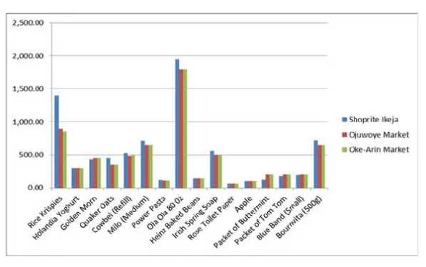

**Figure 2.1 comparison of prices between shoprite, Oke-Arin market and Ojuwoye market**

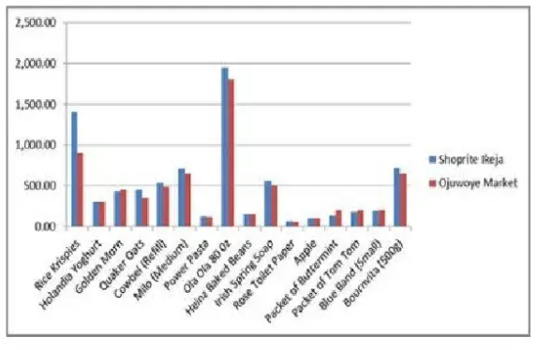

**Figure 2.2 Comparison of prices between Shoprite and Ojuwoye Market only**

**Chapter 3**

**Methodology**

**3.1 Analysis of the Existing System**

The current system operates manual supermarket management system, from stocks, products, ordering and purchases etc. recorded in a book. This is faced with errors, incompleteness, and insufficient data for analysis. Information regarding stocks, products, sales and purchases are still in black and white which is not properly organized and managed. From the wholesalers to retailer bills, receipts of products are recorded in a book but further operations are not being properly handled. As a result, it is difficult in processing, updating and managing.

The factors for these difficulties are:

**Labor-Intensive:** A manual Super Market management systems is that they can be highly labor-intensive to operate. They require continuous monitoring to ensure that each transaction is accounted for and that products are maintained at the appropriate stocking levels. It is also more difficult to share inventory information throughout the business, because the lack of computerization makes accessing inventory records a more cumbersome process. The time spent monitoring inventory levels could be used on more productive activities for the business.

**Human Error:** A manual Supermarket management system relies heavily on the actions of people, which increases the possibility of human error. People might forget to record a transaction or simply miscount the number of goods. This results in needless additional orders that increase the company's inventory carrying costs and use up precious storage space. Inaccurate physical counts could also result in not ordering enough of a product, meaning the business could run out of a crucial item at the wrong time.

**Time Wasting:** A manual Supermarket management system has a huge tendency of time wasting as the sales manager could have a lot to tackle while many customers seek attention and this is really affecting the business.

**3.2 Description/Analysis of the New System**

To reduce the shortcomings of the existing system there is a need to develop a new system that could upgrade the status of the current system which is manual and slow to the system that will be automatic and fast. The new system should be concern with offering the requirements of the customer and the workers, the system should be reliable, easier, fast, and more informative. The new system should possess the qualities stated below.

Qualities of the new System

1. Reduction in processing cost.

2. Error reduction.

3. Automatic posting.

4. Improve reporting.

5. Automatic production of the documents and Reports.

6. Faster response time.

7. Ability to meet user requirements.

8. Flexibility.

9. Reduced dependency.

10. Improves resource uses.

11. Reduction in use of the paper.

12. Reduction in Man Power.

The system is a desktop Windows application.

The system will provide the following Main features:

1.Calculate the bill.

2.Store products and their prices and with other information.

3. The Graphical User Interface of the system.

The System Can’t

1.Print out bills

2.Manage promotion

Due to the following reason: This project is based on the sales transaction and Stocking of items in a supermarket.

**3.3 SYSTEM DESIGN**

System Design is one of the tasking sections of the Programming. In this section of the project many previews are going to be seen and we are gradually getting close to the new system. System design is a transition from a user-oriented document to a document oriented to programmers or database personnel. The system design is structured into the following parts:

1.Output design

2.Input design

4.System Flowchart

**3.4 Output Design**

In a very competitive world that we are, a good and attractive GUI is needed to make customers and administrators enjoy the services of a system, which would serve as a system to increase productivity in supermarket business below are previews of the output designs. The previews of the output view of the design are shown in figure 3.1-3.14

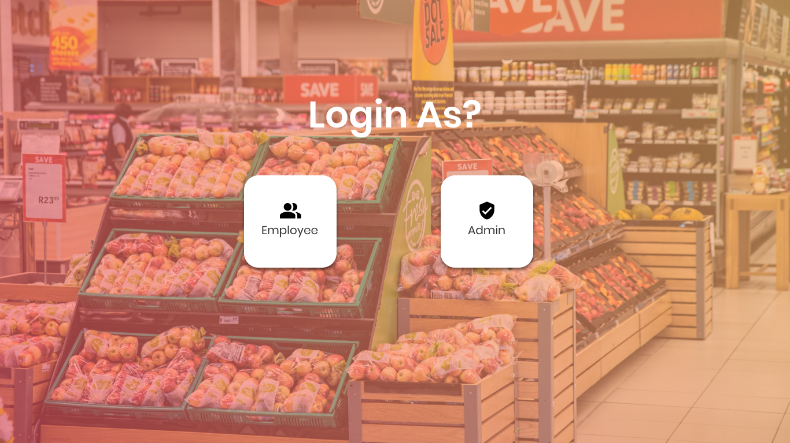

**Figure 3.1-Preview of output design to welcome users**



**Figure 3.2-Preview of login page for admin**

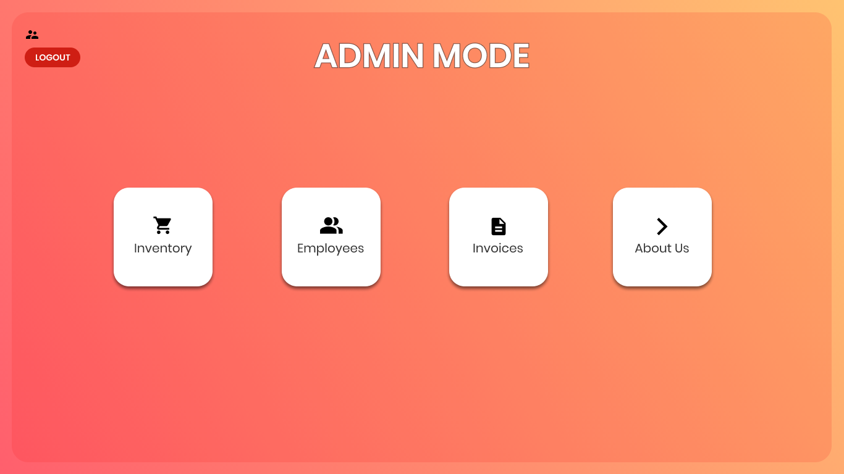

**Figure 3.3-Output screen for admin choices**

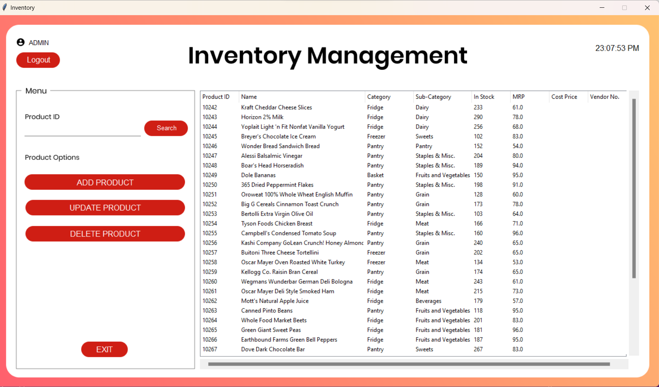

**Figure 3.4-Ouput screen for admin choice 1**

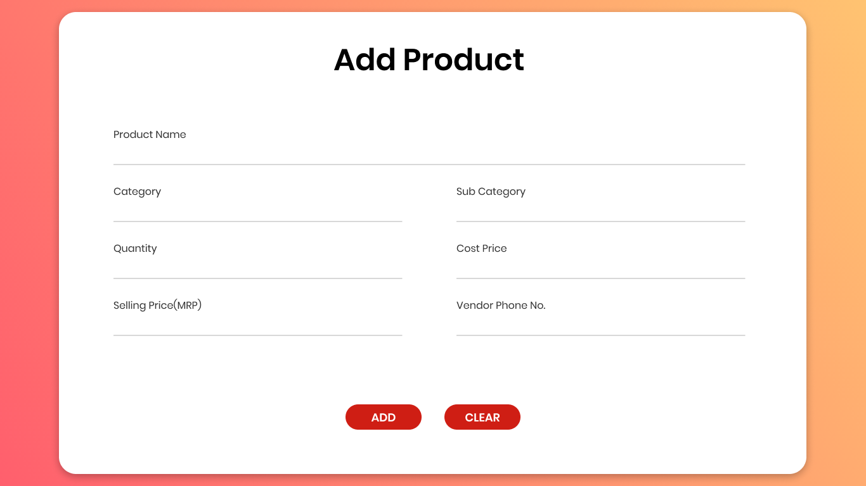

**Figure 3.5-Ouput screen for adding product**

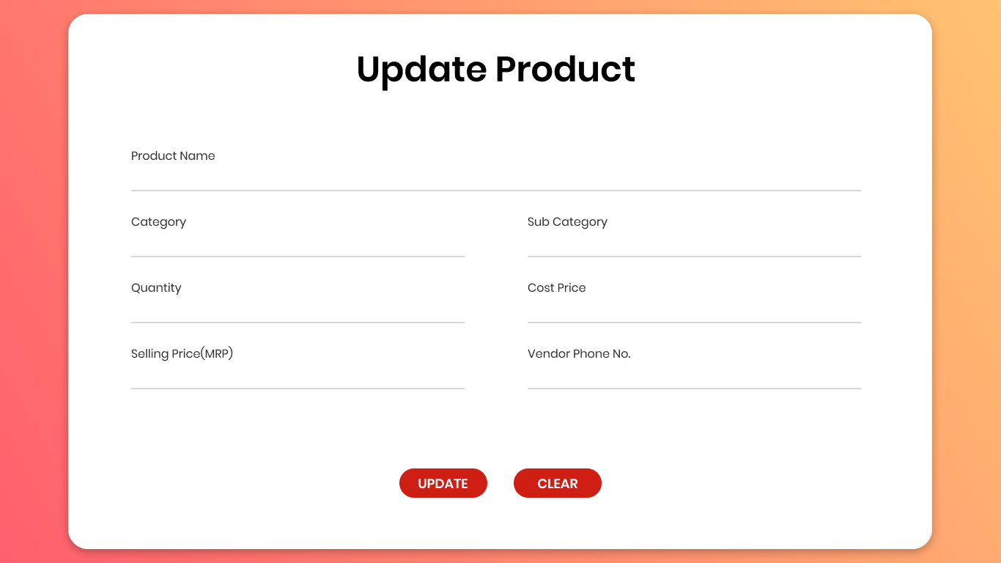

**Figure 3.6-Output screen for updating product**

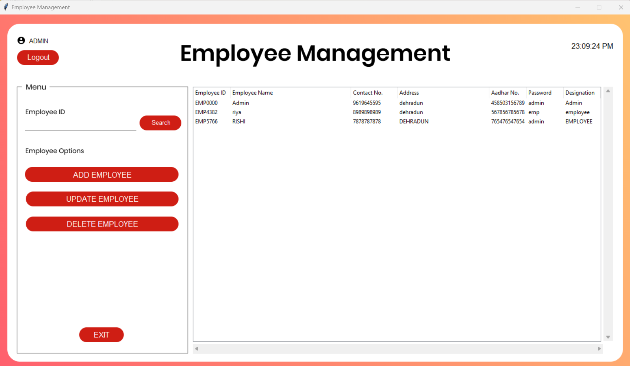

**Figure 3.7-Output screen displaying employees’ details**

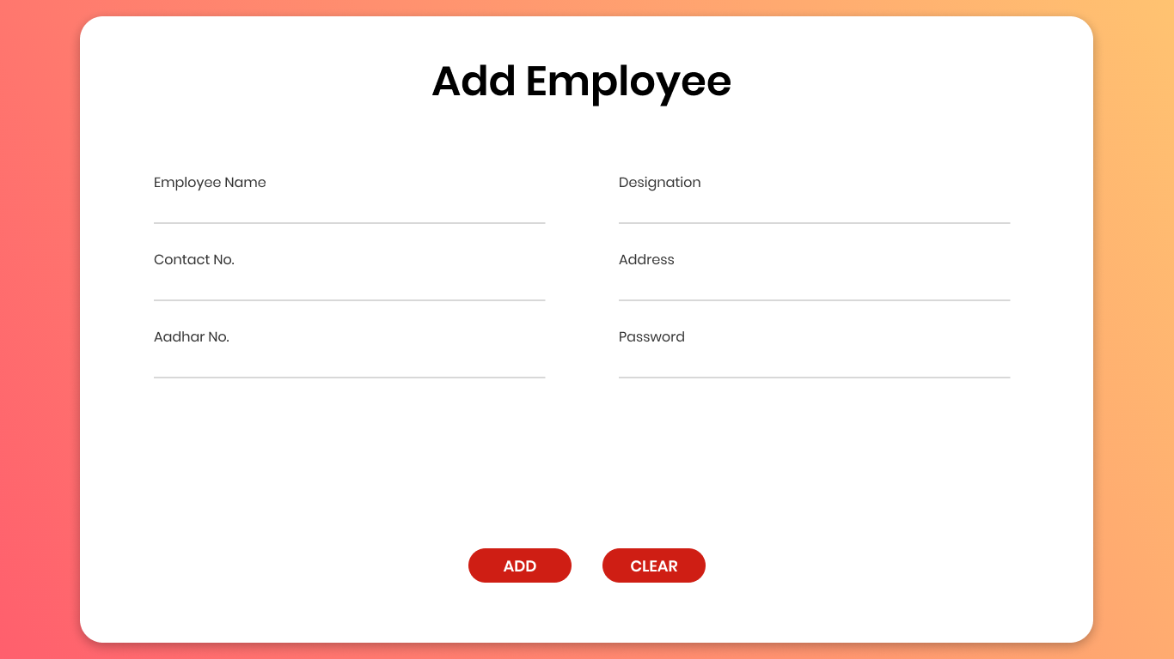

**Figure 3.8-Output Screen for adding a new employee**

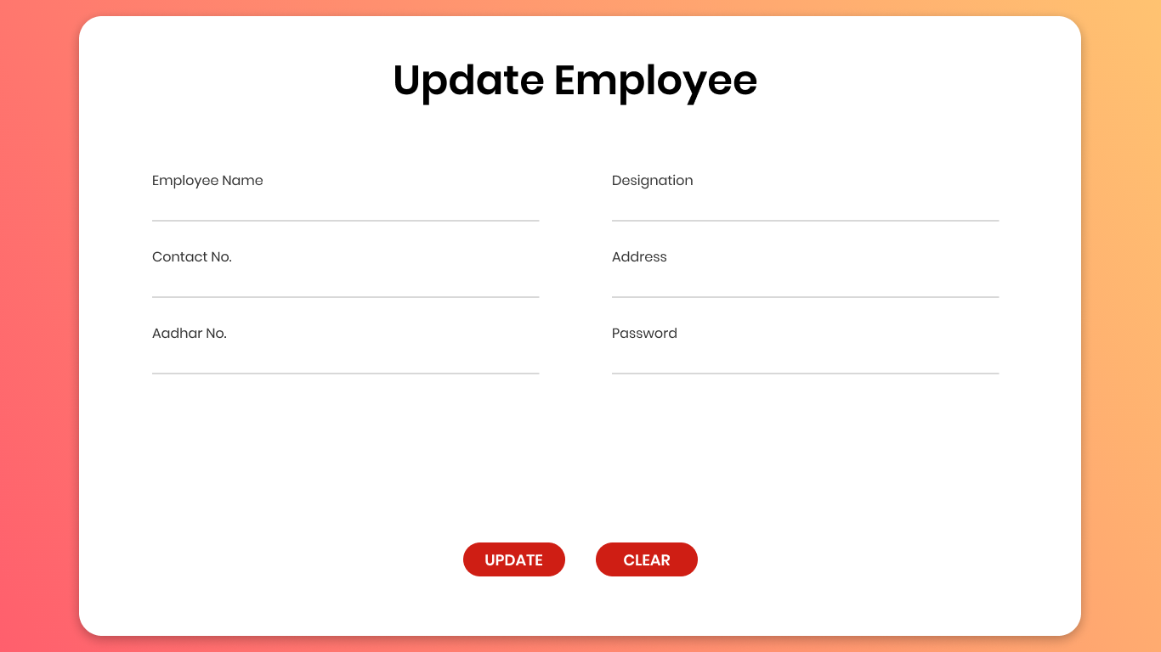

**Figure 3.9-output screen for updating employees’ details**

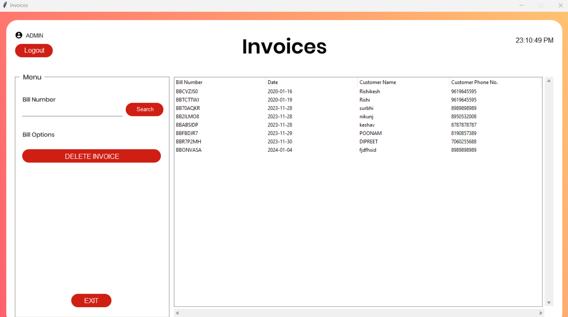

**Figure 3.10-Preview of collection of invoices generated**



**Figure 3.11-output screen for login page of employees**

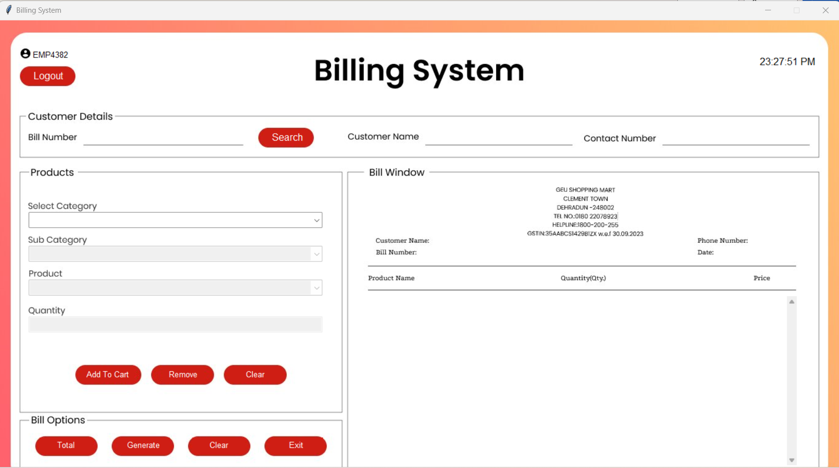

**Figure 3.12-Preview of Billing system**

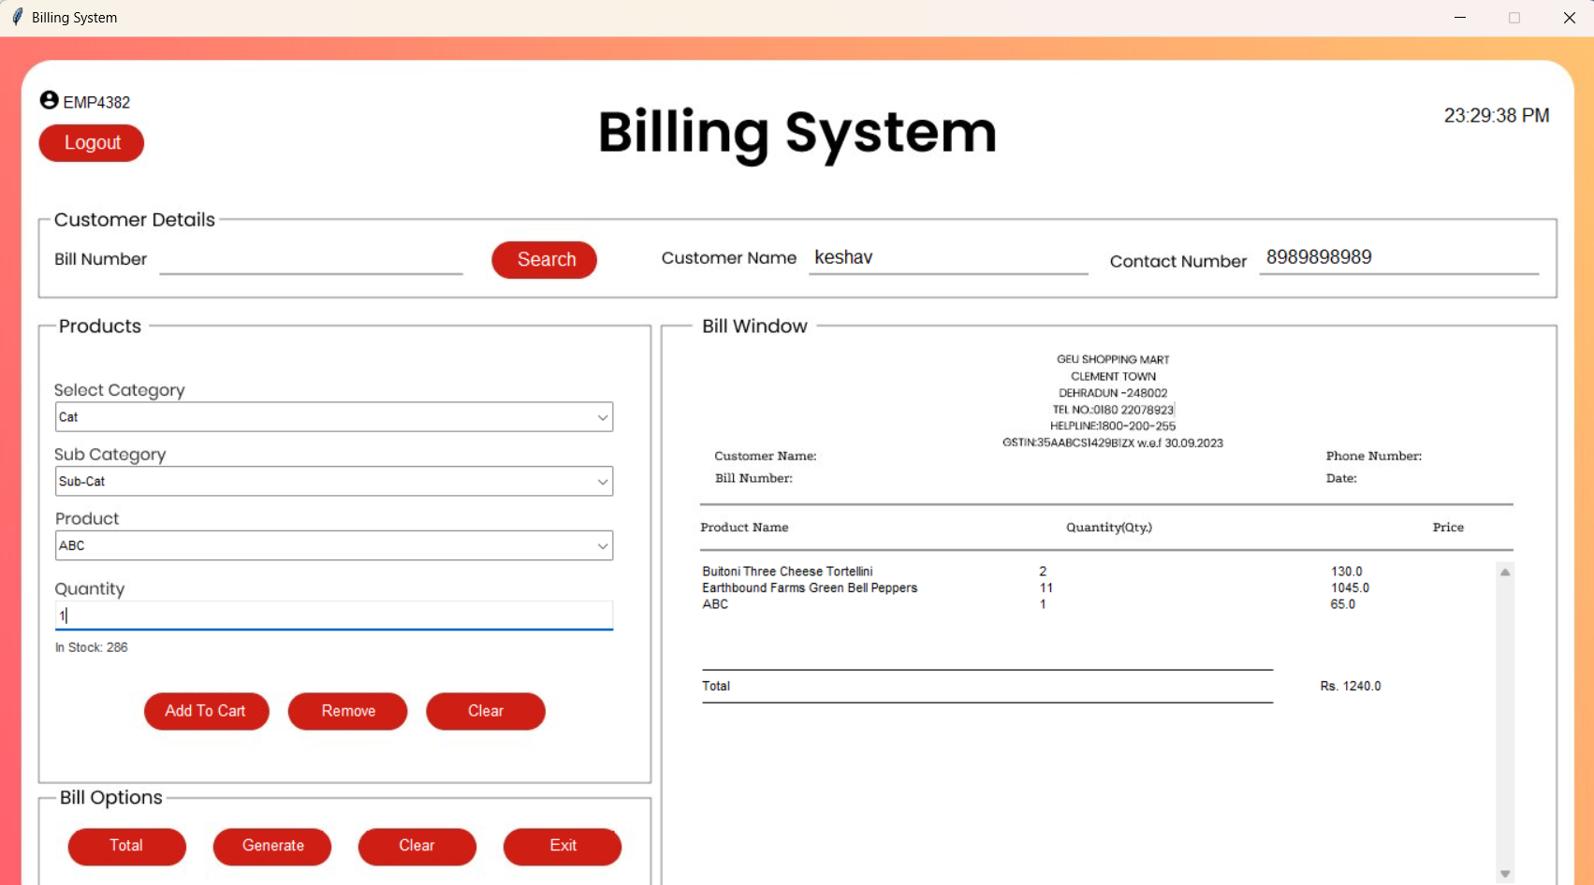

**Figure 3.13 screen showing bill generation**

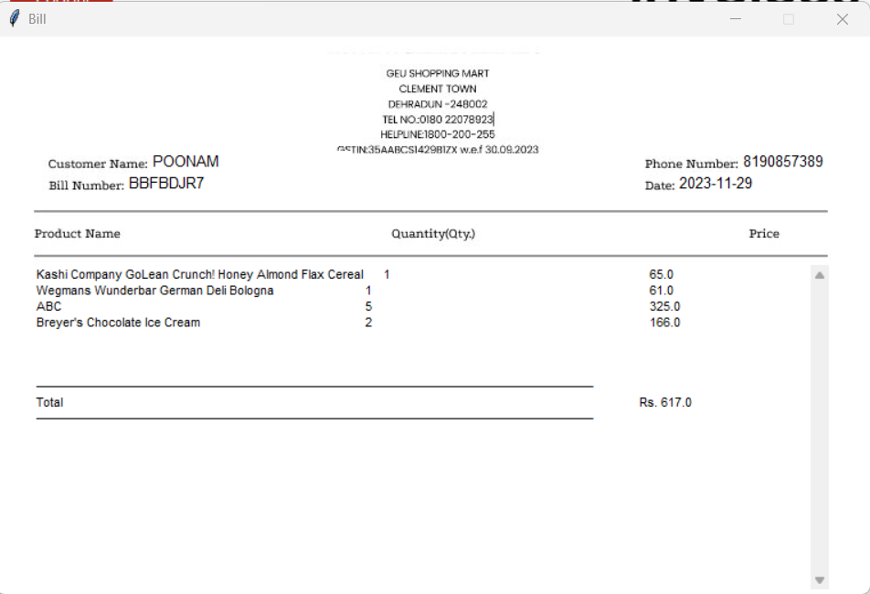

**Figure 3.14- Example of generated bill**

**3.5 Input Design**

In any organization, institution or any system of operation there is always an input into the system which keeps a system going, if the input is wrong definitely the output will be wrong. This design is meant to handle data about a particular product or stock in the Supermarkets as shown in Table 3.1- Table 3.3

|  |  |  |
| --- | --- | --- |
| Field Name | Data type | Field Size |
| Name | Long text | 30 |
| Password | Short text | 10 |
| Contact No. | Number | 10 |
| Address | Short text | 10 |
| Designation | Short text | 10 |
| Aadhar No. | Number | 12 |

**Table 3.1-Table for the input design to add/update employee**

|  |  |  |
| --- | --- | --- |
| Field Name | Datatype | Field Size |
| Username | Short text | 15 |
| Password | Short text | 20 |

**Table 3.2-Table for the input design to login**

|  |  |  |
| --- | --- | --- |
| Field Name | Data type | Field Size |
| Product Name | Short text | 15 |
| Category | Short text | 10 |
| Sub-Category | Short text | 10 |
| Cost Price | Currency | 4 |
| Selling Price | Currency | 4 |
| Quantity | Number | 2 |
| Vendor’s phone no. | Number | 10 |

**Table 3.3-Table for the input design to add/update product**

**3.6 Database Design**

Database is a file composed of records, each containing fields together with a set of operations it helps in organizing data in a logical order for references. Database contains related data which are organized together in a group of object, table, and file.

It can be in form of node. In this project a relational database concept will be used in this appraisal, related data will be store or organize in different table.

The Database design of this system is showed in Figure 3.15

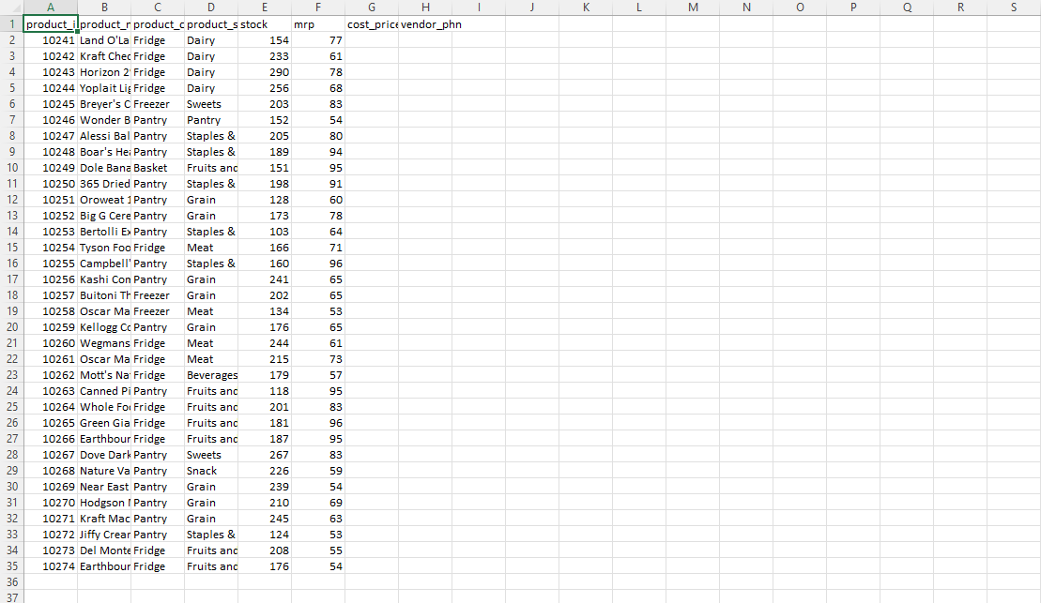

**Figure 3.15-** **Preview for Database Spreadsheet Design for Product**

**3.7 System flowchart**

This is the logical structure that represents the blue print of proposed system in other words, it defines as the algorithm of the software in a concise and logical order. The process design is represented Diagrammatically in the form of system flow chart as shown below in Figure 3.16

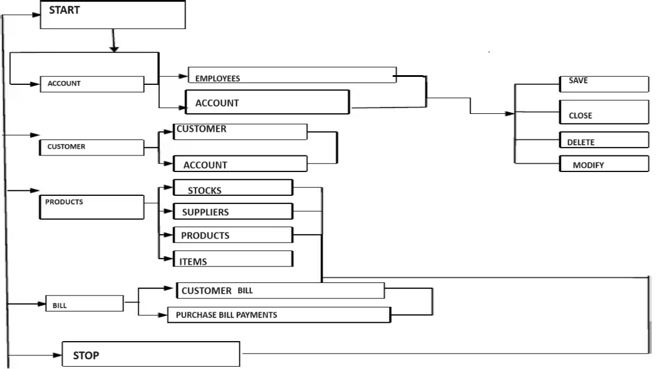

**Figure 3.16- System flowchart**

**Chapter 4**

**Result and Discussion**

**4.1. System Performance**

In terms of response time, our evaluation encompassed both normal and peak usage scenarios. During normal usage, the system exhibited commendable response times, ensuring swift interactions for users. To enhance performance during peak loads, various optimizations were implemented, such as caching mechanisms and load balancing, ensuring a seamless experience even under heavy traffic.

Scalability was a pivotal aspect of our assessment. The system demonstrated robust scalability, effectively handling an increasing number of products, transactions, and users. This scalability was achieved through scalable database architectures and efficient resource allocation, contributing to a responsive and reliable system.

**4.2. User Satisfaction**

User feedback played a pivotal role in refining the Shopping Mart Management System. Throughout user testing and post-implementation phases, valuable feedback was collected and meticulously analyzed. Iterative adjustments were made based on this feedback, ensuring that user suggestions were not only heard but actively incorporated into the system's design.

Usability testing revealed insightful aspects of the user experience. Users consistently found the system intuitive in certain areas, while challenges were identified in others. These findings guided user interface improvements and workflow optimizations to further enhance overall usability.

**4.3. Functionality**

The effectiveness of the system in inventory management proved to be a significant achievement. Inventory tracking, product management, and automated alerts for low stock were seamlessly integrated, streamlining the inventory control process.

Sales tracking accuracy was another highlight, with the system demonstrating precision in recording transactions. The generation of meaningful sales reports provided valuable insights for business decision-making. Additionally, the Customer Relationship Management (CRM) functionalities effectively maintained customer profiles, tracked purchases, and facilitated personalized recommendations, fostering customer engagement.

**4.4. Security**

The implemented authentication system, leveraging technologies such as JSON Web Tokens (JWT), proved effective in safeguarding user access. Robust security measures were implemented to protect sensitive information, including data encryption techniques applied to secure data stored in the database.

**4.5. Testing Results**

Test coverage spanned a significant portion of the codebase, ensuring comprehensive examination. Identified bugs and issues were promptly addressed during the testing phases, contributing to the overall stability and reliability of the system.

**4.6. Challenges and Solutions**

Throughout development and testing, challenges were encountered and effectively addressed. These challenges ranged from technical complexities to unforeseen obstacles. Solutions were meticulously implemented, ensuring the successful deployment and operation of the system.

**4.7. Comparison with Project Goals**

An evaluation of the project against its initial goals showcased commendable achievements. While certain deviations from the initial plan occurred, these were justified and rooted in the evolving needs of the project, enhancing its overall alignment with business objectives.

**4.8. Future Considerations**

Future enhancements were identified, providing a roadmap for the continual improvement of the Shopping Mart Management System. User feedback and testing results will be integral in shaping these enhancements, ensuring that the system remains adaptive and responsive to emerging retail trends and customer needs.

**4.9. Conclusion**

In conclusion, the Shopping Mart Management System has made a substantial impact on retail operations. Its robust performance, user-centric design, and advanced functionalities have not only met but exceeded expectations. As the system continues to evolve, it stands as a testament to our commitment to innovation and excellence in retail management technology.

**Chapter 5**

**Conclusion and Future Work**

**5.1 Conclusion**

In conclusion, Supermarket Management System has to do with making appropriate effort to stop the rising problem to all manual supermarket operation in order to enhance the operation of such supermarket. In this project, the software or system that can be used to aid all supermarkets that is still operating manually have been successfully developed. The software can be implementing in all types of super market as mentioned in the second chapter. The software has a large memory of storing all the goods in the supermarket and also keeping record it is highly effective and accurate.

**5.2 Future Work**

In the future, the following components can be added to the system in order to improve the effectiveness and efficiency of the system, which includes:

1.An advanced password system that will be embedded into all login pages to increase the security of the system.

2.A good Printing module should be included.

3.A good internet backup should be automated after everyday sales.

4.Internet Transactions should be allowed.

**References**

[1] Ballou, R.H. (1999). Business Logistics Management: Planning, Organizing and Controlling the Supply Chain, 4th ed., Prentice-Hall International, London.

[2] Billington, C., Callioni, G., Crane, B., and Ruark, J.D., et al, (2004)“Accelerating the Profitability of HewlettPackard's”

[3] Supply Chains”. Interfaces. Linthicum Breugelmans, E., Campob, and K.,Gijsbrechts (2006).

[4] “Opportunities for active stock-out management in computerized stores: Theimpact of the stock-out policy on computerized stock-out reactions © 2006 NewYork University. Published by Elsevier Inc.

[5] Bucklin, L.P. (1965). "Postponement, speculation, and the structure of distribution channels", Journal of Marketing Research, Vol. 2 No. 1.

[6] Bowersox, C. (2009). “Inventory Speculation: Cause and Effect”, Ohio, UnitedStates 89511

[7] Fleischmann, M., van Nunen, J.A.E.E., and Grave, B., (2003). “IntegratingClosed-Loop Supply Chains and Spare-Parts Management at IBM” Interfaces.

[8] Linthicum: Vol.33, Iss. 6; Frazelle .E. (2009). “Supply Chain Strategy: TheLogistics of Supply Chain Management”, New York,

[9] Monczka, R.M, Trent, RJ. AndHandfield, R.B. (2002). Purchasing and SupplyChain Management, 2nd éd., South-Western, Cincinnati, Ohio, United States.

[10] Pagh, J.D. and Cooper, M.C. (1998). "Supply chain postponement andspeculation strategies: how to choose the right strategy", Journal of BusinessLogistics, Vol. 19

[11] Patton, M.Q. (1990). Qualitative Evaluation and Research Methods, 2nd edition, New Bury Park, CA.

[12] Rietze, S. (2008). “Examination of supply response”, WA 98237, Vol 7.

[13] Seuring, S. (2011), “Supply chain management for sustainable products – insights from research applying mixed methodologies”, Cleveland, OH 44106Vol. 11.

[14] Wallin, C., Rungtusanatham, M.J., and Rabinovich, E (2006). “What is the"right" inventory management approach for a purchased item?” InternationalJournal of Operations & Production Management.

[15] Yang, B., and Burns, N.D. (2003). "Implications of postponement for the supplychain", International Journal of Production Research, Vol. 41 No.9.