Beginner Linux Challenges

Task 1
- ls
1.1. The terminal lists the directories that are within the directory
1.2. This means ls command lists the contents that are within the current working directory
- pwd
2.2. The terminal writes the current working directory
2.2. This means the pwd command instructs the terminal to display the current working directory
- Please refer to figure 1
- workspace directory
3.1. The terminal returns nothing
3.2. This means there’s nothing withing the current working directory
figure 1
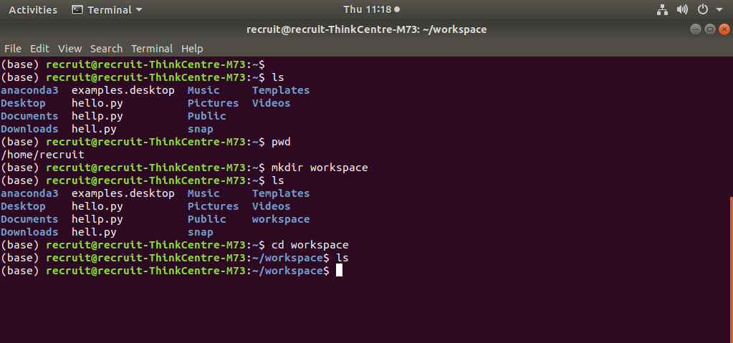

- Please refer to figure 2
- CHANGELOG.md file
figure 2
