**Snake README**

**What is Snake?**

Snake is a 2-D game where the key controls are used to move a live snake figure. The objective of the game is to maneuver the snake to eat the food that is randomly laid out on the map. Upon the snake eating food, it’s length will grow, and the speed of the snake will increase. However, if the snake moves into the edges of the map, the game will end.

**How to install and run Snake?**

In order to play Snake, there are a few required downloads.

First, you will need to install Python for your operating system found here:

<https://www.python.org/downloads/>

Second, you will need to install PyGame. There are two ways you can do this

1. Install the .tar file for version 1.9.4.post1 and then extract the contents and run the setup.py file. If the Python file prompts whether you would like the default install, then enter "Y" as in yes.

.tar file: <https://www.pygame.org/download.shtml>

1. The other option is to use your operating systems built-in terminal to download python. The commands can be found here: <https://www.pygame.org/wiki/GettingStarted>

Once you have the requirements, you can install the Snake game two ways.

1. 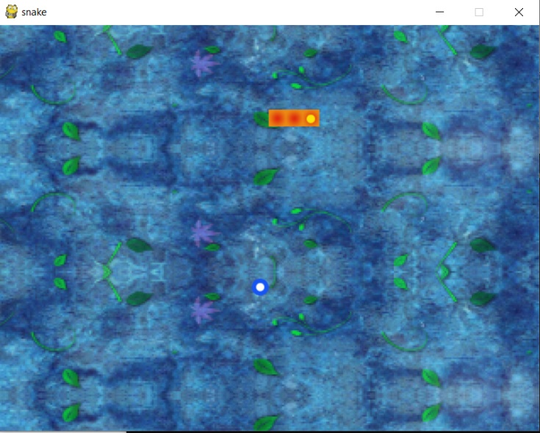Going to the attached GitHub link below, pressing the 'Clone or download' button and then downloading the ZIP file. Then extract the ZIP file and run snake.py using Python. If all the requirements are downloaded correctly, the game should display in a window and the snake will be moving.

GitHub link:

<https://github.com/khxuan/snake-game.git>

1. You may also use git commands from terminal to clone this game and then run snake.py

Using the following command in terminal:

$ git clone <https://github.com/khxuan/snake-game.git>

**How to Play Snake?**

Controls:

‘W’ – Makes the snake move up

‘A’ – Makes the snake move left

‘S’ – Makes the snake move down

‘D’ – Makes the snake move right

‘F’ – Rewinds the snake to the start of the game, press ‘F’ again to continue

‘P’ – Pauses the game, press ‘P’ to continue

Use the controls to make the snake run into the food that is randomly generated on the map.

**What the game should look like:**

This is the snake just before it eats the food:

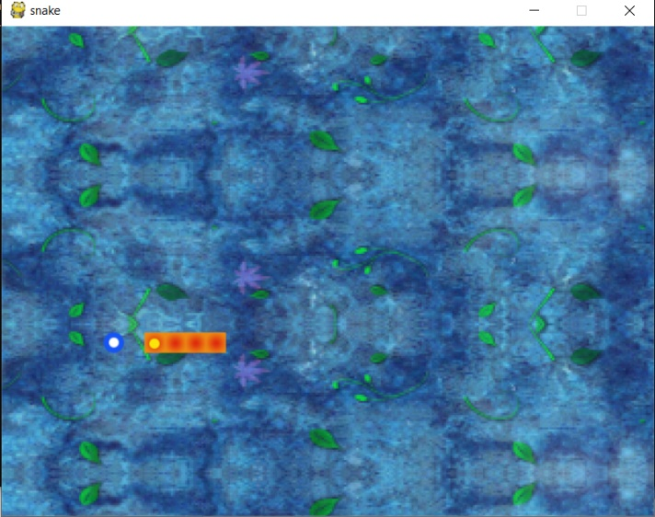

Here is the egg respawning after it was eaten:

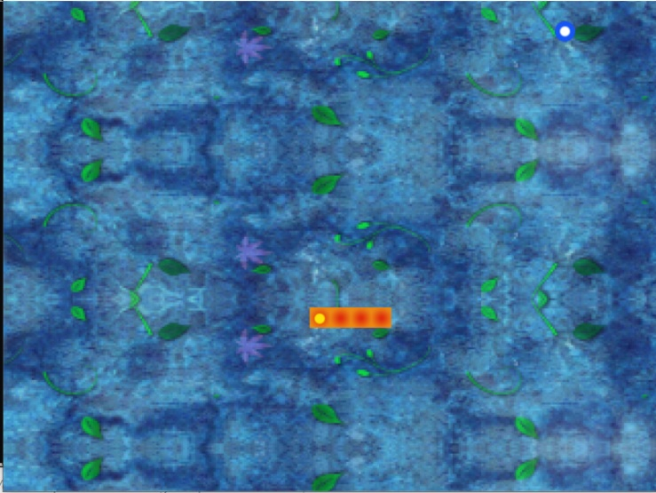

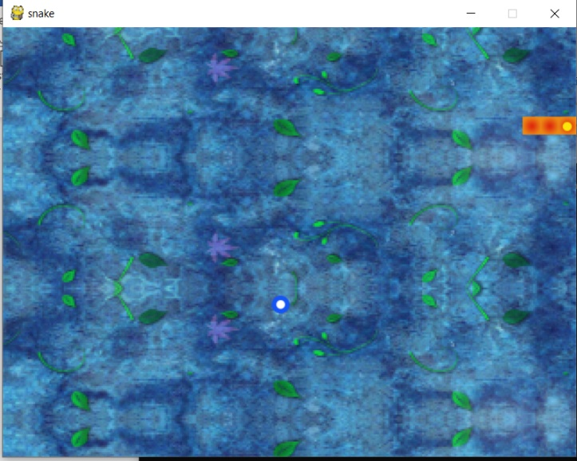Here are the final moments of the snake before running into the edge of the map and dying: