Khyatee Desai

Professor Lija Hogan

SI 422

24 February 2017

**Heuristic Evaluation**

Tinder is a smart phone dating application. Users of the application make an account by linking up to their Facebook accounts. To use the application, users can select up to six pictures to display on their profiles. They can also adjust filters to find matches within a specific radius (1-100 miles) and age range (18-55+) and sexual orientation. While the age range is fairly broad, the majority of people using Tinder are generally between the ages of 18 and 30. User profile can also include a short biography, current work place, school, Instagram pictures, and gender. Once their profile is complete, the application will locate matches corresponding to the selected preferences. Matches appear on the main screen, and users have the option to “swipe right” with a green heart, or “swipe left” with a red X. If two users swipe right on one another, the application will indicate that a match has been made, and open up the option to chat using the app’s messenger feature. Tinder also offers a premium upgrade (Tinder Plus) that unlocks a few additional features for ten dollars per month. Tinder Plus offers users the option to “Super Like” a potential match, essentially revealing their interest regardless of a mutual “right swipe.” Tinder Plus also offers the option to “Rewind” the last swipe, “Boost” a user’s profile to reach an extended audience, turn off advertisements, and extend location beyond the standard 100 mile radius.

One problem with Tinder is its lack of solid visibility of a user’s status on the application. When matches are loading, the application displays concentric circles radiating outwards on the main screen (*Figure 1*), to indicate that matches are being located. This feature however, is very ambiguous, and does not include any quantifiable information about the process. Users cannot tell if matches are actually being located, how long it is taking to find matches, and how many matches are available. In regards to severity of this issue, the problem is somewhat frequent, based on how constrictive the user’s discovery preferences are set, and is also persistent, but does not have an extremely debilitating impact on the user experience of the app. Therefore this problem receives a severity level of 2/5.

Tinder’s “Swipe with Friends” feature (*Figure 2.)*  is confusing. The feature is supposedly made for groups of friends to be able to swipe on Tinder together, with other groups of people. However, this functionality is not made very clear on the app, and requires outside research. The feature violates the heuristic of matching between the system and the real world. This is an disconnect of understanding that makes this feature difficult for a new user to understand. This problem is not very frequent, or persistent, because it only affects a side-feature of the application, and is only confusing initially, until the user figures out how to use it. The problem does have a medium impact on the user experience however, because it disrupts the otherwise easy-to-understand interface of Tinder. This problem receives a severity level of 2/5.

One major problem with Tinder is the rewind feature, and the fact that it is only available to users who upgrade to Tinder Plus. As Tinder is controlled by a quick “swiping” motion, it is a common problem for users to mistakenly swipe in the wrong direction on a profile. For non-upgraded users, there is no way to reconcile this mistake. This is a very big violation of the User Control & Freedom heuristic, because it takes away the user’s ability to “undo” a mistake. This problem is moderately frequent, impactful, and persistent, therefore it receives a severity rating of 4/5.

Going hand-in-hand with the User Control problem, Tinder also lacks in a system of error prevention for accidental mis-swipes. While the premise of Tinder is to allow the user to quickly swipe through a large amount of profiles, this creates the problem on not having a safety net to prevent mis-swipes. This problem violates the error prevention heuristic because Tinder does not provide a prompt to verify a user’s swipe. This problem is moderately frequent, impactful, and persistent, however it is also an intentional one, therefore it receives a severity rating of 3/5.

Tinder includes a few ways for users to edit their profiles. There is a pencil icon on the user’s profile screen, a “Settings” button, and also an “Edit Info” button (*Figures 3 &4*.) As a general trend, these three names and buttons are often used interchangeably, however on the app, they each serve slightly different functions. “Settings” allows the User to edit their discovery filters, while “Edit Info” and the pencil icon allow the user to edit their display pictures and biography. This problem violates Consistency and Standards and while it is not frequent, it is rather persistent due to the ambiguity of terms and does negatively impact the user experience. Therefore, this problem receives a severity rating of 3/5.

A central premise of Tinder is that users can only view one profile at a time. However, this creates the problem of a lack of Flexibility & Efficiency, because users cannot view multiple profiles at a time, which would drastically increase the volume of profiles that a user is able to swipe on at a given time. This is a persistent and impactful problem, but due to the fact that it is intentionally implemented, it receives a severity rating of 3/5.

Tinder has a very limited scope of error messages. Essentially it just contains one, that says, “There’s no one new around you” (*Figure 5.*) This error message is very non-descriptive and offers the user no alternative actions or quantitative details. This violates the heuristic of Helping Users Recover from Errors, and receives a severity score of 2/5 due to the fact that it is frequent, persistent, and relatively impactful to the user experience.

Tinder has undergone numerous interface design changes since its initial conception. While the app initially only contained the options to swipe left or right, the latest version of Tinder has introduced swiping with friends, “Super Likes,” “rewinds,” and “Boosts.” All of these extraneous features, while useful to some who have paid to upgrade to Tinder Plus, detract from the App’s reputation of minimalism and usability by adding clutter. This problem violates the heuristic of Aesthetic and receives a severity score of 2/5 due to the fact that it is frequent and persistent.

Tinder is successful due to the fact that it is simple to learn, widely accessible and used by many people, and quick to use. While it does contain a number of problems from an objective heuristic perspective, including a cluttered interface, and a lack of user control and “rewinds,” Tinder was designed with a specific type of dating and user interface in mind, and likely violates some of these heuristics intentionally.

**Appendix**

I chose not to discuss the heuristics of Help & Documentation and Recognition rather than Recall in this report, due to the fact that Tinder includes a fairly comprehensive Help feature, and does not rely on user’s memory for its primary features.

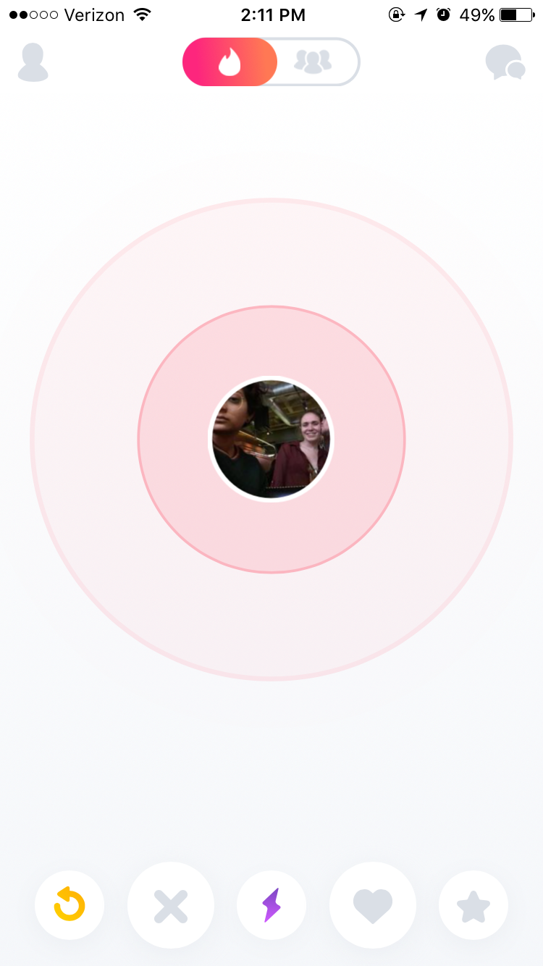 Figure 1. 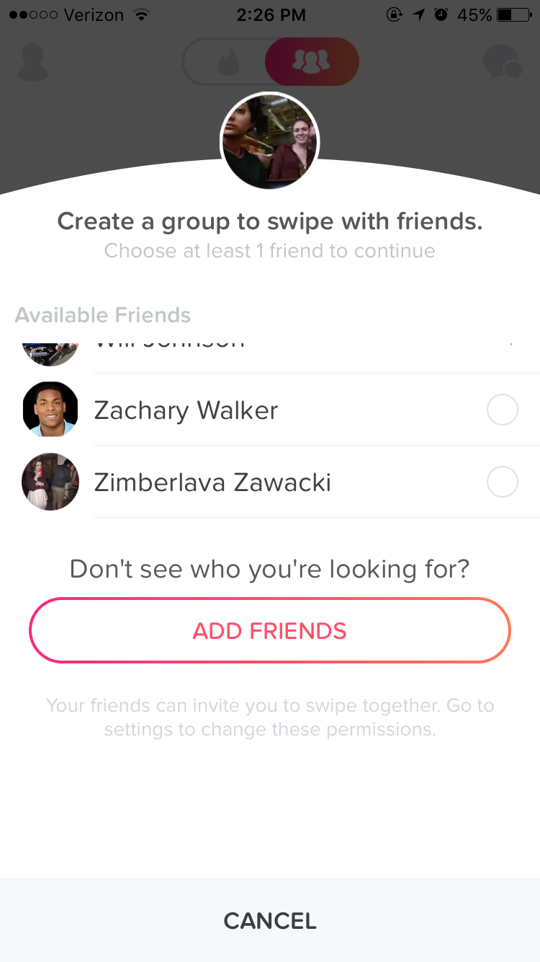Figure 2. Figure 3. Figure 4. 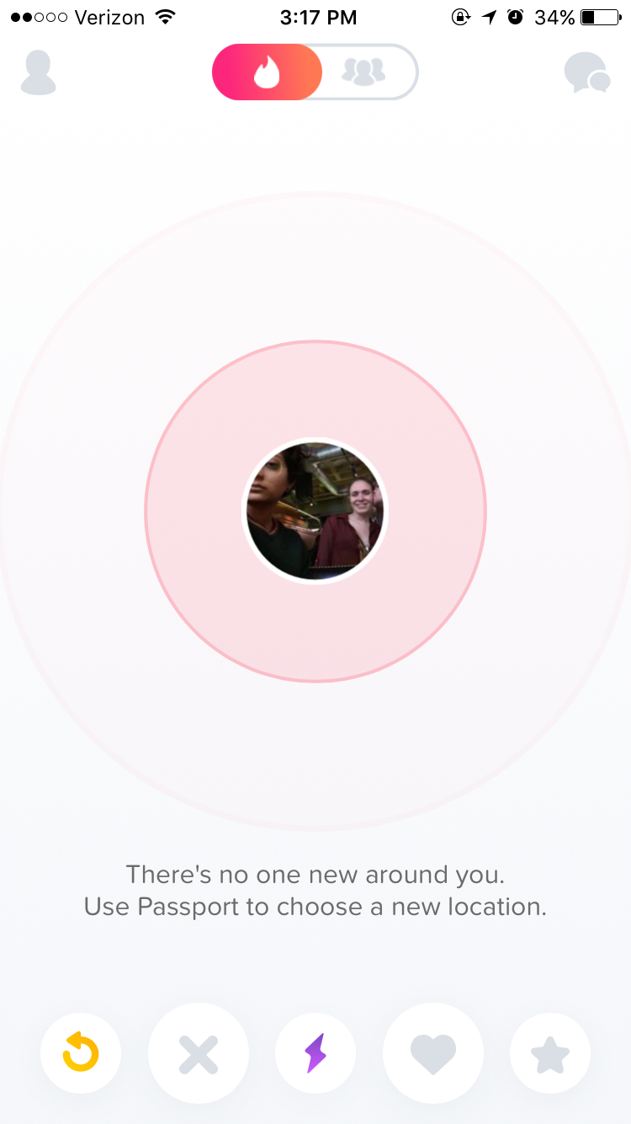 Figure 5.