**OM 386: Pricing & Revenue Management**

**Assignment #3**

*Please paste your answers within this file and save it as “HW3_ eid1_eid2_eid3” (Where eids refer to your group members’ EIDs) on Canvas at appropriate place. If you used MS Excel or any other statistical software to arrive at your answers, please submit the relevant files/annotated code as well.*

**Write the names of your team members here**: Aadithya Anandaraj, Anisha Alluru, Anshika Ahuja, Khyathi Balusu

**Part 1: Protection Level**

The New England Aquarium currently offers two types of daily-pass tickets: refundable full-fare tickets available any time for $34.95, and non-refundable discounted $24.95 tickets for online purchases made at least 2 weeks in advance. For safety reasons, the number of people in the aquarium at a given time is limited to 300. Therefore, the aquarium does not sell more than 300 tickets for each day, and wants to protect some of its limited capacity for full-fare customers. Assume that the demand for refundable (full-fare) tickets is distributed by the following table, and that the demand for discounted tickets is high enough to fill up the unprotected capacity ahead of the full fare demand.

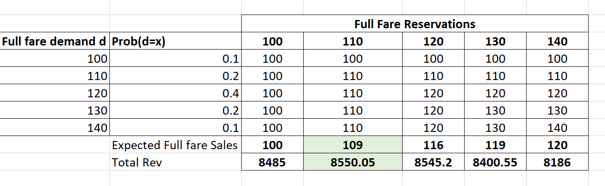

Find the optimal (revenue-maximizing) protection level for full-fare tickets.

**Optimal (revenue-maximizing) protection level for full-fare tickets** = 110

Compute the expected number of discounted and full-fare tickets sold (in each day) under the optimal protection level, as well as the total expected revenue (please show your formula and code if you use software).

**Expected number of Full fare tickets/day under optimal protection level** = 109

**Expected number of Discounted fare tickets/day under optimal protection level** = 190

**Total Expected Revenue** = 8550.05$

**Part 2: Overbooking**

The Newport Bay Boat Rental (NBBR) has found that the number of people who reserve full-day boat rentals and simply do not show up is distributed according to the following table.

To maximize its revenue, NBBR is thinking of overbooking its boat rentals, and wants you to calculate how much overbooking is optimal. Here is what NBBR’s costs and prices look like:

* NBBR normally charges $250 to rent a standard 20-foot boat for the day.
* NBBR signed a deal with its local competitor, Balboa Island Watercraft Rental (BIWR), to help provide extra capacity when required, for an agreed-upon fixed price. Specifically, whenever an NBBR customer cannot rent a boat due to a shortage in available boats, NBBR will send that bumped customer to BIWR. NBBR pays BIWR $400 per boat for the accommodation.
* NBBR thinks it can increase its short-term revenues by overbooking, but it is worried that there will be an additional long-term goodwill loss of $560 for every bumped customer.

Show your work (formula and spreadsheet/code if you use software) and answer the following questions:

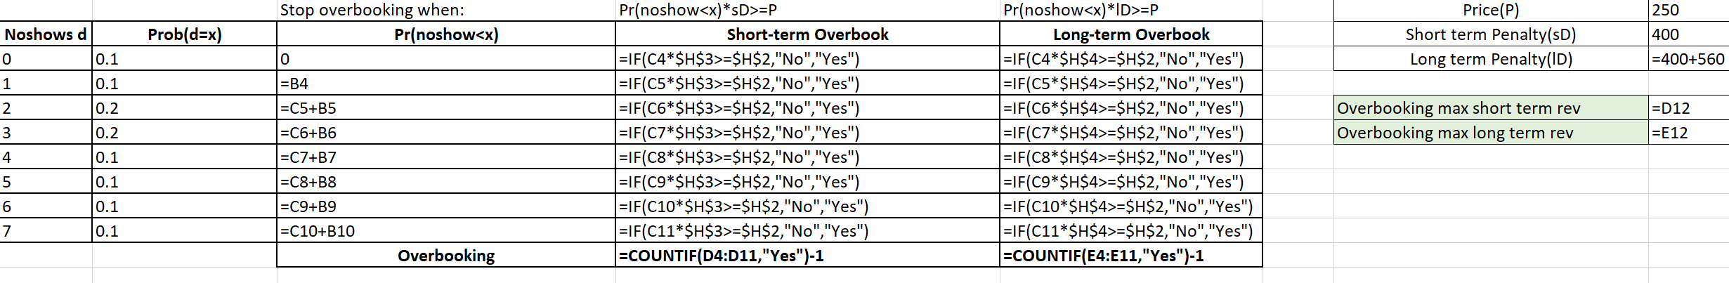

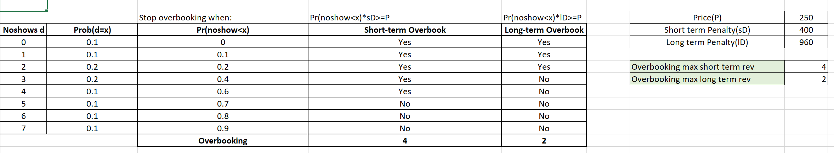

1. How many boats should NBBR overbook on a daily basis if it is concerned about maximizing its short-term revenue? (Hint: Customers defecting to the competition do not affect short-term revenue.)

**Number of boats to overbook/day maximizing short term revenue** = 4

1. How many boats should NBBR overbook on a daily basis if it is concerned about maximizing its long-term revenue? (Hint: Customers defecting to the competition do affect long-term revenue.) (10 points)

**Number of boats to overbook/day maximizing short term revenue** = 2

1. Say NBBR decides to overbook by 4 boats. What is the expected number of bumped customers? What is the expected number of unused boats? (please show your formula and code if you use software).

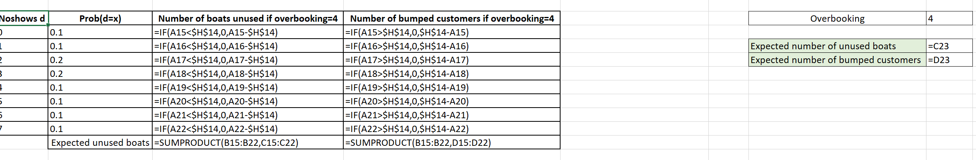

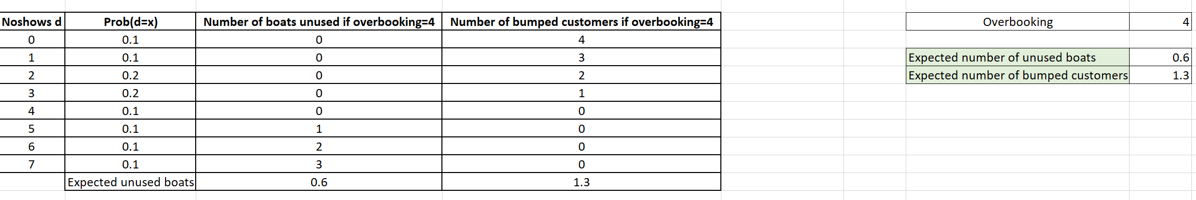

**Expected number of unused boats =** 0.6

**Expected number of bumped customers =** 1.3