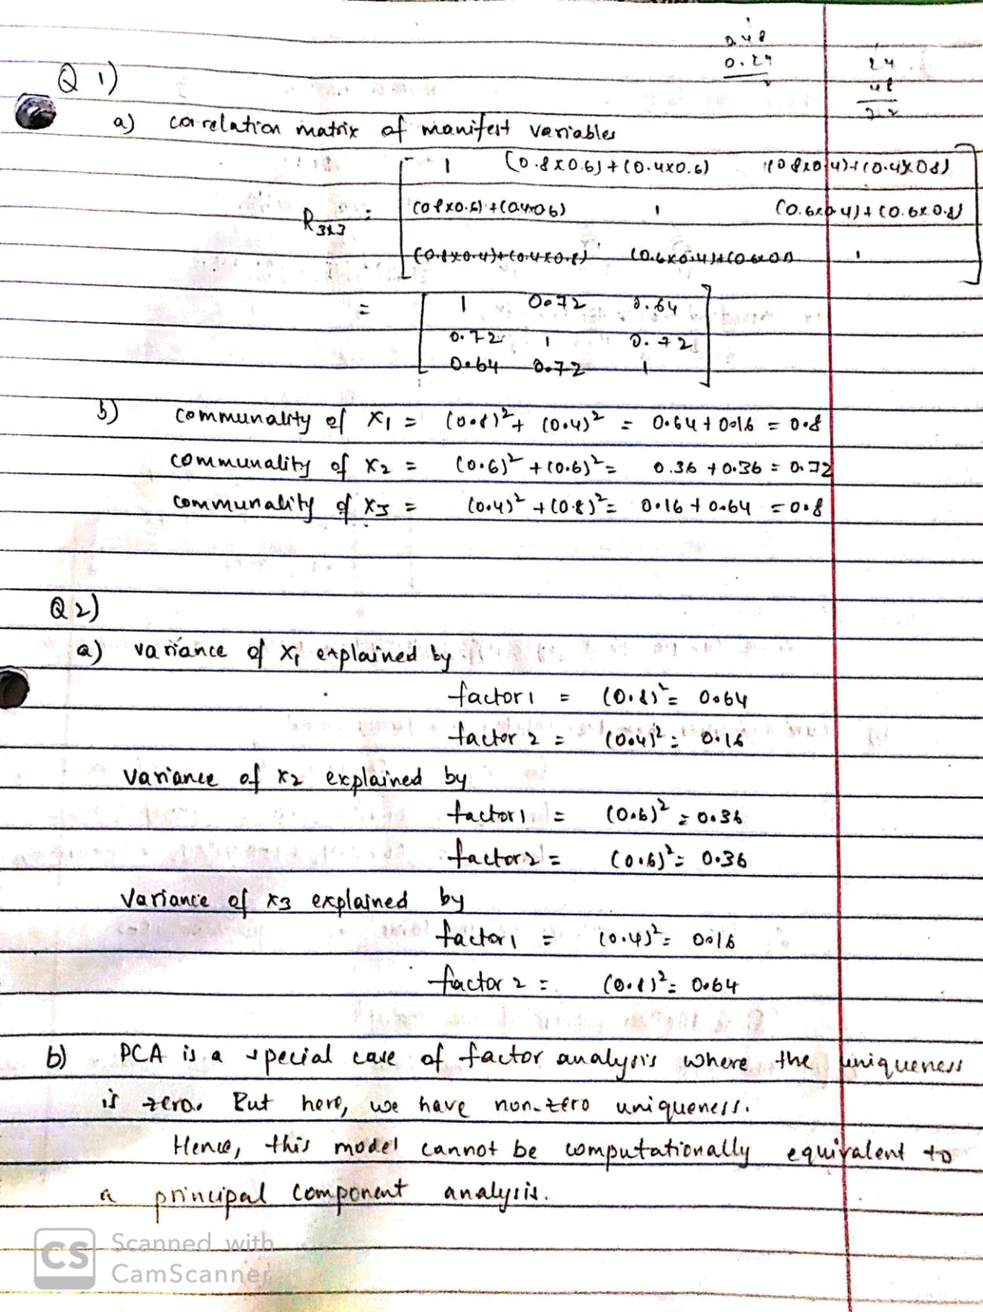
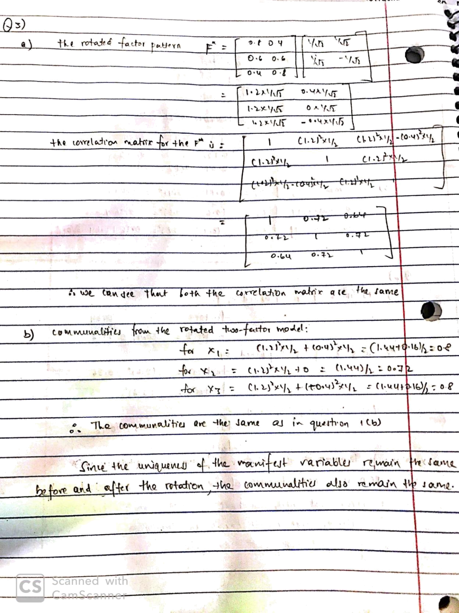
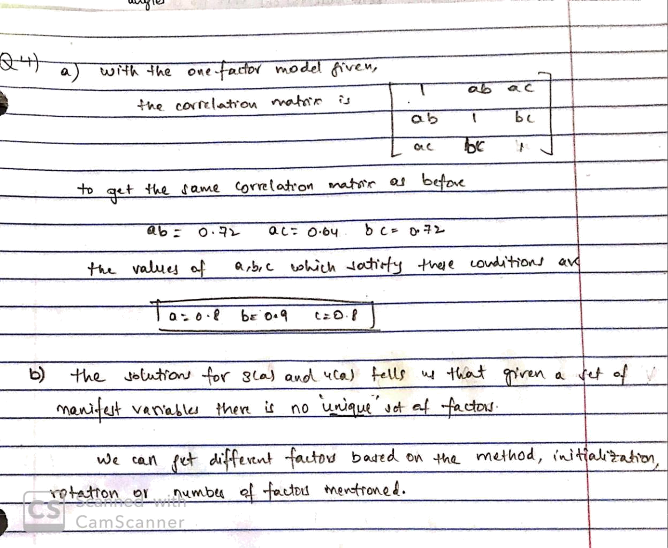

Question5:

Part a:

PROC FACTOR DATA=work.evaluate_supervisors METHOD=principal PRIORS=one MINEIGEN=0 NFACTORS=6;

VAR beefs previlege newlearn raises critical advance; TITLE "PC style factor analysis Factor Analysis - 6 factors "; RUN;
Part b:
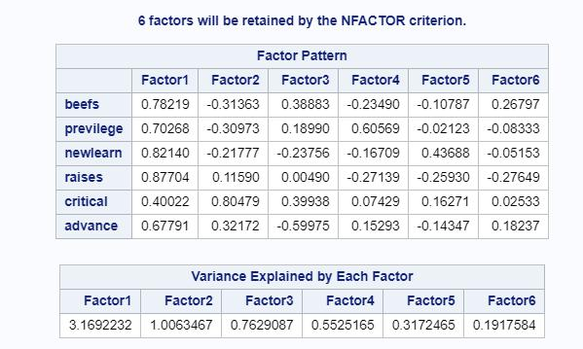

I would retain the first two factors as they are the only factors with eigen value greater than 1

Part c:

The first factor descirbes factors which contribute to most of the good attributes of a supervisor. A person who settles complaints well, encourages merit, new learning and advances the employees career but this supervisor shows favoritsm as well.

The second factor addresses the not too good characteristic of an supervisor. Someone who is very critical, doesn’t encourage new learnings and doesn’t solve employee complaints.

Question6:

To see how each of the 6 factors explain the overall supervisor rating, we ran 7 regression models.

First 6 models is for each factor on the ‘overall’ rating column

And seventh model uses all the six factors

Model1: Overall ~ Factor1 R2 = 0.457

Model2: Overall ~ Factor2 R2 = 0.0788

Model3: Overall ~ Factor3 R2 = 0.0878

Model4: Overall ~ Factor4 R2 = 0.089

Model5: Overall ~ Factor5 R2 = 0.006

Model6: Overall ~ Factor6 R2 = 0.0139

Model7: Overall ~ Factor7 R2 = 0.73
Question7:

Part a:

PROC FACTOR DATA=work.evaluate_supervisors METHOD=principal PRIORS=SMC NFACTORS=6 OUT=q7_factors;

VAR beefs previlege newlearn raises critical advance;

TITLE "Rsquare style factor analysis Factor Analysis - 6 factors ";

RUN;

Part b:
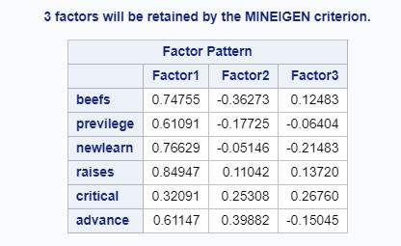

The first factor descirbes factors which contribute to most of the good attributes of a supervisor. A person who settles complaints well, encourages merit, new learning and advances the employees career but this supervisor shows favoritsm as well.

Second factor describes a supervisor who is ‘critical’ and helps employees ‘advance’ their careers but isn’t rated high in terms of solving employers complaints (lower ‘beefs’ score)

Part c:

In the factor analysis for Q5, we assume the uniqueness of each manifest variable is zero and assume that the factors explain all the variance. So the results are same as the results from principal component analysis.

And for Q7, we assume that the uniqueness is non zero. So to get the initial values of the commonalities, we regress each variable on the other variables and get the R2. These values would be the initial values.
Question8:

Part a:

PROC FACTOR DATA=work.evaluate_supervisors METHOD=principal PRIORS=SMC NFACTORS=2 ROTATE=varimax OUT=work.evaluatesupervisors_scores;

VAR beefs previlege newlearn raises critical advance;

TITLE "Rsquare style factor analysis Factor Analysis - 2 factors "; RUN;

Part b:
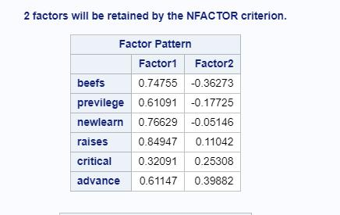

Yes, the first two factors for this question are not the same as the first 2 factors for the previous question

Part c:

The VARIMAX factor rotation matrix is:
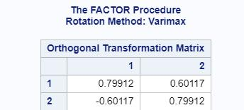

Checking for orthonormality:
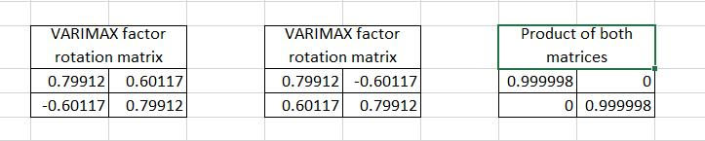
Hence we see that the matrix is orthonormal

Part d:
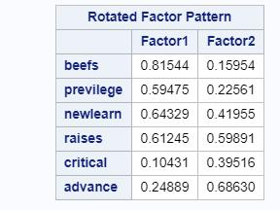

The first factor descirbes factors which contribute to a supervisor who solves employee complaints efficiently, encourages new learnings and recognizes the employees by merit. Although these employees also tend to show favoritsm.

The second factor describes supervisors who tends to focus on the improvement of employees – either by recongnizing merit or encouraing new learnings or helping employees advance in their roles.

Question9:

Part a:
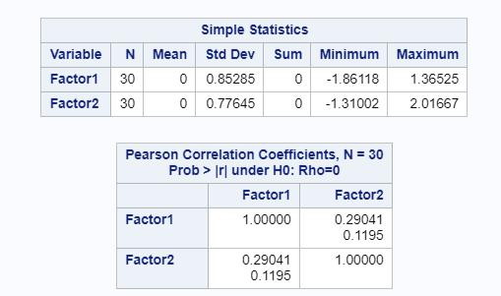

The statistics shows us that both the factors have standard deviations which are not one. This is surprising as the factors generally tend to be standardized with zero mean and unit standard deviation.

Also the correlations between the factors is non zero which is surprising as well.

Part b:
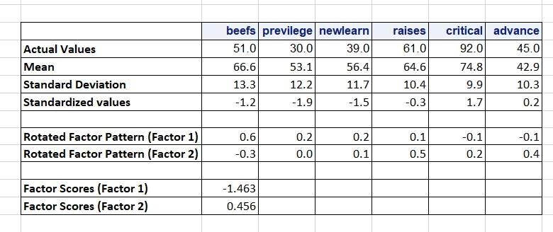

Question10:

PROC FACTOR DATA=WORK.evaluate_supervisors METHOD=ML PRIORS=smc ULTRAHEYWOOD;

VAR BEEFS--ADVANCE;

TITLE 'Maximum likelihood factors with SMC for communality, 6 factors, VARIMAX rotation -- Evaluation Data';

RUN

Part a:
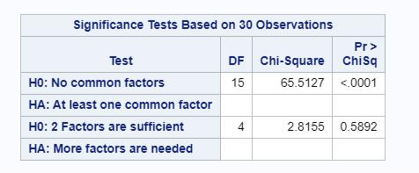

For the Null Hypothesis: No common factors, the p-value is less than 0.05, which suggests that we can reject the null hypothesis. Hence, the output suggests that common factors exist.

Part b:

For the Null Hypothesis: 2 Factors are sufficient, the p-value is greater than 0.05. This suggests that we cannot reject the null hypothesis. This suggests that default number of extracted factors is adequate.

