Question 5:

A:

PROC FACTOR DATA=work.evaluate_supervisors METHOD=principal PRIORS=one MINEIGEN=0 NFACTORS=6;

VAR beefs previlege newlearn raises critical advance; TITLE "PC style factor analysis Factor Analysis - 6 factors "; RUN;
B:
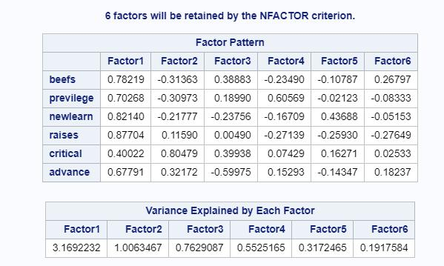

First two factors to be retained as they have eigen value greater than 1

C:

The first factor:
gives factors which contribute towards good attributes of a supervisor. A person who handles incoming complaints reasonably, identifies and gives a hand to merit, encourages learning and growth in the career. Thought inspite of it, this supervisor prefers a few over others.

The second factor:
gives the non good characteristic of an supervisor. Cynicism, no learning encouragement and no heed to complaints.

Question 6:

7 regression models were run.

First 6 models is on each factor on overall rating column

Seventh model uses all six factors

Model1: Overall ~ Factor1 R2 = 0.457

Model2: Overall ~ Factor2 R2 = 0.0788

Model3: Overall ~ Factor3 R2 = 0.0878

Model4: Overall ~ Factor4 R2 = 0.089

Model5: Overall ~ Factor5 R2 = 0.006

Model6: Overall ~ Factor6 R2 = 0.0139

Model7: Overall ~ Factor7 R2 = 0.73

Question 7:

A:

PROC FACTOR DATA=work.evaluate_supervisors METHOD=principal PRIORS=SMC NFACTORS=6 OUT=q7_factors;

VAR beefs previlege newlearn raises critical advance;

TITLE "Rsquare style factor analysis Factor Analysis - 6 factors ";

RUN;

B:

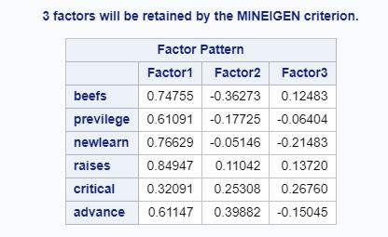

The first factor:
gives factors which contribute towards good attributes of a supervisor. A person who
handles incoming complaints reasonably,
identifies and gives a hand to merit,
encourages learning and growth in the career.
Thought inspite of it, this supervisor prefers a few over others.

Second factor:
Gives factors of supervisor who is :
critical and
helps in advancement in employees’ career
doesn’t solve well the employees’ complaints (low beefs score)

C:

In Q5,
Assumptions are made such that:
the uniqueness of each manifest variable is zero
factors explain all the variance.
Implies this results and PCA results are same

In Q5,
Assumptions are made such that:
the uniqueness of each manifest variable is non zero
For initial values, each variable is regressed on other variables for R2. These will be initial values.
Question 8:

A:

PROC FACTOR DATA=work.evaluate_supervisors METHOD=principal PRIORS=SMC NFACTORS=2 ROTATE=varimax OUT=work.evaluatesupervisors_scores;
VAR beefs previlege newlearn raises critical advance;

TITLE "Rsquare style factor analysis Factor Analysis - 2 factors";

RUN;

B:

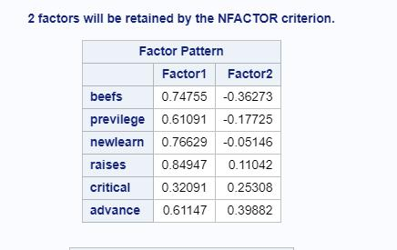

Yes, the first two factors for this question are not the same as the first 2 factors for the previous question

C:

The VARIMAX factor rotation matrix is:

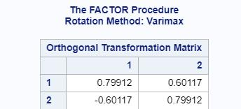

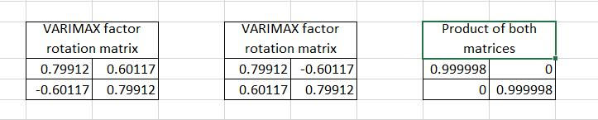
Orthonormality : Matrix is orthonormal
D:

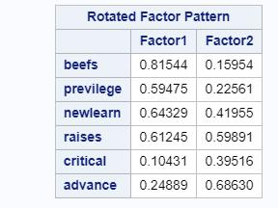

The first factor:
gives factors which contribute towards attributes of a supervisor. A person who
handles incoming complaints reasonably,
identifies and gives a hand to merit,
encourages learning and growth in career.
Thought inspite of it, this supervisor prefers a few over others.
Second factor:
Gives factors of supervisor who is :
Needs to recognize merit
Encourage learnings
Help employees advance in roles

Question 9:

A:

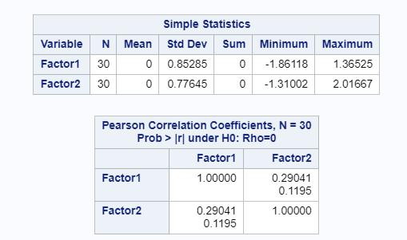

We can see that the factors have standard deviations that are not one. Generally speaking, factors are to be standardized with zero mean and unit standard deviation. Here, correlations are not one either.

B:
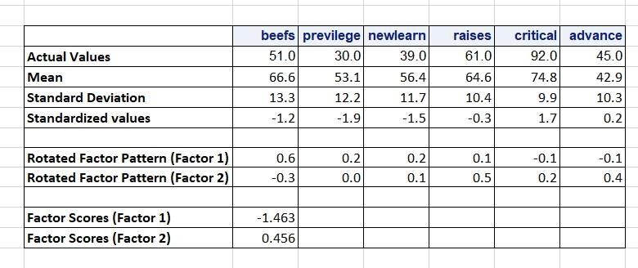

Question 10:

PROC FACTOR DATA=WORK.evaluate_supervisors METHOD=ML PRIORS=smc ULTRAHEYWOOD;

VAR BEEFS--ADVANCE;

TITLE 'Maximum likelihood factors with SMC for communality, 6 factors, VARIMAX rotation -- Evaluation Data';

RUN;

A:

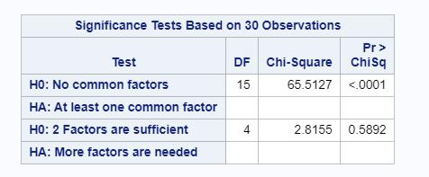

Null Hypothesis:
No common factors,
p-value < 0.05, implying rejection of the null hypothesis.
This shows that common factors exist.

B:

Null Hypothesis:
Two factors that are sufficient,
p-value > 0.05, implying no rejection of the null hypothesis.
This shows that extracted factors that are default in number are enough

