**MODULE-1**

1.No,the html tags and elements are not same because tags means<u> this indicates underline. A specific use like<u>,<b> etc are called tags. Elements means contain between the tags. <u>Khyati</u>this is the example of element.

2. tags means<u> this indicates underline. This is tag.

Attribute means which indicates a specific purpose. For example <a herf=””></a>

3.void elements for html are those elements who doesn’t need a end tag. For example <br>,<hr>.

4. HTML entites means which define a particular meaning like copy right or any register mark or emoji. For example &copy; ,&reg;.

5.Different types of list are given below:

<ul>,<ol> and descriptives type.

Class attribute means used for style. For example< style=”background color=:”blue”. This is called class attribute.

6.Formatting tags for html is <center>,<br>,<hr>,<div> this are formatting tags for html.

7.Cell padding means outer side space and cell spacing means inner side space of the table blocks.

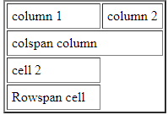For example:

8.to club a row and column in html we use rowspan and colspan to merge cells.

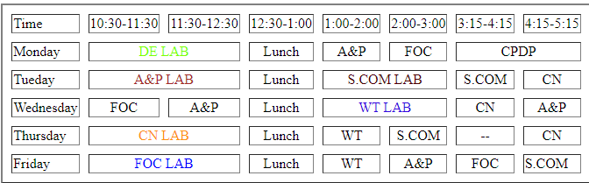For example:

9.Difference between block line and inline element is block element means which covers full page and inline element means it occupies a particular required space.

For example:

10.To crate a hyperlink a in html by using href tag. For example <a href=[www.google.com](http://www.google.com)>

11. to insert a background picture in a webpage using a <Img src=”” width=”200”height=”120”>tag.

12.Active links means which opens in a new tab and normal link which opens in that particular tab.

13.different tags to sperate sections of text are div,br,hr.

14. a logical tags means<em> is used for italic, in this tag, em will logically convert the font in a italic. Physcial tag means<i> which will also convert the font in italic but in a simple manner. Ouputs of both the tags are same.