FIND LOCALS
Revised Project Report
Sections 1–13 | Through Use Case Diagram

Project information | Details
Project title | Find Locals
Project type | Web application
Project category | Local service discovery and booking
Group | 7–8
This report explains the project from its introduction through the use case diagram. It incorporates the review-sheet items marked Need Modifications: project scope and core components, project profile, advantages and limitations, requirement determination, and the use case diagram. Earlier sections are retained and lightly edited for consistency.

1. Introduction
Find Locals is a web application that connects customers with nearby workers who provide household and maintenance services. Customers can discover service professionals such as plumbers, electricians, cleaners, painters, and appliance-repair technicians, review worker information, and request a booking.
The project addresses two connected needs. Customers need a practical way to find and compare local providers, while independent workers need a channel for presenting their services and reaching more customers. Find Locals brings discovery, booking requests, worker profiles, reviews, and administrative management into one platform. The interface is designed for a broad audience and supports multiple languages.

2. Existing System
People commonly find local service providers through relatives, neighbours, local shops, personal contacts, or social-media groups. These methods can work, but they rely on the reach and availability of each person’s network. Someone new to an area may have no dependable recommendations and may need to contact several providers individually.
Traditional searching usually offers limited information for comparison. Customers may not be able to review experience, service categories, ratings, availability, or indicative prices in one place. Workers, in turn, depend heavily on word of mouth and offline promotion, which can limit their visibility.
Bookings and follow-up are often managed through calls or messages. Without a shared record, service details, timing, status, and feedback can be difficult to track. A centralized platform can make discovery and request management more organized while giving both sides a clearer record of their interaction.

3. Need for the New System
A digital system is useful because it reduces the effort required to find a suitable worker and gives local providers a place to present their services. Customers can search by service and location, compare profiles and feedback, and send a booking request. Workers can manage their profiles and respond to incoming requests.
The project is initially intended for a limited service area. It can be extended to more cities and service categories as worker coverage grows. A single platform also creates a foundation for maintaining booking status, service history, and customer feedback.

4. Objective of the New System
The objective is to provide an accessible platform where customers can discover local workers and workers can receive service opportunities. The system aims to:
- Provide an easy way to search for local service providers by service and location.
- Help customers review worker profiles and available feedback before making a choice.
- Allow customers to submit and follow service booking requests.
- Give workers tools to maintain profile details and manage requests.
- Improve worker visibility and access to local job opportunities.
- Support clear status updates and records for bookings.
- Offer multilingual interface support.
- Provide administrative tools for managing accounts, worker verification, categories, bookings, and feedback.

5. Problem Definition
Customers can have difficulty finding a reliable local worker at the time a service is needed, particularly when they do not have trusted personal contacts. Searching through scattered recommendations can take time and may not provide enough information to compare providers.
Local workers may also have difficulty reaching new customers even when they have relevant skills. They often depend on referrals and may lack a structured way to display their services and receive requests.
The project addresses this problem by providing a centralized web application for worker discovery, profile review, booking requests, and feedback, with supporting administration for platform records and worker verification.

6. Scope of the Project and Core Components

6.1 Project Scope
Find Locals covers the customer journey from discovering a service provider to submitting a booking request and sharing feedback after the service. The worker journey covers profile presentation, request response, and job-status updates. Administrators oversee platform records and moderation-related tasks.
The initial deployment is scoped to a defined city or service area. Search results depend on the location and worker coverage recorded in the system. Service categories include plumbing, electrical work, cleaning, painting, appliance repair, and other household services configured by the administrator.
The system supports public browsing of worker discovery information; an account is required to submit a booking. Worker verification is represented in the platform, but verification does not by itself guarantee service quality. Starting prices, where shown, are estimates and may differ from the final amount agreed for a job. The current project records cash-payment status; it does not provide an online card or UPI payment gateway.

6.2 Core Components
Component | Main responsibilities
Customer module | Browse/search workers, inspect profiles, submit booking requests, view booking status, and provide feedback for completed services.
Worker module | Maintain worker profile and service information, receive booking requests, accept or decline requests, and update job progress.
Administrator module | Manage accounts, worker verification, service categories, bookings, reviews, payment records, and platform data.
Worker discovery | Filter available workers by service and location; display profile details, ratings, reviews, and indicative service information where available.
Booking management | Store requests and support request status transitions, cancellation, worker response, completion, and related history.
Feedback and ratings | Associate customer ratings and written feedback with service interactions, supporting transparent comparison.
Notifications and language support | Present booking-related updates and localized interface content according to supported application behavior.
Data storage and API | Persist users, worker profiles, bookings, reviews, categories, and related records through the application API and relational database.

6.3 System Context
Customers and workers use the web interface to access service discovery, profiles, and booking functions. The application API handles requests and exchanges data with the relational database. Administrators use restricted functions to maintain platform records.

7. Project Profile
Profile item | Description
Project title | Find Locals
Project type | Web application
Project category | Local service discovery and booking system
Purpose | Connect customers with nearby service professionals and help workers reach potential customers.
Primary users | Customers, local workers/service providers, and system administrators.
Service coverage | Plumbing, electrical services, cleaning, painting, appliance repair, and other household services.
Main features | Worker discovery and profiles; booking requests and status tracking; ratings and reviews; customer and worker dashboards; worker verification; administrative controls; cash-payment record tracking.
Technology overview | React/Vite web interface, Python API, and MySQL-compatible relational database, as described in the project implementation.
Deployment scope | Initially limited to a specific city or service area; expansion depends on deployment and worker coverage.
Payment boundary | Cash tracking is supported; no card, UPI, or online payment gateway is connected in the current implementation.
The project should be described as a web application rather than a native mobile app. Its mobile-friendly interface can be used on supported browsers, while a live public deployment requires hosting, HTTPS, and production configuration.

8. Assumptions and Constraints

8.1 Assumptions
- Users have a compatible device and internet access when using the application.
- Workers provide accurate profile, service, and contact information.
- Customers provide useful service details and a location that enables the provider to assess the request.
- Customers and workers use the platform honestly and follow up on requests they make or accept.
- Workers are responsible for completing the work they accept and communicating changes in availability.
- Ratings and reviews reflect genuine service experiences and are used respectfully.

8.2 Constraints
- The initial worker directory and service coverage may be limited to one city or area.
- Search and booking depend on internet connectivity and the availability of current worker data.
- Verification is an administrative signal and may not independently establish every credential or guarantee future performance.
- Cash payment tracking does not constitute online payment processing or escrow.
- Indicative starting prices may not equal the final quote.
- The project’s delivery scope is limited by available time, staffing, hosting, and operational resources.
- Service quality, worker availability, and response time depend on individual providers.

9. Advantages and Limitations of the Proposed System
Advantages | Limitations and conditions
Centralizes worker discovery and reduces reliance on personal contacts. | The usefulness of search depends on the number and freshness of worker profiles in each area.
Lets customers compare profile information, ratings, and feedback. | Reviews are user-submitted and should be interpreted alongside other information.
Creates a digital channel for workers to improve local visibility and receive requests. | Workers need internet access and must actively maintain their profiles and respond.
Keeps booking requests and status information in a shared platform. | A booking request is not a guarantee of acceptance or service completion.
Provides administrative tools for worker verification and platform record management. | Verification procedures and their coverage depend on administrator processes.
Supports multilingual interface access and browser-based use. | Language availability and accessibility are limited to what the current interface supports.
Records cash-payment status for completed work. | No online card, UPI, or payment gateway is currently connected; price estimates may change.
Overall, the system improves organization and visibility, but it cannot guarantee provider availability, workmanship, or outcomes. Clear status information and accurate user records are important to its effective operation.

10. Requirement Determination and Analysis
Requirements were derived from the project problem and the distinct needs of customers, workers, and administrators. Customers need to find and compare workers and send service requests. Workers need to represent their services and manage incoming requests. Administrators need to maintain platform accounts, categories, and records.
The analysis also distinguishes system capabilities from service guarantees. The application can record a request and display its status, but the provider must accept it before a confirmed job exists. Ratings can inform a customer’s choice but do not prove future performance. The system is designed for a limited initial service area and depends on accurate profiles and an active worker network.

10.1 Requirement priorities
Priority | Requirement focus | Reason
Essential | Worker discovery by service/location; profiles; account registration and login; booking request and response; booking status; admin oversight. | These functions implement the central customer-worker connection.
Important | Ratings and reviews; worker verification status; category management; cash-payment records; multilingual interface. | These support trust, administration, and usability.
Future extension | Broader geographic coverage, more languages, online payment integration, and additional service categories. | These require expanded operations or integrations and should be presented as future work unless implemented.

11. Requirement Determination

11.1 Functional Requirements
ID | Requirement | Acceptance condition
FR-01 | Account registration and login | A user can register and sign in using valid credentials; administrative accounts are not created through public registration.
FR-02 | Worker profile management | A worker can maintain service and profile information through the worker account.
FR-03 | Worker discovery | A visitor or customer can browse and search worker listings by available service and location criteria.
FR-04 | Profile inspection | A customer can view worker profile details and available ratings/reviews before selecting a provider.
FR-05 | Booking request | An authenticated customer can submit a service request with relevant job details.
FR-06 | Worker request response | A worker can review a request and accept or decline it.
FR-07 | Booking status tracking | The application records and displays supported status changes through the job lifecycle.
FR-08 | Feedback and rating | A customer can submit feedback associated with an eligible completed service.
FR-09 | Cash-payment record | The platform can track cash payment status associated with a completed booking; this is not online payment processing.
FR-10 | Worker verification | An administrator can review and manage worker verification status.
FR-11 | Administrative management | An administrator can manage platform users, worker applications/profiles, bookings, reviews, categories, payment records, and system data.
FR-12 | Language support | A user can access supported interface language options.

11.2 Non-Functional Requirements
ID | Quality requirement | Expected behavior
NFR-01 | Usability | Common tasks such as searching, viewing profiles, and submitting a request should use clear labels and a consistent flow.
NFR-02 | Performance | Search and routine page actions should return within a reasonable time under expected project-scale usage.
NFR-03 | Security and privacy | Authentication and role checks should restrict customer, worker, and administrator actions to authorized functions; private data should be handled carefully.
NFR-04 | Reliability | The system should preserve valid booking and profile records and communicate errors without silently losing user input.
NFR-05 | Compatibility | The web interface should adapt to common desktop and mobile browser widths.
NFR-06 | Maintainability | Service categories and core records should be manageable without redesigning the entire application.
NFR-07 | Scalability | The design should allow additional locations, workers, and categories as the deployment grows, subject to infrastructure capacity.

11.3 User roles and permissions summary
Role | Typical permitted actions
Visitor | Browse worker listings and public profile information.
Customer | Register/sign in, search, submit bookings, view booking updates, and review eligible completed services.
Worker | Manage worker profile, view and respond to requests, update supported job status, and maintain work records.
Administrator | Manage platform accounts and operational records, including worker verification, categories, bookings, reviews, and payment tracking.

12. Targeted Users
Find Locals serves people who need household services and workers who provide them. The administrator role supports the reliable operation of the platform.
- Customers looking for local services such as plumbing, electrical work, cleaning, painting, and appliance repair.
- Skilled local workers seeking job opportunities and a way to present their services.
- People who have recently moved and may not have local service-provider contacts.
- Independent workers and small service providers seeking greater visibility.
- System administrators responsible for accounts, worker verification, service categories, bookings, reviews, and records.

13. Use Case Diagram
The diagram shows the main interactions between visitors, customers, workers, and administrators. A visitor can browse public listings. A customer signs in to request a booking and can review completed services. A worker responds to requests and updates job progress. The administrator manages platform records and verification.
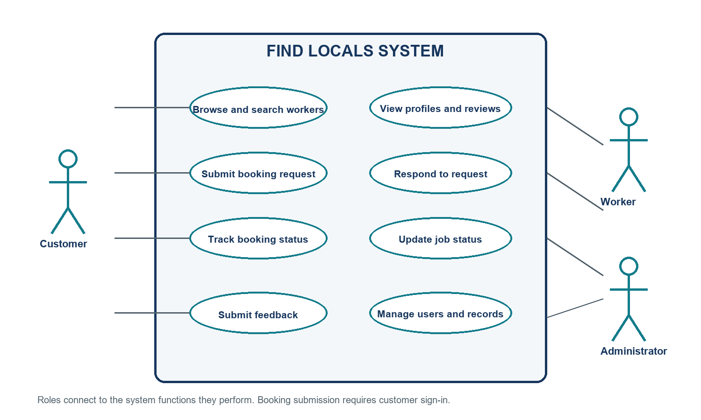
Figure 1. Use case diagram for the Find Locals web application.

13.1 Booking use case explanation
- The customer searches for workers using a service need and location.
- The customer reviews worker profiles and available ratings, then selects a suitable provider.
- The signed-in customer submits a booking request with the required service details.
- The worker reviews the request and accepts or declines it.
- For an accepted request, the worker updates the job status as work progresses and is completed.
- After completion, the customer may provide a rating and feedback; the application stores the associated service record.
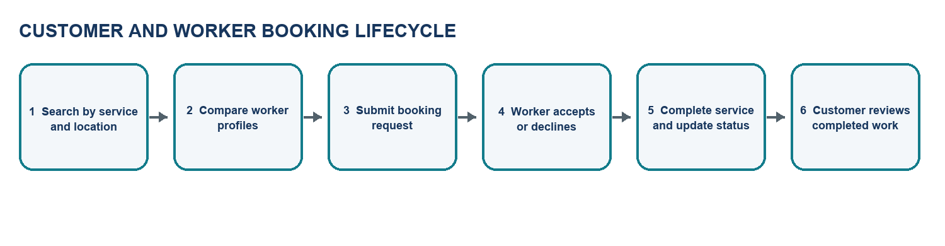
Figure 2. Booking lifecycle from discovery through customer feedback.

13.2 Use case assumptions
- The customer must be authenticated before submitting a booking.
- A booking request remains subject to worker response and availability.
- Feedback is connected to an eligible completed booking.
- Administrators perform verification and management tasks through privileged account access.
- Payment tracking describes cash status only; the use case does not imply online payment processing.

