- Introduction And Motivation

  - Introduction

Data mining refers to extracting or “mining” knowledge from large amounts of data ^{[9]}.It is a process of extracting the hidden valuable information from data ^{[2]}.Data mining also known as “knowledge mining from data”. “Knowledge mining” a shorter term, may not reflect the emphasis on mining from large amounts of data. Nevertheless, mining is a vivid term characterizing the process that finds a small set of precious nuggets from a great deal of raw material. Thus, such a misnomer that carries both “data” and “mining” became a popular choice. Many other terms carry a similar or slightly different meaning to data mining, such as knowledge mining from data, knowledge extraction, data/pattern analysis, data archaeology, and data dredging.

Many people treat data mining as a synonym for another popularly used term, Knowledge Discovery from Data, or KDD. Alternatively, others view data mining as simply an essential step in the process of knowledge discovery. Data Mining is step wise process as follows ^{[9]}:

- Data cleaning:
To remove noise and inconsistent data

- Data integration:
In this step multiple data sources may be combined.

- Data selection:
Here data relevant to the analysis task are retrieved from the database

- Data transformation:
In this step data are transformed or consolidated into forms appropriate for mining by performing summary or aggregation operations, for instance
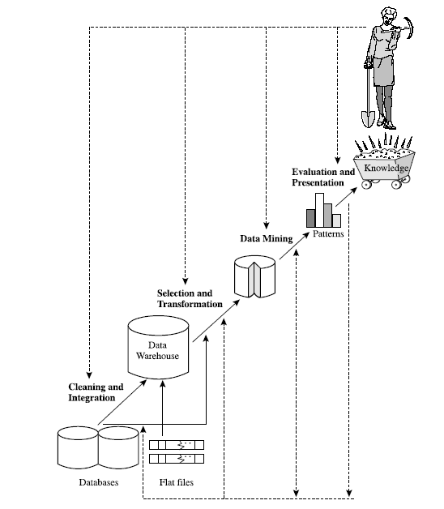

Fig. 1 Steps of Data Mining^{[9]}

- Data mining:
An essential process where intelligent methods are applied in order to extract data patterns

- Pattern evaluation:
To identify the truly interesting patterns representing knowledge based on some I interestingness measures

- Knowledge presentation
In this step visualization and knowledge representation techniques are used to present the mined knowledge to the user

In data mining step classification is used. Classification is a form of data analysis that can be used to extract models describing important data classes or to predict future data trends. Such analysis can help provide us with a better understanding of the data at large. Classification predicts categorical (discrete, unordered) labels, prediction models continuous valued functions.

Many classification and methods have been proposed by researchers in machine learning, pattern recognition, and statistics. Most algorithms are memory resident, typically assuming a small data size. Recent data mining research has built on such work, developing scalable classification and prediction techniques capable of handling large disk-resident data.

  - Problem Statement
Decision tree induction is one of many methods in classification. The foundation stone of the decision tree learning is the concept of learning systems framework approach^{.[3]} It was proposed by Hunt et al in1960. Decision tree is a tree structure similar to the flow chart, which each internal node (non-leaf node) represents an attribute on the test. During the late 1970s and early 1980s, J. Ross Quinlan, a researcher in machine learning, developed a decision tree algorithm known as Iterative Dichotomiser 3.

Iterative Dichotomiser 3 is based on concept of entropy and information gain. Data may be over-fitted or over-classified, if a small sample is tested which leads to have less accuracy. It biased toward tests with many outcomes. It prefers to select attribute having a large number of values In addition to that only one attribute at a time is tested for making a decision.
This accuracy problem needs concern for improving accuracy as well as to improve efficiency of classification

  - Motivation

Data mining has attracted a great deal of attention in the information industry and in society as a whole in recent years, due to the wide availability of huge amounts of data and the imminent need for turning such data into useful information and knowledge. The information and knowledge gained can be used for applications ranging from market analysis, fraud detection, and customer retention, to production control and science exploration.

The abundance of data, coupled with the need for powerful data analysis tools, has been described as a data rich but information poor situation. The fast-growing, tremendous amount of data, collected and stored in large and numerous data repositories, has far exceeded our human ability for comprehension without powerful tools As a result, data collected in large data repositories become “data tombs”—data archives that are seldom visited. Consequently, important decisions are often made based not on the information-rich data stored in data repositories, but rather on a decision maker’s intuition, simply because the decision maker does not have the tools to extract the valuable

Knowledge embedded in the vast amounts of data. In addition, consider expert system technologies, which typically rely on users or domain experts to manually input knowledge into knowledge bases. Unfortunately, this procedure is prone to biases and errors, and is extremely time-consuming and costly. Data mining tools perform data analysis and may uncover important data patterns, contributing greatly to business strategies, knowledge bases, and scientific and medical research. The widening gap between data and information calls for a systematic development of data mining tools that will turn data tombs into “golden nuggets” of knowledge.

Classification is important method in data mining. So to increase efficiency of data mining we need to increase efficiency of classification

- Literature Survey
In this section some related works on various classification methods is presented.

  - Literature Review
    - An Improved Decision Tree Classification Algorithm Based On ID3 And The Application In Score Analysis By Huang Ming, Niu Wenying, Liang Xu,

The researchers have proposed modification for reducing time complexity. The experiment results show that simplified entropy weight algorism spends decrease 65 Seconds compares ID3 algorithm in building up decision tree. It uses technique of Taylor series; here improvements need in terms of accuracy.

This article proposed how to improve ID3 algorithm, and applied the improved ID3 in the student achievement. Finally through experiment, proved the improved ID3 has reduced the complexity, raised accuracy. Especially in huge data quantity, it demonstrates the better classified performance. Generally speaking, the improved ID3 algorithm is answering the actual needs.

    - Research And Application Of The Improved Algorithm C4.5 On Decision Tree By Zhu Xiaoliang, Wang Jian, Yanhongcan, Wu Shangzhuo

The concept as explained in 2.1.1, can be applied for C4.5. It is specified in this paper. It introduces the basic concepts of classifier, the principle of decision tree and algorithm ID3, analyses the algorithm C4.5 and gives further research to improve it. The improved C4.5 algorithm takes up 20s, which is faster than the non-improved one 40%.

The article analysizes the C4.5 and improved methods for the calculation speed of C4.5 algorithm in detail. At least, it is proved by experiment data set that the improved C4.5 algorithm is well-performed on the training speed classify and
accuracy.

    - Study Of Data Mining Algorithm Based On Decision Tree By Linna Li & Xuemin Zhang

In this paper Taylor series is combined with weighted entropy. It focuses on the problems of decision tree algorithm existed in the links of property vacancy and property selection to put forward the concept of Weighted Simplification Entropy, to determine splitting property. It promotes the efficiency, predicted precision and rule conciseness of algorithm.

With the analysis for the common problems in structure process of decision tree, the paper focuses on the problems of decision tree algorithm existed in the links of property vacancy and property selection to put forward the concept of Weighted Simplification Entropy, to utilize the size of Weighted Simplification Entropy to determine splitting property, to put forward optimization strategy based on ID3
algorithm, then to structure decision tree classifier. The example verifies that the method put forward in this article precedes ID3 algorithm, and could effectively promotes the efficiency, predicted precision and rule conciseness of algorithm

    - Re Optimization of ID3 and C4.5 Decision Tree by Devashsish Thakur, Nisarga Markandaiah, and Sharan Raj D

The authors have used Prepruning and rainforest approach for re-optimization of ID3 and C4.5. This change modifies the gain calculation in ID3 and split info calculation in C4.5 and we get a decision tree with higher classification accuracy.
In this paper a new attribute selection measure for ID3 and C4.5 decision trees, to select the splitting attribute of a decision trees. The implementation is done using Java oracle program to test the classification accuracy of our algorithm with that of ID3 and C4.5 and found out that the proposed algorithm had significant higher accuracy.

    - A Knowledge Discovery Using Decision Tree By Gini Coefficient By S.Sivagama Sundhari

Another attribute selection measure for creating decision tree is gini index or gini co-effient, The Relationships discovered by applying Gini Coefficient on decision tree can be expressed as a set of rules, which can then be used in developing an expert system. An ability to produce clear sets of rules makes decision trees particularly attractive to business professionals. Thus knowledge discovered from the decision tree using Gini Coefficient is optimal.

The Relationships discovered by applying Gini Coefficient on decision tree can be expressed as a set of rules, which can then be used in developing an expert system. An ability to produce clear sets of rules makes decision trees particularly attractive to business professionals. Thus knowledge discovered from the decision tree using Gini Coefficient is optimal.

    - ID3 Optimization Algorithm Based On Interestingness Gain By Liu Zhongtao And Wang Hong

ID3 optimization algorithm is a new research orientation in the decision tree algorithm. Based on data classification ID3 algorithm in data mining, this paper introduced the decision tree classification algorithm basic principles. In terms of the deficiencies of traditional ID3 algorithm, these researchers introduced the optimization algorithm with information gains of the user's interestingness attribute values, providing a good solution to attribute selection of ID3 algorithm, and properly retaining compatibility with the original algorithm. Tests showed that, this algorithm is basically consistent with the original algorithm in improving the decision tree classification speed and stabilizing the decision tree structure, but outweighs the original algorithm in terms of dealing with attribute weight classification. In addition, this algorithm improves the quality of data attribute classification and the decision tree structure.

    - Application Of CART Algorithm In Hepatitis Disease Diagnosis by G.Sathyadevi

The medical field collects a huge amount of data which is not appropriately mined and not put to the optimum use. Discovery of these hidden patterns and relationships often goes unexploited. In this paper, the research focuses on this aspect of medical diagnosis by learning pattern through the collected data of hepatitis and to develop intelligent medical decision support systems to help the physicians. In this paper, researcher propose the use of decision trees C4.5 algorithm, ID3 algorithm and CART algorithm to classify these diseases and compare the effectiveness, correction rate among them. Thus, the CART derived model along with the extended definition for identifying (diagnosing) hepatitis disease provided a good classification accuracy based model.

In this paper the comparison of ID3, C4.5 and CART is presented. It is done for hepatitis diseases the decision tree generated by CART algorithm has exactly two or no child. But the decision tree which is generated by other two algorithms may have two or more child. Also, in respect of accuracy and time complexity CART algorithm performs better than the other two algorithms.

The efficiency of algorithms, such as ID3, C4.5, and CART, has been well established for relatively small data sets. Efficiency becomes an issue of concern when these algorithms are applied to the mining of very large real-world databases. In data mining applications, very large training sets of millions of tuples are common. Most often, the training data will not fit in memory! Decision tree construction therefore becomes inefficient due to swapping of the training tuples in and out of main and cache memories.

More recent decision tree algorithms that address the scalability issue have been proposed. Algorithms for the induction of decision trees from very large training sets include SLIQ and SPRINT, both of which can handle categorical and continuous valued attributes. Both algorithms propose presorting techniques on disk-resident datasets that are too large to fit in memory. Both define the use of new data structures to facilitate the tree construction.

SLIQ employs disk-resident attribute lists and a single memory-resident class list. The attribute lists and class list generated by SLIQ for the tuples data. Each attribute has an associated attribute list. Each tuple is represented by a linkage of one entry from each attribute list to an entry in the class list (holding the class label of the given tuple) which in turn is linked to its corresponding leaf node in the decision tree. The class list remains in memory because it is often accessed and modified in the building and pruning phases. The size of the class list grows proportionally with the number of tuples in the training set. When a class list can not fit into memory the performance of SLIQ decreases.

SPRINT uses a different attribute list data structure that holds the class and primary key information, as shown in Figure 6.9. When a node is split, the attribute lists are partitioned and distributed among the resulting child nodes accordingly. When a list is partitioned, the order of the records in the list is maintained. Hence, partitioning lists does not require resorting. SPRINT was designed to be easily parallelized, further contributing to its scalability.

BOAT (Bootstrapped Optimistic Algorithm for Tree Construction) is a decision tree algorithm that takes a completely different approach to scalability. It is not based on the use of any special data structures. Instead, it uses a statistical technique known as “bootstrapping” to create several smaller samples (or subsets) of the given training data, each of which fits in memory. Each subset is used to construct a tree, resulting in several trees. The trees are examined and used to construct a new tree, T0, that turns out to be “very close” to the tree that would have been generated if all of the original training data had fit in memory. BOAT can use any attribute selection measure that selects binary splits and that is based on the notion of purity of partitions, such as the gini index. BOAT uses a lower bound on the attribute selection measure in order to detect if this “very good” tree, T0, is different from the “real” tree, T that would have been generated using the entire data. It refines T0 in order to arrive at T.

.
  - Comparison And Evaluation Of Various Decision Tree Algorithms

On the basis of analytical technique and experimental technique the evaluation and comparison of various decision tree algorithm is as follows.

Algorithm | Advantages | Disadvantages
ID3^{[1][5][7][9]} | - Understandable prediction rules are created from the training data.  - Builds the fastest and shortest tree. | - Data may be over-fitted or over-classified, if a small sample is tested which leads to have less accuracy.  - It biased toward tests with many outcomes. It prefers to select attribute having a large number of values  - Efficiency becomes an issue when applied to the mining of very large real-world databases
C4.5^{[2][5][9]} | - Attempts to overcome biased issue of ID3  - Applies normalization of information gain | - It uses measure Split Info for attribute selection. So when it reaches to zero the algorithm becomes unstable.  - Efficiency becomes an issue when applied to the mining of very large real-world databases
SLIQ^{[9]} | - Handle categorical and continuous valued attribute  - Efficient for very large real-world databases | - Large amount of memory is required for storing attribute list and class list data structure  - Complex mechanism is required for creating and maintaining linkage of one entry from of one entry from each attribute list to an entry in the class list  - When a class list can not fit into memory , the performance of SLIQ decreases
SPRINT^{[9]} | - Removes all memory restrictions,  - Handle categorical and continuous valued attribute  - Efficient for very large real-world databases | - Requires the use of a hash tree proportional in size to the training set. This may become expensive as the training set size grows.

- Proposed Work And Implementation Methodology

  - Iterative Dichotomiser 3

Iterative Dichotomiser 3 uses information gain as its attribute selection measure. This measure is based on theorem by Claude Shannon on information theory, which studied the value or “information content” of messages.

The basic principle of Iterative Dichotomiser 3 algorithm is as follows:
Supposes D=D1×D2×…×Dn is n-dimensional finite vector space, the Dj is finite discrete symbol set, the element d=<v1,v2,..vn>, is called the example^{[1]} and vj є Dj, j=1,2,...,n. Supposing PT(Positive Tuples) and NT(Negative Tuples) is the two example sets, it supposes the sizes of PT and NT respectively are p and q, Iterative Dichotomiser 3 algorithm based on the following two suppositions:

- The class probability that a correct decision tree classify to random example set is consistent with the probability of positive-tuples and negative-tuples in vector space D.

- The information entropy needed for a decision can make correct judgment to an example take A as the root is:

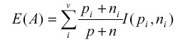 ………………….(1)

In (1)

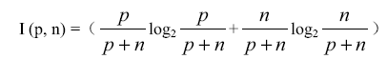 ………………….(2)

3. The Information gained refers to the effective decrement of information entropy, information gain namely take A as the root

………………….(3)

Iterative Dichotomiser 3 algorithm chooses the attribute with maximum Gain (A) as the root node, which means the attributes with the minimum E (A).

  - Optimized Iterative Dichotomiser 3 Using Taylor Series^{[1]}

According to the basic theory and the improved underlying principle of Iterative Dichotomiser 3 algorithm, we may change the information gain formula, thus seek a new standard of choosing attribute.
From the (3),
The I (p, n) is a quota to each node, so selects the value E(A) of the A attribute as the standard between the nodes .now:
In this equality

Put this equation in the above equation and obtain under formula:

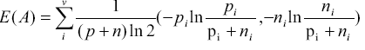

Because (P+N)ln2 is a constant, we can suppose the function e(A) satisfy the following formula:

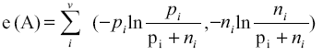 ………………….(4)
From Taylor series we can say that ln(1+x) = x, we may simplify function e(A):

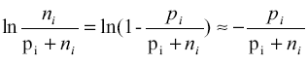

Put above two formula in (4):
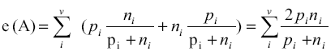 ………………….(5)

Supposed the values of each attribute are N, which is multiplied by function e(A) simplified, than obtain the improved formula:
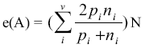 ………………….(6)

It’s obvious that the operation time of the improved E (A) with addition, subtraction, multiplication, division, is shorter than E (A) with logarithmic
Using this formula, time complexity is reduced but accuracy problem remains same. It selects attributes with many values leading to the problem of over classification
    - Example
Here we are solving an example using optimized Iterative Dichotomiser 3 for the following dataset.
No. | Course Type | Test Difficulty | Assignment Time | Score | Comment
1 | A | Middle | Moderate | Superior | Yes
2 | A | High | Moderate | Superior | Yes
3 | C | Middle | Moderate | Superior | Yes
4 | B | Middle | Short | Superior | Yes
5 | B | Middle | Moderate | Good | Yes
6 | C | High | Moderate | Good | Yes
7 | C | Middle | Moderate | Good | Yes
8 | D | Middle | Short | Good | Yes
9 | C | Low | Short | Good | No
10 | B | High | Moderate | Low | No
11 | C | Middle | Moderate | Low | No
12 | A | Low | Short | Low | No
13 | A | High | Short | Low | No
14 | B | Low | Short | Low | No

- Calculation of information entropy of comment attributes:

Before the division, 8 tuples have ” yes” value , 6 tuples have ” no” value in test training samples, therefore the information entropy is
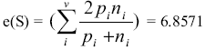

- Calculation of information entropy of other attributes is as follows

- Select the course type as the testing attribute

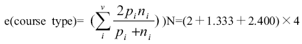
:
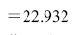
- Select the test difficulty as the testing attribute:

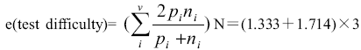

- Select the assignment time as the testing attribute:

- Select the score as the testing attribute

- Calculation of gain:

According the (3) the gain is

The value of Gain (score) is maximum, so take the score as the division attribute for the training set firstly.

Initial sub tree is shown below.
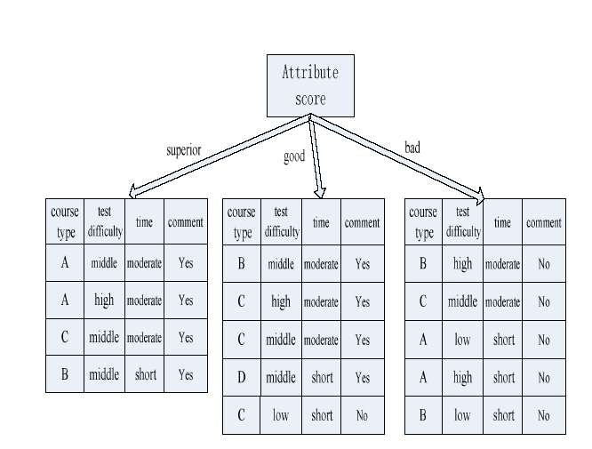

Fig. 2 Initial Decision Tree ^{[1]}

Final decision tree is as follows.

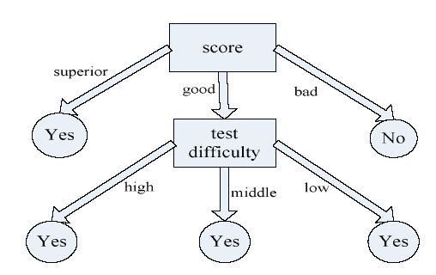
Fig. 3 Final Decision Tree ^{[1]}

  - Evaluation and Comparison
Below table shows the improvement of proposed ID3 to traditional ID3. It can be seen clearly that proposed ID3 has improved accuracy and time complexity.

DataSet | Record Num n | Precision(%) |  | Time(Seconds)
DataSet | Record Num n | ID3 | Optimized Iterative Dichotomiser 3 | ID3 | Optimized Iterative Dichotomiser 3
Dset1 | 525 | 69.7 | 72.5 | 152.9 | 124.7
Dset2 | 730 | 72.5 | 75.8 | 250.4 | 200.8
Dset3 | 910 | 80.4 | 83.9 | 357.6 | 262.4
Dset4 | 1154 | 85.2 | 88.4 | 421.3 | 311.1

Table 1 Comparison Of ID3 and optimized Iterative Dichotomiser 3

  - Proposed Work
The optimized Iterative Dichotomiser 3 can reduce complexity but it is not able to improve accuracy. So the accuracy and over classification problem remains same as ID3. The information gain measure is biased toward tests with many outcomes. That is, it prefers to select attributes having a large number of values.

In my proposed work I will try to improve accuracy of optimized Iterative Dichotomiser 3. To improve accuracy, a function will define. The function will be based on difference between number of tuples that belongs to class 1 and number of tuples that belongs to class 2. Here we have assumed that we have only two classes. The function will apply to each attribute. After that the normalized value will be calculated. This normalized value will be multiplied with Information Gain obtained using ID3 algorithm. This value will be used for creation of decision tree.

Thus the proposed function not only can well overcome the ID3’s deficiency of tending to take value with more attributes, but also can represent the relations between all elements and their attributes. Therefore, the obtained relation degree value of attribute can reflect its importance.

  - Implementation Methodology

For Implementation purpose following tools will be used.

- Weka Tool

- Microsoft .Net 2008

- Microsoft SQL Server

    - Work Flow

The work flow of proposed algorithm is as follows.

Calculation Of Entropy
Calculation Of Function for accuracy

.
Calculation Of Information Gain

Calculation Of Modified Information Gain using accuracy function

Creation of decision tree

- Conclusion

Thus in my dissertation phase 1, I’ve reviewed many algorithm of classification by decision tree. Iterative Dichotomiser 3 is chosen to improve its deficiency regarding accuracy which leads to have over classification. In [1] an attempt is made to improve its time complexity but accuracy problems remains same. So In my work I will improve accuracy of Iterative Dichotomiser 3.

- Future Work

In future work I will implement the proposed algorithm using .net framework. The backend will be Microsoft SQL Server. The front end will be C#.Net. The proposed algorithm will have improved accuracy and time complexity. So efficiency of classification will also be improved.

References
[1] “An improved decision tree classification algorithm based on ID3 and the application in score analysis”, by Huang Ming, Niu Wenying, Liang Xu, Chinese Control and Decision Conference Page No.1876-1880, 2009

[2] “Research and Application ofthe improved Algorithm C4.5 on Decision Tree”,by Zhu Xiaoliang, Wang Jian, YanHongcan, Wu Shangzhuo, International Conference on Test and Measurement, Page No.: 184-188, 2009

[3] ”Decision tree method in financial analysis of listed logistics companies”, by Gu Yu, Guo Wenjuan, International Conference on Intelligent Computation Technology and Automation, 2010

[4] “Study of Data Mining Algorithm Based on Decision Tree”, by Linna Li & Xuemin Zhang, International Conference On Computer Design And Appliations, 2010

[5] “Re Optimization of ID3 and C4.5 Decision Tree”, by Devashsish Thakur, Nisarga Markandaiah, and Sharan Raj D, International Conference on Computer & Communication Technology, 2010

[6] “A Knowledge Discovery Using Decision Tree By Gini Coefficient” by S.Sivagama sundhari
International Conference on Business, Engineering and Industrial Applications,2011

[7] “ID3 Optimization Algorithm Based on Interestingness Gain” by Liu zhongtao and Wang hong, IEEE, 2011

[8] “Application Of CART Algorithm In Hepatitis Disease Diagnosis” by G.Sathyadevi, International Conference on Recent Trends in Information Technology,2011

[9] Data Mining, Concepts and Techniques, Jiawei Han and Michline Kamber, 2nd edition,2010

[10] “Research on Decision Tree in Component Retrieval” by Yanhua Shao, Mingsheng Zhang
And Shengnan Xu, Seventh International Conference on Fuzzy Systems and Knowledge Discovery,2010

[11] “Rough Set and CART Approaches to Mining Incomplete Data” by Jerzy W. Grzymala-Busse, International Conference of Soft Computing and Pattern Recognition,2010

[12] “An Extended ID3 Decision Tree Algorithm for Spatial Data” by Imas Sukaesih Sitanggang, Razali Yaakob, Norwati Mustapha, Ahmad Ainuddin B Nuruddin, IEEE,2011

[13] “Overview of Use of Decision Tree algorithms in Machine Learning” by Arundhati Navada, Aamir Nizam Ansari, Siddharth Patil, and Balwant A.Sonkamble, IEEE Control and System Graduate Research Colloquium,2011

[14] “Evolutionary Data Mining Approaches for Rule-based and Tree-based Classifiers” by Thomas Weise and Raymond Chiong 9th IEEE Int. Conf. on Cognitive Informatics, 2010

[15] “Parallel Decision Tree Algorithm Based on Combination” by Li Wenlong and Xing Changzheng, International Forum on Information Technology and Applications,2010

[16] “Comparison Study on Classification Performance for Short-term Urban Traffic Flow Condition Using Decision Tree Algorithms” by Jiao-Jiao Wang, Jin-Feng Wang, Feng-Lu, Zhi-
Dong Cao, Yi-Lan Liao and Yu-Deng, World Congress on Software Engineering,2009

[17] www.anderson.ucla.edu

[18] www.datamining.typepad.com

[19] www.en.wikibooks.org/wiki/Data_Mining_Algorithms_In_R

