- INTRODUCTION
  - PROJECT SUMMARY:
This project contains information about student and company. In student module, we have personal, technical & educational information. In company module we have company information, company’s area of working & its requirements for recruitment.
  - PURPOSE:
The purpose of this project is to help college administrator or T&P co-coordinator to collect information about all students and companies which provide training and interested in recruitment of students.
  - SCOPE:
The scope of this project is for college use, for company recruitment & for student information. The college administrator can easily get the data of particular student & he can also get company information.
- PROJECT MANAGEMENT
  - PROJECT PLANING
2.1.1 Project Development Approach and Justification
We have Incremental model. According to incremental model, the first version of the project will be developed. After the correction and description of new requirement, 2nd version of project will be developed. According to this the whole project will be developed.

2.1.2 Project Scheduling (gantt chart):
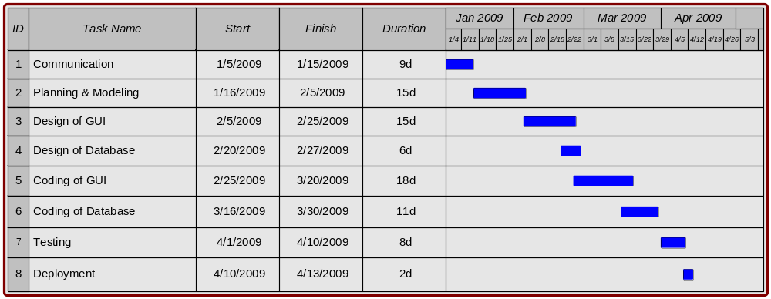
2.2 RISK MANAGEMENT
2.2.1 Risk Identification & Planning
Business Risk:

Conflict with Client
Risk Event | Conflict with Client
Risk Response Action | If there is a conflict with the Client, it is up to the project manager and any applicable team members to sit down with the Client and try to come to an agreement. If no resolution is possible then the matter will be passed onto the Project Supervisor and Unit Coordinator to negotiate.
Description | Acceptance
Assigned To | Project Manager

Product not delivered within schedule
Risk Event | Product not delivered within schedule
Risk Response Action | When the project is running over time, the team will have to inform the relevant parties and make changes to documents and replan and re-negotiate milestones. The team will also have to try and lessen the impact by appeasing stakeholders and others who expected it due the specified date. Success will be ensured by tightly conforming to the WBS and Gantt and thorough change management processes.
Description | Mitigation
Assigned To | Project team

Technical Risk:
Scope changed
Risk Event | Scope changed
Risk Response Action | If the scope is changed due to Client request or other external pressures the team will have to adjust to the change and replan and update documents if the actions are deemed fair by team consensus. Alternatively they can try to avoid the scope change by negotiating with the Client early and defining the scope in the High Concept and Systems Required documents.
Description | Acceptance or avoidance
Assigned To | Project team

Team members lack necessary technical skills
Risk Event | Team members lack necessary technical skills
Risk Response Action | If some of the team members do not have the technical skills required to complete some task the project manager can either avoid the problem by moving team members around to different tasks and maybe bringing in new members to fill in skill gaps, or they can try to mitigate the situation by getting members to complete what they can and leaving the rest to later, possibly with the goal of completion later or leaving some features out.
Description | Avoidance or Mitigation
Assigned To | Project Manager

Hardware not suitable for project
Risk Event | Hardware not suitable for project
Risk Response Action | If the hardware is not up to date at the Client end and the product will not run, it is up to the team to decide which path to take, either inform the Client that they need better hardware and transfer the problem to them, or try and rewrite the software so that it work on the current hardware.
Description | Transfer
Assigned To | Project team

2.2.2 Risk Analysis:
Project risks are assigned a rank and given a risk statement. A risk statement is a refinement of the risk description defined during risk identification. Here we have identified the probability of occurrence, impact, and severity for each risk.
Rank | Risk Statement |  | Probability (P),  Impact (I),  Severity (P & I)
Rank | Event | Consequence | (P) | (I) | (P x I)
10 | Conflict between team members | Project may become unable to continue until conflict is resolved. | Low | Low | Low
5 | Team member not working | Project may become unable to continue or may fall behind its schedule. | Low | Medium | Medium
3 | Loss of team member Low | Project will be slowed or stopped. | Low | High | High
9 | Conflict with Client | Time will be taken up trying to resolve issue. | Medium | Medium | Medium
2 | Scope changed | Project documents may need to be updated and plans changed. | Medium | High | High
1 | Product not delivered within schedule | Product will be over time and will need more resources. | Low | High | High
8 | Hardware not suitable for project | Product will not run on the hardware Client currently has. | Medium | Low | Medium
4 | Project over budget | Project will not be able to proceed without more funds. | Low | Medium | Medium
7 | Team members lack necessary technical skills | Project may be held up as members are not able to complete tasks. | Low | Medium | Medium
12 | Loss of data | Project may be slowed as some work will need to be redone | Medium | High | High
11 | Temporary loss of team member | Project may be held up as other members will need to complete tasks additional tasks that they may not have suitable skills for. | Low | Medium | Medium
13 | Leadership absence | 9 what the previous leader was doing. | Low | Medium | Medium

2.3 ESTIMATION
2.3.1 Effort Estimation

Line Of Code (LOC) = 1800
KLOC = 1.8

Effort = 2.4 (KLOC)^{1.05}
= 2.4 (1.8) ^{1.05}
= 4.45 PM

T_{dev} = 2.5 (Effort)^{0.38}
= 2.5 (4.45)^{0.38}
= 4.408 Months

- SYSTEM REQUIREMENTS STUDY:
  - INTRODUCTION
- Background:
In colleges one software is required that can store student’s record & from that they can easily retrieve information of students. This software is mainly used for this purpose. It also has information of companies which are interested in recruitment of the student from the college.
- Overall Description:
This project contains two modules: student and company.
In student module, it contains three forms to get information from user. These three forms are: Technical, Personal and Educational. In Personal form, it contains student’s name, address, his/her school name and some more information. Educational form contains student’s mark in 10th and 12th standard, marks in all semesters. The total of all this marks and its aggregate will be automatically generated. In students’ search engine, we can search through students’ class (distinction, first class or second class) or through his stream.
In company module, there will be one form for company registration. This will contain information like company name, address, branches, contact person, area of working, constraints etc. In company search engine, we can search through area of working, branches available in specific city, etc.

- Environment Characteristics:-
- Hardware:
- Screen resolution of at least 800*600-required for proper and complete viewing of screens. Higher resolution would not be problem.
- Standalone system or network based not a concern, as it will be possible to run the application on any.
- Peripherals:
- Support for printer (dot-matrix/desk Jet/inkjet etc.-any will do) – that is, appropriate drivers are installed and printer connected printer will be required for printing of reports.

- People
- Educational level:
Anyone who can understand English can use the software. The user must be clear with its goal what he wants to do searching for student, company or wants to register his company.
- Interfaces:
- Interfaces with devices:
It interfaces with printer if user wants to take print out.
- Interfaces with operating system:
None
- Interfaces with database:
The user doesn’t directly interact with database. While submitting the form, the data will be stored in database. MS-Access will be used as backend.
- Interfaces with users:
- From the first screen the user will decide where to go, either in student module or in company module.
- After selecting student module, he has two choices
1) Student search 2) Student entry
- In student entry, the form will be filled up. These three forms are: Personal, Technical and Educational.
- In student search, the user will select the class with which it wants to select student, its stream etc.
- In company module, user also has two choices:
1) Company entry 2) Company search
- In company entry, the company information like name, address of main branch and other branches, area of working etc. are there.
- In company search, the user will search for the company which he wants to select.
- Constraints:
- The marks entered in Educational form, must be digits.
- The search will be performed only according to given criteria.
- In company registration form these fields are compulsory: name, address of main branch, name of guide and contact person and their contacts.
- If any student wants to register then he must fill all the three forms.
  - FUNCTIONAL REQUIREMENTS:
- Functional Partitioning:-
The functionality of this software is mainly divided in to two parts:
1) Student 2) Company
1) Student:
- Student registration
- Student search
2) Company:
- Company registration
- Company search
- Functional Description
The student function will contain all the information regarding student registration and student search. The student search is just like search engine which perform searching of student according to criteria given by user. The student registration will register student and enter all information regarding student.
The company function will perform same two functions: company registration and company search.
- Control Description
First user will have to decide which module he wants to select.
If he selects student module than he has two choices: student registration or student entry. If he selects student search then its form will display. User will enter his choice and according to that the result will display. If he wants to register student than student’s personal information form will display. After that the user must fill educational and technical forms. Then student registration will be done.
If user will select company module than he has two choices: company registration and company search. If user selects company registration then its form will display. If user selects company registration then its form will display.

3.3 BEHAVIOURAL DESCRIPTIONS:
  - System states:
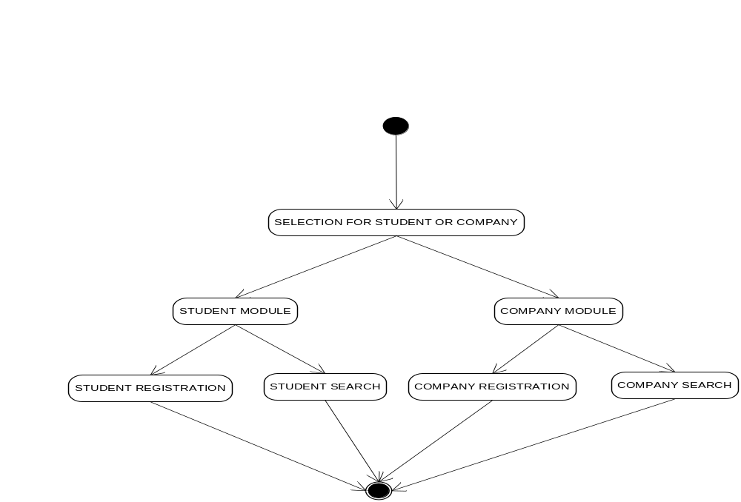

3.2 Actions and event
4. System analysis:

  - Problem and weakness of current system:

The problem within current system is that the search performed by searching form is limited. We can search only within specified criteria. If user has any other choice then this specified criteria then he cannot search.

  - Feasibility Study
4.2.1 Does the system contribute to the overall objective of the system?
The main objective of the customer is to have all the information about student. This system will provide three forms personal, technical, educational through which customer can have all the information regarding student. Thus the system contributes to the overall objectives of the customer.
4.2.2 Can the system be implemented using current technology and within the given cost and schedule constraints?
The system can be easily implemented using current technology and within the given constraints. If the programmer is expert and using advanced technology then it may possible that within the very short time the system will be implemented.
4.2.3 Can the system be integrated with other systems which are already in place?
Not applicable.

  - Class Diagram
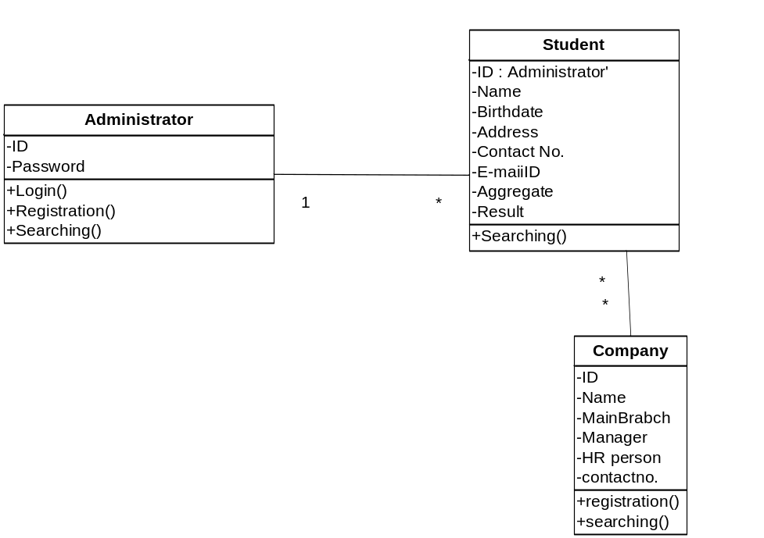

  - System activity
    - Usecase Diagram

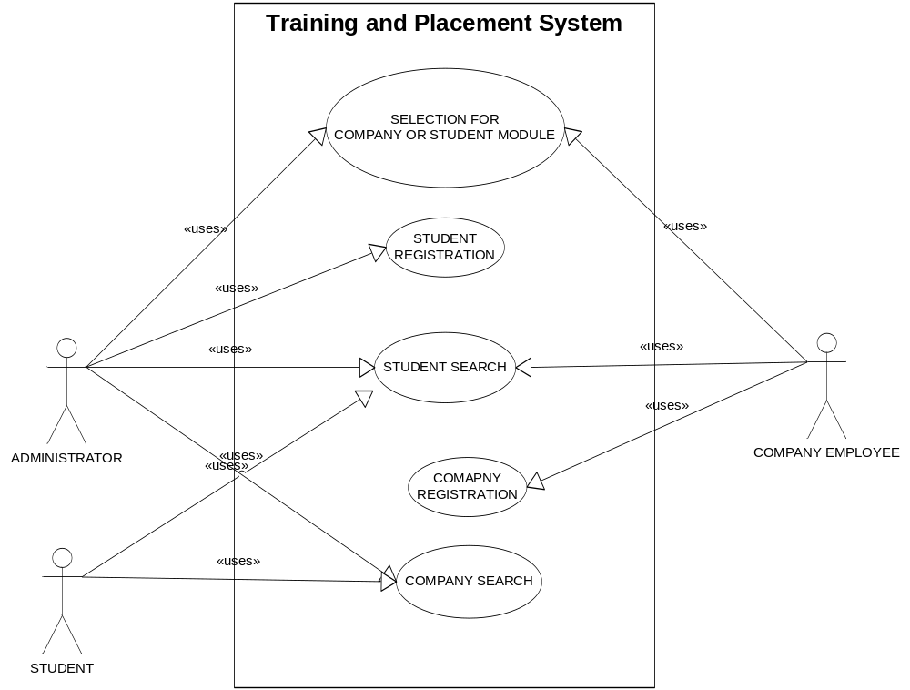

    - Activity Diagram

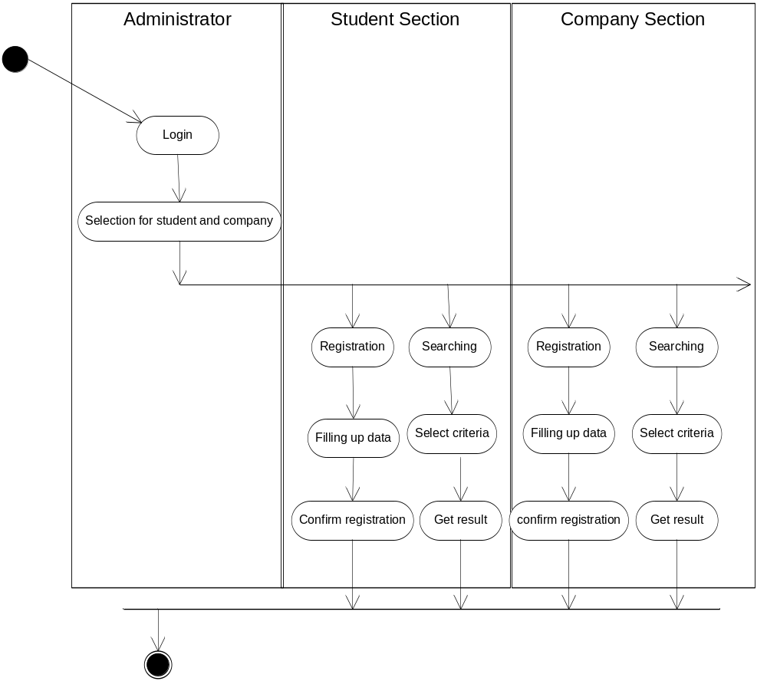

  - Sequence Diagram

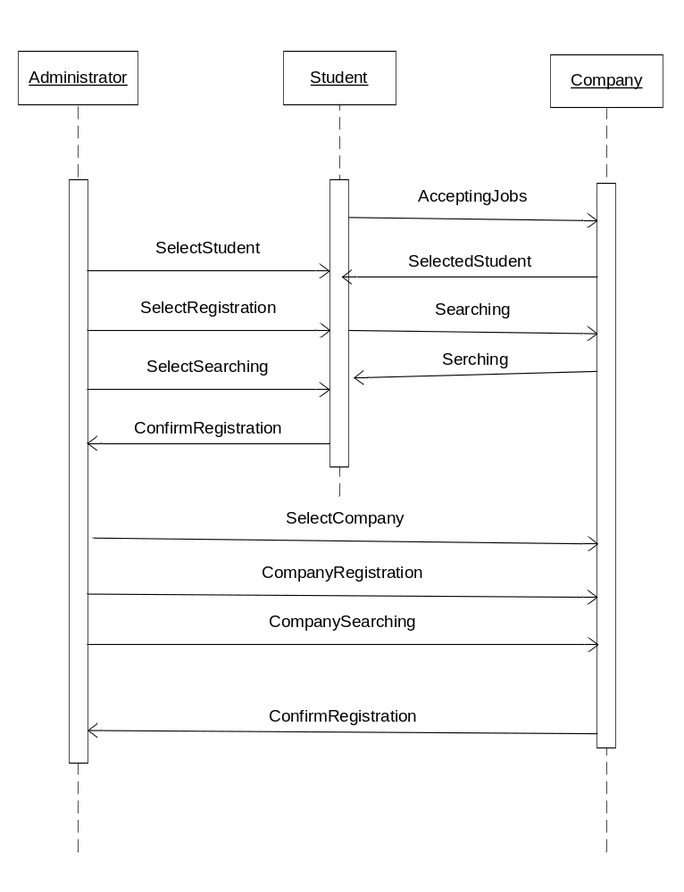

4.6 Data Modeling

4.6.1 ER Diagram

