***Abstract***

This paper presents a detailed implementation of Goertzel algorithm in C language for embedded system. Goertzel algorithm is a signal processing technique used in target frequency detection. This implementation is designed for dual-tone multi-frequency (DTMF) signal detection and audio generation. The algorithm is based on the mathematics methodology: Fast Fourier transform (FFT) and specific modules: Infinite Impulse Response (IIR) filter and Finite Impulse Response (FIR) filter. The code is tested and implemented on an embedded platform, and the results demonstrate a proposed system provides an accurate and reliable method for processing DTMF signals, finding the specific frequencies required in the decoding file.

~~Zver:~~

~~This report presents Goertzel algorithm for dual-tone multi-frequency (DTMF) signal detection and generation. The Goertzel signal processing technique is used in c language and implemented to detect the target frequency in the signal. The results show that the proposed system provides an accurate and reliable method for processing DTMF signals, finding the specific frequencies required in the data bin decoding file.~~

***The introduction***

(Background, application, motivation)

The Goertzel algorithm is a signal processing technique to detect specific frequencies in a signal. It is widely used in various applications, including dual-tone multi-frequency (DTMF) signal detection, which is predominately applied for push-button digital telephone sets. Our implementation focuses on DTMF signal detection and audio generation, which is critical for telecommunications. In this paper, we present a detailed implementation is present in C language for embedded system and a methodology, which includes equations and images to illustrate the signal processing steps. Our implementation based on Goertzel algorithm loop includes feedback and feedforward, which refers to Infinite Impulse Response (IIR) filter and Finite Impulse Response (FIR) filter respectively, to ensure reliable and accurate frequency detection while reducing the computational complexity. We test our codes with specific encoding data bin file and our results show that the decoding audio is as same as the given audio file, which has proven the feasibility. Our implementation can serve as a basis for further developments in DTMF signal processing and other applications need specific frequency detection, such as telephone banking system. In discussion, we also discuss the advantages of Goertzel algorithm in embedded system and elements to optimize the system, includes scale factor, error prevent functions and the memory efficiency.

***GOERTZEL ALGORITHM***

(Previous research, difference)

Various project contains DTMF signalling. In DTMF signalling system, two frequency tones represent a specific digit (1, 2, 3, 4, 5, 6, 7, 8, 9), character (A, B, C or D) or symbol (* or #). To detect tones, this can be achieved by using filters or Discrete Fourier Transform (DFT) [1], [2]. For DFT, bakbfk.

把公式打进overleaf 参考课件及下图

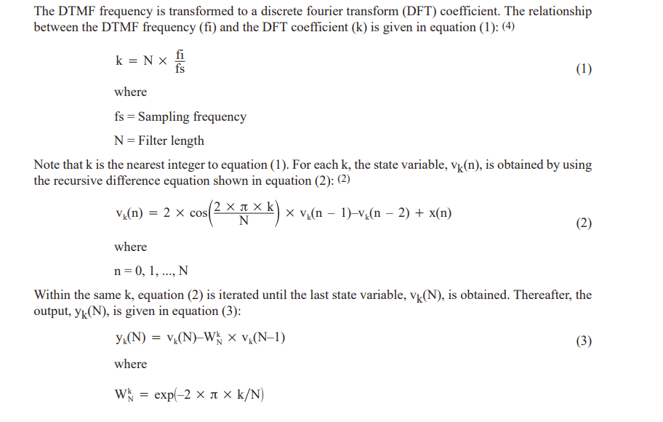

***Implementation***

1000? 分成3部分：Goertzel算法部分，识别部分，音频wave generation部分

每部分记录内部变量

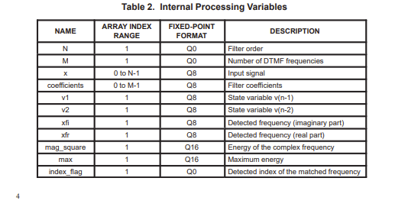

画 flow chart*2 :Goertzel算法部分，识别部分（参考下图）

音频生成介绍下原理

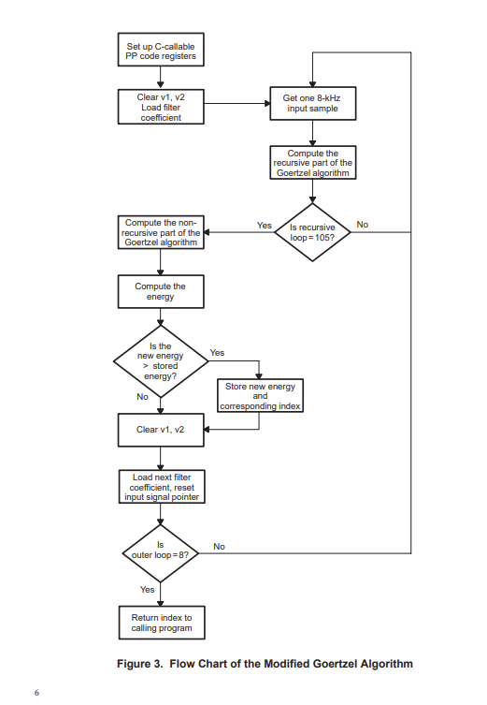

***Results***

300?

***Conclusion***

Result conclusion可以合并成performance?

***Discussion***

In this paper, we have presented a detailed implementation of Goertzel algorithm in C language for embedded system, focusing on DTMF signal detection and audio generation. By focusing on high-order Goertzel algorithm, our proposed system offered a reliable and accurate method for frequency detection while keeping the memory taken low, which makes the memory efficiency extremely impressive at the source.

Overflow is a common problem appears in the embedded system and this might cause data lost and memory efficiency low. To prevent overflow, we add a scale factor to ensure the

***Reference***

[1] Professor Dahnoun, ‘’C for Embedded System’’, Lecture 13, EENG20004 course materials, University of Bristol, 2023 (for powerpoint)

[3] Professor Dahnoun, ‘’Goertzel Algorithm Implementation in C for Embedded System’’, EENG20004 course materials, University of Bristol, 2023 (for codes)

[2] A. Vitali, ‘’The Goertzel algorithm to compute individual terms of the discrete Fourier transform (DFT),’’www.st.com, pp. 1-2, Dec.2017.

Accessed on: Mar. 20, 2023. [Online]. Available:

[The Goertzel algorithm to compute individual terms of the discrete Fourier transform (DFT) (st.com)](https://www.st.com/resource/en/design_tip/dm00446805-the-goertzel-algorithm-to-compute-individual-terms-of-the-discrete-fourier-transform-dft-stmicroelectronics.pdf#:~:text=In%20the%20Goertzel%20algorithm%2C%20a%20set%20of%20N,factor%20W%28t%29%20is%20defined%20as%20exp%28-j%202pi%2FN%20t%29.)

[4] C. S. Burrus, ‘’Fast Fourier Transform (Burrus,’’ LibreTexts ENGINEERING, vol. 4.4, May. 2022.

Accessed on: Apr. 11, 2023. [Online]. Available:

[4.4: Goertzel's Algorithm or A Better DFT Algorithm - Engineering LibreTexts](https://eng.libretexts.org/Bookshelves/Electrical_Engineering/Signal_Processing_and_Modeling/Fast_Fourier_Transforms_(Burrus)/04%3A_The_DFT_as_Convolution_or_Filtering/4.04%3A_Goertzel's_Algorithm_or_A_Better_DFT_Algorithm)

(why goertzel best)

**Implementation部分的reference 改格式**

https://www.st.com/resource/en/design_tip/dm00446805-the-goertzel-algorithm-to-compute-individual-terms-of-the-discrete-fourier-transform-dft-stmicroelectronics.pdf

https://www.ti.com/lit/an/spra066/spra066.pdf?ts=1680647535812&ref_url=https%253A%252F%252Fwww.google.com%252F