Predicting Airbnb Prices Using Regression & Classification

Kiana Mills (kianamills26@ucla.edu)

Department of Psychology, 502 Portola Plaza

Los Angeles, CA 90095 USA

Ajay Dhaliwal (ajayvir98@ucla.edu)

Department of Psychology, 502 Portola Plaza

Los Angeles, CA 90095 USA

Abstract
Airbnb is a home-sharing platform where anyone wanting to post a listing is expected to set their own price. However, there currently does not exist any service that provides a price setting guidance, other than those that make suggestions based on a homeowner inputting some base price. Undertaking the accurate prediction of prices is an important goal because even small differences in prices can mean losses in revenue or inversely, losses in occupancy. Machine learning models can help mitigate these challenges by using key features and large amounts of past user data to determine an accurate price range for the homeowner. Past research used a range of methods from tree-base models to support-vector regression, K-means Clustering, and linear regression and found the SVR had the highest R^2 for validation and test sets (Kalehbasti, Nikolenko & Rezai, 2019). In a simpler work, Yang et al. applied linear regression to study the market accessibility and hotel prices in the Caribbean, including user ratings and hotel classes as contributing influences (2016). Our current research goal was to utilize simple linear regressor and classifier neural network models first and progressively build more complex NNs to determine the best fit, while also uncovering the most important features in predicting price. We hypothesized that a classifier model would yield higher accuracy because neural networks are better suited to this task, yet for this specific task in predicting price, a linear model would naturally fit best; therefore we attempted both.
Keywords: Neural Networks; Linear Regression; Classification; Machine Learning

Dataset
The data was scraped from the public dataset at InsideAirbnb.com on 9/4/19 and includes information from all Los Angeles listings at that time.
For the initial preprocessing, the authors explored each of the 72 columns and dropped columns that (i) were highly correlated, (ii) were Boolean columns with only one one category, and (iii) were uninformative. Missing fields were also filled in using appropriate values, for example using the median for bathrooms and bedrooms, and using the mean for columns of type float. Obvious outliers were also removed, such as in the case of a 1 bed, 1 bath going for over $20,000 per night.

Feature Engineering
Exploratory data analysis was necessary for many of the free text columns, such as housing type, which was condensed based on a schematic of most-likely fit, e.g.

‘Chalet’→ House, ‘Villa’→ House, ‘Loft’→ Apartment, so as to condense the large number of categories with only a few listings. For each listing, an array of amenities was parsed to determine all possible ammenitities and then build features based off these. For example, if a hosting boasted ‘Amazon Echo’, ‘Apple TV’ ‘Game Console’, or ‘Smart TV’, then a new Boolean category of high_end_electronics was added. For the remaining features, categorical features were one hot encoded and numerical features were log transformed so as to minimize the influence of outliers. The data was then split into training, validation, and test sets. Since the dataset was relatively large, only 15% was used as the testing as this seemed sufficient. Feature selection was done manually, but there remained still too many features, so Xgboost Regressor was used to determine feature importance and from there the features could be narrowed down if they contributed ‘zero’ importance to the model.

Methods
Both linear regression and classifier models were implemented in an attempt to see which had the best performance. As stated before, we hypothesized that a classifier model would perform best, because neural networks are best suited for this task. However, classifying required us to manually bin the price variable, a challenging endeavor when there is a wide range of values and many outliers. A classifier also cannot give quite as accurate results, as it will place the estimate in the bin it fits best. In contrast, regression can provide a single prediction and this would give a specific price value to work with.

Widrow-Hoff Linear Associator
We implemented a simple Widrow-Hoff Linear Associator based upon our studies in Psych 186B. This model is a classification one, and so the prices were first binned based on frequency, for a total of 23 bins. The target vectors, which were binary encoded, were therefore 23 x 1 in dimension. An association matrix was computed for each pair of input and output, and was updated over the course of several iterations until the error dipped below the error threshold of 0.00001.
The results of the Linear Associator were actually quite poor, despite the relatively quick minimization of error over 17 iterations. We believe that this may be due to our lack of sufficient binning, and because of the misrepresentation of larger price values in our bins. The linear associator was probably too simple of a solution regardless, as it does not introduce nonlinearity into the unit.

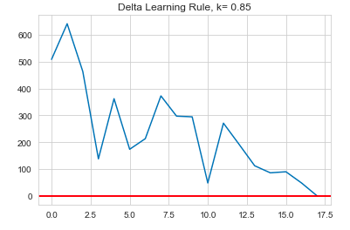
Figure 1: SSE over 17 trials with initial k = 0.85

Four Layer Neural Network
For the initial version of a full neural network, a relatively shallow 4 layers network was created. It consisted of densely connected layers and because this was a regression problem, a relu (rectified linear unit) activation function was used for the 2 hidden layers. To measure loss, we used MSE.

Table 1: Layers of the 4-Layer NN

Layer | Nodes |  |  | DIM | Weight Connections
Input Layer |  | 128 |  | 128 |  | 10368
Hidden Layer 1 |  | 256 |  | 256 |  | 33024
Hidden Layer 2 |  | 256 |  | 256 |  | 65792
Output Layer |  |  | 1 | 257 |  | 257

The four-layer network performed much better than the linear associator. MSE for training set was 0.0408, with an R² of 0.9464. For testing set, MSE was 0.2662 with R² of 0.6461.

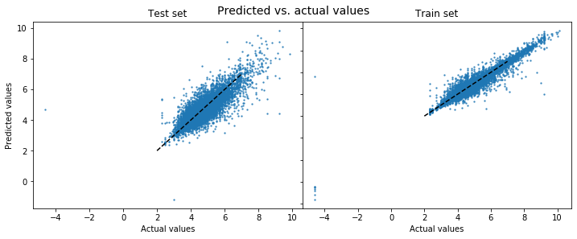

Figure 2: Predicted vs. Actual Values for training set(right) and testing set (left)

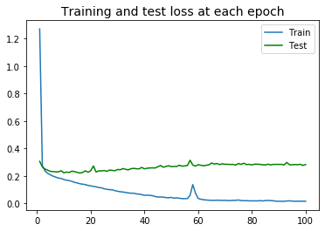
Figure 3: Training and test loss at each epoch

While this model is a vast improvement from the linear associator, we could see that the model was performing much better for the training set than the test set, indicating that overfitting was an issue. Figure 3 further highlights this point, showing the disparity between the train and test set MSE at each epoch. The scatterplots of Figure 2 also depict this via the much tighter clustering around the line of the training set.

Five Layer Neural Network with Gradient Descent
To try and reduce overfitting, we decided to add a fifth layer to the network and to also optimize using stochastic gradient descent (SGD optimizer).

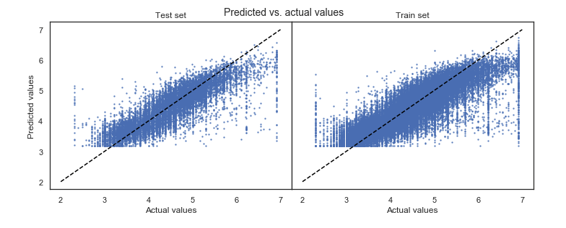
Figure 4: Predicted vs. Actual Values for training set (right) and testing set (left)

The 5-layer network with SGD optimizer performs slightly worse than our 4-layer network. The MSE for the training set was 0.1739 with an R² of 0.7043. The test set had an MSE of 0.1705 and an R² of 0.7077. Despite slightly worse performance, one good outcome here was that the MSE of each set was near similar meaning that overfitting is not an issue in this model. However, this model seemed to not be predicting y-values of less than 3 which is an issue we have yet to uncover.

Breaking the Model
In an attempt to test the limits of the model, six of the most important features were chosen to be corrupted at random. The corrupted values were out of the ‘normal range’ so as to simulate outlier like values. The network was severely impacted by the corruptions, with a training MSE of 2.2729 and a validation MSE of 2.2136.

Conclusions and Future Work
This paper attempts to come up with the best-performing model for predicting Airbnb prices based on a known set of features including amenities, property specifications, reviews, square footage, and location. Neural network models were used to achieve the best results in terms of Mean Squared Error and R² score. Xgboost based feature importance analysis was used to reduce variance and overfitting of the models. A Linear Associator was first implemented using the Delta Learning rule. Poor performance on this simple model led to the implementation of a 4-layer neural network, followed by a 5-layer neural network optimized using stochastic gradient descent. Among the models tested, the 4-layer neural network performed best and produced an R² of 65% and a MSE of 0.266 on the test set. This level of accuracy is promising; as a comparison Kalehbasti et al. achieved an R² of 69% with a Support Vector Machine, which is not far off from our results.
Still, even our best model was only able to explain 65% of the variation in price. One possible explanation for the remaining variation may be due to the photo data that we had to drop initially. The photos of properties on Airbnb are very important and often a deciding factor for guests when choosing to book or not. Therefore, photos would probably have a significant impact on price (better quality photos equal higher prices). We were unable to explore the image data due to time constraints, but a potential future direction for modeling would be to find a way to incorporate image quality into the model (a convolutional neural network would probably be best suited for this task).
Another potential direction for future work also includes using natural language processing to augment the model, which is again something we did not have the time for nor the experience. Yet NLP would be extremely valuable for predictions due to the many number of free test columns from the dataset at InsideAirbnb, for example listing descriptions, reviews, and keywords.

Acknowledgments
Special thanks to our lovely TA, Lucy Cui, and to our most dedicated professor, Zili Liu, for their efforts and time spent enlightening us on the possibilities of neural networks!

References
Kalehbasti, P., Nikolenkon, L. & Rezaei, N. (2019). Airbnb Price Prediction Using Machine Learning and Sentiment Analysis. Stanford University.
Y. Ma, Z. Zhang, A. Ihler, and B. Pan, “Estimating warehouse rental price using machine learning techniques.,” International Journal of Computers, Communications & Control, vol. 13, no. 2, 2018.
Y. Li, Q. Pan, T. Yang, and L. Guo, “Reasonable price recommendation on airbnb using multiscale clustering,” in Control Conference (CCC), 2016 35th Chinese, pp. 7038–7041, IEEE, 2016.
“Airbnb public dataset.” http://insideairbnb.com/get-the-data.html. Accessed: 2019-11-01.
https://scikit-learn.org/stable/, scikit-learn Machine Learning in Python.
https://keras.io/, Keras: The Python Deep Learning Library.

