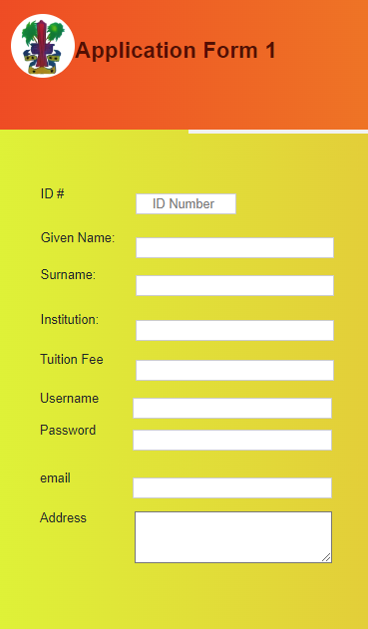

home

broy

br@gmail.com

br23

5000

UOG

Roy

Bill

22