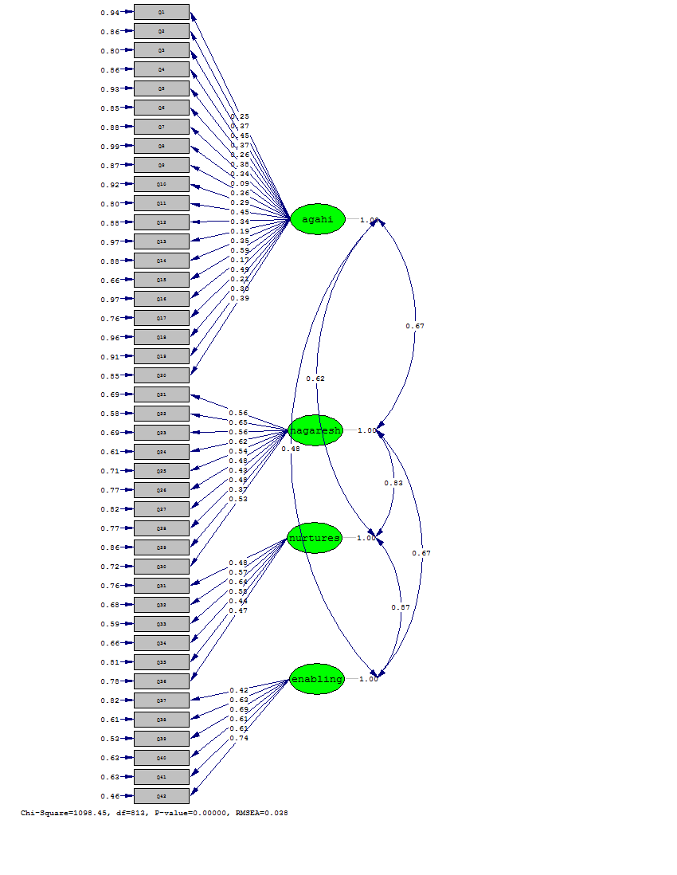

**Figure 1.** Standard estimation model based on binary correlation coefficients of questionnaire structures