Experiment No. 8
Software Engineering Lab – Data Flow Diagram (Data View Analysis)

Part A – Theory

Aim:
To draw the Level 0 and Level 1 Data Flow Diagrams (DFDs) for the ContextGuard Verification System.

Theory:
A data flow diagram (DFD) maps out the flow of information for any process or system. It uses defined symbols like rectangles, circles and arrows, plus short text labels, to show data inputs, outputs, storage points and the routes between each destination. Data flowcharts can range from simple, even hand-drawn process overviews, to in-depth, multi-level DFDs that dig progressively deeper into how the data is handled.
They can be used to analyse an existing system or model a new one. Like all the best diagrams and charts, a DFD can often visually “say” things that would be hard to explain in words, and they work for both technical and nontechnical audiences, from developer to CEO.

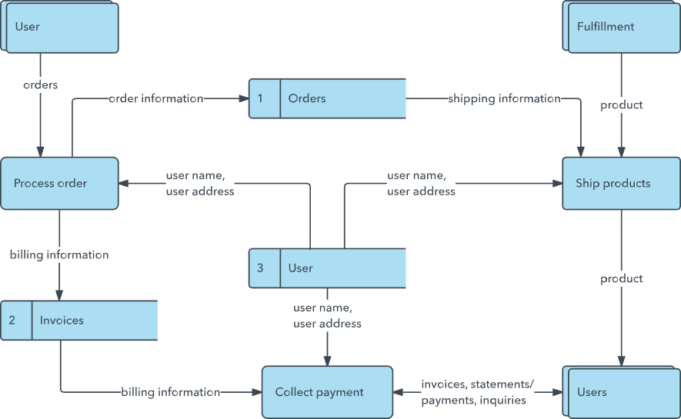

That’s why DFDs remain so popular after all these years. While they work well for data flow software and systems, they are less applicable nowadays to visualizing interactive, real-time or database-oriented software or systems.

Example Output: A data flow diagram of the system.

Level-0:
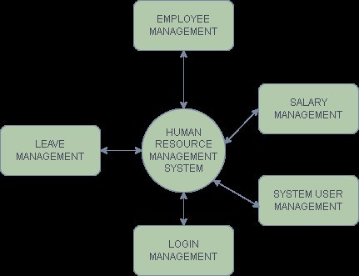

Level-1:
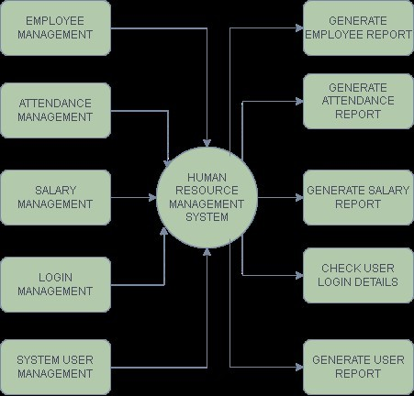
PART -B

Experiment No. 8
DATA FLOW DIAGRAM FOR CONTEXTGUARD VERIFICATION SYSTEM
ContextGuard – Developed DFD (Data Flow Diagram) Level-0 and Level-1

Name: Snehal Kumar (B054) | Suhanee Midha (B062) | Kian Jain (B131)
Class: BTech Computer Engineering | Batch: B2
Date: 11 October 2026

Description of the System
ContextGuard is a software verification system designed to analyse pull requests and support code review. It receives pull request details from GitHub, performs an initial AI-based review, retrieves relevant repository context, and synthesises tests to verify proposed fixes. The system then produces a final verdict, sends notifications, maintains audit records, and generates evaluation reports.
The system interacts with developers, reviewers, engineering managers, repository administrators, GitHub, an LLM service, and a test or code execution environment.

Level 0 DFD (Context Diagram)
The Level 0 DFD represents the complete ContextGuard Verification System as a single process labelled “0 ContextGuard Verification System.” It shows the exchange of information between the system and seven external entities.

The external entities are:
- Developer (PR Author): Submits the pull request link and receives the verified verdict, evidence, and notification.
- Reviewer/Maintainer: Provides review decisions or override instructions and receives evidence-backed verdicts and notifications.
- Engineering Manager: Requests evaluation reports and receives performance metrics and ablation reports.
- Repository Administrator: Provides repository connection and retrieval-scope information and receives connection status.
- GitHub: Supplies pull request differences, descriptions, metadata, and repository files.
- LLM Service: Receives review and test-synthesis prompts and returns an initial verdict, proposed fixes, HyDE queries, and candidate tests.
- Test/Code Execution Environment: Receives original code, proposed fixes, and synthesised tests, and returns test execution results.
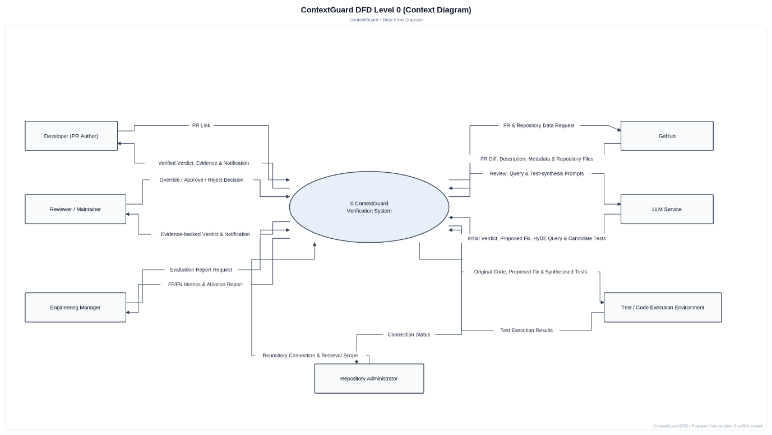
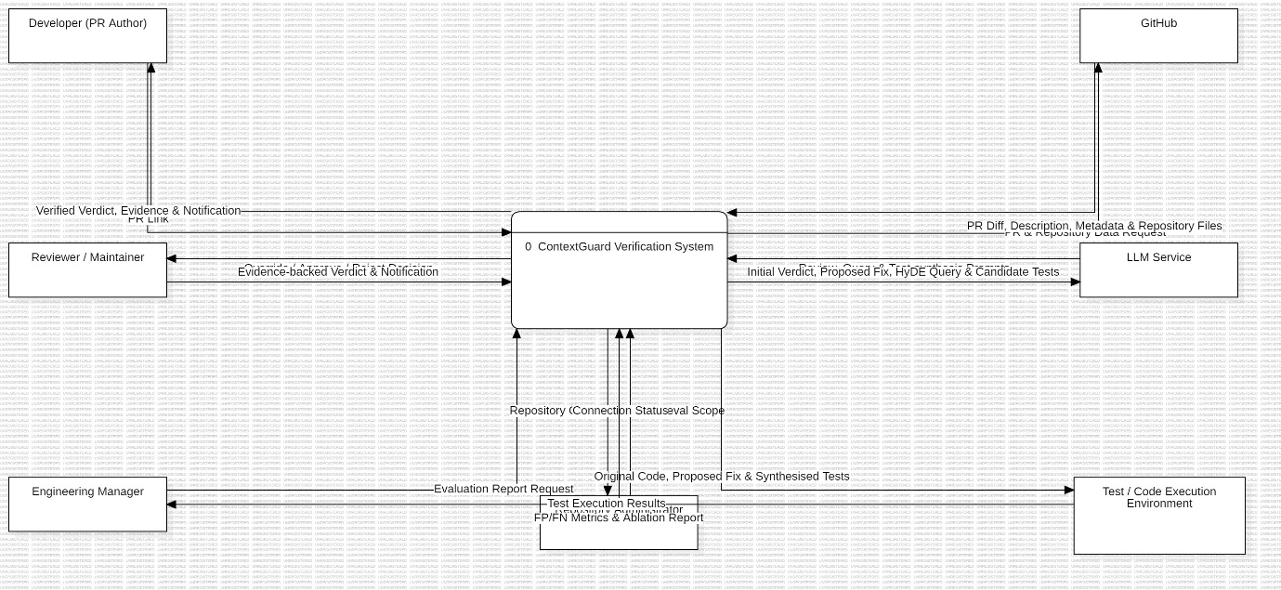

The Level 0 diagram contains 14 labelled data flows. It provides a high-level view of the system without showing the internal processes or data stores.

Level 1 DFD (Decomposition)
The Level 1 DFD expands the main ContextGuard process into eight smaller processes and six data stores. It explains how the system handles pull request validation, AI review, repository retrieval, test generation, verification, reporting, and auditing.

Processes
- PR Intake & Validation: Receives the pull request link, checks its validity, and validates the pull request data before passing it to the next stage.

2.0 Initial AI Review: Analyses the pull request information and generates an initial verdict and proposed fix. It also identifies non-compliant changes that require further review.

3.0 Repository Context Retrieval: Retrieves relevant code, repository information, and candidate functions or tests using dense retrieval, sparse retrieval, and Hypothetical Document Embeddings (HyDE).

4.0 Verification Test Synthesis: Uses the retrieved context and AI-generated information to prepare candidate tests for verifying the proposed fix.

5.0 Fix-guided Verification: Executes verification tests to determine whether the proposed fix produces the expected results. It compares the verification outcome with the initial verdict.

6.0 Final Verdict, Notification & Audit Logging: Combines the verification outcome and review information to produce a final verdict. It sends notifications and records the final decision for future reference.

7.0 Repository & Scope Management: Manages repository connections, indexing, configuration, and the scope of information used during retrieval.

8.0 Evaluation & Reporting: Analyses verdict history and test results to calculate evaluation metrics and generate reports for the engineering manager.

Data Stores
- D1 – PR & Review Store (DuckDB): Stores pull request information, review details, and related intermediate results.
- D2 – Repository Index (ChromaDB + BM25): Stores indexed repository content and supports semantic and keyword-based information retrieval.
- D3 – Repository Config & Scope: Stores repository configuration and the scope used to retrieve relevant repository information.
- D4 – Synthesised Tests Store: Stores the tests generated for verifying proposed fixes.
- D5 – Verdict & Audit Log: Stores final verdicts, audit entries, and verdict history.
- D6 – Evaluation Results: Stores evaluation metrics and results used for performance analysis and reporting.

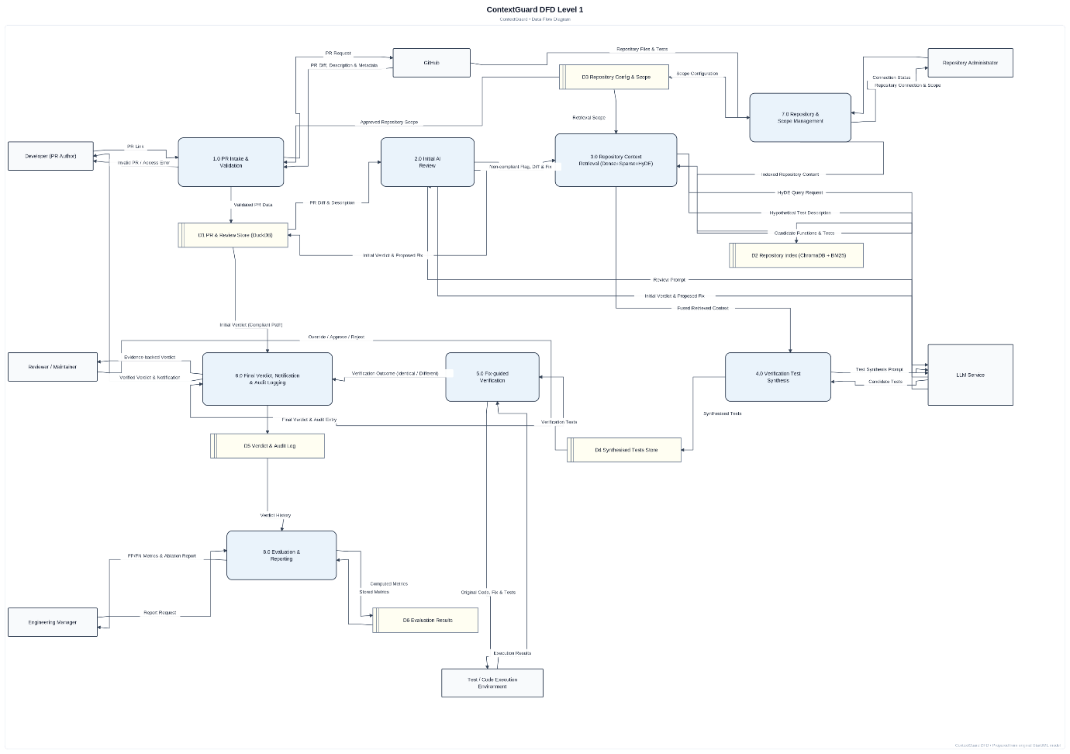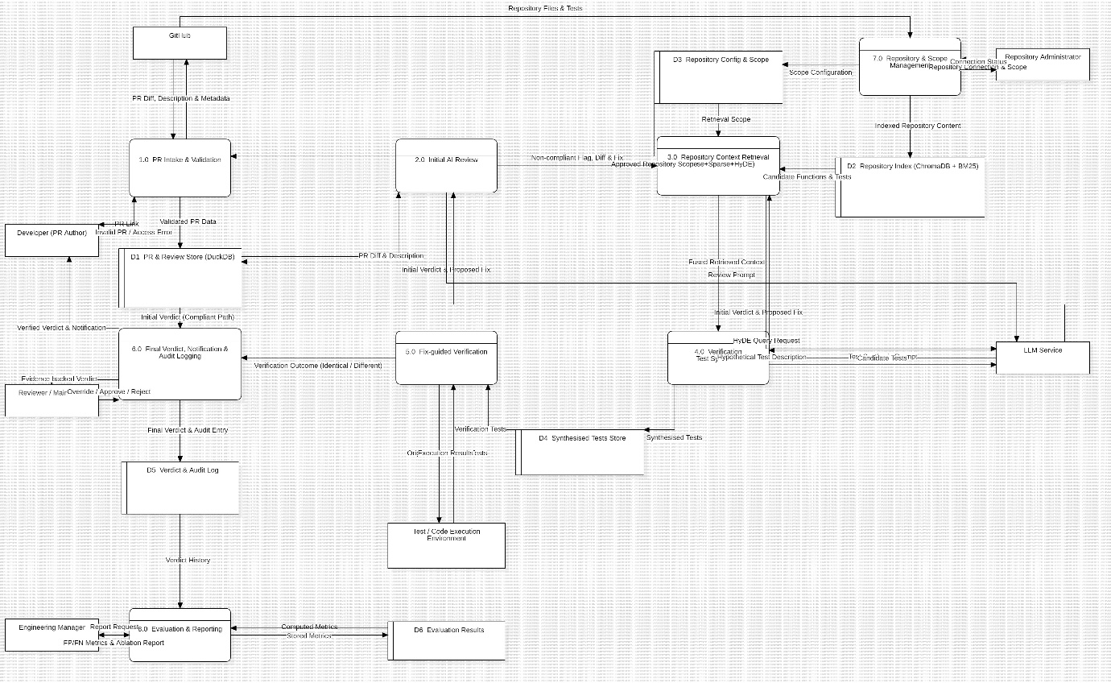

The Level 1 DFD contains 38 labelled data flows. These flows show how information moves between the processes, data stores, and external entities. The diagram provides a more detailed view of the internal working of the system than the Level 0 DFD.

Result
The Level 0 and Level 1 Data Flow Diagrams for the ContextGuard Verification System were prepared. The Level 0 diagram represents the system and its interactions with seven external entities, while the Level 1 diagram explains its eight internal processes, six data stores, and data flows.
Conclusion
The experiment helped in understanding how a Data Flow Diagram represents the movement of information within a software system. The Level 0 DFD provided an overview of the ContextGuard Verification System, whereas the Level 1 DFD explained its internal processes and data storage. These diagrams help in understanding the system structure, identifying the inputs and outputs, and analysing how different components work together to perform software verification.

