**ENHANCED DORMITORY MANAGEMENT SYSTEM FOR USM MEN’S DORMITORY**

**KIAN JEARARD G. NAQUINES**

**BAILING LABOG MAMALUBA**

**KEVIN CLIEN P. ALDABON**

**COLLEN LAUREN**

**JEAN M. FABRO**

**BACHELOR OF SCIENCE IN INFORMATION SYSTEM**



**DECEMBER 2023**

**INTRODUCTION**

University dormitories are places where student study and reside throughout their tenure at the institution, dormitories must first meet the health and comfort requirements what a dormitory should have. Empirical evidence underscores the pivotal relationship of boarding conditions has a significant impact on the quality of student learning, whereby poor boarding student experiencing poor health, increasing behavioral problems, and declining academic performance. Meanwhile sustaining satisfaction with the residential of the university dormitories has play an important role as part of the success of every student in their whole career and achieving academic excellence where student was equipped with good facilities and stunning infrastructure and provide services where boarders satisfied.

Managing a university dormitory is a tedious task for a dormitory manager and considered as a complex task to perform. As a dormitory manager his responsibility are the maintenance of the dormitory, room allocations, manage student requests, payments, billing, ensuring the safety and peace of the student during their stay in the premises of the university dormitory where security is the most top priority. Seamless business process is one of the functions that needs to improve, as a dormitory manager its managerial task will be more efficient in adapting a software base solution to improve its process and to provide services where nobody will complain to its services provides.

The University of Southern Mindanao Men's Dormitory are situated along Kabacan, Aringay Road, in proximity to the university's rear exit gate. These dormitories consist of three buildings. Building I serve as the primary dormitory, Building II acts as a supplementary dormitory for overflow boarders, and Building III is exclusively designated for university athletes. All three buildings are overseen by a single dorm manager who manages payment collection and addresses student boarder concerns. However, the current dormitory management system is manual and has proven to be inefficient. It is labor-intensive, susceptible to errors, and unable to provide effective and streamlined services to the students. The manual system in place at University of Southern Mindanao Men’s Dormitory cannot adequately handle the growing number of students. It relies heavily on paperwork, which is prone to errors and leads to processing delays.

Moreover, the absence of automation results in slower response times to student inquiries and complaints, potentially causing dissatisfaction and frustration among the students. Furthermore, the University of Southern Mindanao Men’s Dormitory manual management system has limited features for students. It lacks the capacity to provide information regarding room availability, amenities, and other relevant services. This makes it challenging for students to find accommodation that suits their needs. Additionally, the manual system does not offer an efficient way to manage payments, further complicating matters for the students.

**Statement of the Problem**

The current manual dormitory management system at the University of Southern Mindanao Men's Dormitory is inefficient, prone to errors, and unable to provide effective services to students. Specifically, it relies heavily on paperwork, leading to processing delays, slower response times to student inquiries, limited information on room availability and amenities, and complications in managing student payments. This results in dissatisfaction and frustration among students. There is a need for an automated, streamlined dormitory management system to improve services and address the growing number of student boarders.

**Objectives of the Project**

The primary objective of this project is to develop an automated dormitory management system for the University of Southern Mindanao to manage transactions using the system.

Specifically, it aims to:

1. develop a module that will provide seamless processing information on student information,
2. provide online reservation for student to apply for dormitory accommodation, including room selection, and reservation fee,
3. develop a module that will accept monthly payment of boarders via online e-wallet like Gcash or Maya,

4. generate of the following:

4.1. Student list,

4.2. Monthly Payments and Yearly Payment,

4.3. Room List and,

5. Evaluate the functionality of the system using Technology Acceptance Model (TAM).

**Significant of the Project**

Encouraging the adoption of a software-based solution that encourages a shift towards modern management of the dormitory in the University Men's Dormitory that will improve the processes of the institution boarding where students reside in the dormitory while offering this kind of automated process this will boost the productivity of a dormitory manager. Furthermore, this will boost the productivity of a student who reside their tenure as a university student. The proposed improvement targets the students within the dormitory where all the process will be automated using the proposed system.

**Scope and Limitation of the study**

**People**

The present study provides an in-depth analysis of the challenges faced by the University of Southern Mindanao Men's Dormitory, it is essential to acknowledge the limitation associated with external validity. The exclusive focus on a singular institution may restrict the generalizability of the study's findings to a wider academic context. University dormitories vary significantly in terms of organizational structures, student demographics, and geographical locations, and the issues identified in the University of Southern Mindanao Men's Dormitory may not be universally representative.

**Data**

Furthermore, the enhanced dormitory management system, focuses only on the data that is associated with the University of Southern Mindanao student’s information that identify them. Moreover, this will collect first name, last name, student identification, birth date, and many more.

**Technology**

Moreover, enhanced dormitory management system is designed as a versatile application, accessible through both web and mobile platforms. The web-based application functions as the Application Programming Interface (API), housing all the essential business logic. Meanwhile, the mobile application serves as a dedicated student portal, providing students with a secure login and enabling them to perform activities tailored to their role.

The core technology stack for the API is built on MERN (MongoDB, ExpressJS, ReactJS, and NodeJS) technology, ensuring a robust and efficient framework for seamless operations. On the other hand, the mobile application is developed using the Dart programming language and the Flutter framework. This combination not only ensures a smooth user experience but also facilitates the creation of a dynamic and responsive mobile application for effective student engagement.

**Process**

Consequently, caution should be considered when applying the study's conclusions to other educational institutions. Furthermore, research endeavors should consider conducting similar investigations across diverse university dormitories to validate and have a more comprehensive understanding of the challenges in dormitory management and the effected process on the proposed processes will be the reservations, billing, payment, and other process on the dormitory. This would contribute to the development of broadly applicable recommendations and solutions that can address the varying complexities inherent in distinct academic settings.

**Project Development Approach**

**Agile Methodology**

The chosen development approach for this project is the "Agile Methodology" due to its suitability for handling the dynamic and evolving nature of dormitory management systems. Agile's adaptability to change allows the team to seamlessly incorporate evolving user requirements and regulatory needs throughout the development process. The emphasis on incremental progress ensures that stakeholders receive tangible results in the form of functional components at regular intervals.

Agile's collaborative nature encourages ongoing communication between developers and stakeholders, including dormitory administrators and users, facilitating continuous feedback loops. The iterative development process in Agile, organized into fixed-time sprints, enables a controlled pace with a focus on specific functionalities during each iteration. Daily stand-up meetings, user stories, and a prioritized backlog contribute to efficient planning and execution.

Continuous testing and integration ensure code quality, and the flexibility to adapt to changing requirements results in a dormitory management system that not only meets but exceeds the expectations of its end-users.

**Phase 1: Planning**

**Define Project Scope and Objectives**

Conduct a clear outline of features and functionalities of Enhance Dormitory Management System. To ensure conducting meetings with stakeholders to gather requirements and expectation.

**Risk Assessment and Mitigation**

Identify potential risks related to development, implementation and user adoption. Developing a risk mitigation plan can address identified risks.

**Phase 2: Analysis and Design**

**Database Design**

Design a robust and secure database structure to store dormitory and information. Implementing data privacy and security measures.

**User Interface Design**

Create wireframes and prototypes for the user interface. Collect feedback from stakeholders and make necessary adjustments.

**Phase 3: Development**

**Front-end and Back-end Development**

Implement the user interface design using modern web development technologies. Build the server-side logic, database interactions, and application functionality.

**Phase 4: Testing**

**Unit Testing**

To ensure that system works we tested it with other device that fits the system. We identify and fix bugs or issues before we implement. Stakeholders are involving in testing the system’s functionality.

**Phase 5: Implementation**

**Deployment**

Roll out the enhanced dormitory management system in a controlled environment. Monitor system performance and address any issues.

**Training**

Provide training sessions for administrators and residents on how to use the new system effectively.

**Data Schema**

The Database Schema presented here embodies the foundational structure and design of the proposed Enhanced Dormitory Management System for USM Men. Serving as the backbone of the system's data architecture, that governs the storage and retrieval of information within the database.

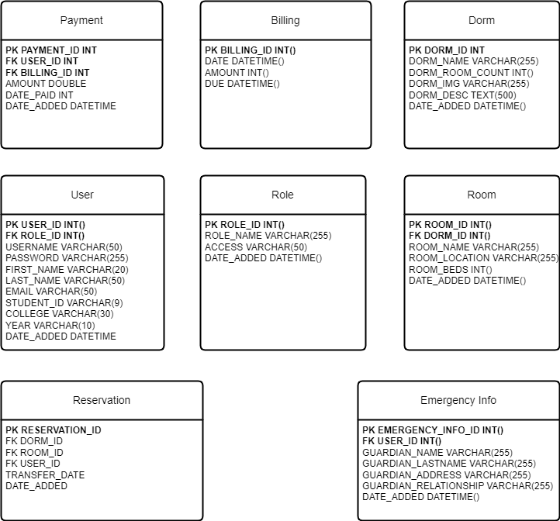

***Figure 1.*** *Data Schema of Enhanced Dormitory Management System for USM Men*

**Entity Relationship Diagram**

The Entity Relationship Diagram (ERD) presented herein encapsulates the blueprint and structural design of the proposed system. Serving as a visual representation of the system's underlying architecture, the ERD meticulously outlines the relationships between various entities, illustrating how data is organized, stored, and interconnected within the system.

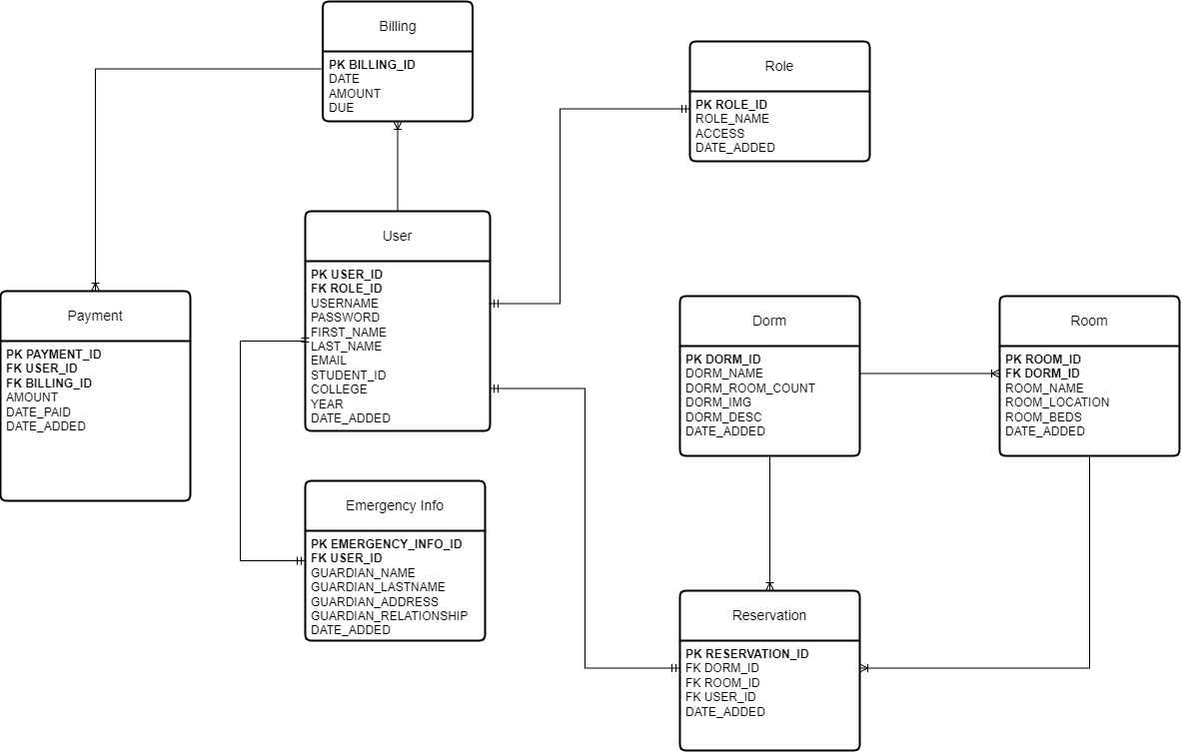

***Figure 2.*** *ERD of Enhanced Dormitory Management System for USM Men*

**Use Case Diagram**

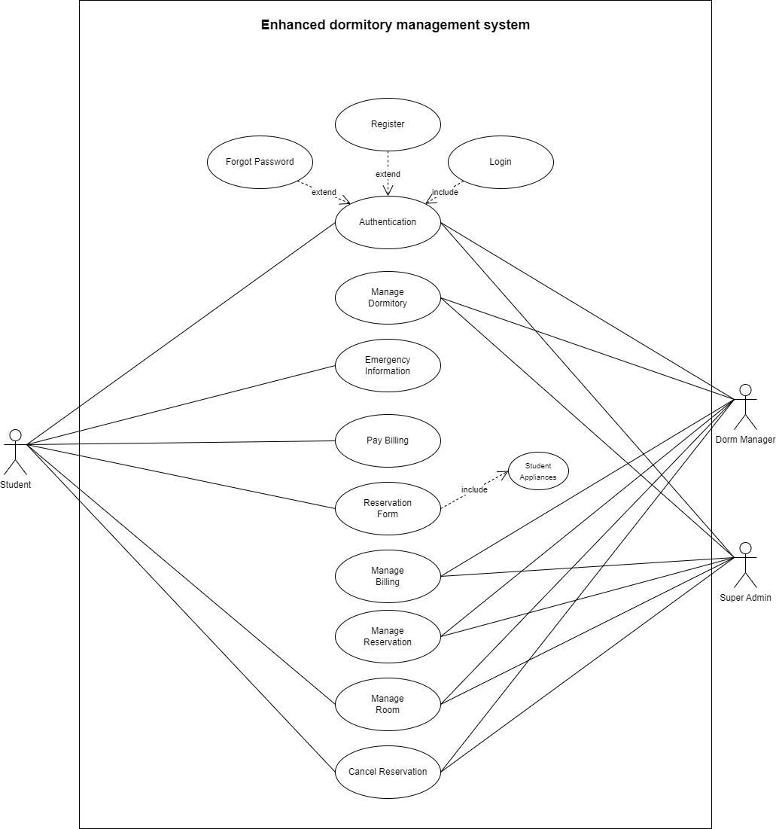The enclosed Use Case diagram provides a comprehensive illustration of the proposed Enhanced Dormitory Management System for USM Men, offering a visual representation of how users, administrators, and external systems interact with the system's functionalities.

***Figure 3.*** *Use Case Diagram of Enhanced Dormitory Management System for USM Men*

**Activity Diagram**

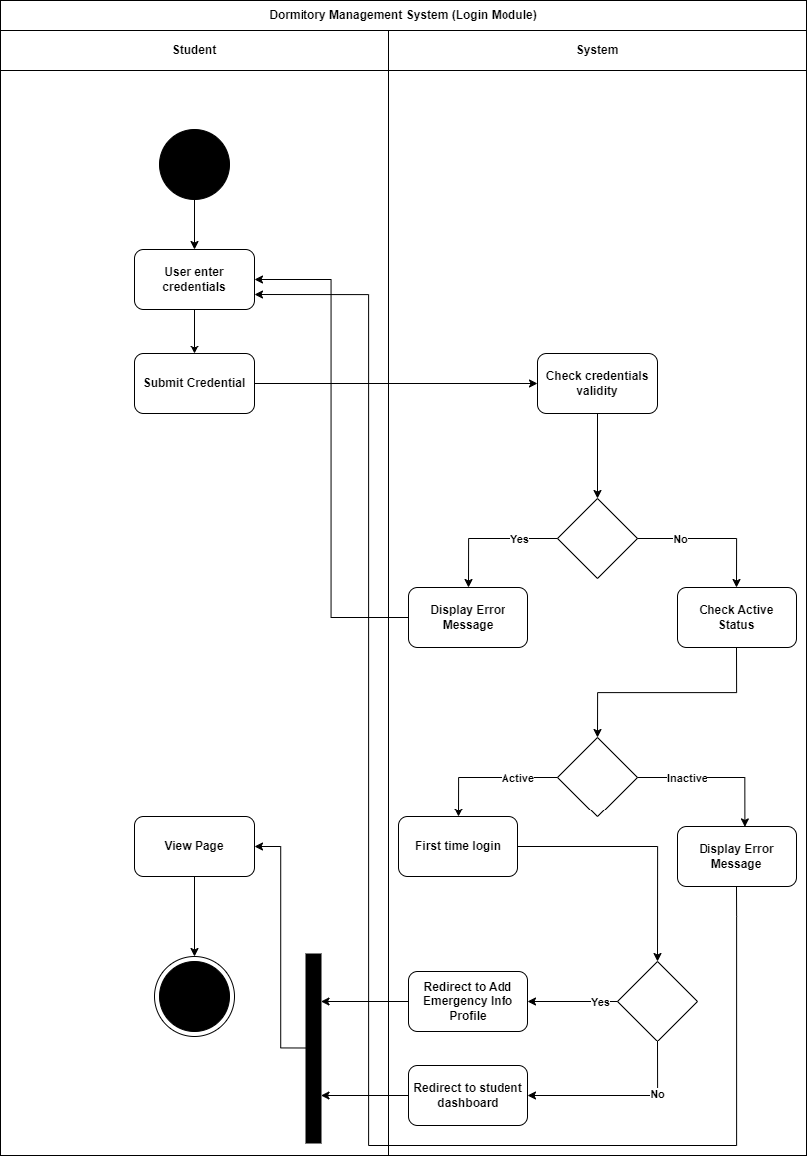The set of Activity Diagrams presented herewith offers an insightful visualization of the proposed Enhanced Dormitory Management System for USM Men, detailing the dynamic aspects of its design and operation.

***Figure 4.***  *Dormitory Management System (Login Module) Activity Diagram*

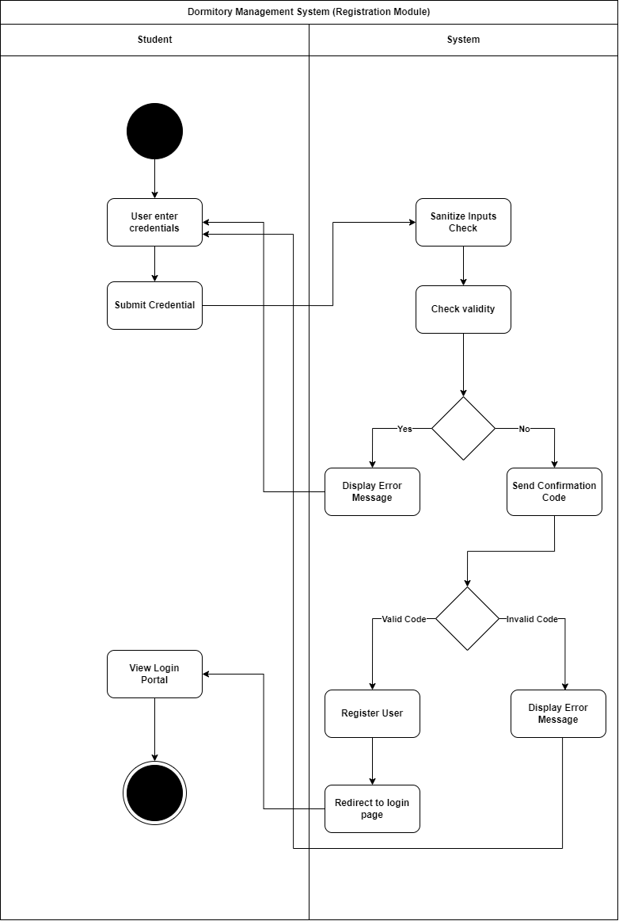

***Figure 5.***  *Dormitory Management System (Registration Module) Activity Diagram*

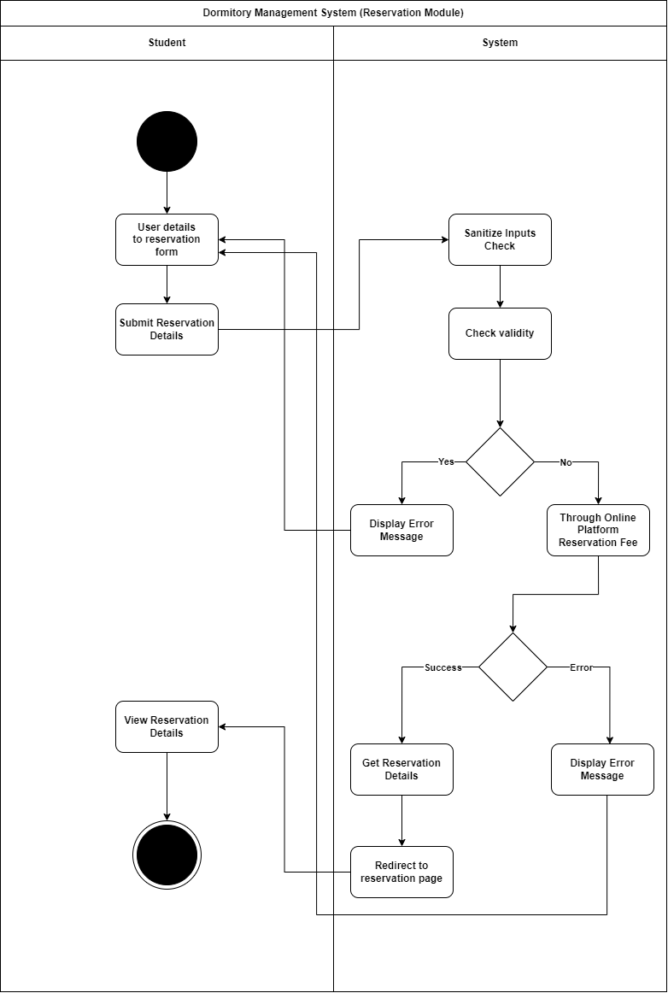

***Figure 6.***  *Dormitory Management System (Reservation Module) Activity Diagram*

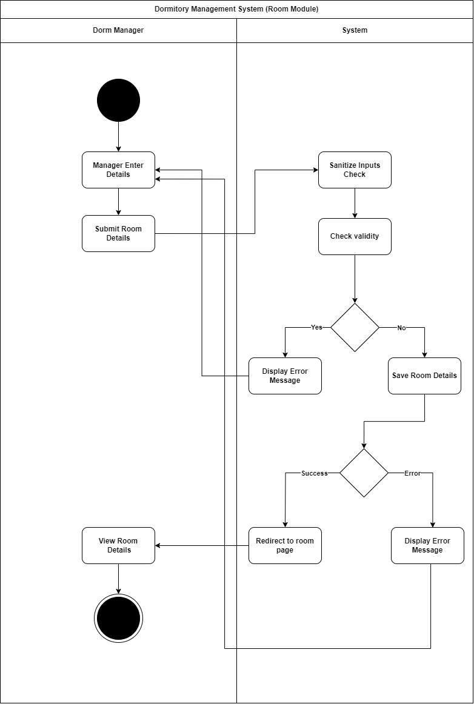

***Figure 7.***  *Dormitory Management System (Room Module) Activity Diagram*

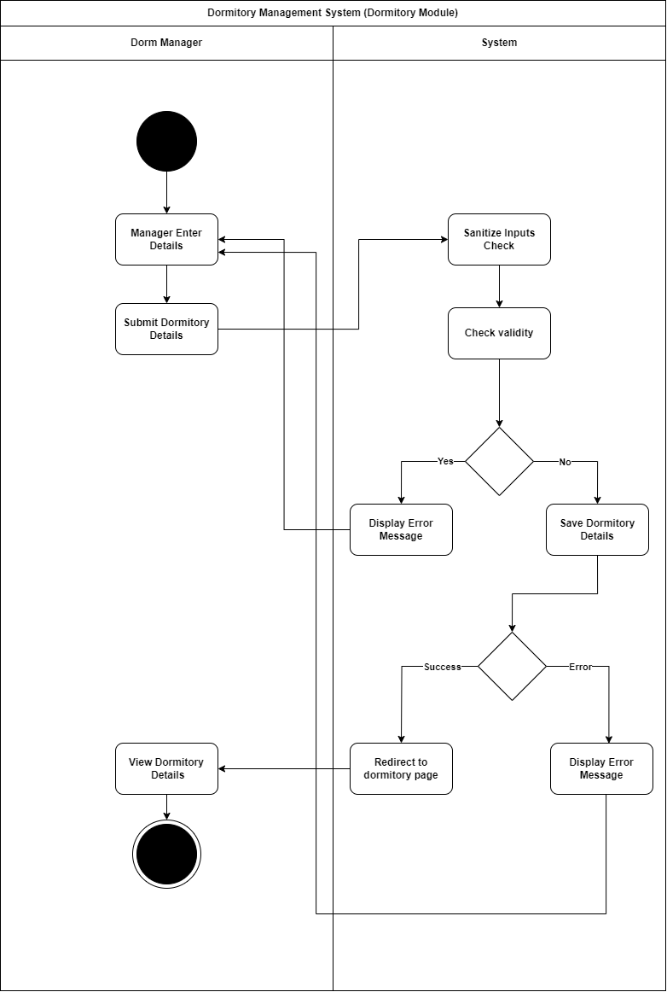

***Figure 8.***  *Dormitory Management System (Dormitory Module) Activity Diagram*

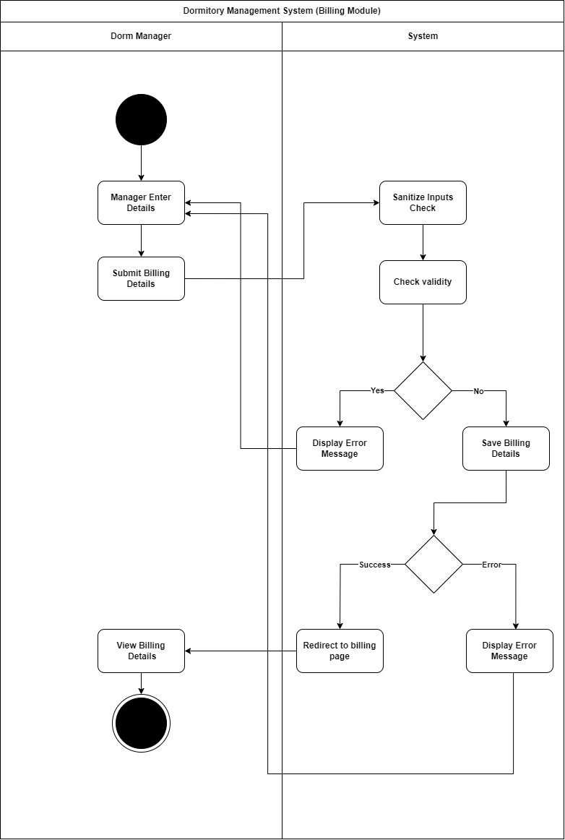

***Figure 9.***  *Dormitory Management System (Billing Module) Activity Diagram*

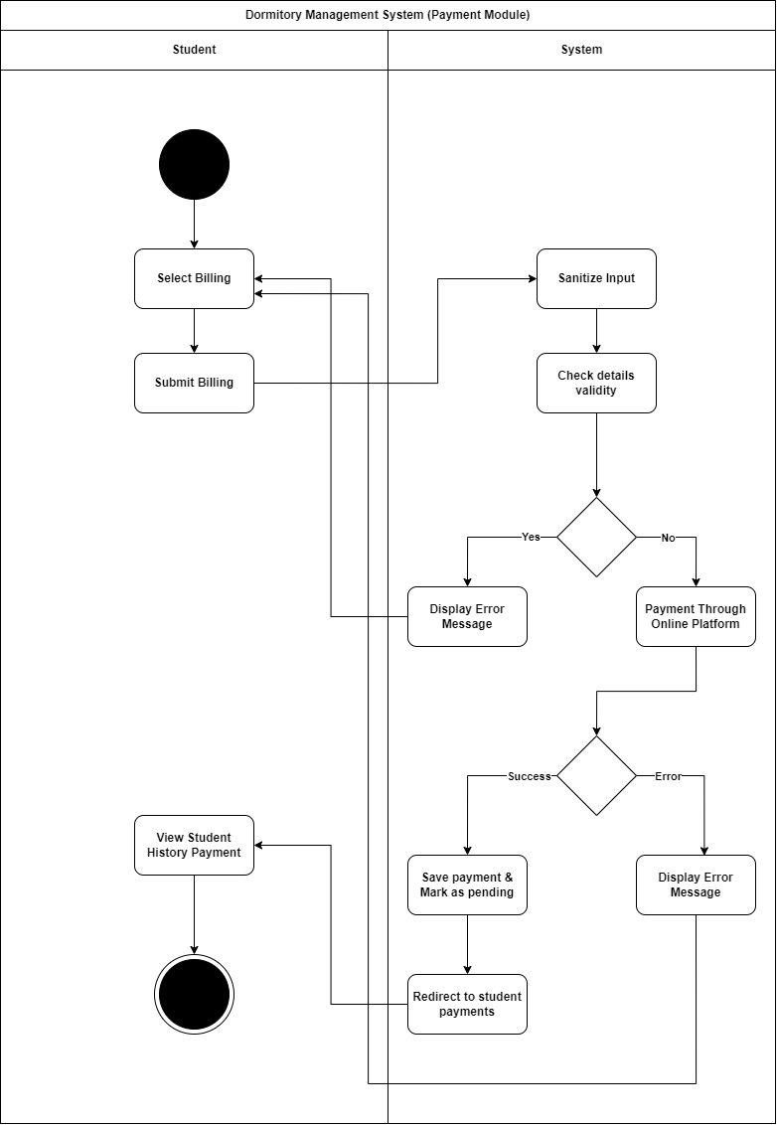

***Figure 10.***  *Dormitory Management System (Payment Module) Activity Diagram*

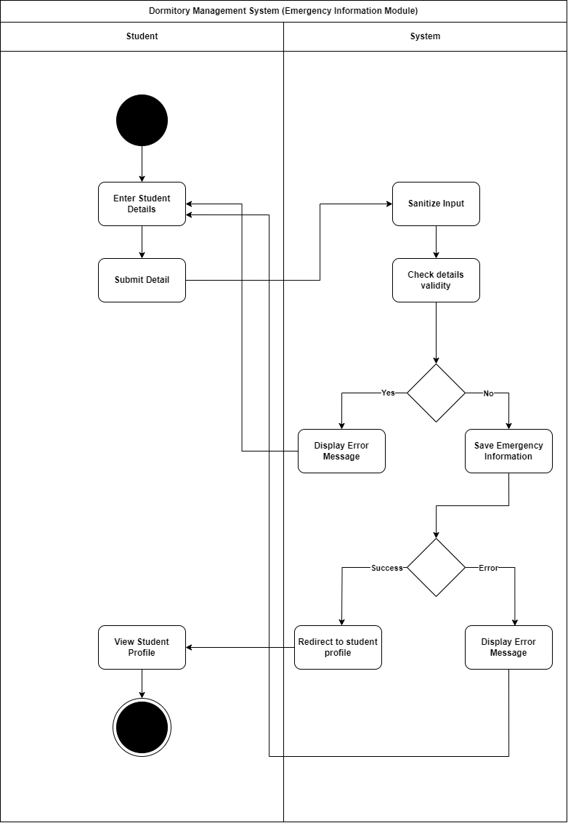

***Figure 11.*** *Dormitory Management System (Emergency Info Module) Activity Diagram*

**LITERATURE CITED**

Lubis, M., Fauzi, R., Lubis, A., & Fauzi, Rahmat. (2018). A Case Study of Universities Dormitory Residence Management System (DRMS) in Indonesia. doi:10.1109/CITSM.2018.8674313

Yang, Y., & Chen, S. (2022). Design and Implementation of College Dormitory Management System. In 2022 Fourth International Conference on Emerging Research in Electronics, Computer Science and Technology (ICERECT), Mandya, India (pp. 1-5). doi:10.1109/ICERECT56837.2022.10059902.

Peng, Z., Liu, T., & Mai, L. (2020). Design and Implementation of Dormitory Management System based on SSM framework. In Proceedings of the 2020 International Symposium on Parallel and Distributed Computing (ISPDC) (pp. 321-325). doi:10.1109/ISPDS51347.2020.00074.

Huang, L. (2018). Research on Dormitory Management System in Colleges and Universities. DEStech Transactions on Social Science, Education and Human Science. doi:10.12783/dtssehs/adess2017/17908.

Peng, M., & Xie, X. (2015). The Design of Dormitory Management System for College Students Based on Android Platform. In International Conference on Interaction Sciences.

Wei, W., & Chen, L. (2019). A Survey of College Student Dormitory Lifestyle and Related Management Strategies. Asian Education Studies, 4(1), 1. <https://doi.org/10.20849/aes.v4i1.567>.

Al-Saqqa, S., Sawalha, S., & Abdel-Nabi, H. (2020). Agile Software Development: Methodologies and Trends. International Journal of Interactive Mobile Technologies (iJIM), 14, 246. <https://doi.org/10.3991/ijim.v14i11.13269>.