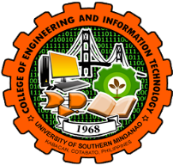**UNIVERSITY OF SOUTHERN MINDANAO**

**College of Engineering and Information Technology**

Kabacan, Cotabato

Philippines

**Dear** Ma’am/Sir,

We are 3rd year college students taking **Bachelor of Science in Information Systems** from the **University of Southern Mindanao**.

As part of our academic curriculum in the course InfoSys312b – System Analysis and Design, we are required to conduct company/industrial visits to gain firsthand insights into real-world business processes. These visits are instrumental in helping us understand the intricate workings of businesses and enable us to develop innovative solutions aimed at enhancing operational efficiency and overall performance. Furthermore, our study will contribute to enhancing the organization's existing business processes, rendering them more efficient and effective, while also facilitating improved management for its stakeholders.

Please be assured that the information collected will be handled with the highest level of confidentiality and utilized exclusively for academic purposes.

Thank you in anticipation of your favorable response on this matter.

Respectfully yours,

NAQUINES, KIAN JEARARD G.

ALDABON, KEVIN CLIEN P.

FABRO, JEAN M.

LAUREN, COLLEN C.

MAMALUBA, BAILING L.

NELSON G. BALNEG JR.

System Analysis and Design Instructor