USER LOG-IN AND HOMEPAGE
Demos: PC/Laptop - https://youtu.be/z1Yp69ObgEU Mobile Phone- https://youtu.be/UT6rexYG9uA
Instructions:
- OPENING PROJECT FOLDER
  - For PC/Laptop Users:
    - Open Visual Studio Code and extend project Module4-Files.
  - For Mobile Phone Users:
    - Open ACode and extend project Module4-Files.

- IMPLEMENT USER LOG-IN PAGE
  - Right Click users directory and create a new file login-page.php. Provide the following codes.
<!DOCTYPE html>
<html>
<head>
<title>USER APPLICATION</title>
<!-- Include meta tag to ensure proper rendering and touch zooming -->
<meta name="viewport" content="width=device-width, initial-scale=1">

<!-- Include jQuery Mobile stylesheets -->
<link rel="stylesheet" href="../../jquery/jquery.mobile-1.4.5.min.css">

<!-- Include the jQuery library -->
<script src="../../jquery/jquery-1.11.3.js"></script>

<!-- Include the jQuery Mobile library -->
<script src="../../jquery/jquery.mobile-1.4.5.min.js"></script>

<!-- Include the Custom CSS -->
<link rel="stylesheet" href="../assets/css/custom.css">
</head>

<body>
<!-- PAGE FOR USER LOGIN -->
<div id="userLogIn" data-role="page">
<div data-role="header" data-position="fixed">
<center><h4>USER LOG-IN</h4></center>
</div>
<div data-role="content">
<form action="#" method="post" id="frmUserLogIn" name="frmUserLogIn">
<!-- TEXT INPUT ELEMENTS -->
<div class="ui-field-contain">
<label for="User_ID_Log">User ID:</label>
<input type="text" name="User_ID_Log" id="User_ID_Log" placeholder="Enter User ID" value="" required>
</div>

<div class="ui-field-contain">
<label for="User_Pass_Log">Password:</label>
<input type="password" name="User_Pass_Log" id="User_Pass_Log" placeholder="Enter Password" value="" required>
</div>

<div class="ui-field-contain">
<p>Please provide a valid User ID and Password.</p>
<p>Contact the system administrator if problem occurs.</p>
</div>

<footer id="Ftr" data-role="footer" data-position="fixed">
<div data-role="navbar">
<ul>
<li><button type="submit" href="#" id="btnLogin" data-icon="action">Log-In User</a></li>
<li><button type="reset" href="#" id="btnLogin" data-icon="back">Reset</a></li>
</ul>

</div>
</footer>
</form>
</div>

<!-- Add JavaScript References -->
<script src="../assets/js/user.js"></script>
</body>
</html>

  - Open xampp and start apache server >> Open any browser and provide the url http://localhost/code-CourseYearSection-Initials/module4-files/users/login-page.php
  - The output should look like the image below:
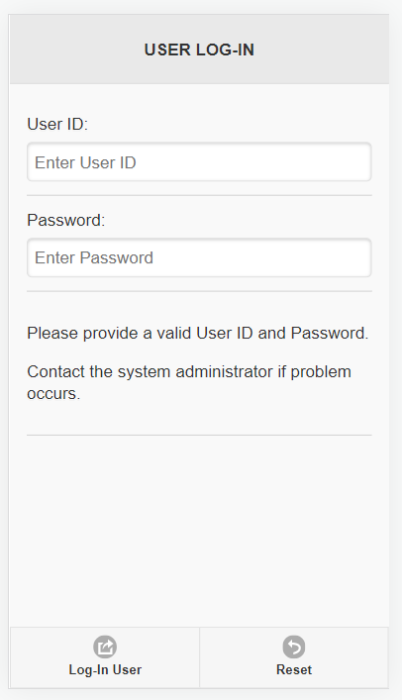

  - Right Click users directory and create a new file login.php. Provide the following codes:
<?php
error_reporting(0);
//CALL DATABASE CONNECTION SCRIPT
include("../config/database.php");

//CREATE THE QUERY TO SELECT ALL RECORDS FROM THE TABLE
$query="SELECT COUNT(*) as totCount FROM tbl_user_info WHERE User_ID=? AND Password=?";

//PREPARE QUERY AND STORE TO A STATEMENT VARIABLE
$stmt = $pdo->prepare($query);

$id = isset($_GET['id']) ? $_GET['id'] : die();
$pass = isset($_GET['pass']) ? $_GET['pass'] : die();
//BIND VALUE TO DATABASE PARAMETER
$stmt->bindValue(1, $id);
$stmt->bindValue(2, $pass);

//EXECUTE STATEMENT
$stmt->execute();

$user_arr=array();
$user_arr["records"]=array();

//GET RECORDS PER ROW
while ($row = $stmt->fetch(PDO::FETCH_ASSOC)){
// extract row
// this will make $row['name'] to
// just $name only
extract($row);

$user_arr = array(
"totCount" => $totCount
);
}
echo json_encode($user_arr);
?>

- IMPLEMENT THE LOGIN AJAX
  - Extend assets directory and open user.js inside js folder, after the $(document).ready(function(){ }); code provide the following:

//WHEN LOGIN BUTTON WAS CLICKED
$(document).on('submit', '#frmUserLogIn', function(){
//GET USER INPUTS FROM HTML FORMS
userid = document.getElementById("User_ID_Log").value;
pass = document.getElementById("User_Pass_Log").value;

//CREATE AJAX TO CALL UPDATE-USER PHP SCRIPT
$.ajax({
url: "login.php?id=" + userid + "&pass=" + pass,
type : "POST",
dataType : 'json',
success : function(result) {
intCount = result.totCount;
if(intCount==1){
$.mobile.changePage("user-page.php", { transition: "slide", reloadPage:true })
}
},
error: function(xhr, resp, text) {
console.log(xhr, resp, text);
}
});
});
  - Open xampp and start apache server >> Open any browser and provide the url http://localhost/code-CourseYearSection-Initials/module4-files/users/login-page.php
  - The output should look like the image below:

  - Provide a valid User ID and Password and click Log-In User Button.
  - User List will be displayed.

- UPDATING VIEW ONE RECORD IMAGE/PHOTO
  - Extend assets directory and open user.js inside js folder, look for function onReadOne(e,data) method implementation and update the following codes:
document.getElementById("imgUser").src = "../assets/images/" + result.PicPath;
Notes:
- Include your initials in naming your projects, variables, class names, method names, parameters and object names. Please see examples:
  - dblJCBFee
  - OrderJCBSystem
  - computeJCBOrders
  - txtJCBLName
- Using any screen recording software (Open Broadcaster Software, Bandicam or Filmora), record the machine problem output demonstration.
- Submit the activity in the assignment section of the course in Neo LMS
- Upload via Youtube
  - Video Filename: USR-LOG-CODE-INITIALS.
  - YouTube link or URL of the recorded output demonstration.
- Five (5) points deductions will be given to each submission protocol violations:
  - Not including initials in naming your projects, variables, class names, method names, parameters and object names.
  - Not using activity and machine problem worksheets.
  - Incorrect Filenames Format: USR-LOG-CODE-INITIALS
  - Incomplete Source codes and output screenshots in PDF or video output demonstrations.
  - Broken YouTube Links or no video demonstration outputs.
- Any similarities on the source codes or any sign of “Copy and Paste” codes will be marked as CHEATING and will be graded ZERO (0).

