Project Proposal

Kianté A. Fernandez

5/6/2020

# Prompt:

Each group should turn in a one-page proposal for the project (Due May 6, 2020)

## a. Description of the problem:

I am intrested in what drives the public’s attitudes towards neuromodulation technology. The public’s role in the disseminatnion of science tends to be crusial; thier support funds our efforts and outrage constriane our avuene for expansion. However, when public interprets of the trade offs betweeen risk of harm and likilood of gain surrounding these technologies rather than using the objective probablilites our tendecy is to rely on a sets of subjective probalitis…. Understanding what are the influences on an individuals intuitions to endorse neruotechnologies gives us leveraage for designing and implmenting policy that bolsters the public’s decsion making competances therby better aligining the mapping between what scientist actully know about neruomodulation efficacy and what the public uses to make choices surrounding these technologies in both clincial and consumer settings.

Some literature points to people not be sensitive to the risks and benefits in trade offs related to *scared values*. Here we meaesrue someones ideological dispostions by looking at religiosity and moral foundaions..

I want to better understand whether ideology predicts risk preferences as measured by loss aversion. WE predict people score higher on these measure will not provide task data to fit risk reward trade offs to.

the influence of ideological profile on evidence insensitive when assessing arguments about risks and benefits related to decisions to treat cognition with abstract technologies.

## b. Description of the dataset:

Here we are using task from a visual analog judgment task as well as a set of validated batteries and demographics gathered from an Mturk sample.

data <- read.csv("../data/Cleaned_Pilot.03.csv", header=TRUE, comment.char="#", stringsAsFactors=TRUE) %>%  
 select(user_id, risk, gain, no_effect, experimental_treatment_selected, trial_index,   
 age, sex, education, race_ethnicity,  
 ReligionRaised,ReligionNow, Religiosity, Spirituality, AttendChurch,   
 ReligiousActivity, meditation,   
 Harm,Fairness,Loyalty,Athority,Sancticy,  
 POWER,ACHIEVEMENT,HEDONISM,STIMULATION,SELF.DIRECTION,  
 UNIVERSALISM,BENEVOLENCE,TRADITION,CONFORMITY,SECURITY,  
 Lying,Assasination,Torture,Murder,Stealing,ForcedSterilization)  
  
  
tt2 <- ttheme_default()  
grid.arrange(tableGrob(head(data[,1:6]), theme=tt2))

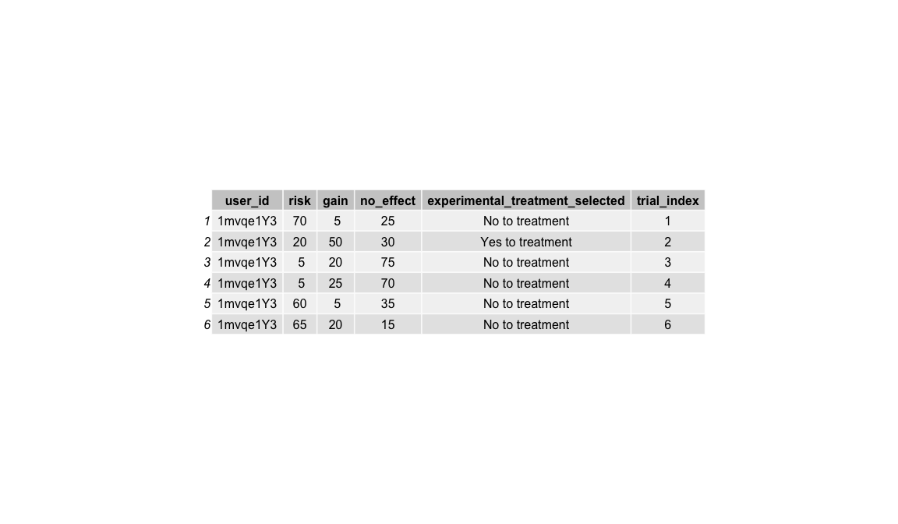

knitr::include_graphics('../images/taskexample.png')

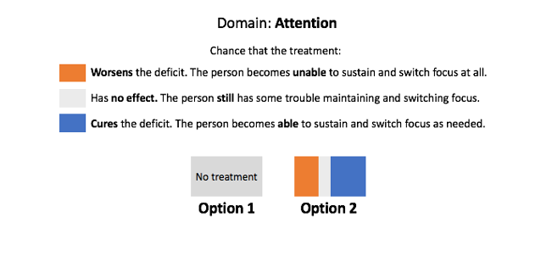

Behavioral task example

knitr::include_graphics('../images/task.png')

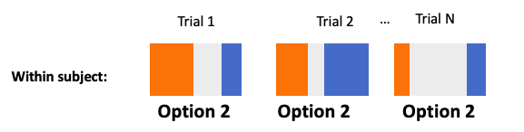

Behavioral task example

This is a data set that my research group and I have been gathering over Amazon mechanical Turk. It has two main components; Behavioral task data, and Qualtrics survey batteries.

Currently I have in total piloted about 100 subjects after my exlclusion for careless responces. I will be launching a much larger data collection effort in the next few days for about 800 subjects.

## c. Supervised or unsupervised? Regression or classification?

This is a supervised machine learning project because we are using information about both the responces (task data) and a set of predictors (our survey data) to fit a model. Resampling techniques will be used to validate our model fit. To start, using the task data, we would first fit within subject logistic regressions (or maybe some other type of classifications method) and use the set of these outputs as my outout for a between subject anylsis.

Right now I am on the fence as to which type, regression or classification, this problem is best conceptulized as.

For me it’s a matter of how to think about my responce in a manner that best communicates individuals insensitivity to risk and benfit trade offs.

We could:

* use the betas
* use wether the model was significant or not

## d. Comments and/ or concerns.

Current one of my concerns is the scale of the data set. When I tend to think of ‘Big Data’ projects, my data set does not met the high dimensional nature (n < p) standards and I am not sure if that is something you would like to see us wrangle with.

I am still working on putting it all together, but I would apperciate if we could set up a meeting to further dicuss this.