Fixation patterns in multi-response choice do not reflect optimal information sampling
Kianté A. Fernandez¹, Frederick Callaway², and Ian Krajbich¹
¹ Department of Psychology, University of California, Los Angeles
² Department of Psychology, New York University
Corresponding author: Kianté A. Fernandez, kiantefernan@gmail.com

Abstract
Many everyday choices require selecting several items from a set rather than one. Models of attention in simple choice describe how a decision maker should sample noisy evidence about the options’ values, and people’s fixations follow these models. Here we extend the metalevel Markov decision process of Callaway, Rangel, and Griffiths to selecting $k$ of $n$ items. Because selecting $k$ items is the same decision as rejecting the other $n−k$, the optimal policy for choosing three of four items mirrors the policy for choosing one: sampling should concentrate on the two lowest estimates rather than the two highest. We tested this prediction with webcam eye tracking in 75 participants who chose one, two, or three of four snack foods. Attention was value-directed, but the mirror image did not appear. Before their first keypress, participants allocated attention in the same way for every selection size; after each keypress attention moved down the ranking of the remaining items. Responses were ordered by estimated value and spaced about half a second apart. These are the patterns of a decision maker who decomposes the task into successive single-item decisions. Of three normative policies for when to commit each item, the one that solves single-item problems in sequence, carrying its beliefs forward, reproduces the absence of the mirror image, the dependence of decision time on the values on offer, and the spacing of responses. The decomposition costs nothing when two of four items are chosen and between 3% and 49% of net reward when three are, depending on the cost of switching attention. Attention in multi-response choice is organized around the item to be chosen next rather than around the set to be chosen.

Author summary
When we choose, we look back and forth between the options, and where we look shapes what we choose. Recent work has shown that in choices of a single item, people look where it pays to look: at the options that are promising and still uncertain. But many choices involve picking several things at once, such as three snacks for a road trip. We worked out how an ideal decision maker should distribute attention when choosing several items, and found a surprising prediction. Choosing three of four items means rejecting one, so the ideal decision maker should focus on the two worst options to find the one to leave out. We then recorded eye movements with webcams while people chose one, two, or three of four snacks. People did not behave this way. Until their first keypress they looked at the options as they do when choosing a single item, and only afterwards did their attention move to the remaining options. They chose roughly in order of preference, about half a second per additional item. People solve “choose three” by solving “choose the best” three times in a row, and we measure what that habit costs.

Introduction
Consider a shopper filling a basket, a diner assembling a plate at a buffet, or a student picking three electives from a list. Each must select several items from a set. Each must also decide, moment by moment, which option to think about next. Research on simple choice, in which a single item is chosen, has established two features of this process. First, choices and response times are well described by the sequential accumulation of noisy evidence about the options’ values [1–4]. Second, visual attention shapes the accumulation: items that are fixated longer are more likely to be chosen [5–10], an effect captured by models in which the fixated item’s evidence is weighted more heavily [6,7,11–13].
What determines where people look while deciding? One answer is that fixations are deployed to sample information where it is most useful. Callaway, Rangel, and Griffiths [14] formalized simple choice as a metalevel Markov decision process in which each fixation buys a noisy sample of the fixated item’s value at a cost, and approximated the policy that maximizes the value of the chosen item net of sampling costs. The optimal policy fixates items whose value estimates are both high and uncertain, and in three-item choice it concentrates attention on the two best estimates. Fixation patterns in binary and trinary choice matched these predictions, and related work has derived optimal attention policies for binary choice by dynamic programming [15], optimal stopping for value-based choice [16–18], sequential sampling under rational inattention [19], and the reference-dependent effects of attention and confidence on choice that Bayesian updating implies [20]. Unlike models that take fixations as given, these models predict where the eyes go and how the costs of sampling should shape search [13]. Attention in value-based choice thus appears to follow the logic of rational metareasoning [21–24], the resource-rational form of bounded rationality [25–29], as it does in visual search and perceptual tasks [30–33]. The same framework has been applied to planning [34], to the control of memory recall, where an optimal model decides which memory to search and when to give up [35], and to the allocation of encoding effort across items that differ in reward [36].
These accounts concern the choice of one item. Choosing several items is a different decision problem with the same ingredients. The decision maker still gathers noisy evidence about each item’s value and still controls which item is sampled, but the quantity to be maximized is the summed value of a set, and the set is reported as a sequence of responses. Little is known about how attention should be allocated in this case or how it is. Studies of multi-alternative choice have examined how people search larger sets [37–40], and recent work has shown that attention follows the goal of the choice: when the task is to choose the worst option, people look at low-value items, and when it is to appraise a set they look evenly [41–44]. Choosing several items has been studied as a problem of variety seeking and bundling [45,46] and, more recently, as inclusive choice in which any number of items may be taken [47]. In a companion study of the choice task used here, people selected items roughly in order of preference, with a slow first response followed by faster ones [Fernandez KA, Callaway F, Karmarkar UR, Krajbich I. Rank-order preferences are not quickly accessible. In preparation]. None of these studies has characterized the optimal allocation of attention when $k$ items must be chosen, or compared it to what people do.
Here we do both. We extend the metalevel MDP of Callaway et al. [14] to selecting $k$ of $n$ items, where the terminal reward is the summed value of the chosen set, and derive the value of sampling each item in closed form under the directed-cognition approximation [48,49]. The analysis gives a simple result. Because selecting the $k$ best items is the same decision as rejecting the $n−k$ worst, the optimal policy for a problem $(n,k)$ at a given belief is the optimal policy for the problem $(n,n−k)$ with every estimate negated. Choosing one of four items and choosing three of four are mirror images: the former concentrates sampling on the two highest estimates, the latter on the two lowest, because the decision hinges on which single item to leave out. Choosing two of four concentrates sampling on the boundary between the second and third estimates. The theory also leaves open when each response should be made. We consider three normative policies: one that selects the whole set when sampling stops, one that solves a sequence of single-item problems, and one that commits each item as soon as no further sampling could change whether it belongs to the chosen set.
We then compare these predictions to webcam eye tracking from 75 participants who chose one, two, or three of four snacks, in blocks. Attention was value-directed, as in simple choice, but the mirror image predicted for choosing three of four did not appear. Before the first keypress, the allocation of attention across item ranks was the same in all three conditions and favored the highest-rated items. After each keypress, attention moved down the ranking of the items that remained. Responses were ordered by value and spaced about half a second apart. We show that these patterns are those of a decision maker who decomposes the task into successive single-item decisions, that a policy which does so accounts for the data better than the policies that treat the trial as one subset decision, and we quantify what the decomposition costs relative to optimal subset selection.

Model

Sequential sampling for subset selection
A decision maker (DM) is presented with $n$ items and must choose $k$ of them, $1≤k<n$. Each item $i$ has a true value $u^{(i)}$ that is unknown to the DM. Following previous work [6,14,16], the DM gathers noisy samples of the items’ values, integrates them into posterior beliefs, and when sampling stops chooses the $k$ items with the highest posterior means. Her payoff is the summed true value of the chosen items minus the cost of the samples she took.
The DM’s beliefs about the item values at time $t$ are a set of Gaussian distributions with means $μ_{t}^{(i)}$ and precisions $λ_{t}^{(i)}$ (Fig 1). They are initialized to a prior over values in the environment, $u^{(i)}∼N(\overset{‾}{μ},{\overset{‾}{σ}}^{2})$, so that $μ_{0}^{(i)}=\overset{‾}{μ}$ and $λ_{0}^{(i)}={\overset{‾}{σ}}^{−2}$ for every item. When this prior matches the distribution of values in the context, sampling moves an item’s estimate toward its true value from the middle of the distribution, so attention raises the estimate of above-average items and lowers that of below-average ones, a prediction that Frömer et al. [20] confirmed by controlling exposure experimentally; we return to it in the Results. As in Callaway et al. [14], we model attention by assuming that the DM samples only from the item she fixates. If she samples item $c$ at time $t$, she receives a signal
$$x_{t}∼N​\left(u^{(c)},σ_{x}^{2}\right), (1)$$
where $σ_{x}$ is a free parameter, and she updates her belief about that item by Bayesian inference,
$$λ_{t+1}^{(c)}=λ_{t}^{(c)}+σ_{x}^{−2}, μ_{t+1}^{(c)}=\frac{σ_{x}^{−2}x_{t}+λ_{t}^{(c)}μ_{t}^{(c)}}{λ_{t+1}^{(c)}}, (2)$$
leaving the beliefs about the other items unchanged. Each sample costs $γ_{\text{sample}}$, and a sample from an item other than the one sampled last costs an additional $γ_{\text{switch}}$, the cost of a saccade. Writing ${\text{last}}_{t}$ for the item sampled at step $t−1$ (with ${\text{last}}_{1}=⌀$ at the start of the trial), the cost of computation $c_{t}$ is
$$\text{cost}(c_{t})=γ_{\text{sample}}+1​\left({\text{last}}_{t}≠⌀∧c_{t}≠{\text{last}}_{t}\right)γ_{\text{switch}}. (3)$$
The DM can also stop sampling by selecting $c_{t}=⊥$. If she stops at step $T$, she chooses the set $S_{T}^{*}$ of $k$ items with the highest posterior means, and her payoff on the trial is
payoff=i∈ST*​u(i)−t=1T−1cost(ct), (4)
the summed utility of the chosen items minus the cognitive cost of the samples that informed the choice. Because her prior is accurate and she updates by Bayes’ rule, the expected utility of the chosen set given her belief is the sum of its posterior means [14,24]. Writing $μ_{(1)}≥μ_{(2)}≥…≥μ_{(n)}$ for the posterior means in descending order, the expected reward for terminating in belief state $b$ is therefore
$$R(b,⊥)=\sum_{i=1}^{k}{μ_{(i)}}. (5)$$
For $k=1$ this is the model of Callaway et al. [14].
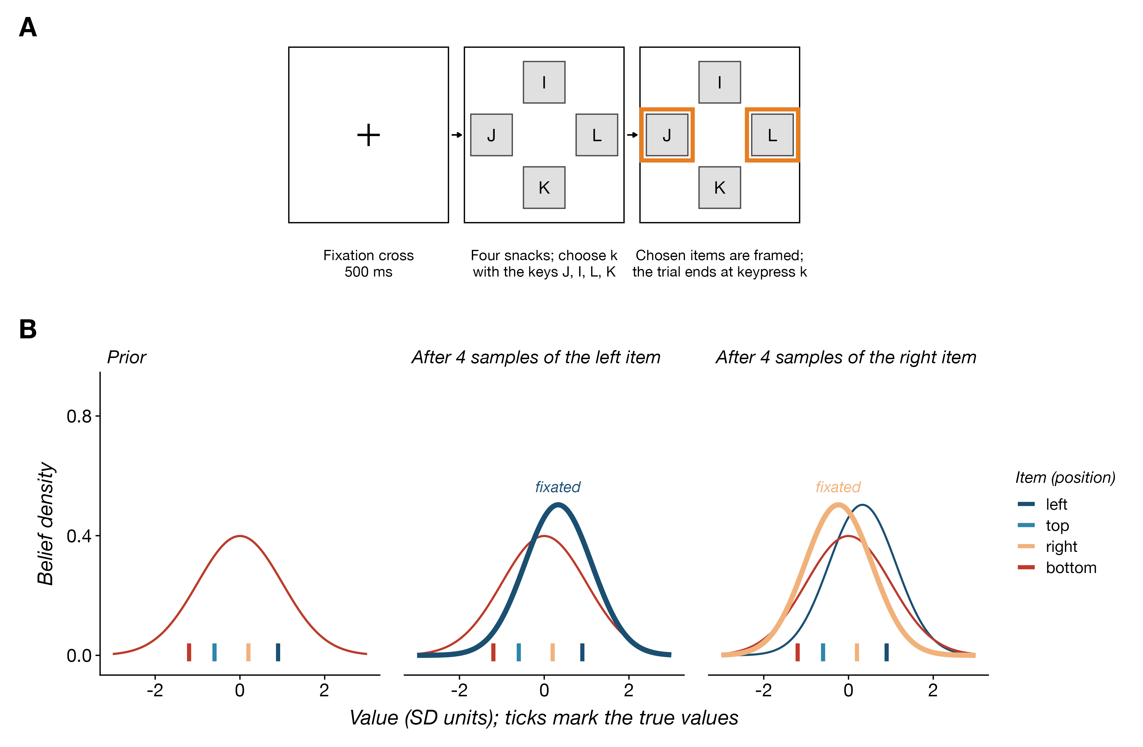
Task and model. (A) Trial sequence. After a fixation cross (500 ms), four snack foods appeared in a cross, and participants chose one, two, or three of them with the keys J, I, L, and K (selection size blocked). Each chosen item was framed, and the trial ended with the $k$-th keypress. (B) The decision maker holds a Gaussian belief about each item’s value (colors: screen positions), samples only the fixated item (thick line), and updates that item’s belief by Bayesian inference; unfixated items keep the prior. Ticks mark the true values.

Optimal policy
Where to fixate and when to stop are decisions about computations, and we treat them as a metalevel Markov decision process [14,22,24]. The states are belief states $b_{t}=(μ_{t},λ_{t},{\text{last}}_{t})$, with $2n+1$ dimensions; the actions are the $n$ sampling computations and termination, $c_{t}∈\{1,…,n\}∪\{⊥\}$; the transitions are the sampling and updating of Eqs 1 and 2 together with ${\text{last}}_{t+1}=c_{t}$; and the metalevel reward is $R(b_{t},c_{t})=−\text{cost}(c_{t})$ for a sampling computation and $R(b_{T},⊥)$ of Eq 5 for termination. A policy $π$ selects the next computation given the current belief, $c_{t}∼π(b_{t})$, and the optimal policy maximizes the expected total metalevel reward,
$$π^{*}=arg\max_{π} E​\left[\sum_{t=1}^{T}{R}(b_{t},c_{t}) | c_{t}∼π(b_{t})\right], (6)$$
which is the expectation of the payoff in Eq 4. The optimal policy can be expressed through the value of computation [21,22], the expected increase in total metalevel reward from executing computation $c$ once and then continuing optimally, rather than terminating now:
$$\text{VOC}(b_{t},c)=R(b_{t},c)+E​\left[\sum_{t^{′}=t+1}^{T}{R}(b_{t^{′}},c_{t^{′}}) | c_{t^{′}}∼π^{*}(b_{t^{′}})\right]−R(b_{t},⊥). (7)$$
In the language of reinforcement learning, $\text{VOC}(b,c)=Q^{*}(b,c)−R(b,⊥)$, where $Q^{*}$ is the optimal state-action value function, and by definition $\text{VOC}(b,⊥)=0$. The optimal policy selects a computation with maximal VOC, $π^{*}(b)∼\text{Uniform}(arg\max_{c}\text{VOC}(b,c))$, and therefore terminates when no computation has positive value.
Computing the VOC exactly is intractable, because it requires the optimal value of every reachable belief state. Callaway et al. [14] approximated it with a weighted combination of value-of-information features whose weights were tuned by policy search [50]. Here we use a simpler and fully analytic approximation, directed cognition [48,49], which asks what the DM would gain if she committed to taking exactly $N$ samples of item $c$ and then decided, and takes the best such commitment:
$${\text{VOC}}_{\text{DC}}(b,c)=\max_{N≥1}\left[{\text{VOI}}_{N}(b,c)−\text{cost}(b,c)−(N−1)γ_{\text{sample}}\right]. (8)$$
Because the committed plan is one the optimal policy could follow, ${\text{VOC}}_{\text{DC}}$ is a lower bound on the true VOC, and a policy based on it stops somewhat earlier than the optimal policy would [24]. In a Bernoulli version of the problem in which the optimal policy can be computed exactly by backward induction, the directed-cognition policy earned between 97% and 100% of the optimal expected reward for choosing one, two, or three of four items (S1 Appendix, section G). Its advantage is that ${\text{VOI}}_{N}(b,c)$, the expected improvement in the terminal reward from $N$ samples of item $c$, has a closed form for subset selection.
Although maximizing ${\text{VOC}}_{\text{DC}}$ identifies the best-performing policy, people are unlikely to select computations without noise. Following Callaway et al. [14], we assume that computations are chosen by a softmax over these values,
$$p(c∣b)∝exp​\left\{β {\text{VOC}}_{\text{DC}}(b,c)\right\}, {\text{VOC}}_{\text{DC}}(b,⊥)=0,$$
where the inverse temperature $β$ controls the amount of noise. We fix $β=1000$, at which computation selection is nearly deterministic.
Sampling item $c$ can change the terminal reward only if it changes whether $c$ belongs to the chosen set. If $c$ is not currently among the top $k$ estimates, it enters the set only if its new estimate rises above the lowest selected estimate, $μ_{(k)}$; if it is among the top $k$, it leaves the set only if its new estimate falls below the highest unselected estimate, $μ_{(k+1)}$. Call this competing value $\text{cv}(c)$. Before the samples are observed, the updated posterior mean ${\tilde{μ}}^{(c)}$ is itself a random variable, normal with mean $μ^{(c)}$ and standard deviation
$$σ_{\tilde{μ}}=w\sqrt{\frac{1}{λ^{(c)}}+\frac{1}{λ_{\text{obs}}}}, λ_{\text{obs}}=\frac{N}{σ_{x}^{2}}, w=\frac{λ_{\text{obs}}}{λ^{(c)}+λ_{\text{obs}}}. (9)$$
Because the posterior mean is a martingale, the value of information in both cases is the expected size of a change in the chosen set. With $z=(\text{cv}(c)−μ^{(c)})/σ_{\tilde{μ}}$ and $ϕ$ and $Φ$ the standard normal density and distribution functions,
$${\text{VOI}}_{N}(b,c)=\left\{\begin{matrix}E​\left[({\tilde{μ}}^{(c)}−\text{cv}(c))^{+}\right]=σ_{\tilde{μ}}\left[ϕ(z)−z (1−Φ(z))\right] & \text{if }c\text{ is not selected,} \\ E​\left[(\text{cv}(c)−{\tilde{μ}}^{(c)})^{+}\right]=σ_{\tilde{μ}}\left[ϕ(z)+z Φ(z)\right] & \text{if }c\text{ is selected.}\end{matrix}\right. (10)$$
An unselected item is worth sampling in proportion to how far its estimate might rise above the selection threshold; a selected item is worth sampling in proportion to how far its estimate might fall below the best unselected item. Both expressions grow with $σ_{\tilde{μ}}$, so uncertain items are sampled more, and shrink with $|z|$, so items far from the selection boundary are sampled less. Fig 2A shows the resulting value of sampling an item as a function of its estimated value and the precision of that estimate.
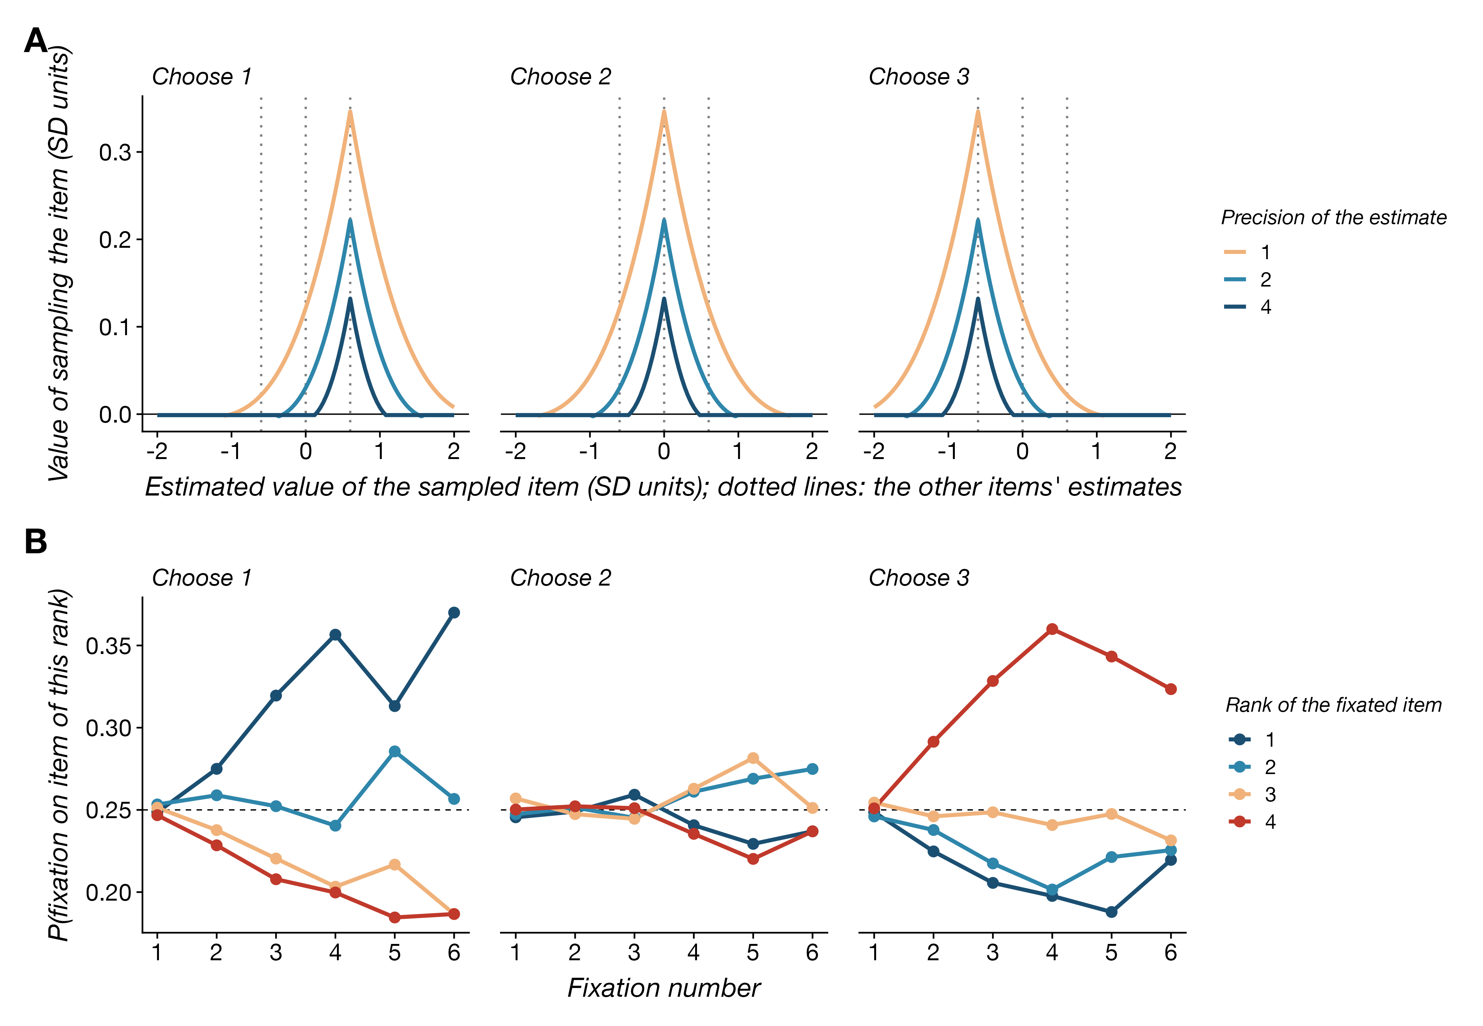
The value of sampling depends on the selection size. (A) The directed-cognition value of computation (Eq 8) for sampling an item as a function of its estimated value, at three levels of precision of that estimate, when the other three items have estimates of 0.6, 0, and $−0.6$ (dotted lines) at precision 4, for choosing one, two, or three of four items, at the parameters of the fitted simultaneous policy. Sampling is most valuable near the selection boundary: the top estimates when one item is chosen, the bottom estimates when three are, and the middle when two are. (B) Probability that each fixation of the simultaneous policy, simulated on the participants’ trials, lands on the item of each rank, by fixation number. Attention concentrates on the two best items when one is chosen and on the two worst when three are.

Selecting $k$ items is rejecting $n−k$
Selecting the $k$ best items is the same decision as rejecting the $n−k$ worst. The terminal reward can be written $\sum_{i=1}^{k}{μ_{(i)}}=\sum_{i=1}^{n}{μ^{(i)}}−\sum_{i=k+1}^{n}{μ_{(i)}}$, and the total i​μ(i) is a martingale whose expectation no sampling policy can change. Negating every observation maps the belief $(μ,λ)$ to $(−μ,λ)$ without changing the costs, so the optimal policy for the problem $(n,k)$ at belief $(μ,λ)$ is the optimal policy for the problem $(n,n−k)$ at belief $(−μ,λ)$. The directed-cognition approximation inherits the symmetry exactly: substituting $−μ$ and $n−k$ into the definition of the competing value exchanges the two cases of Eq 10. The attention policy for choosing one of four items is therefore the mirror image of the policy for choosing three. Where the former concentrates sampling on the two highest estimates [14], the latter concentrates it on the two lowest, because the decision hinges on which single item to leave out (Fig 2B). For $k=n/2$ the policy is symmetric in value and concentrates on the boundary between the $k$-th and $(k+1)$-th estimates.

When to respond
The task requires $k$ keypresses, and the theory above says nothing about when each should be made. We consider three normative policies that share the sampling rule and differ only in when items are committed.
The simultaneous policy treats the trial as one subset decision. At each step it evaluates ${\text{VOC}}_{\text{DC}}(b_{t},c)$ for the full problem $(n,k)$ and selects by the softmax above; when it selects $⊥$ it reports the $k$ items with the highest posterior means, highest first. It is the policy of the previous sections.
The best-first policy solves a sequence of single-item problems. Let $A_{r}$ be the set of items not yet chosen before response $r$, with $A_{1}=\{1,…,n\}$. At stage $r$ the policy evaluates ${\text{VOC}}_{\text{DC}}$ for the problem of choosing one item from $A_{r}$, with the beliefs restricted to $A_{r}$ and ${\text{last}}_{t}$ carried over from the previous stage, and selects by the softmax. When it selects $⊥$ it commits $i_{r}=arg\max_{i∈A_{r}}μ_{t}^{(i)}$, sets $A_{r+1}=A_{r}\backslash \{i_{r}\}$, and continues until $k$ items have been committed. Beliefs persist across stages. For $k=1$ it coincides with the simultaneous policy. It describes a DM who reuses the routine for simple choice $k$ times.
The commit-when-certain policy samples for the subset problem that remains, with $k_{r}=k−r+1$ items still to be chosen from $A_{r}$, but commits an item as soon as no computation with positive value could change that item’s membership in the chosen set. This is option-level stopping in the sense of Hay et al.’s blinkered decomposition [22], applied to each response. Let $S_{t}$ be the $k_{r}$ items of $A_{r}$ with the highest means, $s_{t}$ the member of $S_{t}$ with the lowest mean, and $U_{t}=A_{r}\backslash S_{t}$. Sampling an unselected item can displace only $s_{t}$, so a selected item $i∈S_{t}$ is safe to commit when
$${\text{VOC}}_{\text{DC}}(b_{t},i)≤0 \text{and} \left[ i≠s_{t} \text{or} \max_{j∈U_{t}}{\text{VOC}}_{\text{DC}}(b_{t},j)≤0 \right].$$
All safe items are committed, highest mean first, and removed, so that the problem shrinks to $(|A_{r+1}|,k_{r+1})$; otherwise the policy selects by the softmax, and if it selects $⊥$ it commits all of $S_{t}$. For $k=1$ this policy also coincides with the simultaneous policy. It describes a DM who makes each response as early as it is safe to do so. S1 Appendix gives all three policies as algorithms.
The three policies make different predictions about the order and timing of responses and about where attention goes between them, which we test below. We simulate all three on the trials participants saw, with parameters fitted separately for each policy (Methods).

Results

Participants, task, and data
Seventy-five participants (76 recruited, one excluded; Methods) rated 60 snack foods and then chose one, two, or three of four foods in three blocks of 100 trials, in randomized order, while a webcam recorded their gaze. We use each participant’s ratings as independent measures of the items’ values and index the four items on each trial by rank, 1 for the highest-rated. We report values in units of the standard deviation of each participant’s ratings. After excluding trials with response times outside the pre-registered range (3.0%) and trials without gaze samples on any item (6.9%), 19714 trials from 73 participants entered the gaze analyses, on average 270 per participant. Table 1 summarizes the behavior and the eye-movement measures that bear on the argument; S1 Appendix, Table I1 gives the full set of fixation descriptives.
Participants chose exactly the $k$ highest-rated items on 57%, 47%, and 58% of trials for $k=1$, 2, and 3. The lower accuracy for $k=2$ reflects the combinatorics of the task: two of the four items must be identified rather than one. Response times grew with $k$, from a median of 1.8 s for one item to 2.7 s for three. Because the gaze data are sampled at a median interval of 53 ms by the webcam tracker, we define a fixation as a contiguous run of gaze samples on the same item and measure its duration from the first to the last sample (Methods). Participants made three to four fixations per trial, typically to two or three of the four items, and fixations were long, with a median of about 300 ms and a mean of 420 to 520 ms.
Table 1. Behavior and eye movements by selection size. Means (SDs) over participants.
Measure | Choose 1 | Choose 2 | Choose 3
Trials analyzed | 6637 | 6457 | 6620
Response time, last keypress (ms) | 1980 (751) | 2650 (1033) | 3084 (1318)
Chose exactly the top-$k$ set | 0.57 (0.16) | 0.47 (0.15) | 0.58 (0.15)
First response is the best item | n/a | 0.50 (0.13) | 0.46 (0.13)
Responses in rank order | n/a | 0.61 (0.11) | 0.29 (0.12)
Fixations per trial | 2.93 (1.21) | 3.64 (1.61) | 4.05 (2.08)
Total fixation time (ms) | 1210 (540) | 1679 (772) | 1989 (991)
Dwell share, best item | 0.270 (0.051) | 0.264 (0.045) | 0.242 (0.035)
Dwell share, worst item | 0.233 (0.046) | 0.233 (0.035) | 0.249 (0.035)

Basic psychometrics
We first describe the relationship between item values, choices, and the time spent sampling (Fig 3). Trial difficulty for a subset choice is the gap between the $k$-th and $(k+1)$-th highest ratings, the two items at the selection boundary. Accuracy rose with this gap in all three conditions (mixed logistic regression, $b=0.95$ per SD of the gap, $SE=0.05$, $z=17.7$), with no difference in slope between conditions. Total fixation time fell with the gap ($b=−0.10$ log units per SD, $SE=0.02$, $t=−6.5$) and with the mean rating of the four items ($b=−0.23$, $SE=0.02$, $t=−12.3$), the overall-value effect reported for simple choice [9,14], and grew with $k$ (33% longer for two items and 66% longer for three than for one). The number of fixations followed the same pattern. All three policies reproduced the rise of accuracy with the boundary gap and the distributions of fixation time for one and two items (Fig 3A–B); they predict these relationships because fewer samples are needed to separate items whose estimates are far apart. They differed for three items. The simultaneous and commit-when-certain policies predicted three-item trials about as short as single-item trials, with fixation time rising with the mean rating, because better items make the one to reject harder to find. The data and the best-first policy show longer three-item trials and the same decrease of fixation time with mean rating as for one item (Fig 3C–D).
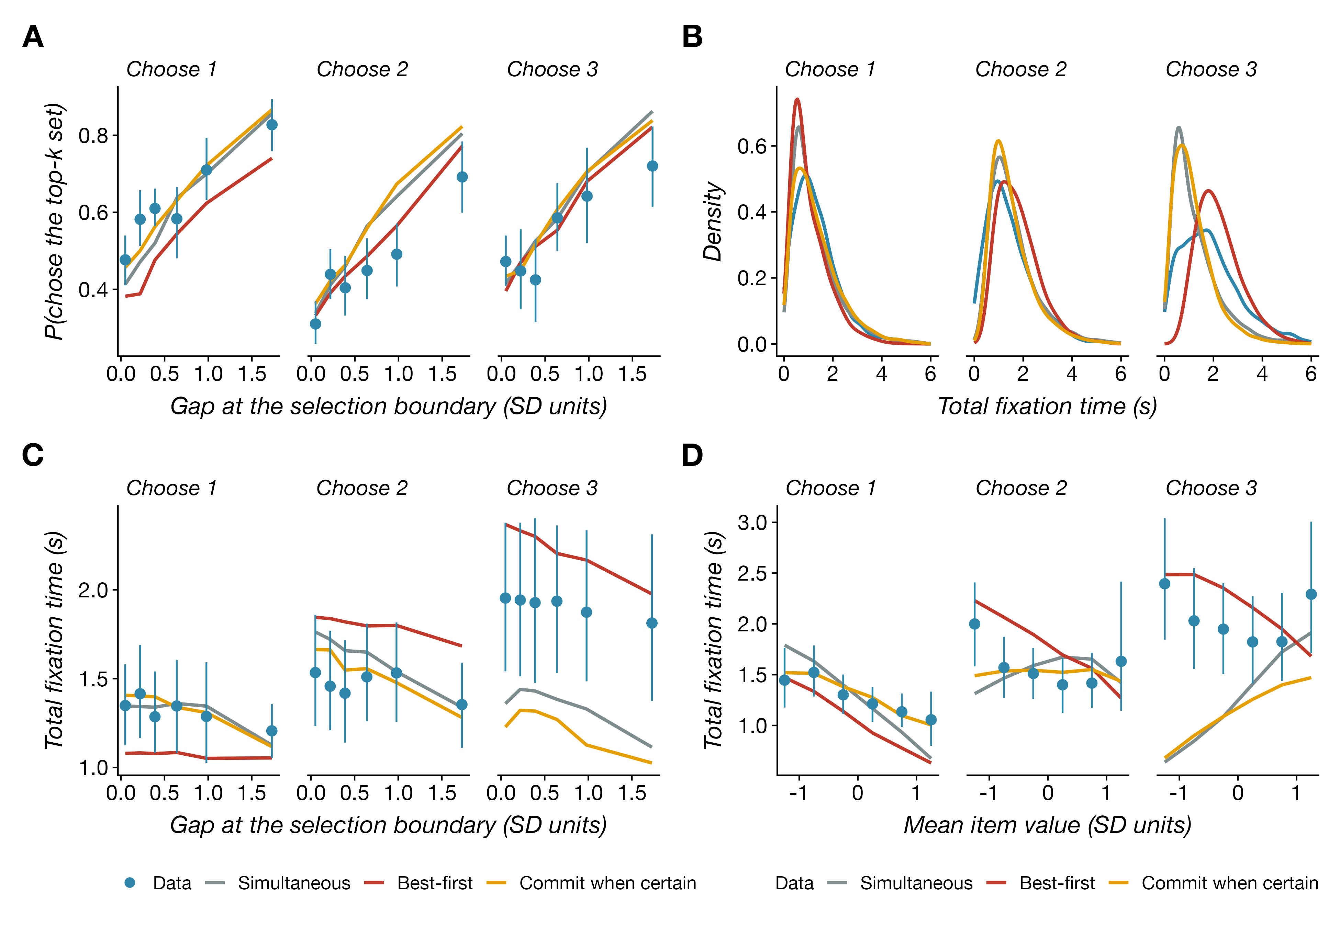
Basic psychometrics. Human data (black, means over participants with 95% bootstrap confidence intervals) and the three policies simulated on the same trials at their fitted parameters (colors). (A) Probability of choosing exactly the $k$ highest-rated items as a function of the rating gap at the selection boundary. (B) Distribution of total fixation time. (C) Total fixation time as a function of the boundary gap. (D) Total fixation time as a function of the mean rating of the four items.

Basic fixation patterns
Fig 4 shows the distribution of the number of fixations, its relationship to difficulty, and the duration of fixations by their position in the trial. Fixation counts were low and right-skewed, with 28%, 20%, and 19% of trials containing a single fixation for $k=1$, 2, and 3, and the number of fixations fell with the boundary gap. Fixations were also unevenly distributed over the display: the first fixation landed on the left, top, and right items on 29%, 28%, and 29% of trials but on the bottom item on only 14%, the bottom item received 16% of fixation time against 26% to 31% for the others, and it was chosen less often than its rating warranted (mixed logistic regression of choice on rank and position, $b=−0.30$ for the bottom position relative to the left, $SE=0.03$). Spatial biases of this kind are common in gaze data [6,7,51]; the policies have no spatial component and treat the four positions alike. Unlike the lab data modeled by Callaway et al. [14], in which final fixations are shorter because the choice cuts them off, first and last fixations here were longer than middle ones (S1 Appendix, Table I1), and the first fixation grew longer with $k$ (8% longer for two items and 16% for three, $t=3.7$ and 6.9). The policies reproduced the number of fixations for one and two items, except that none produced the many single-fixation trials seen in the data (Fig 4A), and the best-first policy made too many fixations for three items (4.7 against 3.7; Fig 4B). All three predict fixations that lengthen over the trial, as in the lab data of Callaway et al. [14], because beliefs grow more precise and need more evidence to change; the webcam data show no such lengthening (Fig 4C).
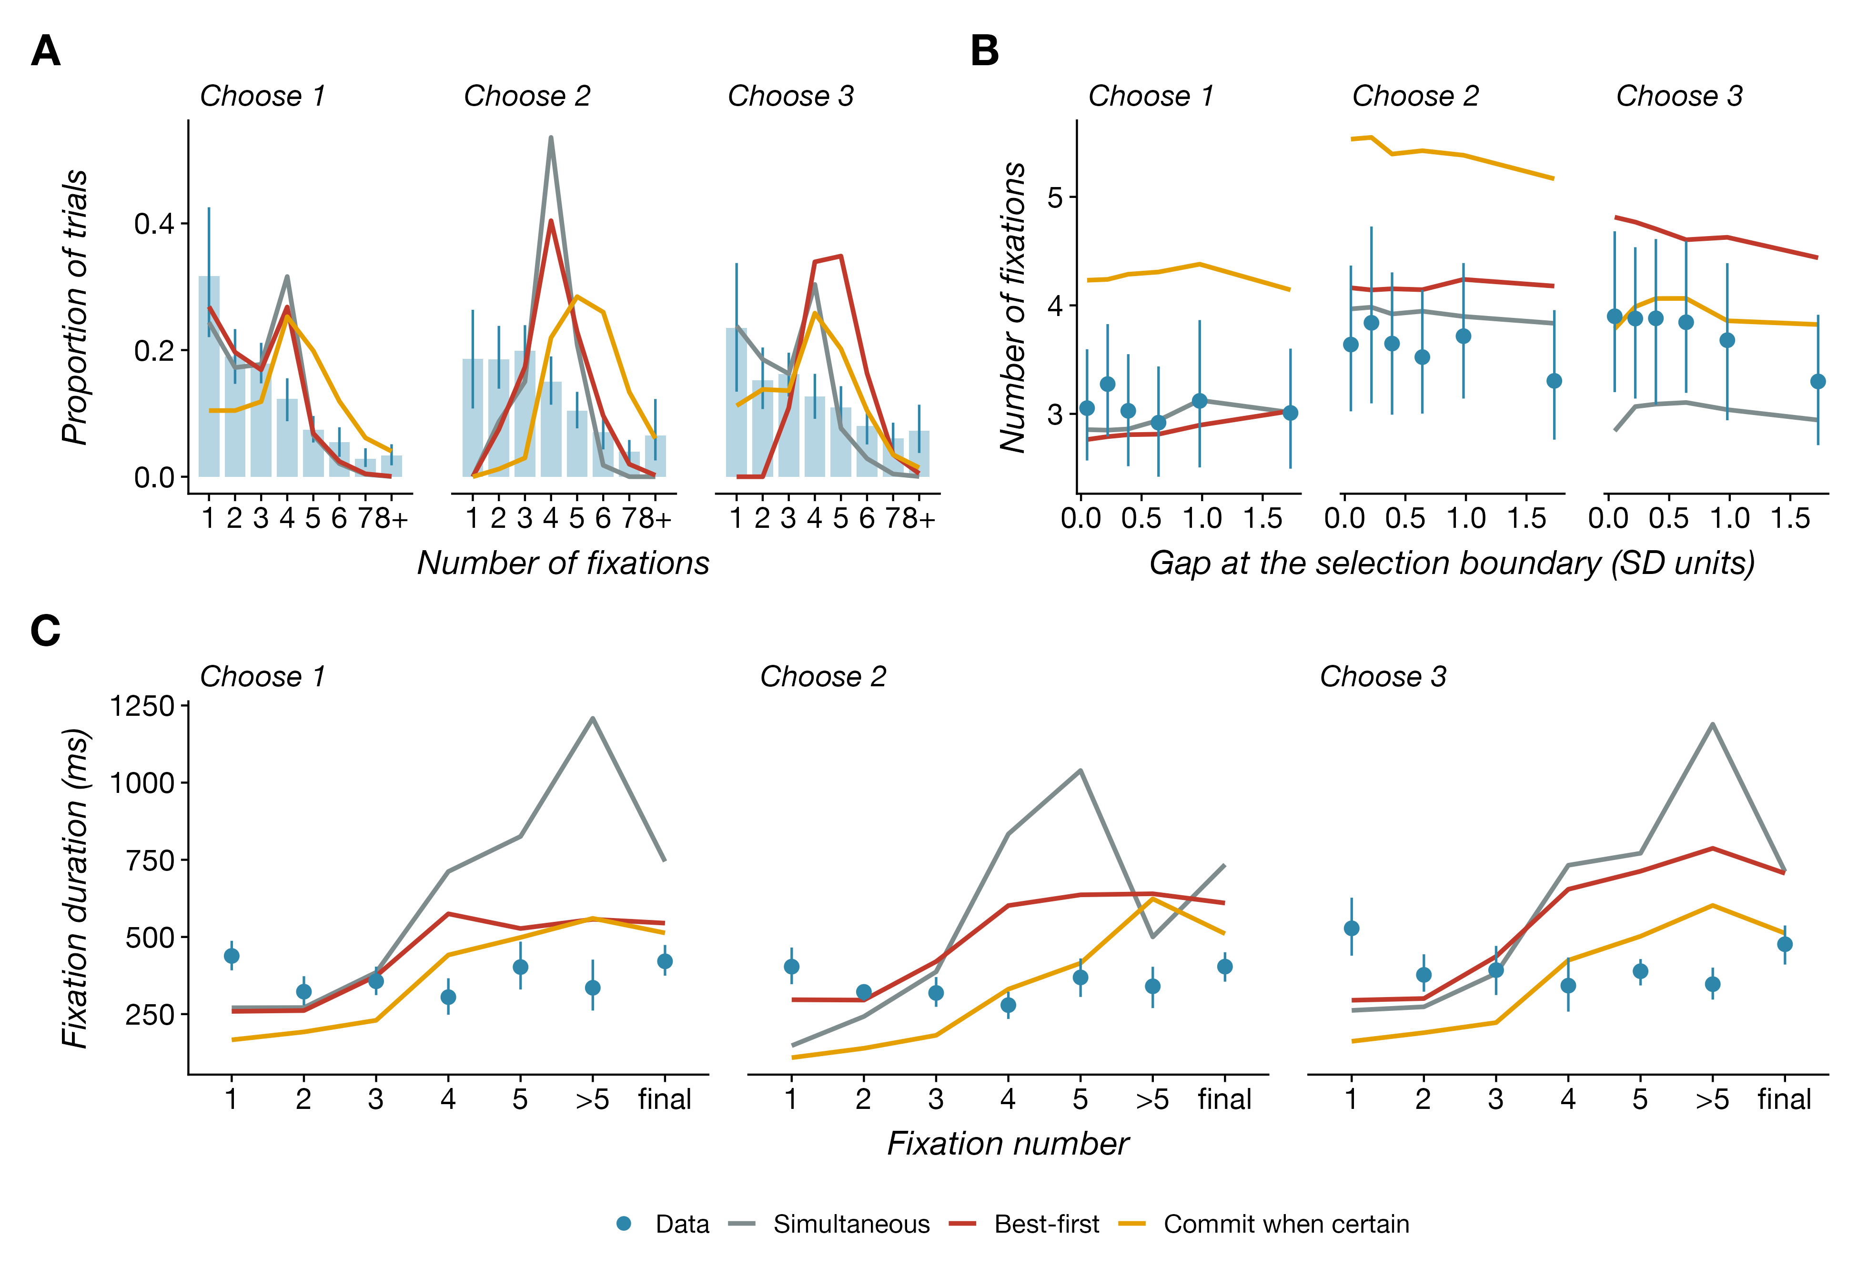
Basic fixation patterns. (A) Distribution of the number of fixations per trial. (B) Number of fixations as a function of the boundary gap. (C) Fixation duration by fixation number; the final fixation of each trial is plotted separately. Conventions as in Fig 3.

Uncertainty-directed attention
One driver of fixations in the optimal policy is uncertainty: because precision grows with the number of samples, fixations should go to items that have received less fixation time, provided the difference justifies the switching cost. Fig 5A shows the fixation advantage of the newly fixated item at the onset of each fixation after the first, its cumulative dwell minus the mean cumulative dwell of the other items. The distribution was centered below zero in all conditions: items were fixated when they had received less attention than the others. Part of this pattern is mechanical, because the item fixated last cannot be the target of a new fixation. A stronger test asks, among the three items not fixated last, whether the target is the one that has received the least attention. When those three items had distinct cumulative dwell times, the new fixation went to the least-viewed of them on fewer than one occasion in ten, far below the one in three expected by chance (Fig 5B): late in a trial, participants returned to items they already favored rather than to items they had neglected. Refixations were common from the third fixation on (Fig 5C), and participants viewed only two or three of the four items in a typical trial (S1 Appendix, Table I1). The policies behave differently. They place the fixation advantage of the newly fixated item in a narrow band just below zero (Fig 5A), spreading samples almost evenly and moving on as soon as an item falls slightly behind, and they survey every item before returning to any, so refixations are absent until the fifth fixation and then universal (Fig 5C). Uncertainty directs attention in the policies more thoroughly than in the participants.
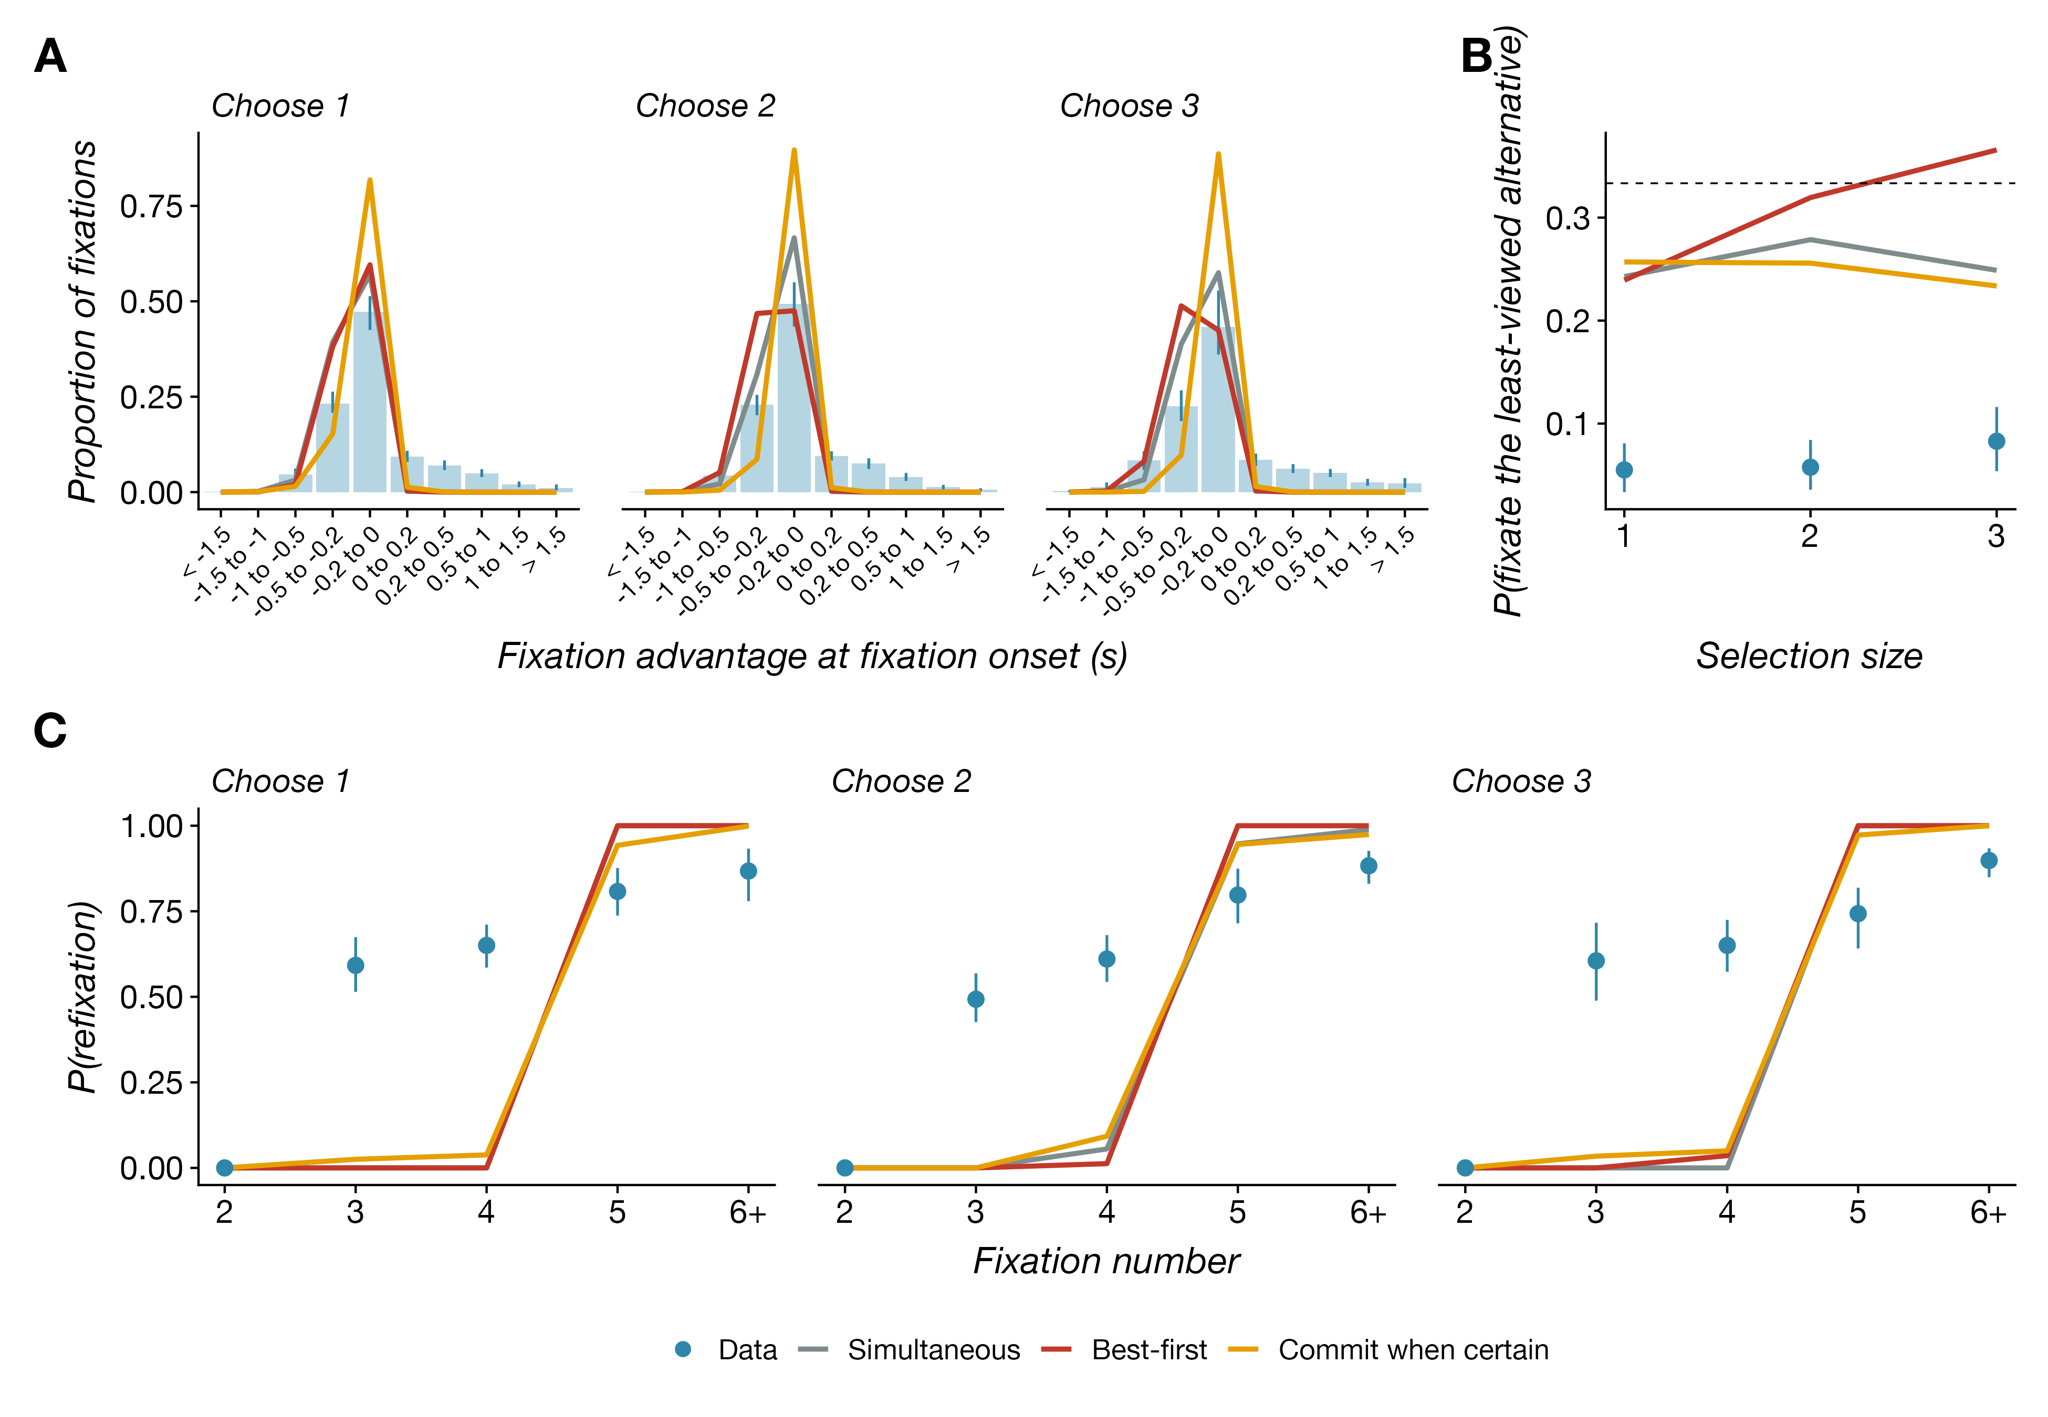
Uncertainty-directed attention. (A) Distribution of the fixation advantage of the newly fixated item at fixation onset (cumulative dwell on that item minus the mean cumulative dwell on the others), excluding first fixations. (B) Probability that a new fixation goes to the least-viewed of the three items not fixated last; the dotted line is chance. (C) Probability that a fixation returns to an item seen earlier in the trial, by fixation number. Conventions as in Fig 3.

Value-directed attention and the missing mirror image
The second driver of fixations is estimated value, and here the theory makes its sharpest prediction: the allocation of attention across item ranks should reverse between choosing one and choosing three of four items. We measured value-directed attention as the share of each trial’s fixation time spent on each item, by the item’s rank (Fig 6A). When choosing one item, participants looked longest at the best item and least at the worst (dwell share fell by $b=0.013$ per rank, $SE=0.002$, $t=−7.4$, mixed-effects regression), the pattern reported for trinary choice by Krajbich and Rangel [7] and predicted by the optimal policy. With two items to choose, the gradient was slightly shallower ($b=−0.010$, $SE=0.002$, $t=−5.6$). When choosing three, it was absent ($b=0.003$, $SE=0.002$, $t=1.6$) and differed reliably from the choose-two gradient (difference $0.012$, $SE=0.003$, $t=5.0$). The mirror image did not appear: participants did not concentrate on the two worst items when the task was to leave one out. The same held for the duration of the first fixation (Fig 6B), which did not depend on the rank of the fixated item in any condition ($b=0.009$ log units per rank, $SE=0.014$, $t=0.7$), unlike the trinary data of Callaway et al. [14], with their longer first fixations to high-rated items.
The time course of attention shows what happened instead (Fig 6C). We computed, within quintiles of each trial’s duration, the probability of fixating the best item minus the probability of fixating the worst. For one item this value-directed index rose over the trial, as estimates became accurate. For three items it was positive early in the trial and became negative only in the last two quintiles. Attention to the worst item rose toward the end of the trial, as the mirror policy requires, but it did so late. Gaze entropy, a measure of how evenly fixation time was spread across the four items [41], was lower when the items were better on average ($b=−0.09$ bits per SD, $SE=0.01$, $t=−7.0$) and when the boundary gap was larger ($b=−0.02$, $SE=0.01$, $t=−2.1$), and higher for larger $k$ (Fig 6D).
The policies separate on these measures (Fig 6A). The simultaneous and commit-when-certain policies predict the mirror image for three items, with dwell share rising from 0.14 to 0.40 across ranks, which the data contradict. By contrast, the best-first policy predicts the flat profile observed for three items and the top-weighted profile for one, though with gradients about three times steeper than the data in every condition, a difference we return to in the Discussion. The time course (Fig 6C) and the overall-value effect (Fig 3D) tell the same story: the two subset policies turn attention to the worst item within the first second of a three-item trial, the best-first policy only after the first response, and the data follow the latter. All policies spread fixation time more evenly across the four items than participants did (Fig 6D), because participants rarely fixated all four.
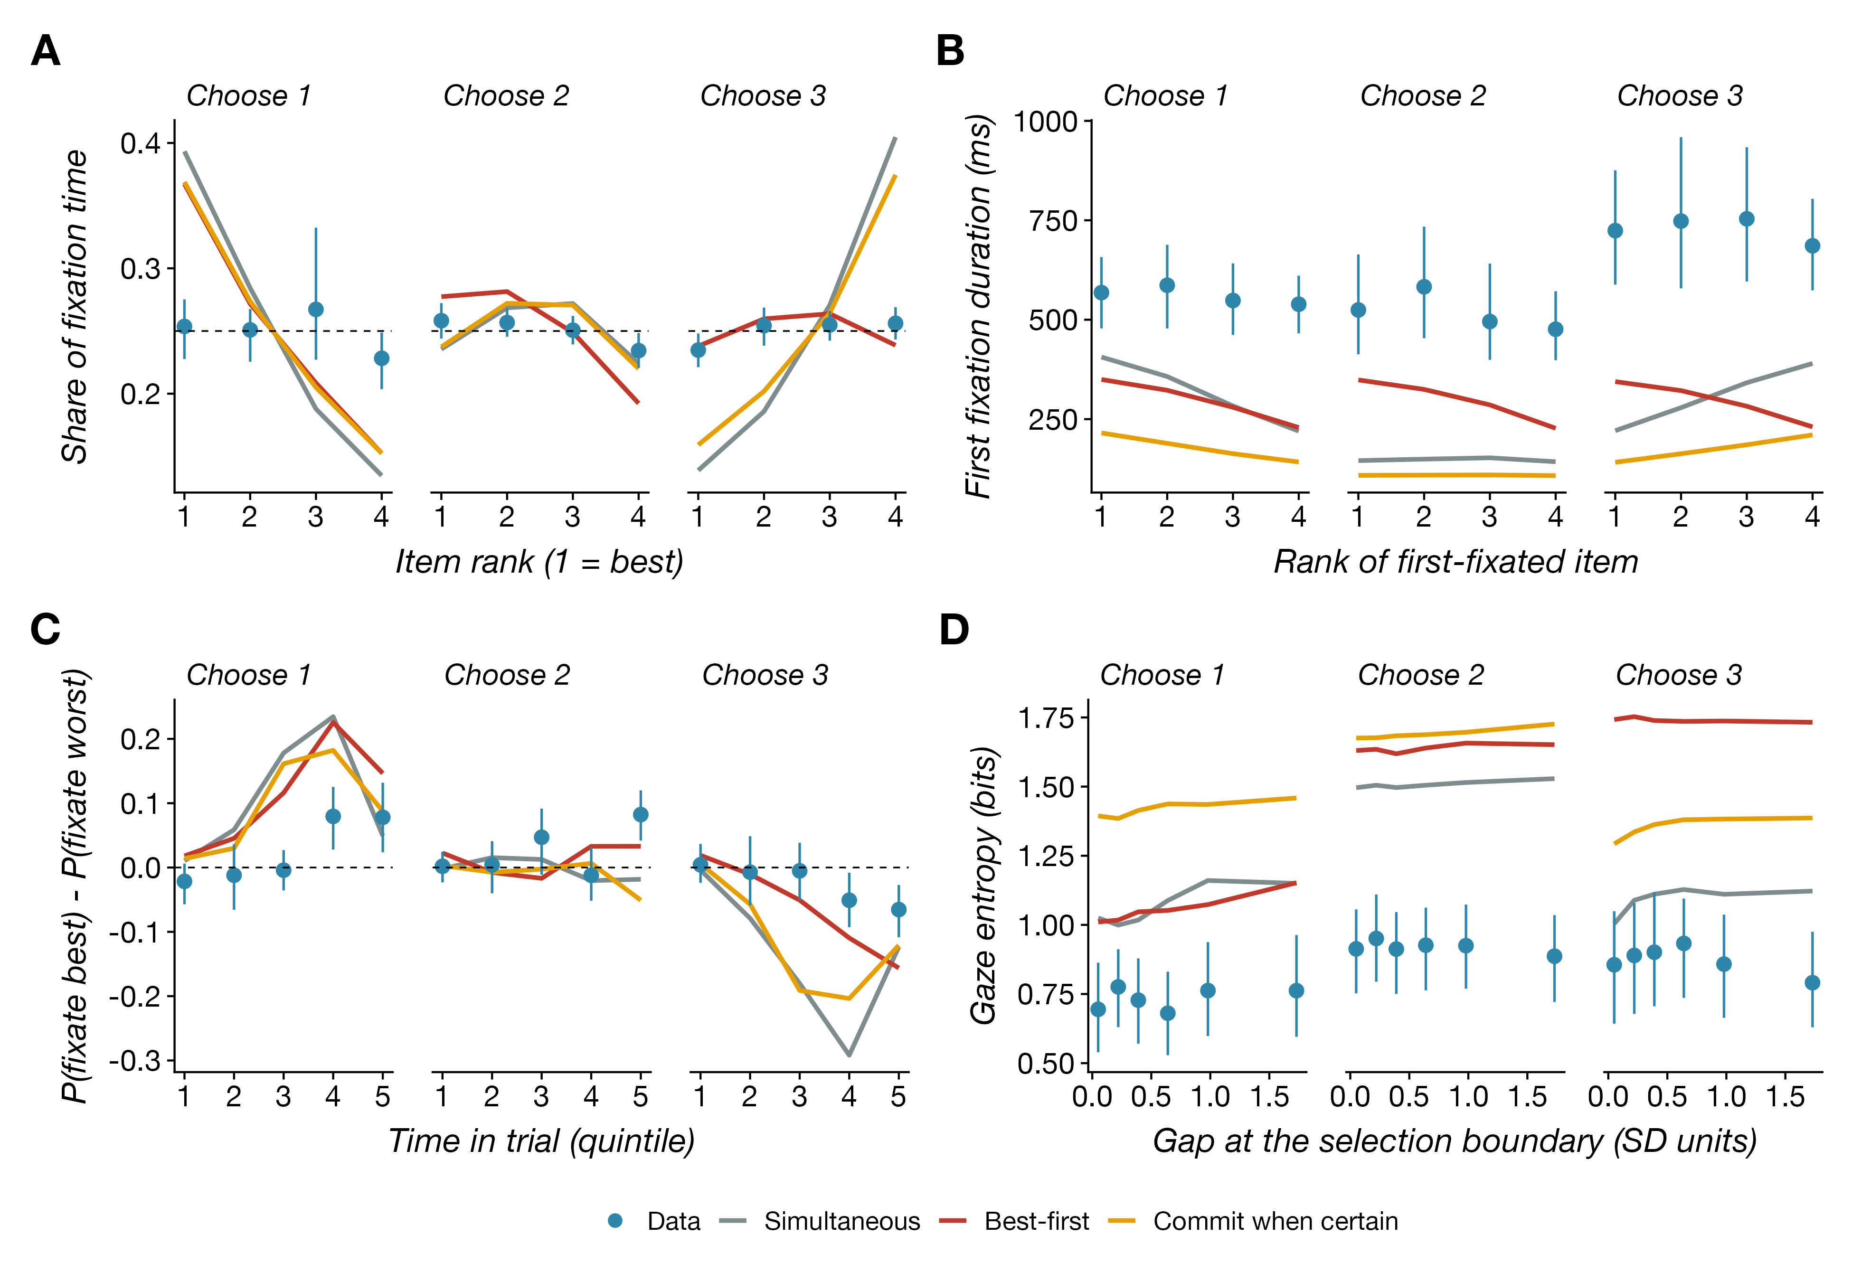
Value-directed attention. (A) Share of fixation time by item rank (1 = highest rated). (B) Duration of the first fixation by the rank of the fixated item. (C) Probability of fixating the best item minus the probability of fixating the worst, within quintiles of the trial’s duration. (D) Gaze entropy as a function of the boundary gap. Conventions as in Fig 3.

Attention is organized around the next response
The late shift toward the worst item suggests that the multi-item trial is not treated as one subset decision. Fig 7A separates fixation time by the response it preceded. Before the first keypress, the allocation across ranks was the same in all three conditions: it favored the best item and fell with rank, with no difference in slope between choosing one, two, or three items ($t=0.5$ and 1.7 against the choose-one slope). The gradient reversed after the first keypress. For three items, the slope of dwell share on rank was $−0.009$ per rank before the first response ($SE=0.002$, $t=−4.5$), $+0.011$ before the second ($SE=0.003$, $t=3.5$), and $+0.031$ before the third ($SE=0.003$, $t=9.6$): attention followed the ranking downward as items were committed. Between responses, participants fixated items they had already chosen on about one fixation in five (Fig 7B); the policies never do, because a committed item carries no further value of information.
Responses were ordered by value and closely spaced. The first of two responses was the best-rated item on 50% of trials and the first of three on 46% (Fig 7D), and when the best item was among those chosen it was chosen first on 62% and 49% of trials. All three responses were in rank order on 29% of choose-three trials, against 17% by chance. The first keypress came after a median of 1.7 s when two items were to be chosen and 1.5 s when three were, close to the 1.8 s of a single-item trial, and each later keypress followed the previous one by about half a second (Fig 7C).
These patterns are those of a decision maker who solves “choose $k$” as a sequence of “choose the best remaining item” problems. Here too the three policies separate. The simultaneous policy orders its responses by estimated value and so reproduces the order statistics, because estimates are noisy when sampling stops (first response is the best item on 53% and 41% of two- and three-item trials, against 50% and 46% observed; all responses in rank order on 63% and 23%, against 61% and 29%), but it makes all responses at once and predicts no attention between them. The best-first policy predicts the same top-weighted attention before the first response as in a single-item trial, with a steeper gradient than the data show, and a shift to the remaining items afterwards, as observed (Fig 7A). Because its beliefs carry over, its later responses are quick, about 600 ms and 300 ms after the previous one against 575 and 533 ms observed (Fig 7C). Its misses are a first response that comes too early (0.8 s against 1.5 s), too many three-item trials in rank order (33% against 29%), and a first response that is the best item too often (51% against 46%; Fig 7D). Finally, the commit-when-certain policy predicts short gaps between responses (100 to 300 ms) and the observed order statistics, and its attention between responses tracks the data (Fig 7A, right), but because membership in a set of three is certified quickly it predicts a first response far earlier than observed (after 0.6 s and 0.4 s of fixation time for two and three items, against 1.45 s and 1.43 s) and the mirror-image allocation of attention before that response. The data therefore combine a first decision that looks like simple choice with later responses that read out a ranking formed during that first decision, which the best-first policy produces by carrying its beliefs from one decision to the next.
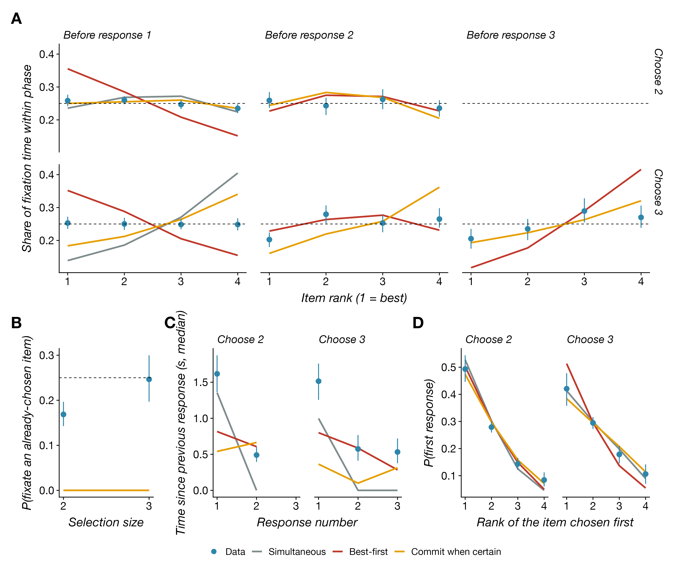
Attention between responses, and the order and timing of responses. (A) Share of fixation time by item rank within the phase before each keypress, for trials with two (top) and three (bottom) responses. (B) Probability that a fixation between responses lands on an item already chosen. (C) Median time from the previous keypress (or trial onset) to each response. (D) Distribution of the rank of the item chosen first. Conventions as in Fig 3.

Time-resolved fixation probability
Following Frömer et al. [41], we also examined the value-directed index at a finer time scale, aligned to stimulus onset and to the first keypress (Fig 8). Aligned to onset, the index rose over the first two seconds when one item was chosen, rose more slowly when two were chosen, and when three were chosen rose briefly before falling below zero after about 1.5 s, when most participants had made their first response and attention had moved to the remaining items. Aligned to the first keypress, the index rose toward the response in all three conditions, so the first response was preceded by attention to the best item regardless of how many items were to be chosen. Cluster-based permutation tests across participants [52] support this description (Methods). Aligned to onset, the index was reliably positive from 1.2 s to the end of the 3 s window when one item was chosen and from 0.7 to 2.8 s when two were chosen, with no reliable cluster when three were chosen; the three-item index was lower than the one-item index from 1.3 to 2.8 s and lower than the two-item index from 1.2 to 2.7 s (both $p<0.001$), whereas one- and two-item trials did not differ. Aligned to the first keypress, the index was reliably positive over the final 800, 900, and 600 ms before the response for one, two, and three items ($p≤0.002$), and three-item trials differed from one-item trials only in the final 300 ms ($p=0.03$). The policies again separate on the three-item trials. Aligned to onset, the simultaneous and commit-when-certain policies drive the index to $−0.2$ within half a second, whereas the best-first policy holds it positive for the first second and lets it fall only after the first response, and the data lie between zero and the best-first prediction. Aligned to the first keypress, the best-first policy predicts the observed rise toward the best item in all three conditions, whereas the simultaneous policy predicts a fall toward the worst item before the first response of a three-item trial, the opposite of what participants did. All policies overpredict the size of these effects.
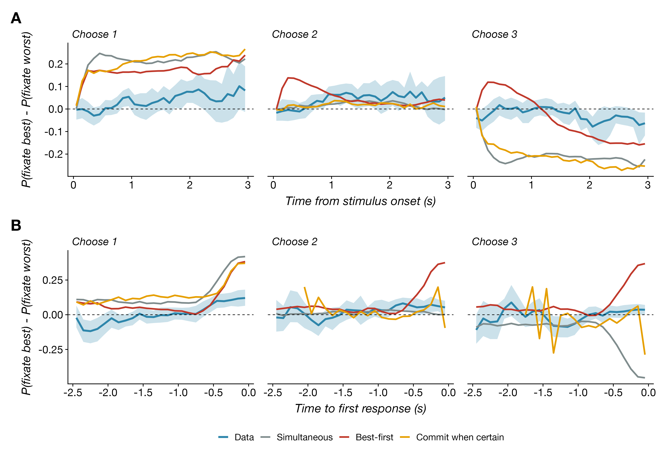
Time-resolved fixation probability. Probability of fixating the best item minus the probability of fixating the worst, in 100 ms bins, (A) aligned to stimulus onset and (B) aligned to the first keypress. Shaded regions are 95% bootstrap confidence intervals over participants; colored lines are the policies.

Attention and choice
Finally, fixations and choices were related as in simple choice (Fig 9). An item’s probability of being chosen rose with its share of fixation time after controlling for its rank ($b=0.57$ per unit share, $SE=0.04$, $z=14.5$), the last-fixated item was chosen more often than its value alone predicts, and the first-fixated item was chosen more often when the first fixation was long. In the optimal model these correlations arise from two sources [14]: a prior centered below the items’ values, under which sampling an item raises its estimate on average, and value-directed attention, under which an item with a high estimate is both fixated and chosen. The policies reproduce the dependence of choice on dwell share and rank (Fig 9A), overpredict the bias toward the last-fixated item in single-item trials (Fig 9B), because their last fixation almost always lands on the item they choose, and for three items the best-first policy reproduces that bias while the two subset policies underpredict it, because they end the trial on the item they reject.
Frömer et al. [20] derived a sharper prediction from the same updating equations: under a prior that matches the values in the context, attention should raise the choice probability of items valued above the mean of the choice set and lower that of items below it, and they confirmed this interaction, with no main effect of attention, when they controlled exposure to the items experimentally in binary choice. Our free-viewing data differ in a way the model explains. An item’s share of fixation time raised its probability of being chosen at every value level (mixed logistic regression controlling for the item’s value relative to the set and for $k$: $z=13.9$ for the main effect of share), and the effect was larger for items below the set mean than above it (interaction $z=−3.9$; for single-item choices, the logit slope on share was 1.57 for an item one SD below the mean and 0.59 for an item one SD above). The fitted best-first policy also predicts a positive effect of share at every value level, because an item is fixated when its estimate is high and chosen for the same reason, a common cause that experimentally controlled exposure removes. It predicts the interaction in the direction Frömer et al. observed, however, because sampling a below-average item under an unbiased prior lowers its estimate on average. The absence of that offset in the data suggests either that participants’ prior lay below the mean of their ratings, as Callaway et al. [14] found for binary choice, or that gaze has an additive influence on choice beyond its role in updating [6,9]. Ting and Gluth [13] noted that the Bayesian models reproduce the dwell-time effect in binary choice only when the prior underestimates the values and questioned whether people do so; our data do not settle the question, because under free viewing value-directed attention produces the main effect on its own.
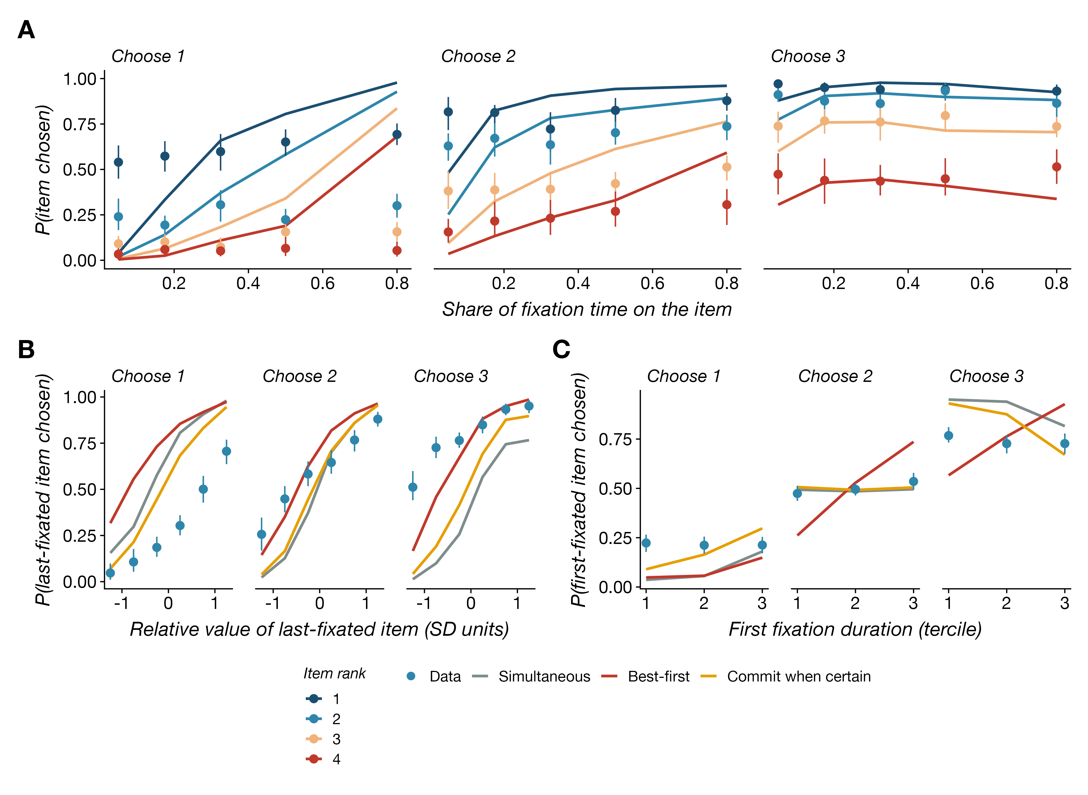
Attention and choice. (A) Probability that an item is chosen as a function of its share of fixation time, by item rank (points: data; lines: commit-when-certain policy). (B) Probability that the last-fixated item is chosen as a function of its rating relative to the other items. (C) Probability that the first-fixated item is chosen as a function of the duration of the first fixation. Conventions as in Fig 3.

The cost of choosing one item at a time
Table 2 gives the parameters that best fit each policy and the statistics they reproduce; the fitting objective recovers both the parameters and the generating policy from simulated data (S1 Appendix, section H). The simultaneous and best-first policies fit the summary statistics about equally well, and the commit-when-certain policy much worse, because no parameter setting lets it delay the first response: it committed the first item after 0.6 s and 0.4 s of fixation time when two and three items were to be chosen, against 1.45 s and 1.43 s observed. The simultaneous policy reproduced accuracy, fixation counts, and the order of responses, but not the growth of fixation time with the selection size, because it makes all responses at once. The best-first policy reproduced the growth of fixation time with the selection size and came closest on the time to the first response, at the price of too many three-item trials in rank order and a first response that was the best item too often. All three fitted a switching cost far above the sampling cost, which reflects the small number of fixations per trial in the webcam data.
Table 2. Fitted parameters of each policy and the statistics they reproduce (even-numbered trials). Parameters are the mean ± SD of the ten best configurations of the refinement stage, in units of the standard deviation of each participant’s ratings; the statistics are those of the best configuration, with times assuming 100 ms per sample.
Policy | σ_x | γ_sample | γ_switch | Loss | Acc. k=1/2/3 | Fixations k=1/2/3 | Fix. time (ms) k=1/2/3 | P(first best) k=2/3 | P(in order) k=2/3 | Time to resp. 1 (ms) k=2/3
Data |  |  |  |  | 0.58 / 0.48 / 0.58 | 3.0 / 3.7 / 4.0 | 1246 / 1691 / 1984 | 0.50 / 0.46 | 0.61 / 0.29 | 1450 / 1433
Simultaneous | 2.00 ± 0.24 | 0.0014 ± 0.0005 | 0.134 ± 0.042 | 6.7 | 0.58 / 0.52 / 0.61 | 2.8 / 4.0 / 2.9 | 1269 / 1642 / 1325 | 0.53 / 0.41 | 0.63 / 0.23 | 1642 / 1325
Best-first | 2.48 ± 0.22 | 0.0033 ± 0.0010 | 0.149 ± 0.034 | 6.6 | 0.51 / 0.48 / 0.60 | 2.7 / 4.2 / 4.7 | 1032 / 1817 / 2247 | 0.50 / 0.51 | 0.62 / 0.33 | 1052 / 1042
Commit when certain | 1.92 ± 0.20 | 0.0017 ± 0.0007 | 0.080 ± 0.011 | 21.4 | 0.59 / 0.52 / 0.61 | 4.2 / 5.4 / 3.8 | 1363 / 1556 / 1190 | 0.46 / 0.39 | 0.55 / 0.22 | 622 / 425
To measure what the decomposition costs, we simulated all three policies on the empirical value sets under each fitted parameter set and under the parameters reported by Callaway et al. [14], and compared their net reward, the summed true value of the chosen items minus the sampling costs (Table 3). For choosing two of four, best-first earned 4% to 8% more than the simultaneous policy under every parameter set: the directed-cognition approximation stops the simultaneous policy early, and the extra sampling that best-first does more than pays for itself. For choosing three of four, best-first earned less under every parameter set, by 3% at the parameters of Callaway et al. and by 24% to 49% at the fitted parameters, under which switching attention is expensive. Best-first establishes the full ranking of items it does not need to rank, and that is cheap when the selection boundary lies in the middle of the ranking and costly when the task is to leave one item out. The commit-when-certain policy was within 6% of the simultaneous policy throughout. The same ordering holds against the exact optimum in the Bernoulli version of the task (S1 Appendix, section G): there best-first lost nothing for two items and 0.5% to 3.5% for three, with the larger losses at the larger switching cost, which indicates that the fitted switching costs, which are large relative to the sampling cost, are what make the decomposition expensive in the Gaussian model.
Table 3. Net expected reward (summed true value of the chosen items minus sampling costs, in SD units) of the three policies on the empirical value sets, under each parameter set. For k = 1 the policies coincide.
Parameter set | k | Oracle | Simultaneous | Best-first | Commit when certain | Best-first vs simultaneous | Commit vs simultaneous
Callaway et al. (2021) | 2 | 1.320 | 0.779 | 0.810 | 0.763 | +4% | -2%
Callaway et al. (2021) | 3 | 1.027 | 0.599 | 0.579 | 0.590 | -3% | -2%
fitted, best-first | 2 | 1.320 | 0.467 | 0.504 | 0.463 | +8% | -1%
fitted, best-first | 3 | 1.027 | 0.446 | 0.235 | 0.418 | -47% | -6%
fitted, commit-when-certain | 2 | 1.320 | 0.677 | 0.713 | 0.674 | +5% | -0%
fitted, commit-when-certain | 3 | 1.027 | 0.554 | 0.420 | 0.556 | -24% | +0%
fitted, simultaneous | 2 | 1.320 | 0.546 | 0.566 | 0.534 | +4% | -2%
fitted, simultaneous | 3 | 1.027 | 0.518 | 0.263 | 0.485 | -49% | -6%

Discussion
We asked how attention should be allocated when several items must be chosen from a set, and how people allocate it. Extending the optimal information sampling model of simple choice [14] to subset selection gave a clear answer to the first question. Because selecting $k$ items is the same decision as rejecting the other $n−k$, the optimal policy for choosing three of four items is the mirror image of the policy for choosing one, and should concentrate sampling on the two lowest estimates. People did not do this. Before their first keypress they allocated attention as in simple choice, favoring the highest-rated items in every condition, and only after each keypress did attention move down the ranking of the remaining items. Their responses were ordered by value and spaced by about half a second. People choose several items by choosing one item at a time.
This decomposition is not what the formal problem calls for, but it may be what a resource-rational decision maker should do. A policy that reuses the routine for simple choice needs no new computation for each value of $k$, while the optimal subset policy requires representing the selection boundary and, for $k=n−1$, inverting the direction of attention. The cost of the decomposition in expected reward was nil when two of four items were chosen and between 3% and 49% when three were, depending on how expensive switching attention is, so the pressure to learn the mirror policy is weak for some selection sizes and strong for others. People select among decision strategies adaptively [53], and the resource-rational analysis of strategy selection [23,24,54–56] predicts that a general strategy will be reused when it performs nearly as well as a specialized one. Krueger et al. [57] found that people’s departures from resource-rational behavior in risky choice arise mainly from which strategy they select rather than from how they execute it. The same division holds here: each single-item decision is carried out much as the optimal model prescribes, and the departure lies in the choice to decompose. Optimal models of metacognitive control in memory make claims of the same form at the level of single operations: whether to continue a recall search and which of two memories to search first [35], and how much encoding effort to give each item in a given reward environment [36], follow from the structure of the task and independently measured constraints rather than from fitting the behavior to be explained. The symmetry result here is a prediction of that kind, because it holds for every setting of the parameters; the decomposition people use is the departure from it that a theory of strategy reuse has to explain. Our results also speak to how goals shape attention. Frömer et al. [41] found that people do attend to low-value items when the instruction is to choose the worst option. Choosing three of four is formally the same problem as rejecting one, but it is not framed that way, and attention followed the framing rather than the formal structure. A direct test would instruct participants to reject one item rather than choose three, holding the decision problem fixed.
Of the three policies, the best-first policy accounts for the most. It predicts the absence of the mirror image, the top-weighted attention before the first response, the longer trials and the falling overall-value effect when three items are chosen, and the quick spacing of later responses, because the beliefs formed while finding the best item already rank the rest. Its first response comes too early and its responses are in rank order too often, so people do more than run the single-item routine three times. The first decision takes longer than the routine would, and the later responses are read out from the ranking it formed with brief checks, as the commit-when-certain policy does for items whose membership is already certain. The response times and selection order in the companion behavioral study of this task [Fernandez KA, Callaway F, Karmarkar UR, Krajbich I. Rank-order preferences are not quickly accessible. In preparation] give the same account; there, a multi-response sequential sampling model with racing accumulators captured the slow first response and the fast later ones. The normative account offered here explains why the first decision looks like simple choice and why later responses can be fast: once the best item has been identified with enough precision to commit it, the estimates of the remaining items are already precise enough that little sampling could change their order.
Several features of the data are not captured by any of the policies. Participants viewed only two or three of the four items in a typical trial and refixated favored items from the third fixation on, whereas every policy surveys all four items before returning to any; a fifth of fixations between responses went to items already chosen, which the policies never revisit. First and last fixations were longer than middle ones and fixations did not lengthen over the trial, whereas the policies predict lengthening fixations and a short final fixation cut off by the response, as in lab eye tracking [6,14]. The long first fixation grew with $k$ and likely includes the time to orient to the display and to the task, which the policies do not represent. The attention gradients in the data were also about three times shallower than those of the policies, which fixate with a consistency no participant shows. Laboratory eye tracking would provide stronger tests of these patterns. On the modeling side, directed cognition is a lower bound on the value of computation and stops early; in a Bernoulli version of the task with an exact solution it came within 0.4% to 3.3% of the optimal reward (S1 Appendix), and dynamic programming on a discretized belief space [15] could extend that check to the Gaussian model for two or three items. We also held the prior unbiased. Callaway et al. found that a prior centered below the item values was needed to reproduce the choice biases in binary choice, whereas Frömer et al. [20] found that an unbiased prior accounts for the effect of experimentally controlled attention on choice; our free-viewing data showed an attention effect that was strongest for below-average items, which an unbiased prior does not produce, so fitting the prior bias is a natural next step.
The broader lesson concerns the unit of decision. Models of attention in choice, including ours, take the decision to be the selection of a set, and derive attention from the information that selection needs. People instead appear to carry a procedure for choosing one item and to apply it repeatedly, letting attention follow the item to be chosen next. Optimal information sampling describes each of those decisions well. It does not describe the whole trial, because the whole trial is not the decision people make.

Materials and methods

Participants
Seventy-six participants were recruited on Prolific, were residents of the United States, and were paid at a rate of $14 per hour. One participant was excluded because the selection-size condition was recorded inconsistently in their gaze records, and two others contributed no usable gaze data, so 75 participants enter the behavioral analyses and 73 the gaze analyses.

Ethics statement
The experiment was approved by the Human Subjects Internal Review Board at the Ohio State University, and participants gave written consent before taking part.

Task
The experiment ran in the browser with jsPsych [58] and used webcam eye tracking with the WebGazer library [59,60]. In the rating phase, participants viewed 60 images of snack foods (750 ms each) and then rated each food on a continuous scale from “Not at all” to “Very much” for how much they would like it as a daily snack, recorded as values from 1 to 100. In the choice phase, four foods were shown in a cross around a central fixation cross, and participants chose one, two, or three of them with the keys J, I, L, and K for the left, top, right, and bottom items. The selection size was blocked, with 100 trials per block and block order randomized across participants. Each trial began with a 500 ms fixation cross; after each keypress an orange frame marked the chosen item, and the trial ended with the $k$-th keypress.

Gaze data
WebGazer estimates a gaze position from the webcam image at every video frame, after a calibration phase in which participants clicked on targets across the screen [59,60]. The median interval between consecutive samples on an item was 53 ms, with a heavy tail when frames were dropped. A sample was assigned to an item when it fell inside a rectangular region of interest extending 50 pixels beyond the item’s image; samples outside every region were discarded. Of the 1.13 million samples recorded during the choice trials of the 73 participants in the gaze analyses, 49% fell inside an item region (median 51% per participant, range 20% to 69%); the remainder include samples near the central fixation cross, in the gaps between items, and tracker errors, as is typical of webcam eye tracking [60,61]. No participant was excluded for tracking quality. Tracking quality attenuates the gaze effects rather than creating them: splitting participants at the median on-item rate, the slope of dwell share on rank for single-item choices was $−0.016$ ($t=−6.5$) in the better-tracked half and $−0.011$ ($t=−4.1$) in the other, and the three-item slopes across response phases were $−0.013$, $0.010$, and $0.035$ against $−0.004$, $0.013$, and $0.025$. A stricter pipeline with a 34-pixel buffer, the largest at which the four regions never overlapped, was available for 42 participants and gave the same patterns (for example, the share of fixation time on the best and worst items was 0.288 and 0.233 when one item was chosen and 0.234 and 0.255 when three were, against 0.274 and 0.238 and 0.243 and 0.248 in the main pipeline). Items are indexed by screen position, which we verified against the keypresses. We defined a fixation as a contiguous run of samples on one item, with onset at its first sample and duration equal to the time from the first to the last sample plus one median inter-sample interval; consecutive runs on the same item were merged. Because the tracker samples irregularly, 20% of these runs lasted less than 100 ms, and we did not impose a minimum duration; excluding runs shorter than 100 ms left the value-directed attention results unchanged (dwell-share slopes on rank of $−0.013$, $−0.011$, and $0.002$ for one, two, and three items, and $−0.010$, $0.012$, and $0.037$ across the three response phases of three-item trials). Cumulative dwell on each item at any moment was computed from these fixations. The phase of a fixation is the keypress that followed its onset: before the first response, between the first and second, or between the second and third.

Trial-level measures
Trial difficulty is the gap between the $k$-th and $(k+1)$-th highest ratings of the four items, in SD units of the participant’s ratings. The share of fixation time on an item is its total fixation time in the trial divided by the total over the four items; the first fixation is the first run of samples on any item. Gaze entropy is −i​pilog2pi over the four shares, which is 0 when one item received all fixation time and 2 bits when the four shares were equal [41]. The fixation advantage of a newly fixated item is its cumulative dwell at the onset of the fixation minus the mean cumulative dwell of the other three items. For a fixation after the first, the least-viewed alternative is the item with the smallest cumulative dwell among the three items not fixated last, defined only when that minimum is unique. The value-directed index in a time window is the probability that the fixated item is the highest-rated item minus the probability that it is the lowest-rated; in Fig 6C the windows are quintiles of each trial’s duration, and in Fig 8 they are 100 ms bins aligned to stimulus onset or to the first keypress, with a bin counted for a trial when a fixation covers its center. Response order is summarized by whether the first keypress selected the highest-rated item and whether all keypresses followed the rating order.

Policy cost
The net reward of a policy on a trial is the summed true value of the items it chose, in SD units, minus $γ_{\text{sample}}$ per sample and $γ_{\text{switch}}$ per change of fixated item. Table 3 reports the mean net reward of each policy over the empirical value sets of all usable trials, simulated at a common parameter set, and the oracle value is the mean sum of the $k$ highest true values.
We excluded trials with response times below 250 ms or above 10 s and, within each participant, trials more than two interquartile ranges beyond the quartiles of the response time distribution (3.0% of trials), and trials without any gaze sample on an item (6.9%). Item values were standardized within participant using the mean and standard deviation of that participant’s 60 ratings, and the item ranks on each trial were computed from the ratings with ties broken at random.

Model simulation
The model was implemented in Julia 1.11 [62]. We simulated each policy on the trials that participants saw, with the true values set to the participant’s standardized ratings of the four items,
$$u^{(i)}=\frac{r^{(i)}−\overset{‾}{μ}}{\overset{‾}{σ}}, (11)$$
where $\overset{‾}{μ}$ and $\overset{‾}{σ}$ are the mean and standard deviation of that participant’s 60 ratings, and with the prior $N(0,1)$ in these units [14]. Up to the change of units, this is the same as simulating in the raw rating space with the prior set to the participant’s rating distribution; the prior mean is taken to be unbiased, which corresponds to $α=1$ in Callaway et al.’s parameterization and to the unbiased-prior model that Frömer et al. [20] found to account for the effects of controlled attention on choice. Each belief state was initialized with all means at 0 and all precisions at 1, and no item fixated. At each step the policy evaluated ${\text{VOC}}_{\text{DC}}$ for every item (Eq 8), treating the number of committed samples $N$ as continuous on $[1,100]$ and maximizing it by golden-section search, and chose among the items and termination by a softmax over these values with inverse temperature $β=1000$, which is nearly deterministic. Consecutive samples of the same item were concatenated into one fixation, and each sample was taken to last 100 ms [14]. The best-first and commit-when-certain policies were simulated as described in the Model section, with beliefs and the last-fixated item carried across responses. Each trial was simulated five times per policy.

Parameter estimation
Each policy has three free parameters, the sampling noise $σ_{x}$, the sampling cost $γ_{\text{sample}}$, and the switching cost $γ_{\text{switch}}$, all in units of the standard deviation of value. We estimated them separately for each policy by random search, with 200 configurations drawn log-uniformly from $σ_{x}∈[1,6]$, $γ_{\text{sample}}∈[0.0005,0.03]$, and $γ_{\text{switch}}∈[0.001,0.3]$, followed by 150 configurations in a box around the ten best. Each configuration $θ$ was simulated once on every even-numbered trial and scored by
L(θ)=k=13s∈Sk​sk(θ)−skτs2, (12)
where $s_{k}$ is a summary statistic of the data at selection size $k$, ${\hat{s}}_{k}(θ)$ is the same statistic in the simulation, and $τ_{s}$ is a scale. The statistics $S_{k}$ were the probability of choosing the top-$k$ set, the mean number of fixations, and the mean total fixation time, and for $k≥2$ also the probability that the first response is the best item, the probability that the responses are in rank order, and the mean fixation time before the first response, with scales $τ_{s}$ of 0.05 for probabilities, one fixation, and 500 ms. As Callaway et al. [14] did for the best configurations of their search, we report the mean and standard deviation of the ten best configurations of the refinement stage (Table 2), and we simulate the single best configuration for the figures. A recovery analysis, in which each policy’s own simulation was refitted with the same procedure, recovered the parameters to within about 10% and identified the generating policy in every case (S1 Appendix, section H). Like the approximate likelihood of Callaway et al. [14], this objective serves only to choose parameters; the model is evaluated on the full set of patterns in the figures. Dwell shares were not fitted, because the spatial error of the webcam tracker attenuates them in the data, and are shown as predictions. All figures show the odd-numbered trials, for the data and for the policies simulated at their best-fitting parameters (Table 2).

Statistical analysis
Summary statistics were computed per participant and then averaged, with 95% confidence intervals from 500 bootstrap resamples of participants. Regression analyses used linear and logistic mixed-effects models with random intercepts for participants, fitted with lme4 (version 2.0.1) [63] in R 4.5 [64]; we report the coefficient $b$ with its standard error and the Wald statistic ($t$ for linear and $z$ for logistic models). Item rank was entered as a centered linear predictor, and values and gaps in SD units of the participant’s ratings. Gaze entropy was computed per trial as −i​pilog2pi over the four items’ shares of fixation time [41]. Time-resolved fixation probabilities were computed in 100 ms bins as the probability, among trials with a fixation covering the bin, that the fixated item was the best minus the probability that it was the worst, aligned to stimulus onset or to the first keypress. These indices were tested with cluster-based permutation tests [52]: for each bin we computed a one-sample $t$ statistic across participants (a paired statistic for the difference between selection sizes), formed clusters of adjacent bins whose statistic exceeded the two-sided 0.05 threshold, summed the statistics within each cluster, and compared each cluster’s mass with the distribution of the largest absolute mass under 5000 random sign flips of participants’ indices.

Data and code availability
The data, the model and analysis code, and the scripts that reproduce every figure are available at https://github.com/kiante-fernandez/optimal-attention.

Supporting information
S1 Appendix. Derivations, policies, parameter search, and validation. Derivation of the distribution of the posterior mean after $N$ samples (Eq 9) and of the value of information for subset selection (Eq 10), the lower-bound property of directed cognition, the proof that selecting $k$ items is rejecting $n−k$, the three response policies as algorithms, the details of the parameter search, the validation of the directed-cognition approximation against the exact optimal policy in a Bernoulli version of the task, and the parameter and policy recovery analysis.

References
1. Ratcliff R, McKoon G. The diffusion decision model: Theory and data for two-choice decision tasks. Neural Computation. 2008;20(4):873–922. doi:10.1162/neco.2008.12-06-420
2. Usher M, McClelland JL. The time course of perceptual choice: The leaky, competing accumulator model. Psychological Review. 2001;108(3):550–92. doi:10.1037/0033-295x.108.3.550
3. Milosavljevic M, Malmaud J, Huth A, Koch C, Rangel A. The drift diffusion model can account for the accuracy and reaction time of value-based choices under high and low time pressure. Judgment and Decision Making. 2010;5(6):437–49. doi:10.1017/s1930297500001285
4. Busemeyer JR, Townsend JT. Decision field theory: A dynamic-cognitive approach to decision making in an uncertain environment. Psychological Review. 1993;100(3):432–59. doi:10.1037/0033-295x.100.3.432
5. Shimojo S, Simion C, Shimojo E, Scheier C. Gaze bias both reflects and influences preference. Nature Neuroscience. 2003;6(12):1317–22. doi:10.1038/nn1150
6. Krajbich I, Armel C, Rangel A. Visual fixations and the computation and comparison of value in simple choice. Nature Neuroscience. 2010;13(10):1292–8. doi:10.1038/nn.2635
7. Krajbich I, Rangel A. Multialternative drift-diffusion model predicts the relationship between visual fixations and choice in value-based decisions. Proceedings of the National Academy of Sciences. 2011;108(33):13852–7. doi:10.1073/pnas.1101328108
8. Armel KC, Beaumel A, Rangel A. Biasing simple choices by manipulating relative visual attention. Judgment and Decision Making. 2008;3(5):396–403. doi:10.1017/s1930297500000413
9. Smith SM, Krajbich I. Gaze amplifies value in decision making. Psychological Science. 2019;30(1):116–28. doi:10.1177/0956797618810521
10. Bhatnagar R, Orquin JL. A meta-analysis on the effect of visual attention on choice. Journal of Experimental Psychology: General. 2022;151(10):2265–83. doi:10.1037/xge0001204
11. Thomas AW, Molter F, Krajbich I, Heekeren HR, Mohr PNC. Gaze bias differences capture individual choice behaviour. Nature Human Behaviour. 2019;3(6):625–35. doi:10.1038/s41562-019-0584-8
12. Krajbich I. Accounting for attention in sequential sampling models of decision making. Current Opinion in Psychology. 2019;29:6–11. doi:10.1016/j.copsyc.2018.10.008
13. Ting CC, Gluth S. Unraveling information processes of decision-making with eye-tracking data. Frontiers in Behavioral Economics. 2024;3:1384713. doi:10.3389/frbhe.2024.1384713
14. Callaway F, Rangel A, Griffiths TL. Fixation patterns in simple choice reflect optimal information sampling. PLOS Computational Biology. 2021;17(3):e1008863. doi:10.1371/journal.pcbi.1008863
15. Jang AI, Sharma R, Drugowitsch J. Optimal policy for attention-modulated decisions explains human fixation behavior. eLife. 2021;10:e63436. doi:10.7554/elife.63436
16. Tajima S, Drugowitsch J, Pouget A. Optimal policy for value-based decision-making. Nature Communications. 2016;7:12400. doi:10.1038/ncomms12400
17. Tajima S, Drugowitsch J, Patel N, Pouget A. Optimal policy for multi-alternative decisions. Nature Neuroscience. 2019;22(9):1503–11. doi:10.1038/s41593-019-0453-9
18. Fudenberg D, Strack P, Strzalecki T. Speed, accuracy, and the optimal timing of choices. American Economic Review. 2018;108(12):3651–84. doi:10.1257/aer.20150742
19. Hébert B, Woodford M. Rational inattention when decisions take time. Journal of Economic Theory. 2023;208:105612. doi:10.1016/j.jet.2023.105612
20. Frömer R, Callaway F, Griffiths TL, Shenhav A. Considering what we know and what we don’t know: Expectations and confidence guide value integration in value-based decision-making. Open Mind: Discoveries in Cognitive Science. 2025;9:791–813. doi:10.1162/opmi.a.3
21. Russell S, Wefald E. Principles of metareasoning. Artificial Intelligence. 1991;49(1-3):361–95. doi:10.1016/0004-3702(91)90015-c
22. Hay N, Russell S, Tolpin D, Shimony SE. Selecting computations: Theory and applications. In: Proceedings of the twenty-eighth conference on uncertainty in artificial intelligence (UAI 2012) [Internet]. PMLR; 2012. p. 344–53. Available from: https://proceedings.mlr.press/r10/hay12a.html
23. Lieder F, Griffiths TL. Resource-rational analysis: Understanding human cognition as the optimal use of limited computational resources. Behavioral and Brain Sciences. 2020;43:e1. doi:10.1017/s0140525x1900061x
24. Lieder F, Callaway F, Griffiths TL. The rational use of cognitive resources. Princeton, NJ: Princeton University Press; 2026.
25. Simon HA. A behavioral model of rational choice. The Quarterly Journal of Economics. 1955;69(1):99–118. doi:10.2307/1884852
26. Russell SJ, Subramanian D. Provably bounded-optimal agents. Journal of Artificial Intelligence Research. 1995;2:575–609. doi:10.1613/jair.133
27. Lewis RL, Howes A, Singh S. Computational rationality: Linking mechanism and behavior through bounded utility maximization. Topics in Cognitive Science. 2014;6(2):279–311. doi:10.1111/tops.12086
28. Griffiths TL, Lieder F, Goodman ND. Rational use of cognitive resources: Levels of analysis between the computational and the algorithmic. Topics in Cognitive Science. 2015;7(2):217–29. doi:10.1111/tops.12142
29. Gershman SJ, Horvitz EJ, Tenenbaum JB. Computational rationality: A converging paradigm for intelligence in brains, minds, and machines. Science. 2015;349(6245):273–8. doi:10.1126/science.aac6076
30. Najemnik J, Geisler WS. Optimal eye movement strategies in visual search. Nature. 2005;434(7031):387–91. doi:10.1038/nature03390
31. Yang SCH, Lengyel M, Wolpert DM. Active sensing in the categorization of visual patterns. eLife. 2016;5:e12215. doi:10.7554/elife.12215
32. Gottlieb J. Attention, learning, and the value of information. Neuron. 2012;76(2):281–95. doi:10.1016/j.neuron.2012.09.034
33. Hoppe D, Rothkopf CA. Learning rational temporal eye movement strategies. Proceedings of the National Academy of Sciences. 2016;113(29):8332–7. doi:10.1073/pnas.1601305113
34. Callaway F, Opheusden B van, Gul S, Das P, Krueger PM, Griffiths TL, et al. Rational use of cognitive resources in human planning. Nature Human Behaviour. 2022;6(8):1112–25. doi:10.1038/s41562-022-01332-8
35. Callaway F, Griffiths TL, Norman KA, Zhang Q. Optimal metacognitive control of memory recall. Psychological Review. 2024;131(3):781–811. doi:10.1037/rev0000441
36. Ma S, Popov V, Zhang Q. Cognitive constraints and reward environments jointly shape memory formation. Psychological Review. 2026. doi:10.1037/rev0000612
37. Reutskaja E, Nagel R, Camerer CF, Rangel A. Search dynamics in consumer choice under time pressure: An eye-tracking study. American Economic Review. 2011;101(2):900–26. doi:10.1257/aer.101.2.900
38. Russo JE, Leclerc F. An eye-fixation analysis of choice processes for consumer nondurables. Journal of Consumer Research. 1994;21(2):274–90. doi:10.1086/209397
39. Gluth S, Spektor MS, Rieskamp J. Value-based attentional capture affects multi-alternative decision making. eLife. 2018;7:e39659. doi:10.7554/elife.39659
40. Gluth S, Kern N, Kortmann M, Vitali CL. Value-based attention but not divisive normalization influences decisions with multiple alternatives. Nature Human Behaviour. 2020;4(6):634–45. doi:10.1038/s41562-020-0822-0
41. Froemer R, Ting CC, Shenhav A, Gluth S. Goals shape dynamics of attention and selection for value-based decisions. Topics in Cognitive Science. 2026;e70076. doi:10.1111/tops.70076
42. Frömer R, Dean Wolf CK, Shenhav A. Goal congruency dominates reward value in accounting for behavioral and neural correlates of value-based decision-making. Nature Communications. 2019;10:4926. doi:10.1038/s41467-019-12931-x
43. Sepulveda P, Usher M, Davies N, Benson AA, Ortoleva P, De Martino B. Visual attention modulates the integration of goal-relevant evidence and not value. eLife. 2020;9:e60705. doi:10.7554/elife.60705
44. Kovach CK, Sutterer MJ, Rushia SN, Teriakidis A, Jenison RL. Two systems drive attention to rewards. Frontiers in Psychology. 2014;5:46. doi:10.3389/fpsyg.2014.00046
45. Simonson I. The effect of purchase quantity and timing on variety-seeking behavior. Journal of Marketing Research. 1990;27(2):150–62. doi:10.1177/002224379002700203
46. Read D, Loewenstein G. Diversification bias: Explaining the discrepancy in variety seeking between combined and separated choices. Journal of Experimental Psychology: Applied. 1995;1(1):34–49. doi:10.1037/1076-898x.1.1.34
47. Leng X, Frömer R, Summe T, Shenhav A. Mutual inclusivity improves decision-making by smoothing out choice’s competitive edge. Nature Human Behaviour. 2025;9(3):521–33. doi:10.1038/s41562-024-02064-7
48. Gabaix X, Laibson D. Bounded rationality and directed cognition [Working paper] [Internet]. Harvard University; 2005. Available from: https://scholar.harvard.edu/sites/scholar.harvard.edu/files/xgabaix/files/bounded_rationality.pdf
49. Gabaix X, Laibson D, Moloche G, Weinberg S. Costly information acquisition: Experimental analysis of a boundedly rational model. American Economic Review. 2006;96(4):1043–68. doi:10.1257/000282806779468544
50. Callaway F, Gul S, Krueger PM, Griffiths TL, Lieder F. Learning to select computations. In: Proceedings of the thirty-fourth conference on uncertainty in artificial intelligence (UAI 2018) [Internet]. PMLR; 2018. p. 775–84. Available from: https://proceedings.mlr.press/r16/callaway18a.html
51. Orquin JL, Mueller Loose S. Attention and choice: A review on eye movements in decision making. Acta Psychologica. 2013;144(1):190–206. doi:10.1016/j.actpsy.2013.06.003
52. Maris E, Oostenveld R. Nonparametric statistical testing of EEG- and MEG-data. Journal of Neuroscience Methods. 2007;164(1):177–90. doi:10.1016/j.jneumeth.2007.03.024
53. Payne JW, Bettman JR, Johnson EJ. Adaptive strategy selection in decision making. Journal of Experimental Psychology: Learning, Memory, and Cognition. 1988;14(3):534–52. doi:10.1037/0278-7393.14.3.534
54. Lieder F, Griffiths TL. Strategy selection as rational metareasoning. Psychological Review. 2017;124(6):762–94. doi:10.1037/rev0000075
55. Shenhav A, Musslick S, Lieder F, Kool W, Griffiths TL, Cohen JD, et al. Toward a rational and mechanistic account of mental effort. Annual Review of Neuroscience. 2017;40:99–124. doi:10.1146/annurev-neuro-072116-031526
56. Kool W, Botvinick M. Mental labour. Nature Human Behaviour. 2018;2(12):899–908. doi:10.1038/s41562-018-0401-9
57. Krueger PM, Callaway F, Gul S, Griffiths TL, Lieder F. Identifying resource-rational heuristics for risky choice. Psychological Review. 2024;131(4):905–51. doi:10.1037/rev0000456
58. Leeuw JR de. jsPsych: A JavaScript library for creating behavioral experiments in a Web browser. Behavior Research Methods. 2015;47(1):1–12. doi:10.3758/s13428-014-0458-y
59. Papoutsaki A, Sangkloy P, Laskey J, Daskalova N, Huang J, Hays J. WebGazer: Scalable webcam eye tracking using user interactions. In: Proceedings of the twenty-fifth international joint conference on artificial intelligence (IJCAI-16) [Internet]. 2016. p. 3839–45. Available from: https://www.ijcai.org/Abstract/16/540
60. Yang X, Krajbich I. Webcam-based online eye-tracking for behavioral research. Judgment and Decision Making. 2021;16(6):1485–505. doi:10.1017/s1930297500008512
61. Semmelmann K, Weigelt S. Online webcam-based eye tracking in cognitive science: A first look. Behavior Research Methods. 2018;50(2):451–65. doi:10.3758/s13428-017-0913-7
62. Bezanson J, Edelman A, Karpinski S, Shah VB. Julia: A fresh approach to numerical computing. SIAM Review. 2017;59(1):65–98. doi:10.1137/141000671
63. Bates D, Mächler M, Bolker B, Walker S. Fitting linear mixed-effects models using lme4. Journal of Statistical Software. 2015;67(1):1–48. doi:10.18637/jss.v067.i01
64. R Core Team. R: A language and environment for statistical computing [Internet]. Vienna, Austria: R Foundation for Statistical Computing; 2025. Available from: https://www.R-project.org/

S1 Appendix. Derivations, policies, parameter search, and validation
Equation numbers refer to the main text.

A. Distribution of the posterior mean after $N$ samples (Eq 9)
Consider item $c$ with current belief $u^{(c)}∼N(μ,1/λ)$ and $N$ further samples $x_{1},…,x_{N}$, each $N(u^{(c)},σ_{x}^{2})$ given $u^{(c)}$. Applying Eq 2 $N$ times is the same as one update with the sample mean $\overset{‾}{x}$ at precision $λ_{\text{obs}}=N/σ_{x}^{2}$:
$$\tilde{λ}=λ+λ_{\text{obs}}, \tilde{μ}=w\overset{‾}{x}+(1−w)μ, w=\frac{λ_{\text{obs}}}{λ+λ_{\text{obs}}}.$$
Before the samples are observed, $\overset{‾}{x}$ is the sum of the uncertain value and the sampling noise, so its marginal distribution under the current belief is $N(μ,1/λ+1/λ_{\text{obs}})$. The updated mean is a linear function of $\overset{‾}{x}$, hence
$$\tilde{μ}∼N​\left(μ,σ_{\tilde{μ}}^{2}\right), σ_{\tilde{μ}}^{2}=w^{2}\left(\frac{1}{λ}+\frac{1}{λ_{\text{obs}}}\right)=\frac{1}{λ}−\frac{1}{λ+λ_{\text{obs}}},$$
which is Eq 9. The second form shows that the variance of the future mean equals the reduction in the variance of the belief, and that $E[\tilde{μ}]=μ$: the posterior mean is a martingale. The beliefs about the other items do not change.

B. Value of information for subset selection (Eq 10)
Let $μ_{(1)}≥…≥μ_{(n)}$ be the current means in descending order and $S$ the set of the $k$ items with the highest means, so that R(b,⊥)=i∈S​μ(i) (Eq 5). After $N$ samples of item $c$ only $μ^{(c)}$ changes, to $\tilde{μ}$; the new terminal reward is the sum of the $k$ largest elements of the multiset $\{\tilde{μ}\}∪\{μ^{(i)}:i≠c\}$. The value of information is ${\text{VOI}}_{N}(b,c)=E[R(\tilde{b},⊥)]−R(b,⊥)$, where $\tilde{b}$ is the belief after the samples.
Item $c$ not selected ($c∉S$). The $k−1$ largest means among the other items are $μ_{(1)},…,μ_{(k−1)}$, all members of $S$, and the $k$-th largest is $μ_{(k)}$, the lowest selected mean. The new reward is therefore $\sum_{i=1}^{k−1}{μ_{(i)}}+max(\tilde{μ},μ_{(k)})$, and
$${\text{VOI}}_{N}(b,c)=E​\left[max(\tilde{μ},μ_{(k)})\right]−μ_{(k)}=E​\left[(\tilde{μ}−μ_{(k)})^{+}\right].$$
Item $c$ selected ($c∈S$). The $k−1$ largest means among the other items are the other members of $S$, and the $k$-th largest is $μ_{(k+1)}$, the highest unselected mean. The new reward is i∈S,i≠c​μ(i)+max(μ,μ(k+1)), so
$${\text{VOI}}_{N}(b,c)=E​\left[max(\tilde{μ},μ_{(k+1)})\right]−μ^{(c)}=E​\left[(μ_{(k+1)}−\tilde{μ})^{+}\right],$$
using $max(a,x)=x+(a−x)^{+}$ and $E[\tilde{μ}]=μ^{(c)}$.
Both expectations are integrals of a Gaussian tail. For $X∼N(μ,σ^{2})$ and $z=(a−μ)/σ$,
$$E​\left[(X−a)^{+}\right]=σ\left[ϕ(z)−z (1−Φ(z))\right], E​\left[(a−X)^{+}\right]=σ\left[ϕ(z)+z Φ(z)\right],$$
where $ϕ$ and $Φ$ are the standard normal density and distribution functions. The first identity follows from $\int_{a}^{∞}{(}x−a) N(x;μ,σ^{2}) dx=(μ−a)(1−Φ(z))+σϕ(z)$, and the second from $(a−X)^{+}=(X−a)^{+}−(X−a)$ together with $E[X−a]=−σz$. Substituting $X=\tilde{μ}$, $σ=σ_{\tilde{μ}}$, and $a=\text{cv}(c)$ gives Eq 10. In the code the same quantity is computed as $E[max(\tilde{μ},\text{cv})]$ with a truncated normal, minus the baseline, which is algebraically identical.
For $k=1$ only the first case arises, with $\text{cv}(c)=μ_{(1)}$ for every non-leading item, and the second case reduces to the value of sampling the leader against the runner-up. These are the quantities that drive attention to the top two items in Callaway et al. (2021).

C. Directed cognition bounds the value of computation from below
The plan “sample item $c$ exactly $N$ times, then terminate” is a feasible policy from belief $b$. Its expected total reward relative to terminating now is ${\text{VOI}}_{N}(b,c)−\text{cost}(c)−(N−1)γ_{\text{sample}}$, because the switching cost is paid at most once, on the first sample. The optimal continuation after sampling $c$ once does at least as well as the best such plan, so
$$\text{VOC}(b,c) ≥ \max_{N≥1}\left[{\text{VOI}}_{N}(b,c)−\text{cost}(c)−(N−1)γ_{\text{sample}}\right]={\text{VOC}}_{\text{DC}}(b,c).$$
A policy that terminates when $\max_{c}{\text{VOC}}_{\text{DC}}(b,c)≤0$ may therefore stop in states where the optimal policy would continue, in particular where the value of sampling lies in a sequence that alternates between items. The maximization over $N$ treats $N$ as continuous on $[1,100]$ and uses golden-section search; the maximand is unimodal in $N$ in every case we examined.

D. Selecting $k$ items is rejecting $n−k$
Let $π_{n,k}^{*}$ be an optimal policy for the problem with $n$ items and $k$ to be selected. Write the terminal reward as
$$R_{k}(b,⊥)=\sum_{i=1}^{k}{μ_{(i)}}=\sum_{i=1}^{n}{μ^{(i)}}−\sum_{i=k+1}^{n}{μ_{(i)}}.$$
The first term is the sum of all posterior means. Under any policy, each $μ_{t}^{(i)}$ is a martingale with respect to the information gathered (Appendix A), and the policy’s choice of what to sample does not change the expected value of a martingale at a stopping time, so E[i​μT(i)]=i​μ1(i) for every policy and every stopping rule. Maximizing the expected value of $R_{k}(b_{T},⊥)$ minus costs is therefore the same as maximizing the expected value of $−\sum_{i=k+1}^{n}{μ_{(i)}}$ minus costs.
Now define the reflected belief $\overset{‾}{b}=(−μ,λ,\text{last})$. Negating every observation, $x_{t}↦−x_{t}$, maps the belief trajectory of a problem with values $u$ onto the trajectory of a problem with values $−u$ under the same policy (Eq 2 is linear in $x_{t}$ and $μ$, and the precision update does not involve them), and the costs (Eq 3) do not depend on the observations. The $n−k$ lowest means of $μ$ are the $n−k$ highest means of $−μ$, so $−\sum_{i=k+1}^{n}{μ_{(i)}}=R_{n−k}(\overset{‾}{b},⊥)$. Hence $π_{n,k}^{*}(b)=π_{n,n−k}^{*}(\overset{‾}{b})$: the optimal policy for selecting $k$ at belief $b$ is the optimal policy for selecting $n−k$ at the reflected belief.
The directed-cognition approximation has the same property exactly. Under reflection, the item with the $k$-th highest mean becomes the item with the $(n−k+1)$-th lowest, selected items become unselected items, and the competing value $μ_{(k)}$ (lowest selected) becomes $−μ_{(k)}$, which is the highest unselected mean of the reflected problem; the two cases of Eq 10 exchange, with $z↦−z$, and the identity $ϕ(−z)+(−z)Φ(−z)=ϕ(z)−z(1−Φ(z))$ shows that the values coincide. For $n=4$ and $k=3$ the policy therefore allocates to the two lowest estimates exactly what the $k=1$ policy allocates to the two highest (Fig 2).

E. The response policies as algorithms
All three policies use the same primitive, $Step(b,A,k^{′})$: evaluate ${\text{VOC}}_{\text{DC}}(b,c)$ for each $c∈A$ in the problem with $|A|$ items of which $k^{′}$ are to be chosen (beliefs restricted to $A$; $\text{last}$ as in $b$, counting as a switch if the last-fixated item is no longer in $A$), draw $c$ from the softmax over $A∪\{⊥\}$ with ${\text{VOC}}_{\text{DC}}(b,⊥)=0$, and if $c≠⊥$ sample item $c$ and update $b$ by Eqs 1 and 2.
Simultaneous. Set $A=\{1,…,n\}$. Repeat $Step(b,A,k)$ until it returns $⊥$. Report the $k$ items of $A$ with the highest means in descending order of mean; all responses are made at the step of termination.
Best-first. Set $A_{1}=\{1,…,n\}$. For $r=1,…,k$: repeat $Step(b,A_{r},1)$ until it returns $⊥$; commit $i_{r}=arg\max_{i∈A_{r}}μ^{(i)}$ at the current step; set $A_{r+1}=A_{r}\backslash \{i_{r}\}$. When $|A_{r}|=k−r+1$ the remaining items are committed without sampling.
Commit when certain. Set $A=\{1,…,n\}$ and $k^{′}=k$. While $k^{′}>0$: if $|A|=k^{′}$, commit all of $A$ and stop. Otherwise let $S$ be the $k^{′}$ items of $A$ with the highest means, $s$ the member of $S$ with the lowest mean, and $U=A\backslash S$; compute $v_{c}={\text{VOC}}_{\text{DC}}(b,c)$ for $c∈A$ in the problem $(|A|,k^{′})$; let $F=\{i∈S:v_{i}≤0\text{ and }(i≠s\text{ or }\max_{j∈U}v_{j}≤0)\}$. If $F$ is nonempty, commit its members in descending order of mean at the current step, set $A=A\backslash F$ and $k^{′}=k^{′}−|F|$, and continue without sampling. If $F$ is empty, run one $Step(b,A,k^{′})$; if it returns $⊥$, commit all of $S$ in descending order of mean and stop.
In every policy, consecutive samples of the same item are concatenated into one fixation, each sample lasts 100 ms, and the response times are the sample counts at which items are committed.

F. Parameter search
Each policy has three parameters, $θ=(σ_{x},γ_{\text{sample}},γ_{\text{switch}})$, in units of the standard deviation of the participant’s ratings. Stage 1 drew 200 configurations log-uniformly from $σ_{x}∈[1,6]$, $γ_{\text{sample}}∈[0.0005,0.03]$, and $γ_{\text{switch}}∈[0.001,0.3]$. Stage 2 drew 150 configurations log-uniformly from the box spanned by the ten best stage-1 configurations, widened by a factor of 1.3 on each side. Every configuration was simulated once on each even-numbered trial with usable response time and gaze data (9857 trials), with the true values set by Eq 11, and scored by Eq 12. The best configuration of stage 2 was then simulated five times on every usable trial for the figures, which show the odd-numbered trials. Because the simulation is stochastic, the loss surface is noisy; the ten best stage-2 configurations of each policy lie within a factor of about 1.5 of each other on every parameter, and their predictions are visually indistinguishable in the figures.

G. Validation of the directed-cognition approximation against the exact optimum
The belief space of the Gaussian model is continuous and seven-dimensional, so the optimal policy cannot be computed exactly. Following the validation in Callaway et al. (2021), we therefore compared directed cognition with the exact optimal policy in a Bernoulli version of the subset-selection problem, in which the belief space is discrete. Each of four items has an unknown success probability $p_{i}∼\text{Beta}(1,1)$; a sample of item $c$ is a Bernoulli$(p_{c})$ outcome; the belief about an item is its count of successes and failures plus one, with posterior mean $α_{i}/(α_{i}+β_{i})$; the terminal reward is the sum of the $k$ highest posterior means; the costs are as in Eq 3; and at most $T=12$ samples may be taken per trial, a cap known to the optimal policy. The optimal value $V^{*}$ follows by backward induction over the reachable count vectors. Directed cognition is defined as in Eq 8, with ${\text{VOI}}_{N}$ computed by summing Eq 10’s gain over the beta-binomial predictive distribution of the successes in $N$ samples and with $N$ capped by the samples remaining. The value of the directed-cognition policy was computed exactly by evaluating it on the same state space, and the best-first and commit-when-certain policies were evaluated by simulation (20000 trials; the simulated value of the directed-cognition policy agreed with its exact value to within 0.003 in every case).
Table G1 gives the results for selection sizes 1 to 3 at two sampling costs and two switching costs. Directed cognition earned between 96.7% and 99.6% of the optimal expected reward, least when switching was costly, where committing to a plan of samples of one item forgoes the option to alternate. For comparison, the policy-search approximation of Callaway et al. (2021) achieved 92% of the optimal reward in the worst case of its Bernoulli validation. The exact optimum also confirms the symmetry of the main text: at every cost setting, $V^{*}$ for $k=3$ exceeded $V^{*}$ for $k=1$ by exactly 1.0000, which is the identity V4,3*=V4,1*+E[i​pi]−1 implied by Appendix D with E[i​pi]=2. Measured against the true optimum, the best-first decomposition cost nothing when two items were chosen and between 0.5% and 3.5% of the optimal reward when three were, more when switching was costly, which is the same ordering as in the Gaussian model (Table 3); the larger losses in the Gaussian model arise at the fitted switching costs, which are far larger relative to the sampling cost than the values used here.
Table G1. Expected reward of the exact optimal policy and of the three approximate policies in the Bernoulli model with four items and at most 12 samples per trial.
k | γ_sample | γ_switch | V* (exact optimum) | Directed cognition | DC / V* | Best-first / V* | Commit when certain / V*
1 | 0.002 | 0.000 | 0.7274 | 0.7201 | 0.990 | 0.988 | 0.988
1 | 0.002 | 0.020 | 0.6860 | 0.6672 | 0.973 | 0.972 | 0.972
1 | 0.010 | 0.000 | 0.6707 | 0.6621 | 0.987 | 0.987 | 0.987
1 | 0.010 | 0.020 | 0.6342 | 0.6133 | 0.967 | 0.967 | 0.967
2 | 0.002 | 0.000 | 1.3017 | 1.2916 | 0.992 | 0.994 | 0.990
2 | 0.002 | 0.020 | 1.2431 | 1.2191 | 0.981 | 0.979 | 0.973
2 | 0.010 | 0.000 | 1.2338 | 1.2289 | 0.996 | 0.987 | 0.985
2 | 0.010 | 0.020 | 1.1756 | 1.1533 | 0.981 | 0.979 | 0.980
3 | 0.002 | 0.000 | 1.7274 | 1.7201 | 0.996 | 0.982 | 0.993
3 | 0.002 | 0.020 | 1.6860 | 1.6672 | 0.989 | 0.966 | 0.987
3 | 0.010 | 0.000 | 1.6707 | 1.6623 | 0.995 | 0.978 | 0.992
3 | 0.010 | 0.020 | 1.6342 | 1.6133 | 0.987 | 0.974 | 0.988

H. Parameter and policy recovery
To check that the fitting objective (Eq 12) identifies the parameters and distinguishes the policies, we treated the simulation of each policy at its fitted parameters (one repetition on the even-numbered trials with gaze, the same trials used for fitting) as data, computed the same summary statistics, and ran the same two-stage search for each of the three policies. Table H1 gives the loss of the best configuration of each fitted policy on the data generated by each policy. Each generating policy was best fitted by itself, and the margins were large: the losses on the diagonal were between 0.5 and 2.5, and the smallest loss off the diagonal was 6.8. The objective therefore separates the three response policies, which differ most in the timing of the first response and in the growth of fixation time with the selection size. Table H2 compares the generating parameters with the recovered ones, the mean and standard deviation of the ten best configurations of the refinement stage. All three parameters were recovered to within about 10% of their generating values. The spread of the recovered sampling costs reflects the trade-off between $σ_{x}$ and $γ_{\text{sample}}$ noted by Callaway et al. (2021): a noisier signal with a cheaper sample produces nearly the same number of samples per trial.
Table H1. Policy recovery. Loss (Eq 12) of the best configuration of each fitted policy (columns) on the data generated by each policy (rows).
Generating policy | Fitted: Simultaneous | Fitted: Best-first | Fitted: Commit when certain | Best-fitting policy
Simultaneous | 0.7 | 16.2 | 17.5 | Simultaneous
Best-first | 20.3 | 2.5 | 33.2 | Best-first
Commit when certain | 6.8 | 21.1 | 0.5 | Commit when certain
Table H2. Parameter recovery. Generating values are the best-fitting parameters of each policy (Table 2 of the main text); recovered values are the mean ± SD of the ten best configurations of the refinement stage when the policy is fitted to its own simulated data.
Policy | σ_x generating | σ_x recovered | γ_sample generating | γ_sample recovered | γ_switch generating | γ_switch recovered
Simultaneous | 1.91 | 1.89 ± 0.28 | 0.0011 | 0.0013 ± 0.0005 | 0.146 | 0.143 ± 0.037
Best-first | 2.46 | 2.54 ± 0.34 | 0.0034 | 0.0038 ± 0.0016 | 0.118 | 0.115 ± 0.053
Commit when certain | 1.96 | 1.94 ± 0.35 | 0.0015 | 0.0018 ± 0.0009 | 0.072 | 0.072 ± 0.016

I. Eye-movement descriptives
Table I1 gives the full set of trial-level behavioral and eye-movement measures by selection size, including the rows omitted from Table 1 of the main text. Fixations are contiguous runs of gaze samples on one item (Methods); first, middle, and last refer to position within the trial; a refixation is a fixation on an item already fixated in the trial; gaze entropy is computed over the four items’ shares of fixation time.
Table I1. Behavior and eye movements by selection size. Means (SDs) over participants.
Measure | Choose 1 | Choose 2 | Choose 3
Trials analyzed | 6637 | 6457 | 6620
Response time, last keypress (ms) | 1980 (751) | 2650 (1033) | 3084 (1318)
Chose exactly the top-$k$ set | 0.57 (0.16) | 0.47 (0.15) | 0.58 (0.15)
First response is the best item | n/a | 0.50 (0.13) | 0.46 (0.13)
Responses in rank order | n/a | 0.61 (0.11) | 0.29 (0.12)
Fixations per trial | 2.93 (1.21) | 3.64 (1.61) | 4.05 (2.08)
Items fixated at least once (of 4) | 2.16 (0.62) | 2.38 (0.64) | 2.51 (0.69)
Total fixation time (ms) | 1210 (540) | 1679 (772) | 1989 (991)
Fraction of trial time on items | 0.61 (0.13) | 0.62 (0.12) | 0.63 (0.11)
Fixation duration, all (ms) | 422 (152) | 484 (199) | 524 (233)
First fixation duration (ms) | 521 (223) | 638 (358) | 696 (389)
Middle fixation duration (ms) | 311 (90) | 340 (84) | 372 (108)
Last fixation duration (ms) | 502 (226) | 634 (341) | 673 (357)
Refixations (item seen before in the trial) | 0.34 (0.13) | 0.41 (0.14) | 0.43 (0.15)
All four items in the first four fixations | 0.13 (0.12) | 0.12 (0.12) | 0.13 (0.12)
First fixation on the best item | 0.25 (0.05) | 0.25 (0.05) | 0.26 (0.05)
Last fixation on a chosen item | 0.37 (0.13) | 0.59 (0.09) | 0.76 (0.06)
Gaze entropy (bits; 2 is uniform) | 0.74 (0.37) | 0.85 (0.38) | 0.91 (0.41)
Dwell share, best item | 0.270 (0.051) | 0.264 (0.045) | 0.242 (0.035)
Dwell share, worst item | 0.233 (0.046) | 0.233 (0.035) | 0.249 (0.035)

