COUNTRY PROFILE AND MARKET INTELLIGENCE

Indonesia
Executive summary

Photo: Gunawan Kartapranata (Public domain), via Wikimedia Commons

Contents
At a glance 2
Health system 3
Market and competition 4
Institution directory 5
CSI position and risks 6
Prepared 7 October 2026. Analyst review draft. Numbered citations refer to Indonesia_Profile_DRAFT_SOURCES.docx.

At a glance
About 285.7 m  Population, 2025 estimate² | About 17,660  GDP per capita, current international dollars (PPP), 2025⁴
5.11%  GDP growth, 2025¹⁸ | 2.70%  Current health expenditure, share of GDP, 2023³⁹
31.1%  Out-of-pocket share of current health expenditure, 2023⁴² | 0.52  Physicians per 1,000 people, 2023⁴⁶
1.37  Hospital beds per 1,000 people, 2023⁴⁸ | 58%  Private share of general hospitals, 2024³²

Country background
Indonesia, with Jakarta as its capital, is a republic led by a directly elected president.¹ President Prabowo Subianto and Vice President Gibran Rakabuming Raka were sworn in on October 20, 2024, for the 2024 to 2029 term.⁵
Its population was estimated at about 285.7 million in 2025, with 59.4 percent living in urban areas and 7.5 percent aged 65 and over.^{2,8,10} Life expectancy was 71.3 years in 2024, when fertility stood at 2.12 births per woman.^{9,11} The economy grew 5.11 percent in 2025; the World Bank's June 2026 forecast projects 5.0 percent growth in 2026.^{18,20} GDP was about 5.05 trillion current international dollars at purchasing power parity in 2025.³
Noncommunicable diseases cause about two-thirds of deaths, while tuberculosis incidence was 382 per 100,000 people in 2024.^{12,25} A central financing risk is JKN's deficit: BPJS Kesehatan warned it could begin missing claim payments by July 2027 without government intervention.³¹

Key takeaways for CSI
• JKN covered 282.7 million people at the end of 2025, but only 81.45 percent of members were active.^{30,31}
• World Bank financing is deploying 419 catheterization laboratories and is expected to upgrade 560 hospitals by 2029.¹²
• The Health Ministry projects a shortage of around 70,000 specialists through 2032, despite plans to expand domestic training.^{49,50}
• Batam's planned 250-bed Mayapada-Apollo hospital targets full operations for late 2027, combining local investment with foreign expertise.³⁸

Health system
• Health service visits under JKN rose from 378 million in 2020 to 686 million in 2024, the World Bank reports.¹²
• Government financed 53.6 percent of health spending in 2023, while households paid 31.1 percent out of pocket.^{41,42}
• Hospital-based specialist training prioritizes general practitioners from underserved regions; the health minister says local trainees will not pay fees.⁵⁰
Indonesia: health spending and out-of-pocket share, 2012 to 2023
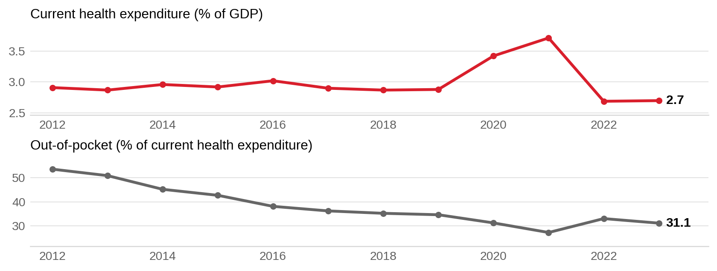
Current health expenditure is shown as a share of GDP; out-of-pocket spending is shown as a share of current health expenditure. Sources: ^{39,42}
Physicians per 1,000 people, Indonesia and comparators
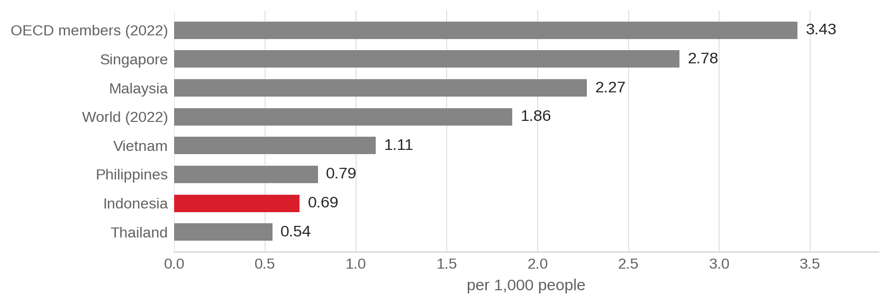
Historical World Bank cross-section: 2021 for countries and 2022 for OECD members and world aggregates. Indonesia’s separately reported 2023 value is 0.52 physicians per 1,000; the chart retains the common 2021 country reference year and does not establish a comparable trend. Sources: ⁴⁶

Market and competition
• Private operators ran 1,576 of 2,710 general hospitals in 2024, and listed hospital chains continue to expand.^{32,36}
• Malaysia-based A1Health owns nine Indonesian hospitals, including RS Premier facilities, adding foreign ownership to the competitive landscape.⁵²
• Australia's Icon operates Bali International Hospital's cancer service, while SingHealth supports the institution as its academic partner.^{53,54}
Indonesia: hospital beds per 1,000 people, 2012 to 2023
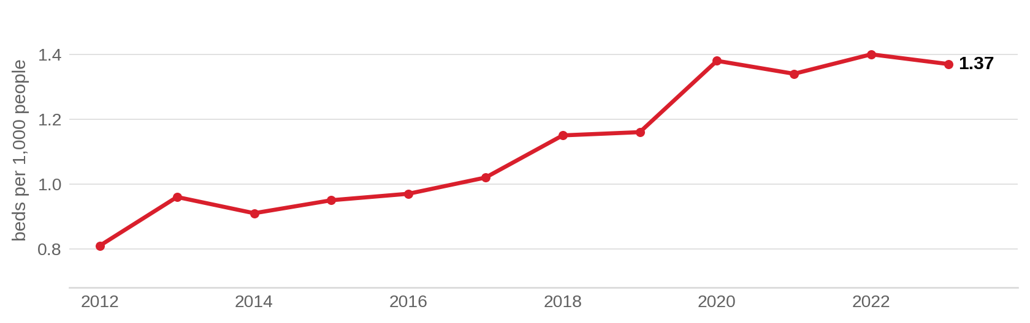
Hospital beds per 1,000 people as published in the World Bank indicator SH.MED.BEDS.ZS. Sources: ⁴⁸

Active partnerships in Indonesia
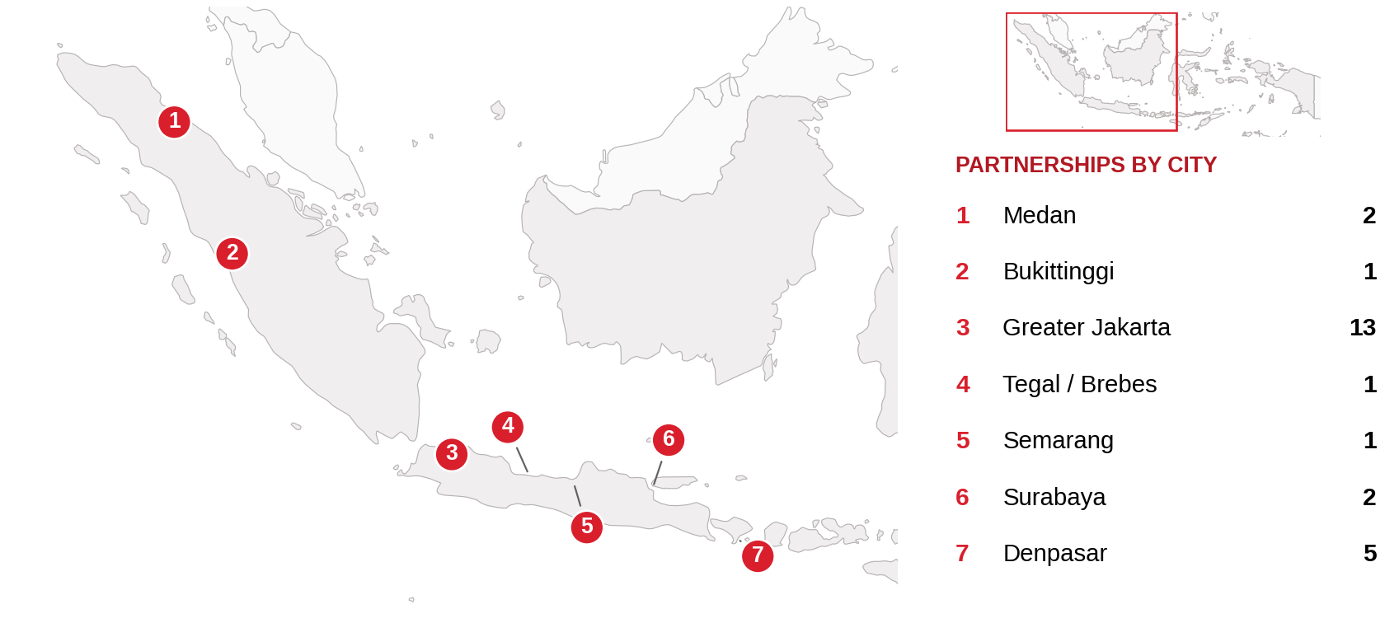
Active foreign health-system partnerships by city of the partner in Indonesia. Source: CSI partnerships tracker, verified 2026-10-07. Boundaries: Natural Earth; not an official depiction. Mapped: 22 active relationships with identified Indonesian sites. Five national or overseas-training programs are omitted. Greater Jakarta and Tegal/Brebes are grouped; one relationship may span cities. The planned Batam hospital is not shown.

Institution directory
25 foreign institutions with confirmed active partnerships (27 in all): 12 training and education, 8 clinical affiliation, 2 research collaboration, 2 advisory and consulting, 2 ownership or management, 1 government agreement. Sources in the profile and the partnerships tracker.
Institution | Nature of collaboration
Cedars-Sinai | Training and education
Harvard Medical School and Brigham and Women's Hospital (Program in Global Primary Health Care) | Research collaboration
MD Anderson Cancer Center | Advisory and consulting, Government agreement
Mayo Clinic | Clinical affiliation
St. Jude Children's Research Hospital | Training and education
Apollo Hospitals | Clinical affiliation
Asia OneHealthcare (A1Health; formerly Columbia Asia Healthcare) | Ownership or management
Chung Shan Medical University (Taiwan) | Training and education
Hong Kong Asia Medical Group (HKAMG) | Clinical affiliation
Icon Group (Icon Cancer Centre) | Ownership or management
International University of Health and Welfare (IUHW) | Training and education
Kobe University | Research collaboration
Monash Health | Training and education
Ramathibodi Hospital, Mahidol University | Training and education
Sapporo Cardiovascular Clinic | Clinical affiliation
Seoul National University Hospital | Clinical affiliation, Training and education
SingHealth | Advisory and consulting
SingHealth Duke-NUS Global Health Institute (SingHealth and Duke-NUS Medical School) | Training and education
Sun Medical Center / Sun Healthcare International | Clinical affiliation
Taipei Veterans General Hospital | Clinical affiliation
Tokushukai Medical Group | Clinical affiliation
University of Glasgow and CRUK Scotland Institute | Training and education
Wuhan Asia Heart Hospital | Training and education
Zhongda Hospital (Southeast University) | Training and education
Zhongshan Hospital (Fudan University) | Training and education

CSI position and risks

CSI partnerships in Indonesia
[MANUAL INPUT REQUIRED]
To be completed by CSI from internal data; not researched.

Opportunities for CSI
[MANUAL INPUT REQUIRED]
To be completed by CSI from internal data; not researched.

Risks and watch items
• The JKN fund recorded a Rp 17.13 trillion (US$948 million) deficit in 2025, compared with Rp 7.66 trillion (US$424 million) in 2024.⁴⁵
• Indonesia's 2.70 percent health expenditure share of GDP in 2023 trailed Malaysia, Thailand, Vietnam and the Philippines.⁴³
• Foreign-doctor licensing remained difficult in early 2025, with medical association requests for Indonesian language skills and needs-based recruitment.⁷

Recent developments
2026-08-04
Free health checks reached 73.8 million in 2026 through July 31, following about 70 million during 2025.¹⁶
2026-06-09
BPJS Kesehatan reported monthly deficits of about Rp 2 trillion (US$111 million) and expected a Rp 20 trillion (US$1.11 billion) government capital injection.³¹
2026-08-14
The 2027 draft health budget proposed Rp 244.9 trillion (US$13.5 billion), up 1.7 percent on the 2026 outlook of Rp 240.8 trillion (US$13.3 billion).³⁵

